**Pre-requisite:**

* Java version should be 1.8 .

**Step 1** : Download latest version Jenkins war file from <https://jenkins.io/download/>.

**Step 2** : Navigate to path where you have placed the jar file and give below command

“java -jar jenkins.war --httpPort=9090” in command prompt.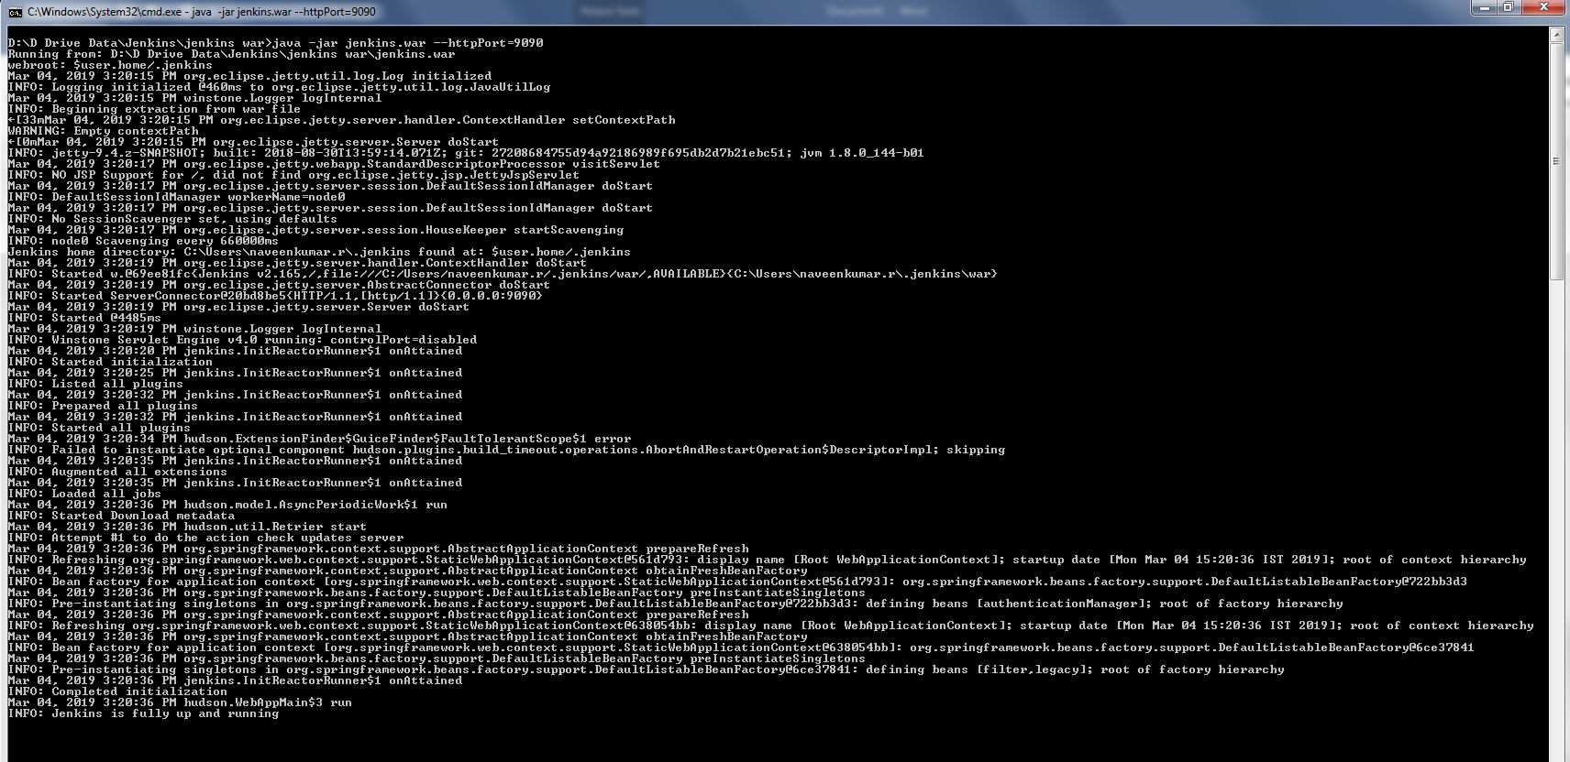Note : 9090 – Is the Port number. We can choose port number as per our wish.

**Step 3 :**  To Create a new task for Jenkins, click on “New Item” then enter an item name that is suitable for your project and select Freestyle project. Now click Ok.

**Step 4** : Select the GitHub project checkbox and set the Project URL to point to your GitHub Repository.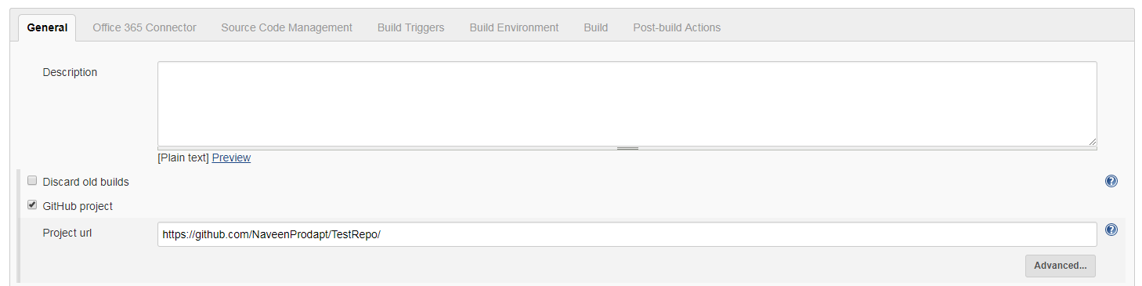

**Step 5 :** Under Source Code Management tab, select Git and then set the Repository URL to point to your GitHub Repository.

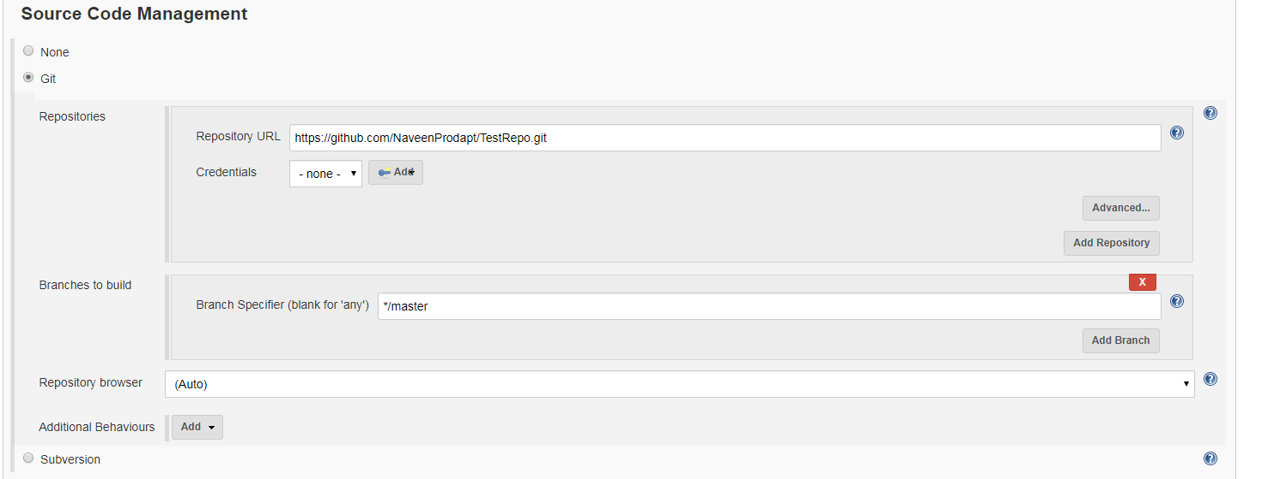

**Step 6 :** On the build trigger section, Select Checkbox – Build Periodically

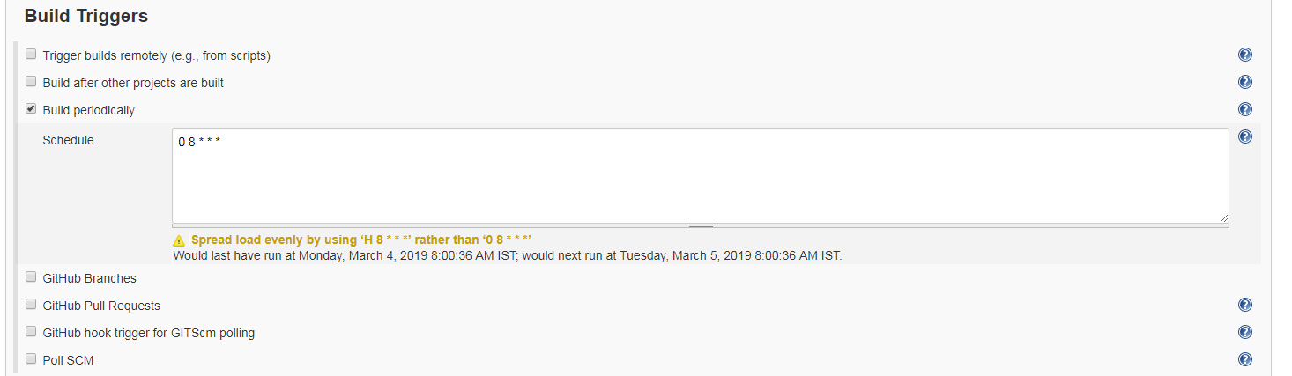

0 8 * * * : Will run automation jar everyday at 8 AM.

**Step 7 :** On the Build Section, Select “Execute Windows Batch Command”

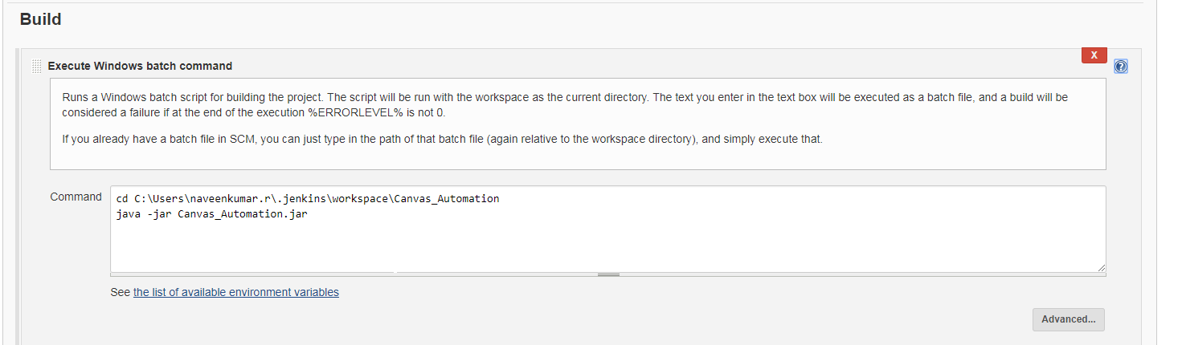

**Step 8 :** In the Post Build Action, Select Editable Mail Notification section, from which you can see mail configuration.

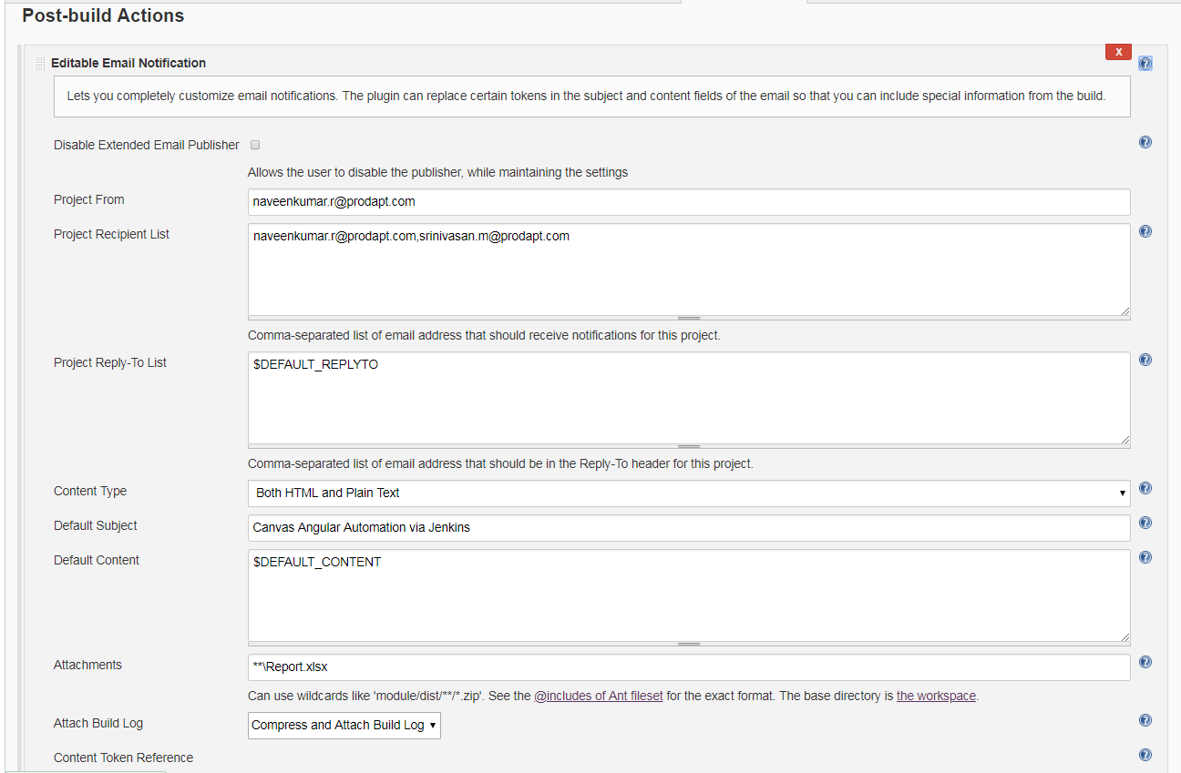

**Note :** To enable mail notification, navigate to Manage Jenkins -> Configure System-> Email Notification

