**Pre-requisite :**

* Java version should be 1.8
* IDE : Eclipse IDE (Neon Version)
* Selenium version along with Jars : 2.35.1
* Browser : We need to use relevant driver.exe files (for example : browsername.exe) for Chrome and IE Browers. (ChromeBrower file attached in Github)

**Files Added in Git Hub :**

* **Under Selenium folder I have updated all the documents.**
* Required JARS updated in **Jars_UsedIn_Selenium**
* Selenium Code under “com/canvas/automate/”
* Excel file, which we are getting input details for Username/Password(**Input.xls)**
* **I have attached Brower file(chromedriver.exe)**

**Steps to run Selenium Code in Eclipse :**

1. Create JAVA Project ( File 🡪 New 🡪 Java Project)
2. Add Project Name and give NEXT, you can see below window:

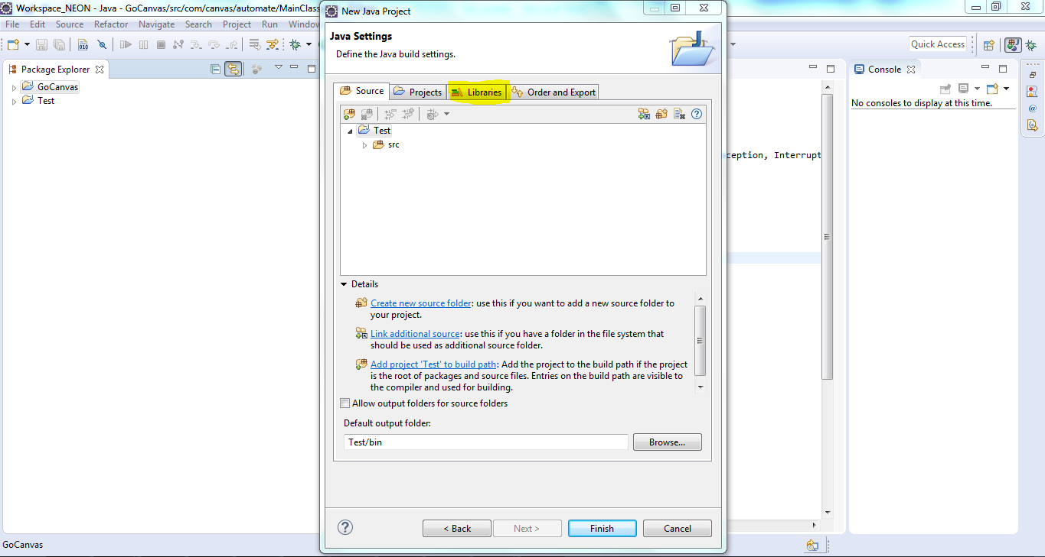

Select Libraries as highlighted in the above screenshot

1. In the Library Page, Select “**Add External Jars**”, and upload the jar files: Select all the JAR Files, which is placed under **“Jars_UsedIn_Selenium”(Folder attached in Github)**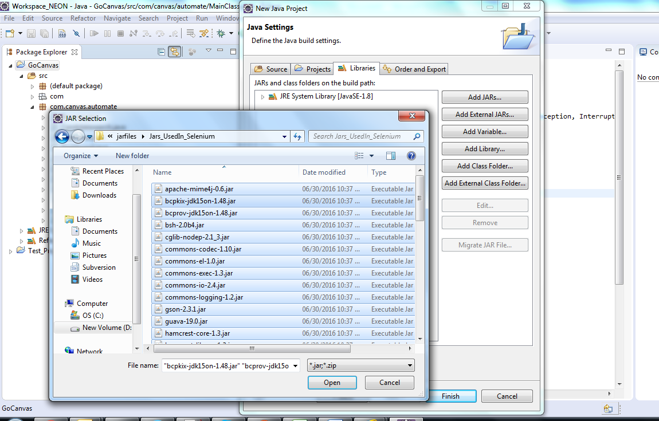
2. Click Finish.
3. Project will created on the left hand side.

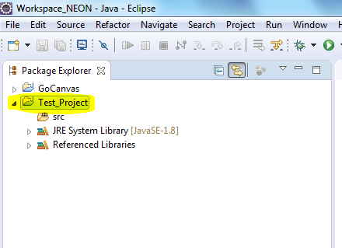

1. Right Click “**src(folder) 🡪 Import 🡪General 🡪 File System**”

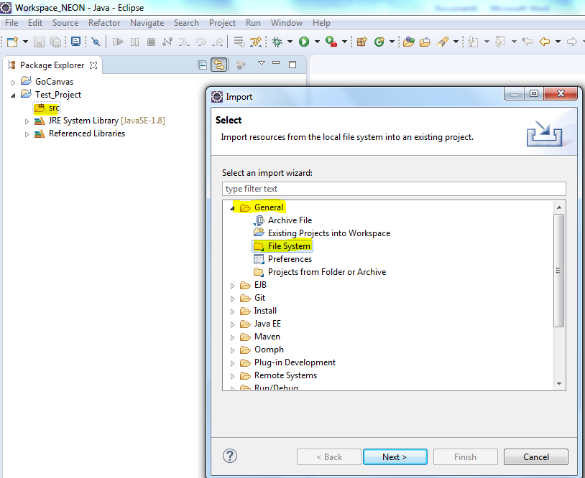

1. In File Browse the java files from local, (Latest code Updated in Github), select from com folder and also “Select Create top-level folder” 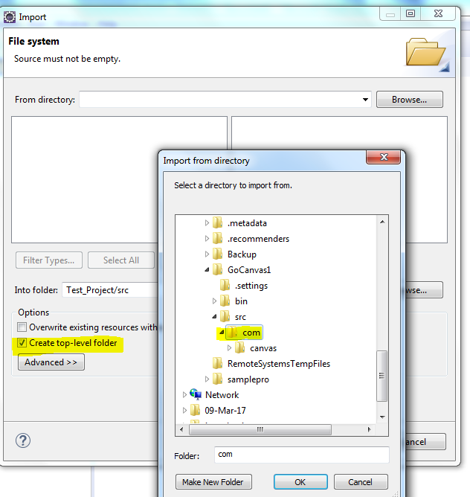

**Click “OK”**

1. Select all the folder, and click **Finish** 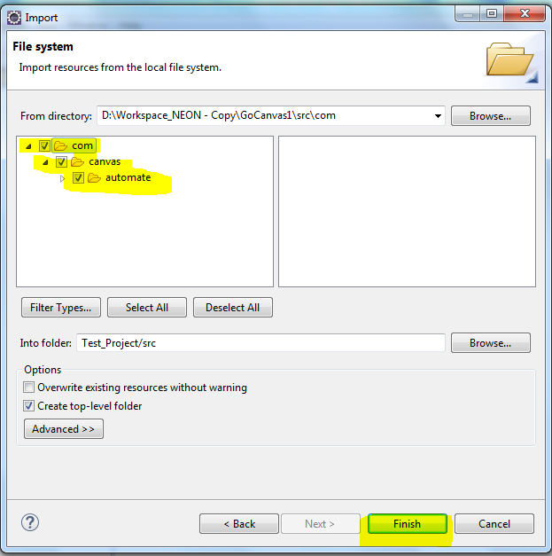
2. In the Java Project, you can see all the java files added successfully in the left corner.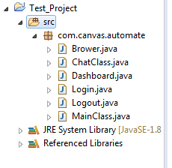
3. Update Path details in “**Login.java**”

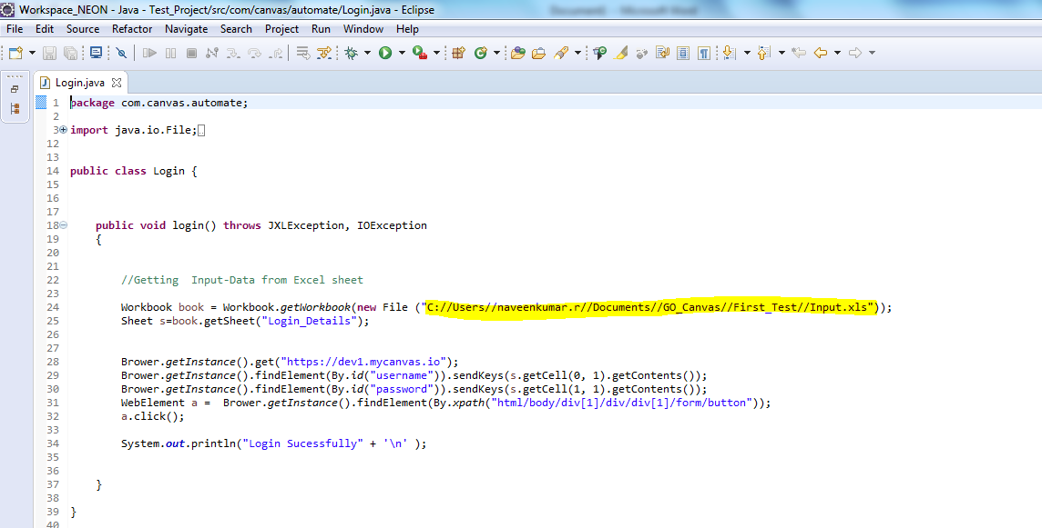

1. Please help to update Path details, in **Browser.java**

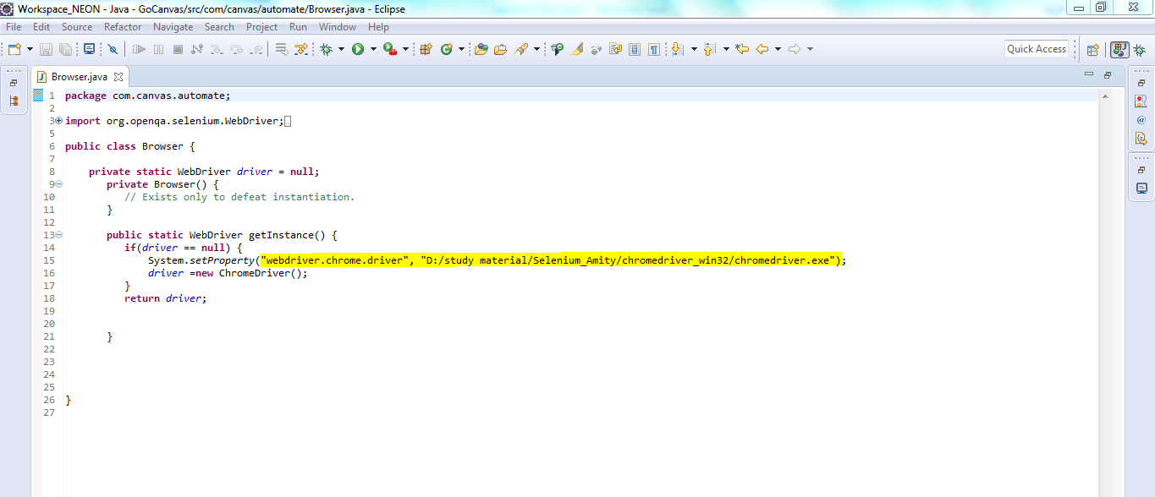

1. You can run “**MainClass.java**”.