**EXP NO: 06**

**DATE: - -2022**

**ASSIGNMENT 6**

**NAME: NAVEENKUMAR M**

**ROLL NO: 1905097**

**Aim:**

To solve the given problems using concept of DFA in C.

**1.** Write a C Program to generate a DFA for a regular expression which accepts a string if the substring "abb" is present.

**Code:**

#include <stdio.h>

#include <string.h>

int check(char x[]){

printf("%s",x);

int state=1;

int i=0;

int len=strlen(x);

printf("%d",len);

while (state!=4 && i<len){

printf("state: %c ",x[i]);

if (state==1){

if (x[i]=='a'){

state=2;

}

}

else if(state ==2){

if (x[i]=='b'){

state=3;

}

}

else if (state==3){-

if (x[i]=='b'){

state=4;

}

else {

state=2;

}

}

i+=1;

}

if(state==4){

printf("Accepted");

}

else{

printf("Not accepted");

}

return 0;

}

int main(){

char x[20];

printf("Enter the string: ");

scanf("%s",x);

check(x);

return 0;

}

**Output:**

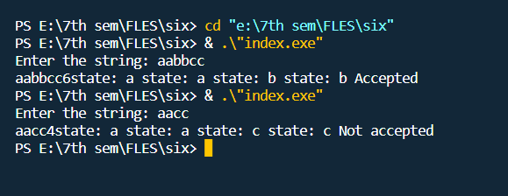

**Result:**

The programs have been executed successfully.