**EXP NO: 08**

**DATE:**

**ASSIGNMENT 8**

1. Write a lex and yacc program to implement arithmetic calculator

**CODE:**

%{

#include <stdio.h>

int yylex();

int yyerror(char*);

%}

%token NAME NUMBER

%%

statement: NAME '=' expression { printf("pretending to assign %s the value %d\n", $1, $3); };

|expression { printf("= %d\n", $1); }

;

expression: expression '+' NUMBER { $$ = $1 + $3;

printf ("yacc result - Recognized '+' expression.\n");

}

|expression '-' NUMBER { $$ = $1 - $3;

printf ("yacc result - Recognized '-' expression.\n");

}

|expression '*' NUMBER { $$ = $1 * $3;

printf ("yacc result - Recognized '*' expression.\n");

}

|expression '/' NUMBER { $$ = $1 / $3;

printf ("yacc result - Recognized '/' expression.\n");

}

|NUMBER { $$ = $1;

printf ("yacc result - Recognized a number.\n");

}

;

%%

int main(void) {

return yyparse();

}

int yyerror(char *msg) {

return fprintf (stderr, "YACC: %s\n", msg);

}

%{

#include "8a.tab.h"

extern int yylval;

%}

%%

[0-9]+ { yylval = atoi (yytext);

printf ("lex result - scanned the number %d\n", yylval);

return NUMBER; }

[ \t] { printf ("skipped whitespace\n"); }

\n { printf ("reached end of line\n");

return 0;

}

. { printf ("found other data \"%s\"\n", yytext);

return yytext[0];

}

%%

int yywrap()

{

return 1;

}

**Result:**

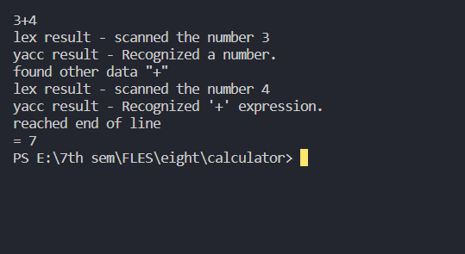

**2.** )Write a Lex and Yacc program to recognize the set of all strings of 0’s and 1’s  
with even number of 0’s and 1’s

**Code:**

%{

#include <stdio.h>

#include<stdlib.h>

int yylex();

int yyerror(char*);

%}

%token ONE ZERO NL

%%

s: s1 NL { printf("Accepted\n");

exit(0);}

;

s1: ONE s2

|ZERO s3

|

;

s2: ONE s1

|ZERO s4

;

s3: ONE s4

|ZERO s1

;

s4: ONE s3

|ZERO s2

;

%%

int main(void) {

return yyparse();

}

int yyerror(char *msg) {

printf("Not Accepted\n");

exit(0);

}

**Result:**

