**EXP NO: 05**

**DATE: - -2022**

**ASSIGNMENT 5**

**NAME: NAVEENKUMAR M**

**ROLL NO: 1905097**

**Aim:**

To solve the lex problems.

**1.** ) Construct a DFA that accepts all the words of a & b with exactly 2 a's

**Code:**

%{

#include <stdio.h>

%}

%%

(b*ab*ab*) {

printf("Accepted");}

.+ { printf("Not Accepted"); }

%%

void main(){

yylex();

printf("%d",i);

}

int yyerror(){

return 1;

}

int yywrap(){

return 1;

}

**Output:**

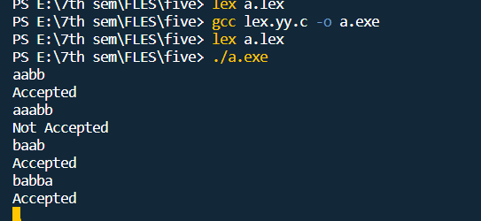

**2.** Write a lex program to verify a given  IMEI number for a mobile is valid or not.

Code:

%{

#include<stdio.h>

#include<ctype.h>

void check(char*);

%}

pattern [0-9]{2}+[-]+(516604|292908|469904|015420)+[-]+[0-9]{6}[-][0-9]

%%

{pattern} check(yytext);

.* {printf("not valid");}

%%

int main(){

printf("Enter the IMEI number");

yylex();

}

void check(char* a)

{

int sum=0;

int i,x,j=0;

int len=17;

for(i=0;i<17;i++){

if (i==2|| i==9||i==16){

if (a[i]=='-')

continue;

}

else if (j%2==1){

x=(int)a[i]-(int)'0';

x*=2;

sum+=x%10;

x/=10;

sum+=x%10;

j++;

}

else{

sum+=(int)a[i]-(int)'0';

j++;

}

}

if( (((int)a[17]-(int)'0')+sum )%10==0){

printf("Valid");

}

else{

printf("Not valid");

}

}

int yyerror(){

return 1;

}

int yywrap(){

return 1;

}

**Ouptut:**

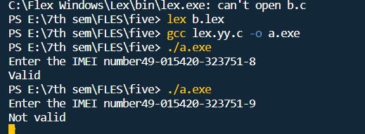

**Result:**

The programs have been executed successfully.