**EXP NO: 04**

**DATE: 1 -0 -2022**

**ASSIGNMENT 4**

**NAME: NAVEENKUMAR M**

**ROLL NO: 1905097**

**Aim:**

To solve the lex problems.

**1.**  Write a lex program to copy the content from input file and replace the character  "S" with "W" paste it in the output file.

**CODE:**

%{

#include <stdio.h>

#include <string.h>

%}

%%

[s] {

fprintf(yyout,"%s","W");

}

fprintf(yyout,"");

%%

int yywrap(){

return 1;

}

int main(){

extern FILE *yyin,*yyout;

yyin=fopen("input.txt","r");

yyout=fopen("output.txt","w");

yylex();

return 0;

}

**OUTPUT:**

**Input.txt**

Naveenkumar is a good boy s

**Output.txt**

Naveenkumar iW a good boy W

2. Write a lex program to read the expressions from a file and categorize into infix, prefix or post-fix  into the output files.

**CODE:**

%{

#include<stdio.h>

%}

infix [a-zA-Z]+[a-zA-Z+/*]+[a-zA-Z)]+

prefix [+*/]+[a-zA-Z+*/]+[a-zA-Z]+

postfix [a-zA-Z]+[a-zA-Z+*/]+[+*/]+

%%

{infix} {fprintf(yyout,"\n%s -- Infix expression",yytext);}

{prefix} {fprintf(yyout,"\n%s -- Prefix expression",yytext);}

{postfix} {fprintf(yyout,"\n%s -- Postfix expression",yytext);}

%%

int main(){

extern FILE *yyin,*yyout;

yyin=fopen("input2.txt","r");

yyout=fopen("output42.txt","w");

yylex();

}

int yyerror(){

return 1;

}

int yywrap(){

return 1;

}

**OUTPUT:**

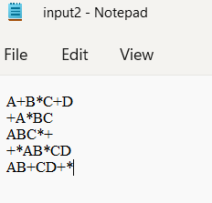 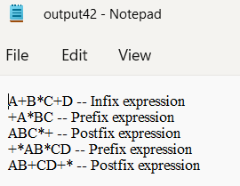

Result:

The programs has been executed successfully.

.