**EX NO: 9 C SCANNER USING LEX AND YACC**

**DATE :21.11.22**

**AIM:**

write a lex and yacc program to implement C scanner for the following:  
variables, keywords, arrays, structures, files and functions.

**PROGRAM:**

**EX9.l**

%{

#include"EX9.tab.h"

char* checkspecifier(char*);

%}

var ([a-zA-Z]+[0-9]*)+

special [+|*|_|\ |-|?|\%|/]

inp [\ ]*\&([a-zA-Z]+[0-9]*)+[\ ]*

dtype (int|char|float)

alp [a-zA-Z]

num [0-9]

sp (%d|%c|%f)

%%

(\#include)\<(stdio|conio|stdlib|string)\.[h]\> {return HEAD;}

(void)[\ ](main)\((.*)\) {return MAIN;}

{dtype}[\ ]{var}(;) {printf("\nValid Variable %s\n",yytext);return LINE;}

{dtype}(\ )({alp}+{num}*)+(\[{num}*\])+(;) {printf("Array valid %s\n",yytext); return LINE;}

(printf)(\(\"({alp}*{num}*{special}*)*\"(\,{var})*\))[;] {printf("\nPrintf valid\n"); return LINE;}

(scanf)[\ ]*(\([\ ]*\"(.*{sp}.*)+\"[\ ]*(\,{inp})+)\)[\ ]*[;] {printf("%s\n",checkspecifier(yytext));return LINE;}

(break;|continue;) {printf("KEYWORD VERIFIED\n");return LINE;}

(strcmp)(\({var}\,{var}\))[;] {printf("strcmp valid\n"); return LINE;}

(strcmp)(\({var}\,\"({alp}*{num}*{special}*)*\"\))[;] {printf("STRCMP valid\n");return LINE;}

(strcmp)(\(\"({alp}*{num}*{special}*)*\"\,{var}\))[;] {printf(" strcmp valid\n");return LINE;}

[\}|\{] {return yytext[0];}

(\n|\t) {return *yytext;}

. {return 0;}

%%

char* checkspecifier(char *a){

int i=0;

int countspecifier=0;

int equispecifier=0;

while(a[i]!='\0'){

if(a[i]=='\"'){

i++;

while(a[i]!='\"'){

if(a[i]=='%'&&(a[i+1]=='d'||a[i+1]=='f'||a[i+1]=='c')){

countspecifier+=1;

}

i++;

}

}

while(a[i]==','){

equispecifier+=1;

i++;

while(a[i]!=',' && a[i]!=')') i++;

}

i++;

}

if(equispecifier==countspecifier){

return "Valid Function";

}

return "Missing specifier/variable";

}

int yywrap(){

return 0;

}

**EX9.y**

%{

#include <stdio.h>

#include<stdlib.h>

extern FILE *yyin;

int yylex();

int yyerror(char*);

%}

%token HEAD

%token MAIN

%token LINE

%%

S : A

;

A : B C F {printf("\nFile Scanned\n");}

;

B : HEAD Z B{printf("\nRecognized Header File\n");}

| HEAD Z

;

C : MAIN D {printf("\nRecognized Function Main \n");}

| MAIN '\n' D

;

D : '{' Z E

;

E : LINE Z E

|

LINE Z

;

F : '}' {printf("\nEnd of Code\n");}

;

Z : '\n' Z

| '\t' Z

| ' ' Z

|

;

%%

void main() {

FILE *fp;

fp=fopen("input.txt","r");

yyin=fp;

yyparse();

}

int yyerror(char *msg) {

return fprintf (stderr, "YACC: %s\n", msg);

}

**input.txt**

#include<stdio.h>

#include<stdlib.h>

void main(){

char a;

scanf("%d %c",&a,&s);

break;

float t;

printf("CIT college");

strcmp(name,"hello");

}

**OUTPUT:**

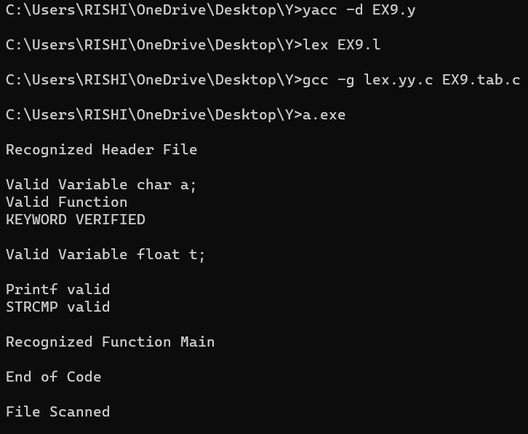

**RESULT:**

Hence the program has been executed successfully.