EX.NO:7 ASSIGNMENT :7 NAME: Naveenkumar M

DATE:23.9.2022 ROLL.NO:1905097

Write a Lex program to validate the following C program syntax.

1. Arrays

2. Control structures(looping statements)

4. Keywords

**CODE:**

**1,2,4:**

%{

#include<stdio.h>

%}

dtype (int|char|float)

alp [a-zA-Z]

num [0-9]

%%

{dtype}(\ )({alp}+{num}*)+(\[{num}*\])+(;) {printf("ARRAY");}

(for)(\(.*;.*;.*\)) {printf("FOR loop ");}

(while)(.*) {printf("WHILE loop -");}

(break)[;] {printf("BREAK SYNTAX ");}

(continue)[;] {printf("CONTINUE SYNTAX");}

.* {printf("Invalid syntax");}

%%

int yywrap(){

return 1;

}

int yyerror(){

return 1;

}

int main(){

yylex();

return 0;

}

OUTPUT:

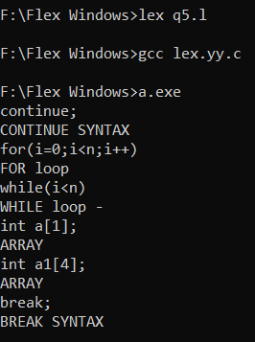

3. Any 3 built-in functions

CODE:

%{

char* checkspecifier(char*);

%}

sp (%d|%c|%f)

special [+|*|_|\ |-|?|\%|/]

alp [a-zA-Z]

num [0-9]

var ([a-zA-Z]+[0-9]*)+

inp \&([a-zA-Z]+[0-9]*)+

%%

(strcmp)(\({var}\,{var}\))[;] {printf("VALID STRCMP SYNTAX");}

(strcmp)(\({var}\,\"({alp}*{num}*{special}*)*\"\))[;] {printf("VALID STRCMP SYNTAX");}

(scanf)(\(\"(.*{sp}.*)+\"(\,{inp})+)\)[;] {printf("%s",checkspecifier(yytext));}

(printf)(\(\"({alp}*{num}*{special}*)*\"(\,{var})*\))[;] {printf("VALID PRINTF SYNTAX");}

.* {printf("Incorrect syntax");}

%%

char* checkspecifier(char *a){

int i=0;

int countspecifier=0;

int equispecifier=0;

while(a[i]!='\0'){

if(a[i]=='\"'){

i++;

while(a[i]!='\"'){

if(a[i]=='%'&&(a[i+1]=='d'||a[i+1]=='f'||a[i+1]=='c')){

countspecifier+=1;

}

i++;

}

}

while(a[i]==','){

equispecifier+=1;

i++;

while(a[i]!=',' && a[i]!=')') i++;

}

i++;

}

if(equispecifier==countspecifier){

return "Valid Function";

}

return "Missing specifier/variable";

}

int yywrap(){

return 0;

}

int yyerror(){

return 0;

}

int main()

{

yylex();

return 0;

}

OUTPUT:

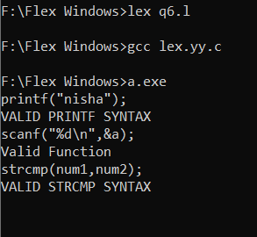

RESULT:

Thus the program has executed successfully.