**EX.NO : 10 CONVERTING PYTHON TO JAVA USING**

**28/10/2022 LEX AND YACC**

**1.Implement a Lex and Yacc program to convert the following Python code  to Java code.**

**CODE:**

**LEX FILE:**

%{

#include <stdio.h>

#include <stdlib.h>

#include "y.tab.h"

%}

variable ([a-zA-Z]+[0-9]*)+

num [0-9]*

special [+|*|_|\ |-|?|\%|/]

alp [a-zA-Z]

%%

{variable}[\ ]*(=)(\[({num}+(\,{num}+)*)*\]) {yylval.f = yytext; return STR;}

{variable}[\ ]*(=)(\[\"({alp}*{num}{special}*)*\"(\,\"({alp}*{num}{special}*)*\")*\]) {yylval.f = yytext; return STR;}

{variable}[\ ]*(=)(\[\'({alp}*{num}{special}*)*\'(\,\'({alp}*{num}{special}*)*\')*\]) {yylval.f = yytext; return STR;}

[\t|\n|.*] {return 0;}

%%

int yywrap()

{

return -1;

}

**YACC FILE:**

%{

#include <stdio.h>

#include <string.h>

#include <stdlib.h>

extern int yylex();

void yyerror(char *msg);

char var[20];

int i=0,k=0;

%}

%union {

char* f;

}

%token <f> STR

%type <f> E

%%

S : E {

while($1[i]!='='){

var[i]=$1[i];

i++;

}

printf("Java : \n");

while($1[i]!='[') i++;

i++;

k=$1[i];

if(k>47){

printf("List<Integer> %s=new ArrayList<Integer>()\n",var);

}else{

printf("List<String> %s=new ArrayList<String>()\n",var);

}

}

;

E : STR {$$ = $1;}

;

%%

void yyerror(char *msg)

{

fprintf(stderr, "%s\n", msg);

exit(1);

}

int main()

{

printf("Python : ");

yyparse();

return 0;

}

**OUTPUT:**

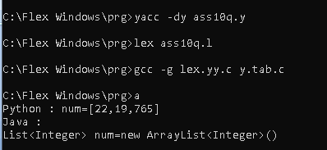

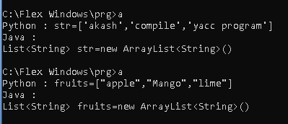

**RESULT:**

The above lex and yacc program for converting PYTHON list to JAVA array was successfully completed.