**EXP NO: 03**

**DATE: 12-08-2022**

**ASSIGNMENT 3**

**NAME: NAVEENKUMAR M**

**ROLL NO: 1905097**

**Aim:**

To solve the lex problems.

**1.Write a lex program to validate the set of all strings over {a,b} with exactly 3 b's.**

**CODE:**

%{

#include<stdio.h>

%}

%%

a*ba*ba*ba*         {printf("accepted\n");}

.*            {printf("not accepted\n");}

%%

void main()

{

  yylex();

}

int yyerror()

{

   return(1);

}

int yywrap()

{

return(1);

}

**OUTPUT:**

**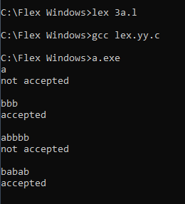  
2.Write a lex program to validate the set of all strings over {a,b} with length 5 and ends with 'a'.**

**CODE:**

%{

#include<stdio.h>

%}

%%

(a|b)(a|b)(a|b)(a|b)a       {printf("accepted\n");}

.*                                 {printf("not accepted\n");}

%%

void main()

{

  yylex();

}

int yyerror()

{

   return(1);

}

int yywrap()

{

return(1);

}

**OUTPUT:**

**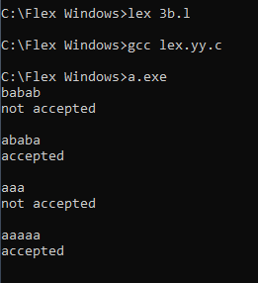  
  
3.Write a lex program which get input from a file and classify the mails as personal, official and others accordingly to the separate file**

%{

#include<stdio.h>

#include<string.h>

%}

%%

[a-z0-9]*@(gmail|yahoo)(.[a-z]*)*.(com|in) {

fprintf(yyout, yytext);

fprintf(yyout, "%s\n", " - Personal");

}

[a-z0-9]*@(cit|zoho)(.[a-z]*)*.(com|in) {

fprintf(yyout, yytext);

fprintf(yyout, "%s\n", " - Official");

}

[a-z0-9]*@[a-z]+(.[a-z]*)*.(com|in) {

fprintf(yyout, yytext);

fprintf(yyout, "%s\n", " - Others");

}

. {fprintf(yyout, "");}

%%

int yywrap(){

return 1;

}

int main()

{

*extern* FILE *yyin, *yyout;

yyin = fopen("Input.txt", "r");

yyout = fopen("Output.txt", "w");

yylex();

return 0;

}

**Ouptut:**

**naveen@gmail.com – Personal**

**Result:**

The programs has been executed successfully.