**EXP NO: 02**

**DATE: 05-08-2022**

**ASSIGNMENT 2**

**NAME: NAVEENKUMAR M ROLL NO: 1905097**

**1. Write a lex program to accept string which have 0’s as last character.**

**CODE:**

%{

#include<stdio.h>

%}

letter [a-zA-Z]

digit [0-9]

%%

({letter}|{digit})*0        {printf("accepted");}

.*                          {printf("not accepted");}

%%

void main()

{

  yylex();

 }

int yyerror()

{

   return(1);

}

int yywrap()

{

return(1);

}

**OUTPUT:**

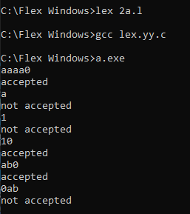

**2. Write a lex program to accept even number of b’s**

**CODE:**

%{

#include<stdio.h>

%}

%%

(a|ba*ba*)*         {printf("accepted");}

.*                  {printf("not accepted");}

%%

void main()

{

  yylex();

 }

int yyerror()

{

   return(1);

}

int yywrap()

{

return(1);

}

**OUTPUT:**

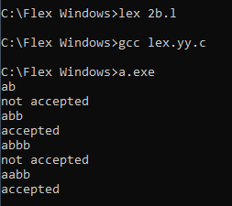

**3. Write a program in lex to accept strings with number of 1’s should be the count of 3**

**CODE:**

%{

#include<stdio.h>

%}

%%

(a|b)*1(a|b)*1(a|b)*1(a|b)*     {printf("accepted\n");}

.*                      {printf("not accepted\n");}

%%

void main()

{

  yylex();

}

int yyerror()

{

   return(1);

}

int yywrap()

{

return(1);

}

**OUTPUT:**

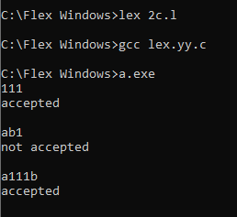

**Result**

The programs has been executed successfully.