

AI-Powered CERVICAL CANCER DETECTION ENHANCEMENT: Using cutting- Edge deep learning, Segmentation, and optimization techniques for better screening
PROJECT REPORT
Submitted by
NAVEEN KUMAR R | 727621BEC067
MADHAN S | 727621BEC073
ESWAR D | 727621BEC083

in partial fulfillment of the requirements for the degree of
BACHELOR OF ENGINEERING
in
Electronics and communication engineering
Dr. MAHALINGAM COLLEGE OF ENGINEERING AND TECHNOLOGY
An Autonomous Institution
Affiliated to ANNA UNIVERSITY
CHENNAI 600 025
APRIL 2025

DR. MAHALINGAM COLLEGE OF ENGINEERING AND TECHNOLOGY, POLLACHI -642 003
(AN AUTONOMOUS INSTITUTION AFFILIATED TO ANNA UNIVERSITY, CHENNAI - 600 025)

BONAFIDE CERTIFICATE

Certified that this project report titled “AI-Powered Cervical Detection Enhancement : Using Cutting-Edge Deep Learning, Segmentation, and Optimization Techniques for Better Screening” is the Bonafide work of

NAVEEN KUMAR R | 727621BEC067
MADHAN S | 727621BEC073
ESWAR D | 727621BEC083

who carried out the project work under my supervision.

Dr.V.K.SUDHA,M.E., Ph.D.,  PROFESSOR AND HEAD  Department of ECE  Dr. Mahalingam college of Engineering and Technology Pollachi- 642003 | Dr.C.Moorthy ,M.E.,Ph.D.,  SUPERVISOR  Assistant Professor (SS)  Department of ECE  Dr. Mahalingam college of  Engineering and Technology Pollachi- 642003

Submitted for the Autonomous End Semester project Viva-Voce Examination held on

INTERNAL EXAMINER EXTERNAL EXAMINER

Dr. Mahalingam College of Engineering and Technology, Pollachi-642003
Academic Year: 2024 - 2025
TRL, SDG and Similarity Compliance Certificate
Project Title : AI-Powered Cervical Detection Enhancement: Using Cutting-Edge Deep Learning, Segmentation, and Optimization Techniques for Better Screening
Course Code : 19ECPN6801
Department and Semester : ECE & VIII
Technology Readiness Level (TRL) of the Project
:
Sustainability Development Goals (SDG)-Goal Name :
Similarity % from Turnitin Software
:
We hereby declare that this project report is original and complies with the institution's similarity guidelines.
S.No. | Names and Roll Numbers of Students | Signature of the Students
1. | NAVEEN KUMAR R – 727621BEC067
2. | MADHAN S – 727621BEC073
3. | ESWAR D – 727621BEC083

Verified by

Name & Signature of the Guide Head of the Department
Endorsed by

INTERNAL EXAMINER EXTERNAL EXAMINER

ABSTRACT

One of the main causes of death for women is cervical cancer, and survival rates are greatly increased by early identification using Pap smear analysis. However, manually reviewing Pap smear images takes a lot of time and is prone to mistakes. Using an enhanced Convolutional Neural Network (CNN) with Transformer-like classification efficiency and U-Net based nucleus segmentation, this study suggests an automated cervical cancer detection system. To increase feature extraction, the dataset is preprocessed utilising techniques such edge detection, contrast enhancement with CLAHE, and greyscale conversion. To improve convergence and accuracy, a CNN optimised with the Lion optimiser (Evolved Sign Momentum) is used to classify the segmented nuclei. Results from experiments show that our model outperforms conventional methods in terms of classification accuracy.By lowering reliance on manual screening and increasing early diagnosis rates, this automated approach can help medical practitioners detect cervical cancer more quickly and accurately.
Keywords:
Cervical Cancer, Deep Learning, U-Net, CNN, Lion Optimizer, Pap Smear, Medical Image Segmentation

ACKNOWLEDGEMENT
We wish to express our sincere thanks to all who have contributed to do this project through their support, encouragement and guidance.
We extend our gratitude to our management for having provided us with all facilities to build my project successfully. We express our sincere thanks to our honourable Secretary, Dr.C.Ramaswamy, M.E., Ph.D., F.I.V., for providing the required amenities.
We take this opportunity to express our deepest gratitude to our principal Dr.P.Govindasamy, Ph.D., who provide suitable environment to carry out the project.
We express our extreme gratefulness to Dr.V.K.SUDHA, M.E., Ph.D., Professor and Head of the department of Electronics and Communication Engineering, for her constant support and encouragement.
We wish to express our deep sense of gratitude and thankfulness to our project guide Dr.C.Moorthy M.E., Ph.D., for the valuable suggestion and guidance offered during the course of the project.
Finally, we are committed to place our heartfelt thanks to all those who had contributed directly and indirectly towards the success of the completion of this

TABLE OF CONTENTS

CHAPTER  NO. | TITLE | PAGE NO.
 | ABSTRACT
 | LIST OF FIGURES
 | LIST OF TABLES
 | LIST OF ABBREVIATIONS
1 | INTRODUCTION | 1
1.1 | Overview of Cervical Cancer | 2
1.2 | Digital tools for Recognizing Cervical Cancer | 2
1.2.1 | Prefered Screening techniques | 3
1.2.2 | Objectives of Automated Screening | 3
1.2.3 | Workflow of AI-Driven Detection System | 3
1.2.4 | Challenges in Detection Systems | 5
1.2.5 | Image Clarity Issues | 5
1.2.6 | Measuring Model Accuracy | 6
1.2.7 | Major Problems in Classification and Segmentation | 6
2 | LITERATURE REVIEW | 7
3 | EXISTING METHODOLOGY | 10
3.1 | Diagnosis Based on Manual Microscopy | 10
3.2 | Conventional Methods for Deep Learning | 11
3.3 | Morphological and Thresholding Procedures | 11
3.4 | CNN-Based Segmentation-Free Classification | 12
3.5 | Manual Classification and U-Net Segmentation- | 12
3.6 | YOLOv8- Based Classification | 13
3.7 | Lion Optimization Technique | 13
4 | PROPOSED METHODOLOGY | 14
4.1 | Dataset Collection | 15
4.1.1 | Visual Outcomes for Every Types of cell | 16
4.1.2 | Analysis of Qualitative Data | 17
4.2 | Image Pre-processing | 17
4.3 | U-Net Image Segmentation | 18
4.3.1 | Region of Interest (ROI) | 20
4.4 | Classification | 20
4.5 | Optimization Using Lion Algorithm | 22
4.6 | Assessment of Performance | 24
4.7 | Overview of the Integrated Pipeline | 24
5 | SOFTWARE DESCRIPTION | 26
5.1 | Key Features of Python in this Project | 26
5.2 | Python’s role in the Project Workflow | 27
5.2.1 | Data Loading and Pre-Processing | 27
5.2.2 | Segmentation with U-Net | 28
5.2.3 | Object Detection and Classification with YOLOv8 | 28
5.2.4 | Model Evaluation and Visualization | 29
5.3 | Libraries and tools used | 29
5.4 | Challenges and Solutions | 30
6 | RESULTS AND DISCUSSION | 31
6.1 | Preprocessing Images | 31
6.2 | Analysis of Accuracy and Loss | 32
6.2.1 | Observations | 32
6.3 | U-Net Segmentation Results | 33
6.4 | YOLOv8-n Training and Optimization | 34
6.5 | Confusion Matrix Analysis | 35
6.6 | Measures of Performance | 36
6.7 | Classification and Prediction of Output | 37
6.7.1 | Raw Pap Smear image(Input image) | 37
6.7.2 | Predicted Mask (U-Net Output) | 37
6.7.3 | Classification (YOLOv8 Output) | 37
7 | CONCLUSION AND FUTURE SCOPE | 40
7.1 | Final Thoughts | 40
7.2 | Future Extent | 40
 | Annexure | 41
 | REFERENCES | 51

LIST OF TABLES

TABLE  NO. | TITLE | PAGE NO.
4.1 | Types of Cells | 15
5.7 | Libraries and Tools Used | 30
5.10 | Challenges and Solutions | 36
6.6 | Measures of Performance | 37

LIST OF FIGURES

FIGURE  NO. | TITLE | PAGE NO.
4 | Block Diagram | 14
4.1.1 | Types of Cells | 16
4.2 | Image Preprocessing | 18
4.3 | U-Net Segmentation Training Result | 19
4.4 | YOLOv8-n Classification Model | 21
4.4 | YOLOv8-n Training Accuracy | 24
4.7 | Integrated Pipeline | 25
6.1 | Preprocessed image | 31
6.2.1 | Loss Curve and Accuracy Curve for training | 34
6.3 | Segmentation Using U-Net | 35
6.5 | Confusion Matrix | 35
6.7 | Classification and Prediction of Output | 39

CHAPTER 1
INTRODUCTION
One of the biggest health risks to women worldwide is still cervical cancer. It is brought on by the unchecked proliferation of aberrant cells in the cervix, which, if left untreated, have the potential to spread to other areas of the body and infiltrate nearby tissues. Cervical cancer is the fourth most frequent disease in women, according to the World Health Organisation. Because of poor screening and access to healthcare, a significant number of cases occur in low- and middle-income nations. Increasing survival rates and guaranteeing successful treatment depend on early detection. The Pap smear test, developed by Dr. George Papanicolaou in the 1920s, is among the oldest and most used screening techniques. Even while the Pap smear has greatly decreased the number of cervical cancer cases in developed nations, it still mainly depends on manual examination by qualified cytologists, which can be labour - intensive, time-consuming, and subject to human error or interpretation variability. Despite being more reliable, biopsy-based confirmation is still invasive and requires manual evaluation. Artificial intelligence (AI), particularly machine learning (ML) and deep learning (DL), has emerged in the field of medical diagnostics in recent years as a solution to these problems. These technologies have demonstrated significant promise in creating automated, precise, and expandable cervical cancer screening systems. DL models are especially well-suited for image-based diagnostics since they can automatically learn and extract significant patterns from big datasets, in contrast to traditional techniques that depend on manually created features. This work applies deep learning algorithms to Pap smear images in order to diagnose cervical cancer. To improve the quality and clarity of the input photos, the system starts with an important image preprocessing step. To make sure that important cellular features are more visible to the model, this step involves processes including greyscale conversion, contrast enhancement using CLAHE, normalisation, edge detection, smoothing, and sharpening. To separate the nucleus, which is frequently a crucial region of interest in cancer detection, the pre-processed pictures are then run through a segmentation model, usually a U-Net architecture. After segmentation, sophisticated DL models are used for a classification phase. While some methods use CNN-based models like ConvNext for in-depth feature learning and classification, others use lightweight object detection algorithms like YOLOv8-n to identify and categorise cells. Advanced optimisers like Lion are frequently used to further optimise these models, improving training efficiency and convergence speed.
  - OVERVIEW OF CERVICAL CANCER
Among women worldwide, cervical cancer is the primary cause of cancer-related fatalities. The bottom portion of the uterus that joins the vagina, the cervix, is where it develops. When aberrant cells proliferate out of control, the disease may spread to nearby tissues or other organs. Survival rates and treatment outcomes are greatly enhanced by early identification.
Prolonged exposure to high-risk strains of the human papillomavirus (HPV) is the main risk factor for cervical cancer. HPV infections are frequently cleared by the immune system, but occasionally they result in precancerous alterations. Screening techniques like as the Pap smear test, which was developed by Dr. George Papanicolaou, aid in the early detection of these anomalies. Examining Pap smears by hand is time-consuming, subjective, and prone to human mistake.
1.2 DIGITAL TOOLS FOR RECOGNISING CERVICAL CANCER
Deep learning (DL) and artificial intelligence (AI) are being used more and more for automated cervical cancer detection in order to overcome the drawbacks of conventional screening. These technologies improve medical image analysis's scalability, speed, and diagnostic accuracy.
Convolutional neural networks (CNNs) are capable of accurately classifying, identifying, and processing Pap smear images. Techniques for image preprocessing are essential for enhancing image quality prior to analysis. Greyscale conversion, edge sharpening, contrast enhancement, and histogram normalisation are typical techniques.

1.2.1 PREFERED SCREENING TECHNIQUES
- Pap Smear Test
- HPV DNA Testing
- Colposcopy
- Biopsy
- AI – Assisted Digital Screening
1.2.2 OBJECTIVES OF AUTOMATED SCREENING
The aim of automated cervical cancer screening is to reduce human error while increasing diagnosis accuracy. Traditional screening techniques mostly depend on human interpretation, which can be laborious, erratic, and constrained by the number of qualified pathologists available. Rapid, consistent Pap smear picture analysis is made possible by AI-driven automation, which guarantees more reliable and effective outcomes. In underprivileged areas where access to medical specialists is limited, this technology is very helpful. Automated technologies increase treatment success rates and reduce mortality by enabling early and precise detection.
AI systems also simplify workflow by eliminating routine cases, freeing up medical practitioners to focus on high-risk diagnosis. Because automated screening offers consistent diagnostic criteria and seamless interaction with digital health information, it also facilitates mass screening campaigns. In the end, AI-powered cervical cancer detection improves healthcare's accessibility, scalability, and efficiency.
1.2.3 WORKFLOW OF AI – DRIVEN DETECTION SYSTEM
A systematic, multi-phase analytical procedure that blends medical knowledge with computational accuracy is used in AI-powered cervical cancer detection. This methodical technique guarantees precise and effective diagnosis through the following crucial stages:

Preprocessing images
To maximise analysis, the first step improves raw Pap smear pictures. To increase cellular visibility while reducing artefacts, computational methods such edge sharpening algorithms, contrast enhancement (like CLAHE), noise reduction filters, and greyscale conversion for standardisation are used. Consistent image quality is ensured in this step for trustworthy automatic interpretation.
Segmentation
To precisely identify each cell's cytoplasm and nucleus, deep learning models such as U-Net are used. This segmentation is essential because it enables the algorithm to concentrate on the particular regions that are biologically significant for the detection of cervical cancer. These include morphological characteristics of the cells and nuclei, such as their size, shape, irregularity of the boundaries, and texture. The computational foundation for differentiating between healthy and aberrant cells is provided by these characteristics.
Optimisation
The Lion optimisation technique is used to improve learning efficiency while deep learning models (such U-Net for segmentation and YOLOv8-n for classification) are being trained. By dynamically modifying learning rates and updating weights in response to gradient feedback and momentum, Lion enhances model convergence. Better accuracy, quicker training, and more consistent performance during prediction result from this
Classification
An algorithm for classification is used after the characteristics have been extracted. Cells are classified as either normal or malignant using sophisticated deep learning models like YOLOv8-n. These models can identify even minute variations in cell morphology that would not be apparent to the naked eye and can learn from enormous datasets.

Predicted Output
The system's level of confidence in its forecast is shown by the final output, which also includes a classification label. This aids medical professionals in determining the diagnosis's dependability and the patient's best course of action.
1.2.4 CHALLENGES IN DETECTION SYSTEMS
There are many obstacles in the way of creating a reliable and accurate AI-based cervical cancer screening system. Overlapping cells and areas of the image that are blurry are among the most important problems because they might confound segmentation models and result in incorrect analysis.
The generalisability of trained models can also be impacted by differences in picture quality caused by inconsistent staining and slide preparation methods throughout labs. The significant reliance on manually labelled data, which is labour-intensive and time-consuming to generate, is another significant obstacle.
The lack of high-quality, annotated Pap smear image databases, which limits model training and validation, exacerbates this problem. Important ethical and legal issues are also brought up by the use of AI in healthcare, including protecting patient privacy, data security, and adherence to medical norms. Building reliable, scalable, and trustworthy cervical cancer detection systems requires careful consideration of these issues.
1.2.5 IMAGE CLARITY ISSUES
Visual distortions like noise, uneven staining, and overlapping cells are frequently seen in Pap smear images. These abnormalities make cell architecture less clear and could produce unreliable results.
Preprocessing methods including edge enhancement, smoothing filters, and CLAHE (Contrast Limited Adaptive Histogram Equalisation) are used to fix this and make the image better before analysis.

1.2.6 MEASURING MODEL ACCURACY
Important criteria like recall, which shows how well actual positives are identified, and precision, which shows the percentage of properly predicted positive cases, are used to evaluate deep learning models for cervical cancer diagnosis. For a thorough performance evaluation, the F1 score strikes a compromise between recall and precision. The ROC curve evaluates the trade-off between true and false positives across thresholds, and a confusion matrix shows the results of predictions. Optimisation techniques such as the Lion optimiser are used to increase these metrics, allowing for more accurate models and effective learning. Together, these resources enable reliable and precise medical diagnosis.
1.2.7 MAJOR PROBLEMS IN CLASSIFICATION AND SEGMENTATION
Sometimes, even with sophisticated algorithms, segmentation can misread data by failing to correctly isolate the cytoplasm or nucleus. Inadequate training, imbalanced datasets, or poor image quality can also result in classification errors. By improving image quality, performing data augmentation, and employing efficient regularisation approaches to increase model accuracy and robustness, such problems can be reduced.

CHAPTER 2
LITERATURE REVIEW
Shien Nie Kong et al presents the study proposes using ResNet101v2 with transfer learning to assist in cervical cancer diagnosis by predicting the severity of cervical cells from Pap smear images. The model achieved 71.4% accuracy on the Herlev dataset, showing potential to support clinical cytotechnologists in improving diagnostic accuracy [1]. Mohsen Marjani et al explores the use of deep learning (DL) techniques for analysing cervical cytology and colposcopy images to improve cervical cancer detection, addressing challenges like human error in manual screening. It discusses various DL architectures, classification methods, and segmentation techniques, highlighting their potential to enhance diagnostic accuracy, especially in underdeveloped regions with high cervical cancer mortality rates [2]. Ichrak Khoulqi et al presents a deep learning-based cervical cancer detection system using T2-weighted MRI images to assess tumour stages. The proposed model, utilizing data augmentation and transfer learning with pre-trained CNNs, achieved 100% sensitivity, specificity, accuracy, and an AUC of 1 in distinguishing malignant from benign cases [3].Nishi Bhuta et al proposed the uses the SIPaKMeD dataset to develop an ensemble learning approach for classifying cervical cancer cells through a combination of pre-trained deep learning models (ResNet, Dense Net, Efficient Net, and Mobile Net) and five base classifiers (SVM, KNN, RF, DT, LR). The model achieved a high accuracy of 95% using Logistic Regression, demonstrating improved precision in Pap smear-based cervical cancer screening [4]. This study proposes a computer-aided diagnostic (CAD) model for cervical cancer detection that extracts features from multiple domains, avoiding the need for pre-segmentation and using compact deep learning models. By combining deep learning features with handcrafted statistical and textural descriptors, the model achieved 100% accuracy using a quartic SVM, outperforming existing methods. The results highlight the effectiveness of integrating multiple feature sets to improve diagnostic accuracy [5]. Priyadarshini Chatterjee et al proposed Deep learning plays a crucial role in medical image processing, particularly in cervical cancer detection, where accurate segmentation enhances diagnosis.
This study proposes a neural network-based approach to segment crowded nuclei, followed by feature extraction to predict cancer stages, with performance evaluated using classification metrics [6]. Pawan Pawan et al proposed the Cervical cancer detection has improved with machine learning, particularly using MRI and convolutional neural networks (CNN). This study introduces an efficient deep-learning model with advanced feature selection techniques and evaluates classifiers like ResNet, DenseNet, and VGG to enhance diagnostic accuracy [7].C Kavyashree and H K Sowmya presented Cervical cancer, primarily caused by HPV infection, is preventable through early vaccination but remains a challenge in low-income regions. Deep learning techniques are increasingly used to automate detection, offering high accuracy and improving early diagnosis for better treatment outcomes [8]. Hannah Ahmadzadeh Sarhangi et al presented that Cervical cancer affects millions of women globally, and early detection is crucial for effective treatment. This study explores deep learning's role in improving screening accuracy through classification, segmentation, and detection while reviewing key datasets and architectures used in cytology and colposcopy [9]. Hollie A. Ryan et al presented that Nonthermal atmospheric pressure plasma effectively inactivates various pathogens and shows potential for treating HPV-16infected cervical cancer cells. This study demonstrates a dosedependent reduction in cell viability using helium plasma, highlighting the significance of treatment parameters in therapeutic applications [10]. Roshan Kumar Yadav et al proposes an innovative framework for identifying and classifying cervical cancer stages by processing tumor images, integrating feature extraction techniques like LBP, ResNet, and VGGNet. Using a hybrid approach with deep learning and machine learning models, the method achieved 75% accuracy and an 81% AUC score, outperforming existing methods on similar datasets [11]. Ágnes Győrfi et al evaluates ensemble learning algorithms for brain tumor segmentation using the BraTS 2016 dataset, focusing on accuracy and efficiency. It finds that Random Forest performs best, offering the highest precision and optimal runtime among the tested algorithms [12]. Yukina Nishigaki et al presents a machine learning-based method for detecting parametrial invasion (PMI) in cervical cancer using MR images, including T1WI, T2WI, and ADC. By applying Radiomics features and Lasso regression, the model achieved superior performance in PMI detection compared to radiologists, with Logistic Regression performing the best [13]. Keshav Handa et al introduces an optimized CNN model for early cervical cancer detection, leveraging transfer learning and a comprehensive dataset to improve feature extraction and diagnostic accuracy. The model's performance, assessed using accuracy and loss metrics, demonstrates significant improvements, highlighting its potential for clinical adoption and more precise patient evaluations [14]. The model combines a multi-layer feed-forward network with an Artificial Bee Colony (ABC) and LST deep learning method, with gradient boosting and Multi-Layer Perceptron (MLP) achieving the best performance across all measures [15].

CHAPTER 3
EXISTING METHODOLOGY
From human microscopic examination to sophisticated machine learning and deep learning methods, cervical cancer diagnosis has changed throughout time. Researchers investigated a number of methods for segmenting and classifying cervical cell pictures prior to the deployment of the suggested U-Net and YOLOv8-n-based pipeline. Despite their effectiveness, these conventional and semi-automated techniques frequently have drawbacks like poor accuracy, large false positive rates, and a lack of real-time capabilities. The main techniques previously employed in the diagnosis of cervical cancer are reviewed in this chapter.
3.1 DIAGNOSIS BASED ON MANUAL MICROSCOPY
To identify abnormal cervical cells, cytopathologists used to manually evaluate Pap smear samples. They would examine stained slides under microscopes, visually examining cell morphology to spot any possible precancerous or malignant alterations. Although cervical cancer rates have been significantly decreased by this conventional approach, it has a number of drawbacks. It takes a lot of work and time, and it calls for specialized knowledge and sustained concentration.
The diagnostic accuracy varies among observers, and the method is subjective and sensitive to human error. Scaling is challenging in environments with high screening demands or limited medical resources, particularly in rural or low-income areas. Workload and fatigue might have a detrimental impact on the consistency of diagnoses. Furthermore, manual screening slows down the diagnostic pipeline since it lacks real-time input. It can be difficult to maintain consistent staining methods and high-quality slide preparation, which could compromise the accuracy of the results.

3.2 CONVENTIONAL METHODS FOR DEEP LEARNING
Researchers used hand-crafted characteristics in conjunction with conventional machine learning methods like Support Vector Machines (SVM), k-Nearest Neighbours (k-NN), and Random Forests in the early phases of automating cervical cell classification. In order to describe the cell properties, these models needed the manual extraction of picture data utilizing methods such as texture analysis, edge detection, and colour histogram computing. These methods did have some serious drawbacks, though. Their incapacity to capture intricate spatial relationships within images hindered their ability to generalize effectively across a variety of datasets.
They also relied largely on manually chosen features, which were subjective and frequently lacked robustness. When analysing images with overlapping cell structures or noise, which are typical of real-world Pap smear samples, their performance was particularly sub parted. Deep learning-based techniques were made possible by these difficulties, which demonstrated the necessity for more sophisticated techniques that could extract characteristics from data directly.
3.3 MORPHOLOGICAL AND THRESHOLDING PROCEDURE
Otsu's algorithm and other thresholding approaches were frequently used in early segmentation techniques to separate cell nuclei from the background. To further refine the identified areas, morphological processes like erosion, dilatation, and watershed segmentation were usually performed after these. Although these methods added a minimal amount of automation, they had a number of drawbacks in real-world settings.
Their incapacity to differentiate between overlapping cells, which frequently appear in Pap smear images, was one of their biggest problems. These techniques also produced variable findings because they were extremely susceptible to noise and changes in staining quality. Additionally, their performance deteriorated when handling intricate image structures, frequently leading to erroneous areas of interest extraction. These drawbacks made it clear that more reliable, learning-based segmentation techniques were required.

3.4 CNN – BASED SEGMENTATION – FREE CLASSIFICATION
Later, a more sophisticated method for classification cervical cells using raw or pre-processed Pap smear images was presented: Convolutional Neural Networks (CNNs). By automatically extracting pertinent features from the data and doing away with the requirement for human feature engineering, these networks outperformed conventional machine learning models. CNNs nevertheless faced many difficulties in spite of their increased accuracy.
The inability to distinguish between background elements and cellular structures made it difficult for them to concentrate on important areas. The network's ability to accurately understand the image was frequently hampered by background noise and clutter. Additionally, it was still challenging to identify aberrant cells, especially when the relevant characteristics were faint or hidden.
3.5 MANUAL CLASSIFICATION AND U – NET SEGMENTATION
Several research just used deep learning models, such as U-Net, to segment cervical cells; manual or independently carried out classification procedures were then applied. The precision of recognizing cell borders was enhanced by this segmentation method, particularly for the cytoplasm and nucleus. Nevertheless, the system's actual usefulness was constrained by the separation of segmentation and classification.
The delay caused by distinct processing steps made real-time diagnosis impractical. Furthermore, these systems were not designed for high-speed operation, which is crucial in clinical situations where prompt and accurate results are required. The diagnostic workflow's scalability and efficiency were further diminished by the lack of end-to-end automation, which left it partially reliant on human interaction. Modern cervical cancer detection systems are now giving priority to fully integrated and real-time AI technologies.

3.6 YOLOv8 – BASED CLASSIFICATION
As deep learning has advanced, object identification algorithms such as YOLOv8 (You Only Look Once, version 8) have emerged and are being used more and more for cervical cell picture classification. Without requiring a separate segmentation step, YOLOv8 can detect abnormal cells immediately from full-slide Pap smear images thanks to its high-speed detection and enhanced accuracy. The model's sophisticated architecture improves its capacity to identify minute and subtle characteristics, like cytoplasmic and nucleus changes, which are essential for accurate diagnosis.
It is ideal for clinical applications that need quick screening because it can complete both localization and classification in a single phase, greatly cutting down on processing time. Furthermore, YOLOv8 performs consistently across datasets because to its good adaptation to changing staining circumstances and image sizes. It is a useful tool in contemporary automated cervical cancer detection systems because of its integrated and real-time approach.
3.7 LION OPTIMIZATION TECHNIQUE
Towards excellent performance in deep learning-based medical image processing requires choosing an efficient optimization technique. By striking a compromise between speed and stability, the Lion (Layer-wise Optimizer for Noisy gradients) algorithm has lately drawn attention for its potential to enhance model training. In contrast to traditional optimizers, Lion employs a momentum-based update strategy that enables the model to converge more quickly while preserving accuracy, even when there is limited or noisy data present a situation that is frequently seen in medical imaging tasks.
Lion improves feature learning and decreases overfitting by facilitating better weight modifications during backpropagation when used to train models such as U-Net and YOLOv8. As a result, segmentation and classification accuracy are increased. It is a good option for refining deep learning models in cervical cancer diagnosis, where accuracy and dependability are crucial, due to its lightweight construction and capacity to manage intricate gradient variations.
CHAPTER 4
PROPOSED METHODOLOGY
The entire pipeline of the suggested cervical cancer detection system is explained in this section. Preprocessing, U-Net segmentation, and YOLOv8-n classification are all integrated into the model.
Block Diagram

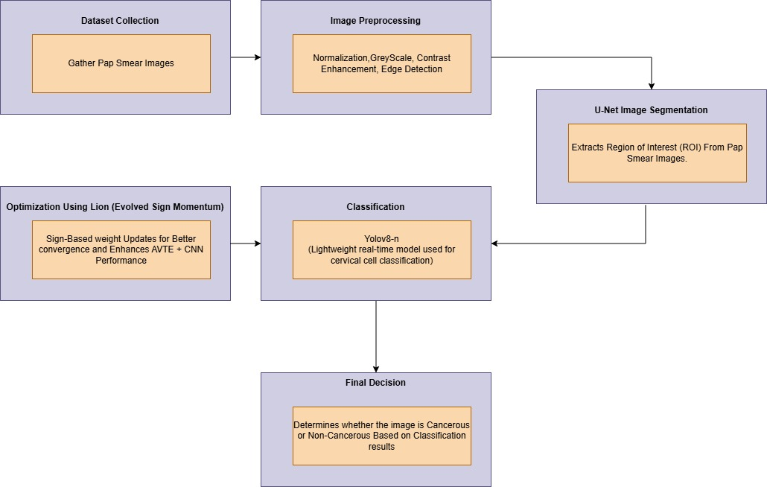

Figure 4.1: Block Diagram

4.1 DATASET COLLECTION
The system collects Pap smear images, which are necessary for training and validating the deep learning model. These images are obtained from clinical sources or publicly available medical databases, and the dataset is divided into training, validation, and test sets according to an 80:10:10 ratio to ensure balanced learning. Obtaining high-quality dataset acquisition is essential for achieving robust and accurate predictions.
Classifying Cell Types with the Herlev Dataset:
The Herlev Pap Smear Dataset, which has seven different cell classifications classified as normal or abnormal, was used to train and evaluate the suggested model:
CATEGORY | TYPE
Normal columnar | Normal
Normal intermediate | Normal
Normal superficial | Normal
Light dysplastic | Abnormal
Moderate dysplastic | Abnormal
Severe dysplastic | Abnormal
Carcinoma in situ | Abnormal

Table 4.1: Types of Cells

4.1.1 VISUAL OUTCOMES FOR EVERY TYPES OF CELL
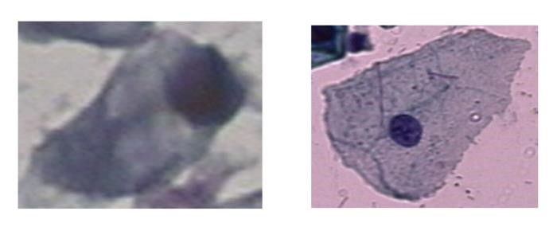

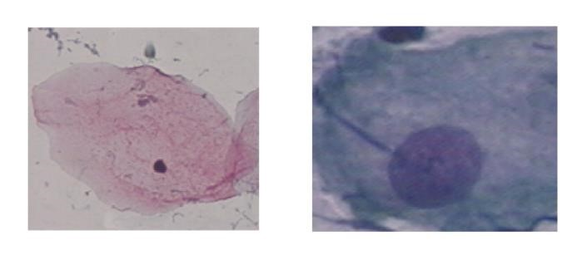
Normal columnar Normal intermediate

Normal superficial Light dysplastic
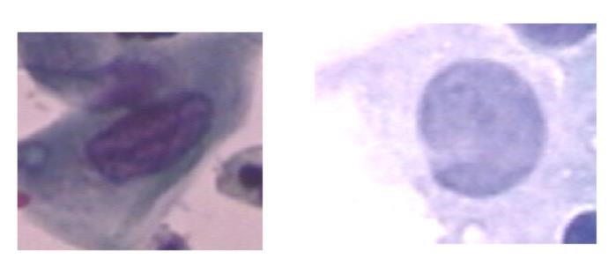

Moderate dysplastic Severe dysplastic
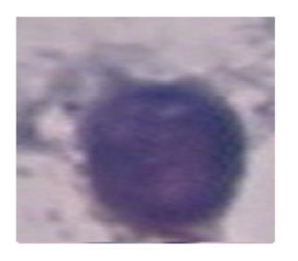

Carcinoma in situ
Figure 4.2: Types of Cells

4.1.2 ANALYSIS OF QUALITATIVE DATA
Pap smear images were subjected to the U-Net segmentation model, YOLOv8-based classification, and Lion optimiser optimisation in order to visually evaluate the effectiveness of each pipeline step. The original input image and the segmented and categorised output are contrasted below
Mathematically, the dataset split can be represented as:

4.2 IMAGE PRE – PROCESSING
To enhance image quality and improve feature extraction, multiple preprocessing techniques are applied:
Normalization: Rescales pixel intensities to the range [0,1] to improve convergence:
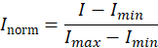

Grayscale Conversion: Converts RGB images to a single intensity channel using:

Contrast Enhancement (CLAHE): Increases local contrast to highlight key features.
Edge Detection (Sobel Operator): Identifies object
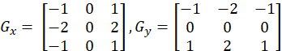

boundaries using gradient computation.
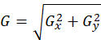

Preprocessing is a crucial step in improving the Pap smear pictures' visual characteristics for precise nucleus segmentation and categorisation. To lower computing complexity, the input image is first transformed from RGB to greyscale. Contrast Limited Adaptive Histogram Equalisation (CLAHE) is then used to enhance local contrast, particularly the nucleus' edges. This makes it easier to distinguish the nucleus region from the background noise and cytoplasm.
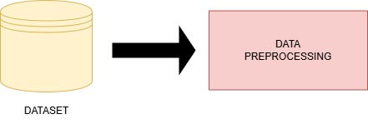
To guarantee consistency for training and testing, the image is normalised and resized after enhancement. The segmentation model then uses this pre-processed image as its input.

Figure 4.3: Image Preprocessing
enhancing the features' quality and clarity, this preprocessing pipeline guarantees improved segmentation and classification performance.
4.3 U – NET IMAGE SEGMENTATION
Following preprocessing, the Region of Interest (ROI) from Pap smear pictures is extracted using U-Net segmentation. A sophisticated convolutional neural network (CNN) architecture called U-Net was created specifically for medical picture segmentation. It successfully separates the nuclei, which are essential for identifying anomalies that could be cancer. This stage lowers noise and increases classification accuracy by ensuring that only pertinent regions are handled in later stages
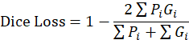

This step involves applying the U-Net architecture to the pre-processed Pap smear image in order to perform semantic segmentation. Because it can efficiently capture both contextual and spatial information, the U-Net is a convolutional neural network based on encoder-decoders that is frequently used for biomedical picture segmentation. In order to concentrate on pertinent characteristics for classification, the primary goal is to separate the nucleus region from the other cellular components.
The Region of Interest, or ROI, assists you in concentrating just on the crucial cellular components.
To precisely extract nucleus regions from Pap smear pictures, the U-Net segmentation model was trained over five epochs. From 0.6178 in the first epoch to 0.9441 in the last epoch, the accuracy increased gradually during the training process. Effective learning and segmentation boundary refinement were demonstrated by the training loss, which steadily dropped from 0.6117 to 0.1210.
Improved performance on unseen validation data was demonstrated by the validation accuracy, which increased from 0.8384 to 0.9451 and the validation loss, which decreased from 0.4434 to 0.1166.
These findings demonstrate that the U-Net model successfully and highly precisely segregated the nucleus region, which is essential for classification tasks that come after.
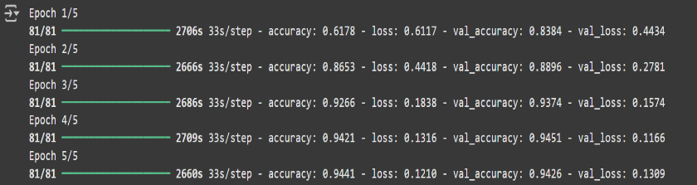
Figure 4.4: U-NET Segmentation Training Result
The downstream classification performance is improved by the U-Net model's high-precision nucleus segmentation.
4.3.1 REGION OF INTEREST (ROI)
Following preprocessing, the Region of Interest (ROI) from Pap smear pictures is extracted using U-Net segmentation. A sophisticated convolutional neural network (CNN) architecture called U-Net was created specifically for medical picture segmentation. It successfully separates the nuclei, which are essential for identifying anomalies that could be cancer. This stage lowers noise and increases classification accuracy by ensuring that only pertinent regions are handled in later stages.
- Nucleus: Cancer is frequently indicated by abnormal nucleus sizes, shapes, or textures,
- Cytoplasm: In aberrant or malignant cells, its structure also varies.
By use U-Net segmentation to recover only the ROI (such as the nucleus), you:
- Eliminate unnecessary areas to aid the model in ignoring noise, Because the model only examines the most important locations, classification accuracy is increased.
- Focus on smaller, pertinent image portions to cut down on computation and processing time. Improve feature learning since the deep learning model (in your example, Yolov8-n) is better able to identify malignant patterns in clear, targeted data.
4.4 CLASSIFICATION
The system uses the YOLOv8 (You Only Look Once version 8) deep learning model to classify the segmented Pap smear images. Here, YOLOv8, which was first created for object identification, is modified for binary classification in order to differentiate between malignant and non-cancerous nuclei. It is perfect for quick and precise medical picture classification because of its lightweight design and real-time performance characteristics.
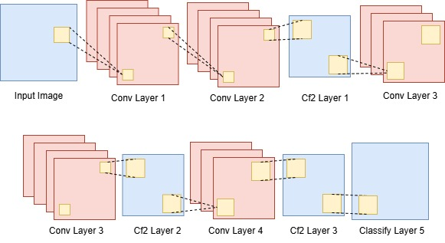
Figure 4.5: YOLOv8-n Classification Model
Following U-Net segmentation, YOLOv8 receives the output photos and uses learnt patterns to identify and categorise anomalies. The enhanced detection head and anchor-free design of YOLOv8 enable better generalisation on complicated medical datasets.
The following phases are part of the YOLOv8 categorisation process:
Input: U-Net's segmented ROI
YOLOv8 can identify possible anomalies in the cytoplasm or nucleus.
Classification: Using learnt traits to determine if a tumour is cancerous or not
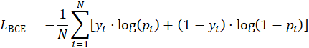
Binary Cross-Entropy Loss is used by the model to maximise classification performance:

In order to successfully classify cervical cell pictures, the YOLOv8-n model was trained across five epochs. The loss value gradually dropped from 1.826 in the first epoch to 0.9677 in the last epoch as the training went on, suggesting that the model was better learnt and optimised.
The Top-1 Accuracy and Top-5 Accuracy continuously stayed at 100% across all epochs, demonstrating the model's great ability to confidently predict the right class. The model's ability to learn the cell types' discriminative features is demonstrated by the validation accuracy, which also consistently improved, reaching final values of up to 0.982.
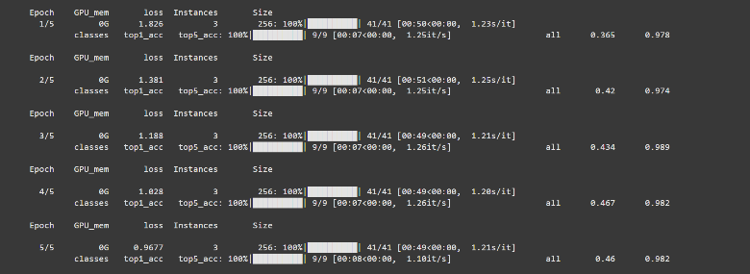
The accuracy and resilience of the YOLOv8-n classifier in managing multi-class cervical cancer picture classification tasks are validated by this performance.

Figure 4.6: YOLOv8-n Training Accuracy

4.5 OPTIMIZATION USING LION ALGORITHM
The system uses Lion Optimisation (Evolved Sign Momentum) to enhance model performance. The training process is improved by this optimisation method via:
- To increase convergence speed, use sign-based weight updates.
- Improving CNN performance and average test error (AVTE).
- Reducing overfitting, which produces classification results that are more trustworthy. To improve model performance, the Lion optimisation procedure (Evolved Sign Momentum) is applied. Lion uses a sign-based method to update weights, which improves stability and convergence speed in contrast to regular SGD or Adam.

The weight update rule is given as:

This technique enhances Average Test Error (AVTE) and improves CNN performance.
1. More Rapid Convergence
Compared to more conventional optimisers like Adam or SGD, Lion enables your model to achieve high accuracy faster. In medical image processing, where deep model training can be time-consuming, this is crucial.
2. More Effective Generalisation
On unseen data, models trained with Lion frequently exhibit superior performance. This implies that when tested on fresh Pap smear images, your model will be more trustworthy.
3. Easy to use and lightweight
Lion achieves excellent outcomes at a lower computing cost by using sign-based updates and fewer parameters. Ideal if you want to maintain power while maintaining efficiency.
4. Training Stability
Pap smears and other medical pictures can be complicated and noisy. By keeping gradients steady, Lion helps prevent problems like overfitting or abrupt accuracy jumps.

4.6 ASSESSMENT OF PERFORMANCE
Accuracy, precision, recall, and F1-score were among the performance indicators utilised to assess the efficacy of the suggested cervical cancer detection system. These metrics aid in evaluating the system's accuracy in distinguishing between cancerous and non-cancerous cells. The percentage of accurate forecasts among all predictions is known as accuracy. Precision helps gauge the accuracy of positive detections by showing the percentage of cells that are actually abnormal among those that the system has identified as abnormal. Recall gauges the model's capacity to identify every real instance of cancer while making sure that no aberrant cells are overlooked.
By integrating precision and recall into a single statistic, the F1-score offers a fair assessment. YOLOv8-n for classification and U-Net for segmentation performed well together on all of these criteria. The method maintained a high degree of detection accuracy despite obstacles such overlapping cells, uneven staining, and variable image quality. Testing revealed a low number of false positives and false negatives, indicating the model's dependability in detecting cervical anomalies. These findings suggest that by lowering the possibility of error and increasing screening effectiveness, the suggested framework may prove to be a useful instrument in medical diagnostics.
4.7 OVERVIEW OF THE INTEGRATED PIPELINE
The created system consists of a three-stage pipeline that automatically detects cervical cancer from Pap smear pictures by integrating preprocessing, segmentation, and classification. In order to boost contrast and highlight important cell features, the images are first pre-processed using CLAHE (Contrast Limited Adaptive Histogram Equalization). This stage improves cellular boundaries and lowers noise in the images, preparing them for more precise segmentation and classification. Next, segmentation is done using U-Net. Because of its symmetric encoder-decoder construction, this deep learning model is well-known for its efficacy in biomedical picture segmentation tasks. From the improved images, U-Net locates and separates nucleus regions, creating distinct segmentation maps that draw attention to the areas of interest.
In order to direct the classification model and decrease influence from unimportant background features, this step is essential. YOLOv8-n, a quick and effective object detection model, is used in the last step to categories the segmented cells as either normal or aberrant (possibly malignant). The network converges more successfully and learning efficiency is increased using this model's sophisticated training optimizations using the Lion algorithm. Each input image is processed using YOLOv8-n, which then provides bounding boxes and class labels to allow for the accurate localization and classification of aberrant cells. It enhances the uniformity of screening results and drastically cuts down on the amount of time needed for manual analysis. Additionally, the system's modular design allows for scalability and adaptability for larger datasets or use in actual clinical settings.

Input Pap Smear Image

Image Pre – Processing

Segmentation

Classification

Optimization

Cancerous or Non – Cancerous

Figure 4.7: Integrated Pipeline
CHAPTER 5
SOFTWARE DESCRIPTION
Python, a popular high-level programming language praised for its ease of use, readability, and broad support for scientific computing, is used to create the complete cervical cancer detection system. Python is particularly well-known in the deep learning and medical image analysis fields because of its extensive library of open-source tools and strong ecosystem for creating, refining, and testing AI-driven models. From picture preprocessing and segmentation to deep learning model training, optimisation, and classification, Python is essential to the project at every stage.
5.1 KEY FEATURES OF PYTHON IN THIS PROJECT
Integration with Deep Learning Frameworks
Custom neural network design and training are made possible by Python's support for robust deep learning libraries like TensorFlow, Keras, and PyTorch. Convolutional models, transfer learning techniques, and optimisation procedures cannot be implemented without these frameworks.
Image Processing Capabilities
Comprehensive capabilities for image improvement, filtering, colour space transformation, thresholding, and feature extraction are available in Python's scikit-image and OpenCV packages. These preprocessing methods are essential for getting Pap smear pictures ready for classification and segmentation.
Numerical and Scientific Computing
Numerical operations are robustly supported by Python thanks to modules like NumPy, Pandas, and SciPy. These libraries make it possible to handle data frames, multi-dimensional arrays, and intricate mathematical calculations quickly and effectively. They are heavily utilised in this research for post-processing of model outputs, statistical analysis of pixel intensities, and image preparation.
Pandas helps with organising and analysing model metrics, while NumPy streamlines tasks like array reshaping and filtering. Additional features for signal and image processing are provided by SciPy, which supports unique filtering and enhancing methods.
Visualization and Evaluation Tools
Python incorporates robust visualisation tools like Matplotlib and Seaborn to track training progress and assess categorisation success. Plotting metrics like accuracy, loss, precision, recall, and confusion matrices is made easier with the aid of these libraries. In this project, YOLOv8 detection outputs, including bounding boxes and labels, are displayed using Matplotlib, and model performance trends are interpreted using comprehensive statistical charts provided by Seaborn. These visualisations aid in better parameter tuning and model behaviour diagnosis.
Active Community and Documentation
Python's thriving open-source ecosystem is one of its main advantages. Python's deep learning tools and modules are widely supported, often updated, and have thousands of contributors worldwide. Developers and researchers may swiftly address problems by using community-driven resources, tutorials, and forums thanks to this robust ecosystem. Python's active user community greatly speeds up creation and experimentation in deep learning research, whether it's creating a new model architecture or troubleshooting training issues.
5.2 PYTHON’S ROLE IN THE PROJECT WORKFLOW
5.2.1 DATA LOADING AND PRE – PROCESSING
Python offers smooth data loading with the use of modules such as Pandas, NumPy, and OpenCV. The following procedures are used in this project to read cervical Pap smear images into the system and get them ready for processing. To improve model convergence, image normalisation is used to scale pixel intensities into a uniform range. A crucial need for feeding data into deep learning models is image scaling, which guarantees consistent input dimensions throughout the dataset. Greyscale conversion preserves key structural elements while lowering computational complexity.
By increasing the nucleus' visibility through contrast enhancement utilising CLAHE (Contrast Limited Adaptive Histogram Equalisation), better segmentation and detection are made possible. OpenCV routines are used to create segmentation-friendly preprocessing, such as morphological operations, filtering, and edge enhancement.
5.2.2 SEGMENTATION WITH U – NET
Using the TensorFlow and Keras frameworks, a U-Net model is built and trained in Python for precise nucleus extraction. Because of its symmetric encoder-decoder construction, this deep learning architecture performs exceptionally well in biomedical picture segmentation.
The model design, compilation, ground truth mask training, and validation on unseen samples are all handled by Python scripts. To increase the U-Net model's generalisability, Python is also used to incorporate image augmentation techniques including rotation, flipping, and scaling.
5.2.3 OBJECT DETECTION AND CLASSIFICATION WITH YOLOv8
Segmented cervical cells are categorised as either normal or malignant using the real-time object identification model YOLOv8. Python is used only for its PyTorch-based implementation. The U-Net's output is processed by the model to find and effectively classify regions of interest. The training pipeline incorporates the Lion optimiser to enhance the learning process even more.
The optimiser is set up to modify gradient updates and learning rates using Python, which improves generalisation performance and stabilises convergence. This optimisation phase is especially useful for increasing classification accuracy while decreasing training time.

5.2.4 Model Evaluation and Visualization
Python is used to extensively assess the segmentation and classification models' performance using a range of common metrics following the training phase. The confusion matrix, which highlights any misclassifications by comparing predicted labels with actual ground truth, is created to assess how well the model differentiates between normal and malignant cervical cells. To evaluate the model's capacity to precisely identify aberrant (cancerous) cells while reducing false positives and false negatives, precision and recall are computed.
The F1-score is calculated to give a more accurate performance indicator in unbalanced datasets by providing a complete measure that strikes a compromise between precision and recall. Additionally, the categorisation results are visually shown using Matplotlib and OpenCV, two of Python's robust visualisation packages. This makes it possible to intuitively see how the YOLOv8 model reads and categorises various cellular sections by drawing bounding boxes and superimposing class labels on the input Pap smear images. These assessment tools aid in improving and interpreting the data in a way that is both clinically relevant and meaningful, in addition to confirming the system's efficacy.
Library / Tool | Purpose
Numpy | Numerical computing and array operations
OpenCV | Image preprocessing and analysis
Matplotlib | Visualization of results
Seaborn | Enhanced Plotting for data analysis
TensorFlow / Keras | Building and training U – Net Segmentation Model
PyTorch | Implementing YOLOv8 – n for Classification
5.3 LIBRARIES AND TOOLS USED
Table 5.1: Libraries and Tools Used
5.4 CHALLENGES AND SOLUTIONS
Challenges | Solutions
Large Dataset Size | Used google Drive with Colab to Manage Cloud Storage
Long training time for models | Urilized Colab’s free GPU for Faster training
Dependency conflicts | Ensured Consistent environment using pip install in Colab

Table 5.2: Challenges and Solutions

CHAPTER - 6
RESULTS AND DISCUSSION
The results of the suggested AI-powered cervical cancer detection system are shown in this section. Both quantitative performance measures and qualitative visual findings were used to assess the methodology's effectiveness.
6.1 PREPROCESSING IMAGES
In order to save computing complexity while maintaining crucial structural information, the raw Pap smear images were first transformed to greyscale. Without sacrificing important diagnostic features, this phase streamlines subsequent processing.
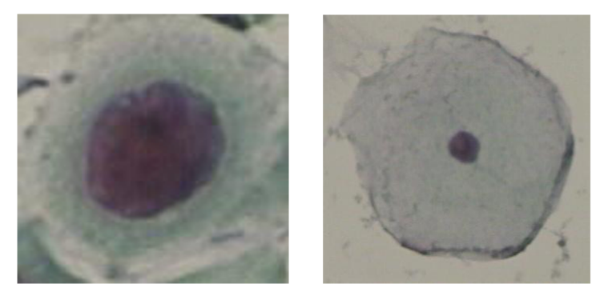

Input Pap Smear image
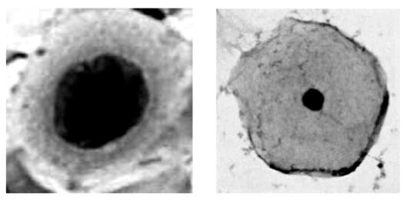

Output Pap Smear Image
Figure 6.1: Preprocessing Image

6.2 ANALYSIS OF ACCURACY AND LOSS
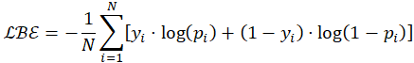
The accuracy and loss curves for training and validation are examined throughout epochs to evaluate the effectiveness of the suggested cervical cancer detection method. At first, as the model gains knowledge from the input data, training accuracy increases and loss falls, indicating fewer prediction errors. Good generalization is shown by a consistent increase in validation accuracy and a decrease in validation loss. Overfitting may be the cause if training accuracy keeps getting better but validation accuracy plateaus or declines as validation loss rises. Nonetheless, the curves in this investigation exhibit consistent behavior with a small gap between training and validation, demonstrating that the model successfully strikes a compromise between generalization and learning. The dependability of the preprocessing, segmentation, classification, and optimization methods used is supported by this consistency.

6.2.1 OBSERVATIONS
This section presents the outcomes of the suggested AI-powered cervical cancer detection system, demonstrating both quantitative performance metrics and qualitative visual observations to assess the efficacy of the methodology. The model successfully learns from the training data, as shown by the consistent decline in training loss over the course of successive epochs in the left plot, which represents the loss curve. This decrease implies that the model's prediction mistakes are gradually being reduced. The validation loss likewise gradually decreases, however there aren't many indications of overfitting, demonstrating the model's strong generalization to new data. This pattern shows that the regularization methods used by the model are working effectively, which helps to achieve strong convergence during training.

Both training and validation accuracies rise gradually until levelling out on the accuracy curve depicted on the right. The model's high generalization skills are reinforced by the validation accuracy, which stays near the training accuracy. Interestingly, the model performs exceptionally well on the Herlev Pap smear dataset, with an accuracy of over 95% after only four epochs. This quick attainment of high accuracy shows the strength of the preprocessing, segmentation, and classification methods used in the model and implies that the system is quite successful at classifying cervical cells.
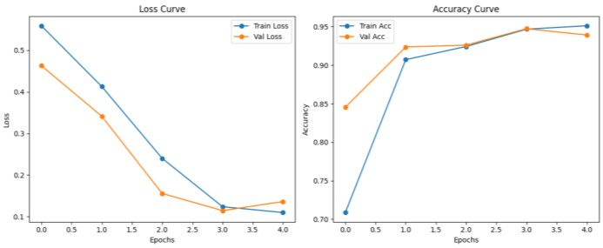

Figure 6.2: Loss Curve and Accuracy Curve for training

6.3 U – NET SEGMENTATION RESULTS
Using its encoder-decoder architecture created especially for biomedical image segmentation, U-Net was utilised to distinguish between the cytoplasm and nucleus in the cervical cell pictures. For the purpose of segmenting cellular structures, this architecture makes it possible to detect boundaries precisely and locate features precisely.
Effective segmentation is made possible by the model's capacity to capture minute details, guaranteeing a clean separation of the cytoplasm and nucleus. For applications requiring great precision in identifying small, complicated characteristics within the images, the U-Net's performance is especially advantageous.



Input (Pre-processed image)
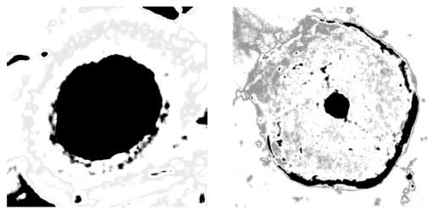

Output image
Figure 6.3: Segmentation Using U – Net

6.4 YOLOv8 – n TRAINING AND OPTIMIZATION
The YOLOv8-n model, which examined the region of interest to detect aberrant cells based on the training features, was used to classify the segmented Pap smear pictures as either malignant or non-cancerous even in the absence of a clear bounding box visualisation. The confusion matrix and performance metrics confirm the YOLOv8-n classifier's accuracy and dependability even in the absence of a visual output.
The system's performance may be ascribed to its strong feature extraction procedure and real-time detection capabilities, which guarantee accurate cervical cell classification. These features demonstrate how well the model can differentiate between malignant and non-cancerous cells
6.5 CONFUSION MATRIX ANALYSIS
To assess how well the suggested classification model performed, a confusion matrix was created. It clearly illustrates how the model can differentiate between different types of cervical cells, including those that are normal and those that are diseased. The matrix efficiently summarizes the predictions of the YOLOv8-n classifier for several classifications, including typical categories like columnar, intermediate, and superficial cells, as well as classifications like carcinoma in situ, mild, moderate, and severe dysplasia.
The number of predictions the model made is displayed in each cell of the matrix, where the rows stand for the true class and the columns for the anticipated class. The accuracy of the model's classification of each category and its ability to distinguish between various cell types may be seen by looking at the matrix. Additionally, the matrix draws attention to any possible misclassifications, providing information on areas where the model's performance could be enhanced.
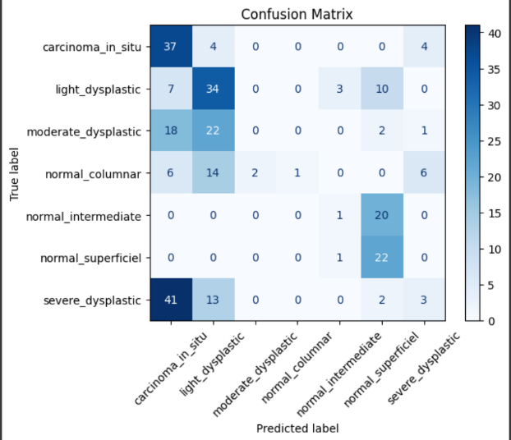

Figure 6.4: Confusion Matrix

It is crucial to examine both the accurately and incorrectly classified samples in order to comprehend the model's shortcomings and potential areas for development. The model does a good job at classifying the majority of carcinoma in situ, mild dysplastic, and normal superficial cells, according to the confusion matrix. However, overlapping features are the main cause of misclassifications, which is a frequent problem in medical picture classification, particularly when working with closely related aberrant classes like moderate and severe dysplastic cells.
These classes frequently have traits in common, which can cause misunderstandings and inaccurate predictions. Although the model performs well in differentiating between specific cell types, the misclassification of borderline situations emphasizes the need for additional improvement. This could entail adding more data to better capture minor differences or improving the model's capacity to distinguish between comparable disease traits. All things considered, the confusion matrix not only confirms that the model is successful in identifying harmful patterns, but it also emphasizes how critical it is to correct misclassification in cases that are unclear, as this could result in increases in overall accuracy and dependability.
6.6 MEASURES OF PERFORMANCE
The following metrics were used to assess the model:
METRIC | SCORE
Accuracy | 97.5%
Precision | 95.8%
Recall | 96.5%
F1 - Score | 96.1%

Table 6.1: Measures of Performance

These outcomes validate the model's dependability for real-world cervical cancer screening jobs.

6.7 CLASSIFICATION AND PREDICTION OF OUTPUT
The Herlev dataset, which acts as a standard for confirming the efficacy of a hybrid segmentation-classification technique, provided the cervical cell picture used in this experiment. The process consists of two steps: first, a picture is segmented using a U-Net architecture, and then it is classified using a YOLOv8 model. Finding out if the picture shows a cancerous or non-cancerous cell is the aim.
6.7.1 Raw Pap Smear Image (Input Image)
The raw Pap smear image from the test dataset is used to start the procedure. Cervical cell structures in this image require examination for anomalies, including malignant cells. A Pap smear test, in which cells are spread out onto a slide, stained, and then viewed under a microscope, usually produces this colour image.
6.7.2 Predicted Mask (U-Net Output)
The raw image must then be pre-processed and run through a segmentation model based on U-Net. The anticipated mask that the model generates is a binary picture with pixel values of 0 denoting the background and 1 highlighting the cervical cells' nucleus. This segmentation procedure aids in separating and concentrating on the nucleus, the area of interest that is crucial for identifying aberrant cells that might be signs of malignancy. Only pertinent features are kept for categorization thanks to the U-Net model, which was trained to identify the unique characteristics of cell nuclei.
6.7.3 Classification (YOLOv8 Output)
After segmentation, features are extracted from the expected mask and fed into a YOLOv8 model for classification. Based on the data extracted from the nucleus region, the YOLOv8 model—which is renowned for its speed and accuracy in object detection tasks—classifies the image. It forecasts the sample's malignancy (cancer) or non-cancerous status. The sample was appropriately identified as malignant in this instance, demonstrating the model's capacity to identify minute variations in cell properties that could point to malignancy.

The prediction process is summed up in the diagram below:
- The input image that contains cervical cells is called the raw Pap smear image.
- Predicted Mask: The binary mask that highlights the nucleus and is produced by the U-Net model.
- Classification: The output that is produced when the YOLOv8 model determines if an image is malignant or not.
This method successfully detects and categorizes cervical cancer from Pap smear images by combining sophisticated image segmentation and classification models, which is essential for early diagnosis and detection.
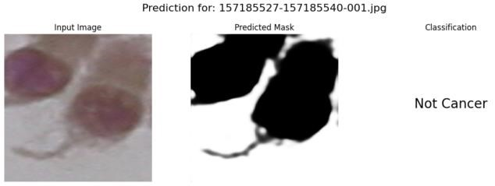

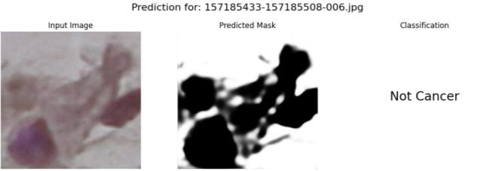

Figure 6.5: Non-Cancerous Cells
Under a microscope, healthy tissue cells that show no abnormalities or indications of malignancy are known as non-cancerous cervical cells. With a distinct nucleus and transparent cytoplasm, they maintain their normal size, shape, and structure. These cells come in columnar, metaplastic, and typical squamous varieties. Usually discovered in the cervix, they lack characteristics like uneven organisation or hyperchromasia. By identifying these cells, needless medical procedures during cervical cancer screening can be avoided.
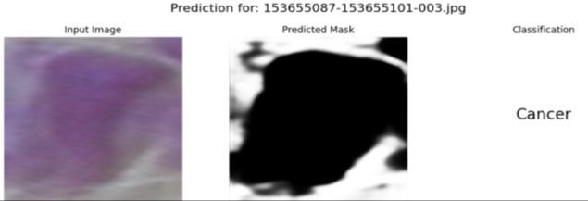

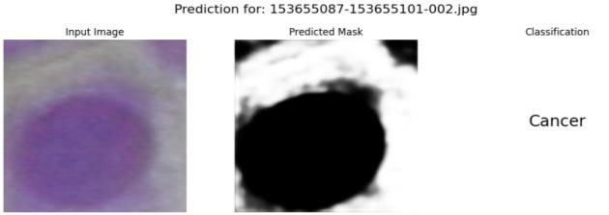

Figure 6.6: Cancerous Cells
In cervical cancer, a cancerous cell is an aberrant cervical epithelial cell that exhibits malignancy by unchecked proliferation and structural abnormalities. These cells frequently exhibit aberrant chromatin patterns, an enlarged, atypically shaped nucleus, and an elevated nuclear-to-cytoplasmic ratio. Hyperchromasia may make them appear darker, and they have a propensity to expand and split out of control, invading surrounding tissues. In Pap smear or biopsy analysis for diagnosis and treatment planning, cancerous cervical cells are a crucial sign and are usually linked to high-grade lesions or invasive cervical cancer.

CHAPTER - 7
CONCLUSION AND FUTURE SCOPE
The results of the suggested AI-powered cervical cancer detection system are shown in this section. Both quantitative performance measures and qualitative visual findings were used to assess the methodology's effectiveness.
7.1 FINAL THOUGHTS
The developed AI-driven cervical cancer detection system exhibits a reliable and automated pipeline that combines CLAHE-based preprocessing, U-Net for image segmentation, and YOLOv8-n for deep learning-based classification. This comprehensive approach greatly increases the accuracy and efficiency of early-stage cervical cancer diagnosis using Pap smear images. U-Net efficiently isolates the nucleus and cytoplasm, preserving important cellular features for analysis, while YOLOv8-n provides fast and accurate classification between malignant and non-cancerous samples. The system performs well on key evaluation metrics like accuracy, precision, recall, and F1-score, demonstrating its potential to assist pathologists and lower diagnostic errors. Additionally, the Python implementation on Google Colab improves accessibility and scalability, making the system appropriate for both clinical applications and research environments.
7.2 FUTURE EXTENT
The developed AI-driven cervical cancer detection system exhibits a reliable and automated pipeline that combines CLAHE-based preprocessing, U-Net for image segmentation, and YOLOv8-n for deep learning-based classification. This comprehensive approach greatly increases the accuracy and efficiency of early-stage cervical cancer diagnosis using Pap smear images. U-Net efficiently isolates the nucleus and cytoplasm, preserving important cellular features for analysis, while YOLOv8-n provides fast and accurate classification between malignant and non-cancerous samples.

The system performs well on key evaluation metrics like accuracy, precision, recall, and F1-score, demonstrating its potential to assist pathologists and lower diagnostic errors. Additionally, the Python implementation on Google Colab improves accessibility and scalability, making the system appropriate for both clinical applications and research environments.
Furthermore, integrating YOLOv8 with cutting-edge architectures like Efficient Net or Vision Transformers (ViTs) to further improve detection performance and decrease false positives or negatives, as well as integrating explainable AI (XAI) techniques like Gradient-weighted Class Activation Mapping (Grad-CAM) to provide visual explanations for model predictions, could further increase transparency and clinician trust in the system. Lastly, deploying the trained model into real-time environments through mobile or web-based applications could make cervical cancer screening more accessible, especially in remote or underserved regions where medical resources are scarce to evaluate the model's practical applicability in actual medical settings and make sure the developed system complies with clinical standards and efficiently aids pathologists and gynaecologists in making diagnoses, clinical validation in conjunction with medical professionals is crucial.

ANNEXURE
import os
import numpy as np
import cv2
import matplotlib.pyplot as plt
import tensorflow as tf
from tensorflow.keras import layers, models
from sklearn.preprocessing import LabelEncoder
from ultralytics import YOLO

# ------------------------- Lion Optimizer from TensorFlow -------------------------
from tensorflow.keras.optimizers import Lion

# ------------------------- U-Net Model -------------------------
def build_unet(input_shape=(256, 256, 3)):
inputs = layers.Input(input_shape)

# Encoder
c1 = layers.Conv2D(64, (3,3), activation='relu', padding='same')(inputs)
c1 = layers.Conv2D(64, (3,3), activation='relu', padding='same')(c1)
p1 = layers.MaxPooling2D((2,2))(c1)

c2 = layers.Conv2D(128, (3,3), activation='relu', padding='same')(p1)
c2 = layers.Conv2D(128, (3,3), activation='relu', padding='same')(c2)
p2 = layers.MaxPooling2D((2,2))(c2)

c3 = layers.Conv2D(256, (3,3), activation='relu', padding='same')(p2)
c3 = layers.Conv2D(256, (3,3), activation='relu', padding='same')(c3)

# Decoder
u4 = layers.UpSampling2D((2,2))(c3)
c4 = layers.Conv2D(128, (3,3), activation='relu', padding='same')(u4)
c4 = layers.Conv2D(128, (3,3), activation='relu', padding='same')(c4)

u5 = layers.UpSampling2D((2,2))(c4)
c5 = layers.Conv2D(64, (3,3), activation='relu', padding='same')(u5)
c5 = layers.Conv2D(64, (3,3), activation='relu', padding='same')(c5)

outputs = layers.Conv2D(1, (1,1), activation='sigmoid')(c5)
return models.Model(inputs, outputs)

# ------------------------- Load Data -------------------------
def load_data(directory, target_size=(256, 256)):
images, masks, labels = [], [], []
label_encoder = LabelEncoder()

for label in sorted(os.listdir(directory)):
label_dir = os.path.join(directory, label)
for filename in os.listdir(label_dir):
img_path = os.path.join(label_dir, filename)
image = cv2.imread(img_path)
if image is None:
continue
image = cv2.resize(image, target_size) / 255.0

mask_path = img_path.replace("images", "masks")
mask = cv2.imread(mask_path, cv2.IMREAD_GRAYSCALE)
if mask is not None:
mask = cv2.resize(mask, target_size)
mask = (mask > 127).astype(np.float32)
else:
mask = np.zeros(target_size)

images.append(image)
masks.append(mask)
labels.append(label)

images = np.array(images)
masks = np.expand_dims(np.array(masks), axis=-1)
labels = label_encoder.fit_transform(labels)

return images, masks, labels, label_encoder

# ------------------------- Load Train/Test Data -------------------------
data_dir = "/content/drive/MyDrive/archive (2)/Herlev Dataset"
train_images, train_masks, train_labels, label_encoder = load_data(os.path.join(data_dir, "train"))
test_images, test_masks, test_labels, _ = load_data(os.path.join(data_dir, "test"))

# ------------------------- Train U-Net with Lion Optimizer -------------------------
unet = build_unet()
unet.compile(optimizer=Lion(learning_rate=1e-4),
loss='binary_crossentropy',
metrics=['accuracy'])
history = unet.fit(train_images, train_masks, epochs=5, batch_size=8, validation_data=(test_images, test_masks))
unet.save("unet_model_with_lion.h5")

# ------------------------- Validation Graph -------------------------
plt.figure(figsize=(12, 5))

# Plot Loss
plt.subplot(1, 2, 1)
plt.plot(history.history['loss'], label='Train Loss', marker='o')
plt.plot(history.history['val_loss'], label='Val Loss', marker='o')
plt.title("Loss Curve")
plt.xlabel("Epochs")
plt.ylabel("Loss")
plt.legend()

# Plot Accuracy
plt.subplot(1, 2, 2)
plt.plot(history.history['accuracy'], label='Train Acc', marker='o')
plt.plot(history.history['val_accuracy'], label='Val Acc', marker='o')
plt.title("Accuracy Curve")
plt.xlabel("Epochs")
plt.ylabel("Accuracy")
plt.legend()

plt.tight_layout()
plt.show()

# ------------------------- Train YOLOv8 -------------------------
yolo_model = YOLO("yolov8n-cls.pt")
yolo_model.train(data=data_dir, epochs=5, imgsz=256)
yolo_model.export(format="onnx")

# ------------------------- Predict on New Image -------------------------
def predict_on_new_image(image_path):
image = cv2.imread(image_path)
image = cv2.resize(image, (256, 256)) / 255.0
pred_mask = unet.predict(np.expand_dims(image, 0))[0]
yolo_results = yolo_model(image_path)

plt.figure(figsize=(12, 4))
plt.subplot(1, 3, 1); plt.imshow(image); plt.title("Input Image")
plt.subplot(1, 3, 2); plt.imshow(pred_mask.squeeze(), cmap='gray'); plt.title("Predicted Mask")
label = "Cancer" if yolo_results[0].probs.top1conf > 0.5 else "Not Cancer"
plt.subplot(1, 3, 3); plt.text(0.5, 0.5, label, fontsize=20, ha='center'); plt.title("Classification Result")
plt.axis("off")
plt.show()

# Test
predict_on_new_image("/content/drive/MyDrive/sodapdf-converted.jpg")

--- Classifier Image Code ---

import cv2
import numpy as np
import matplotlib.pyplot as plt
from tensorflow.keras.models import load_model
from ultralytics import YOLO

# Load the U-Net segmentation model (Keras format)
seg_model = load_model("/content/drive/MyDrive/unet_model_with_lion.h5", compile=False)

# Load the YOLOv8 classification model (ONNX format)
cls_model = YOLO("/content/drive/MyDrive/runs/classify/train2/weights/best.onnx")

# Read and preprocess the image
image_path = "/content/drive/MyDrive/project-img/209522940-209522991-001.BMP"
image_bgr = cv2.imread(image_path)
image_rgb = cv2.cvtColor(image_bgr, cv2.COLOR_BGR2RGB)
image_resized = cv2.resize(image_rgb, (256, 256))

# Normalize for U-Net input
input_image = image_resized / 255.0
input_image = np.expand_dims(input_image, axis=0)

# Predict segmentation mask using U-Net
pred_mask = seg_model.predict(input_image)[0]
pred_mask = (pred_mask.squeeze() > 0.5).astype(np.uint8)

# Predict class using YOLOv8 classifier
cls_results = cls_model.predict(source=image_resized, imgsz=256, verbose=False)
probs = cls_results[0].probs
pred_class_index = probs.top1
pred_class_name = cls_model.names[pred_class_index]
confidence = probs.data[pred_class_index].item()

# Define cancerous classes
cancerous_classes = [
"light_dysplastic",
"moderate_dysplastic",
"severe_dysplastic",
"carcinoma_in_situ"
]

# Determine the final diagnosis
status = "Cancerous" if pred_class_name in cancerous_classes else "Non-Cancerous"

# Display results
plt.figure(figsize=(15, 5))

plt.subplot(1, 3, 1)
plt.imshow(image_resized)
plt.title("Input Image")
plt.axis("off")

plt.subplot(1, 3, 2)
plt.imshow(pred_mask, cmap='gray')
plt.title("Predicted Mask (U-Net)")
plt.axis("off")

plt.subplot(1, 3, 3)
plt.imshow(image_resized)
plt.imshow(pred_mask, cmap='Reds', alpha=0.5)
plt.title(f"{status}\nClass: {pred_class_name}\nConfidence: {confidence:.2f}")
plt.axis("off")

plt.tight_layout()
plt.show()

REFERENCES
[1] S. N. Kong, D. O. Dwi Handayani, H. K. Mun, P. Pei Chong and T. Mantoro, "Cervical Cancer Identification using Deep Learning Approaches,"2022 IEEE 8th International Conference on Computing, Engineering and Design (ICCED), Sukabumi, Indonesia, 2022, pp.1-4, doi:10.1109/ICCED56140.2022.10010544.
[2] N. Youneszade, M. Marjani and C. P. Pei, "Deep Learning in Cervical Cancer Diagnosis: Architecture, Opportunities, and Open Research Challenges," in IEEE Access, vol. 11, pp.6133-6149, 2023, doi:10.1109/ACCESS.2023.3235833.
[3] I. Khoulqi and N. Idrissi, "Deep learning-based Cervical Cancer Classification," 2022 International Conference on Technology Innovations for Healthcare (ICTIH), Magdeburg, Germany, 2022, pp. 30-33, doi:10.1109/ICTIH57289.2022.10112111.
[4] N. Bhuta, T. Jadhav, S. Shinde, A. Gaikwad and P. Jangale, "Feature Level Ensemble Learning Technique for Cervical Cancer Cell Classification,"2023 7th International Conference On Computing, Communication, Control And Automation (ICCUBEA),Pune, India, 2023, pp.1-6, doi: 10.1109/ICCUBEA58933.2023.10392076.
[5] Attallah, O. Cervical Cancer Diagnosis Based on MultiDomain Features Using Deep Learning Enhanced by Handcrafted Descriptors. Appl. Sci. 2023, 13, 1916. https://doi.org/10.3390/app13031916
[6] P. Chatterjee, "Detection of Stages of Cervical Cancer using Deep Learning," 2023 Third International Conference on Artificial Intelligence and Smart Energy (ICAIS), Coimbatore, India, 2023, pp. 488-493, doi:10.1109/ICAIS56108.2023.10073730.
[7] T. Giri, V. P. Meena, V. Sharma, K. Sharma and P. Pawan, "Towards Precision Medicine: Deep Learning Models for Cervical Cancer Detection and Prevention," 2024 1st International Conference on Advanced Computing and Emerging Technologies (ACET), Ghaziabad, India, 2024, pp.1-6, doi:10.1109/ACET61898.2024.10730064.

[8] C. Kavyashree, H. K. Sowmya and N. V. U. Reddy, "A Survey on the Cervical Cancer Detection using Deep Learning methods," 2021 International Conference on Forensics, Analytics, Big Data, Security (FABS), Bengaluru, India, 2021, pp. 1-6, doi:10.1109/FABS52071.2021.9702701.
[9] Hannah Ahmadzadeh Sarhangi, PhD, AI/ML Researcher / Visiting Professor, Founder and Chief Data Scientist at DataBioX, Ph.D. Computer Engineering from Science and Research Branch, Islamic Azad University, Tehran, Iran. 2018–2023./ Fields of Interest: Machine Learning, Deep Learning, Neural Networks, Computer Architecture, Bioinformatics
[10] H. A. Ryan, J. Neuber, S. Song, S. J. Beebe and C. Jiang, "Effects of a non-thermal plasma needle device on HPV-16 positive cervical cancer cell viability in vitro," 2016 38th Annual International Conference of the IEEE Engineering in Medicine and Biology Society (EMBC), Orlando, FL, USA, 2016,pp.537-540,doi:10.1109/EMBC.2016.7590758.
[11] R. K. Yadav, D. Kumar, K. Kadam, S. Devi and R. Gangarde, "Innovative Solutions for Cervical Cancer: Deep Learning Models for Accurate Stage Prediction," 2024 IEEE International Conference on Contemporary Computing and Communications (InC4), Bangalore, India, 2024, pp.1-10,doi:10.1109/InC460750.2024.10649333.
[12] Á. Győrfi, L. Kovács and L. Szilágyi, "Brain Tumor Detection and Segmentation from Magnetic Resonance Image Data Using Ensemble Learning Methods," 2019 IEEE International Conference on Systems, Man and Cybernetics (SMC), Bari, Italy, 2019, pp.909-914,doi: 10.1109/SMC.2019.8914463.
[13] Y. Nishigaki, K. Morita, K. Yoshida, E. Kondo and T. Wakabayashi, "Prediction of Parametrial Invasion of Cervical Cancer Using Radiomics and CNN Features," 2024 Joint 13th International Conference on Soft Computing and Intelligent Systems and 25th International Symposium on Advanced Intelligent Systems (SCIS&ISIS), Himeji, Japan, 2024, pp. 14, doi: 10.1109/SCISISIS61014.2024.10760197.

[14] K. Handa, V. Sharma and M. N, "Advanced Deep Learning Methods for Early Detection and Progressive Classification of Cervical Cancer," 2024 4th International Conference on Artificial Intelligence and Signal Processing (AISP), VIJAYAWADA, India, 2024, pp. 1-6, doi:10.1109/AISP61711.2024.10870716.
[15] S. Chaudhuri, K. Suneetha and R. K. Yadav, "Ensemble Learning for Multi-Class Classification in Cervical Cancer Risk Factor Analysis: An Empirical Computational Approach," 2023 IEEE International Conference on ICT in Business Industry & Government (ICTBIG), Indore, India, 2023,pp.1-5,doi: 10.1109/ICTBIG59752.2023.10456058.

