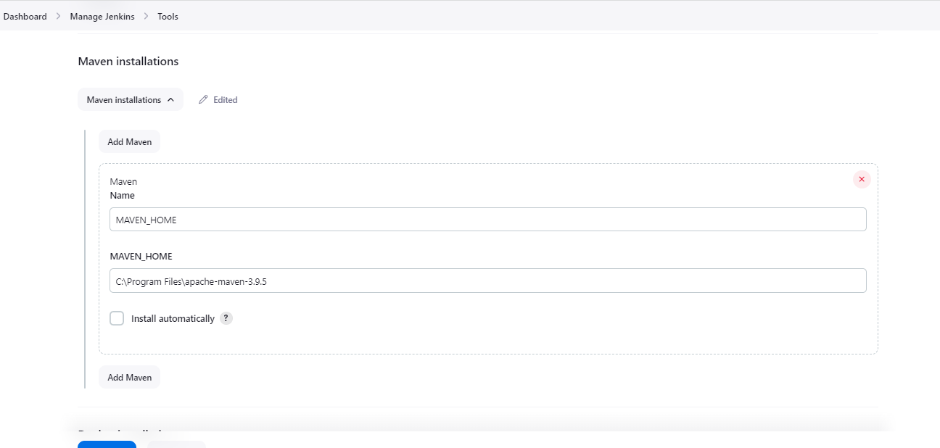

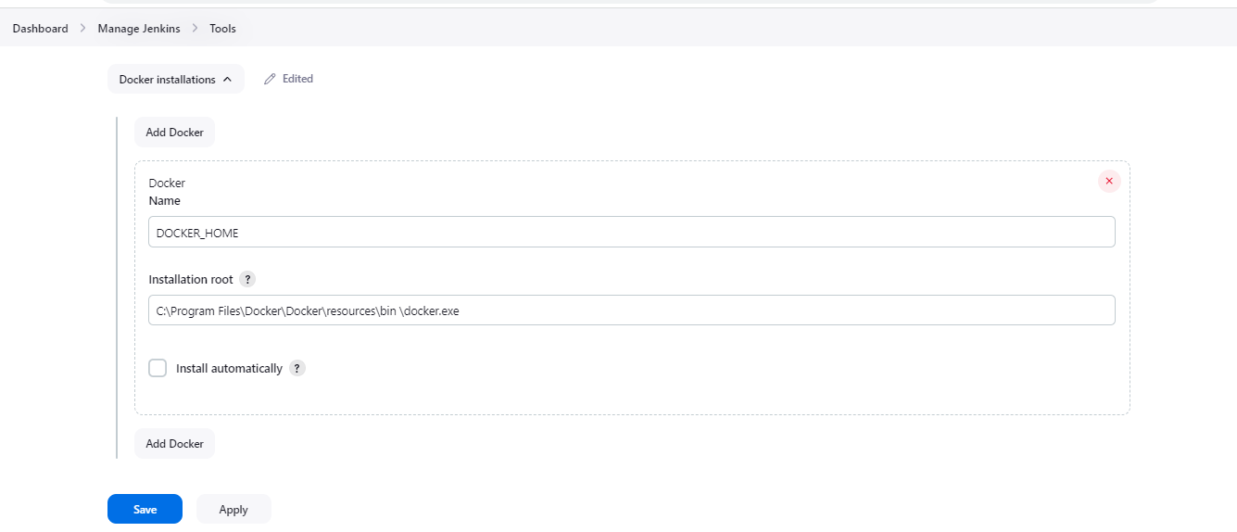

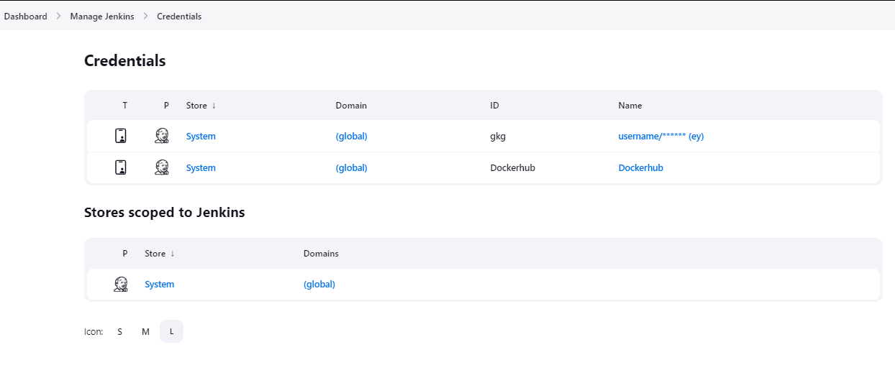

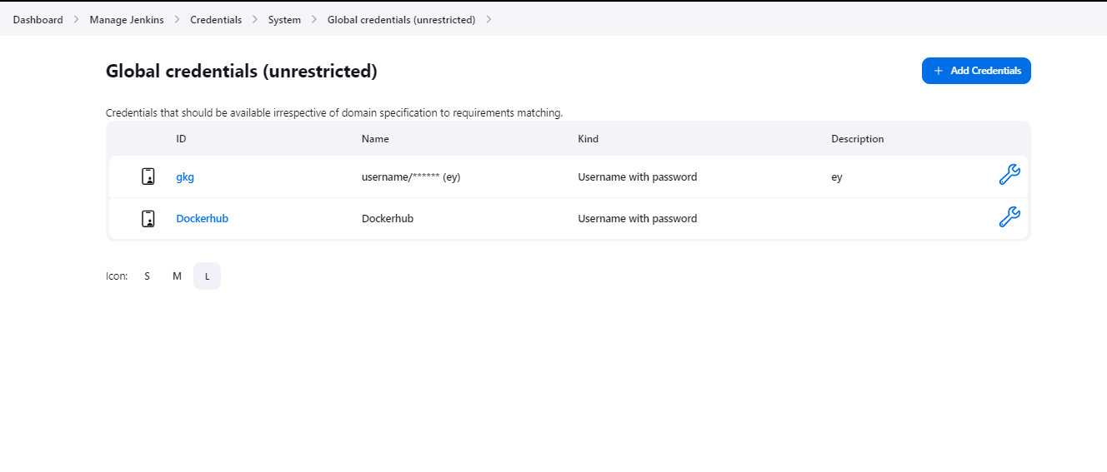

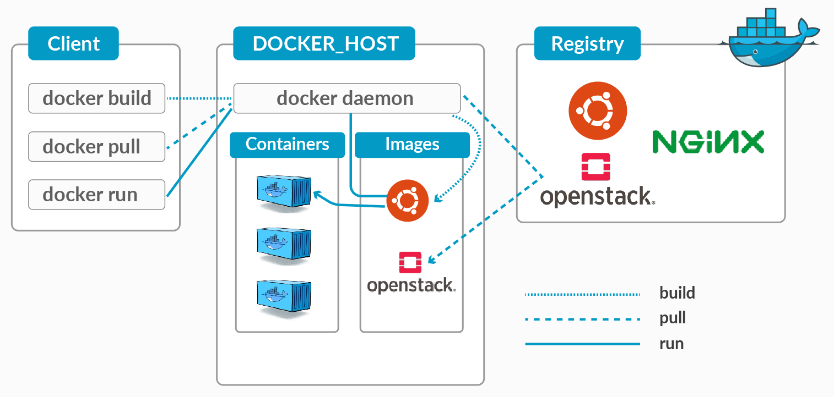s

**PLUGINS**

|  |  |  |  |
| --- | --- | --- | --- |
| [Ant PluginVersion497.v94e7d9fffa_b_9](https://plugins.jenkins.io/ant)  Adds Apache Ant support to Jenkins  [Report an issue with this plugin](https://www.jenkins.io/participate/report-issue/redirect/#15488) |  |  |  |
| [Apache HttpComponents Client 4.x API PluginVersion4.5.14-208.v438351942757](https://plugins.jenkins.io/apache-httpcomponents-client-4-api)  Bundles Apache HttpComponents Client 4.x and allows it to be used by Jenkins plugins.  [Report an issue with this plugin](https://www.jenkins.io/participate/report-issue/redirect/#23052) |  |  |  |
| [Apache HttpComponents Client 5.x API PluginVersion5.2.1-1.1](https://plugins.jenkins.io/apache-httpcomponents-client-5-api)  Bundles [Apache HttpComponents Client](https://hc.apache.org/httpcomponents-client-5.2.x/index.html)and allows it to be used by Jenkins plugins.  [Report an issue with this plugin](https://github.com/jenkinsci/apache-httpcomponents-client-5-api-plugin/issues/new/choose) |  |  |  |
| [Authentication Tokens API PluginVersion1.53.v1c90fd9191a_b_](https://plugins.jenkins.io/authentication-tokens)  This plugin provides an API for converting credentials into authentication tokens in Jenkins.  [Report an issue with this plugin](https://www.jenkins.io/participate/report-issue/redirect/#20323) |  |  |  |
| [Bootstrap 5 API PluginVersion5.3.2-2](https://plugins.jenkins.io/bootstrap5-api)  Provides [Bootstrap 5](https://getbootstrap.com/) for Jenkins Plugins. Bootstrap is (according to their self-perception) the world’s most popular front-end component library to build responsive, mobile-first projects on the web.  [Report an issue with this plugin](https://www.jenkins.io/participate/report-issue/redirect/#28620) |  | Top of Form  **5.3.2-1**  Bottom of Form |  |
| [bouncycastle API PluginVersion2.29](https://plugins.jenkins.io/bouncycastle-api)  This plugin provides a stable API to Bouncy Castle related tasks.  [Report an issue with this plugin](https://www.jenkins.io/participate/report-issue/redirect/#21482) |  |  |  |
| [Branch API PluginVersion2.1128.v717130d4f816](https://plugins.jenkins.io/branch-api)  This plugin provides an API for multiple branch based projects.  [Report an issue with this plugin](https://www.jenkins.io/participate/report-issue/redirect/#18621) |  |  |  |
| [Build TimeoutVersion1.31](https://plugins.jenkins.io/build-timeout)  This plugin allows you to automatically terminate a build if it's taking too long.  [Report an issue with this plugin](https://www.jenkins.io/participate/report-issue/redirect/#15530) |  |  |  |
| [Caffeine API PluginVersion3.1.8-133.v17b_1ff2e0599](https://plugins.jenkins.io/caffeine-api)  [Caffeine](https://github.com/ben-manes/caffeine/) api plugin for use by other Jenkins plugins.  [Report an issue with this plugin](https://www.jenkins.io/participate/report-issue/redirect/#28622) |  |  |  |
| [Checks API pluginVersion2.0.2](https://plugins.jenkins.io/checks-api)  This plugin defines an API for Jenkins to publish checks to SCM platforms.  [Report an issue with this plugin](https://github.com/jenkinsci/checks-api-plugin/issues/new/choose) |  |  |  |
| [Cloud Statistics PluginVersion320.v96b_65297a_4b_b_](https://plugins.jenkins.io/cloud-stats)  Report Jenkins dynamic provisioning activities and statistics  [Report an issue with this plugin](https://www.jenkins.io/participate/report-issue/redirect/#21441) |  |  |  |
| [CloudBees Docker Build and Publish pluginVersion1.4.0](https://plugins.jenkins.io/docker-build-publish)  This plugin enables building Dockerfile based projects, as well as publishing of the built images/repos to the docker registry.  [Report an issue with this plugin](https://www.jenkins.io/participate/report-issue/redirect/#18624) |  |  |  |
| [CloudBees Docker Custom Build Environment PluginVersion1.7.3](https://plugins.jenkins.io/docker-custom-build-environment)  Run builds inside a docker container, defined by a Docker image or Dockerfile stored in project SCM.  [Report an issue with this plugin](https://www.jenkins.io/participate/report-issue/redirect/#20634) |  |  |  |
| [CloudBees Docker Hub/Registry NotificationVersion2.7.1](https://plugins.jenkins.io/dockerhub-notification)  Integrates Jenkins with [DockerHub](http://hub.docker.com/) and Docker Registry  [Report an issue with this plugin](https://www.jenkins.io/participate/report-issue/redirect/#20627) |  |  |  |
| [Command Agent Launcher PluginVersion107.v773860566e2e](https://plugins.jenkins.io/command-launcher)  Allows agents to be launched using a specified command.  [Report an issue with this plugin](https://www.jenkins.io/participate/report-issue/redirect/#23169) |  |  |  |
| [Commons HttpClient 3.x APIVersion3.1-3](https://plugins.jenkins.io/commons-httpclient3-api)  This plugin provides a [patched version](https://github.com/jenkinsci/lib-commons-httpclient) of the deprecated [Commons HttpClient 3.x](https://hc.apache.org/httpclient-legacy/) library for use by other plugins.  [Report an issue with this plugin](https://www.jenkins.io/participate/report-issue/redirect/#29120)  **This plugin is up for adoption!** We are looking for new maintainers. Visit our [Adopt a Plugin](https://www.jenkins.io/doc/developer/plugin-governance/adopt-a-plugin/) initiative for more information. |  |  |  |
| [commons-lang3 v3.x Jenkins API PluginVersion3.13.0-62.v7d18e55f51e2](https://plugins.jenkins.io/commons-lang3-api)  Jenkins Api Plugin that Bundles Apache Commons Lang v3.x. Usage will slim downstream plugin and not require dependency jar being provided by core Jenkins. Provides org.apache.commons:commons-lang3:3.13.0.  [Report an issue with this plugin](https://github.com/jenkinsci/commons-lang3-api-plugin/issues/new/choose) |  |  |  |
| [commons-text API PluginVersion1.11.0-94.v3e1f4a_926e49](https://plugins.jenkins.io/commons-text-api)  Jenkins Api Plugin that Bundles Apache Commons Text v1.x. Usage will slim downstream plugin. Provides org.apache.commons:commons-text:1.11.0.  [Report an issue with this plugin](https://github.com/jenkinsci/commons-text-api-plugin/issues/new/choose) |  | Top of Form  **1.10.0-78.v3e7b_ea_d5a_fe1**  Bottom of Form |  |
| [Conditional BuildStepVersion1.4.3](https://plugins.jenkins.io/conditional-buildstep)  A buildstep wrapping any number of other buildsteps, controlling their execution based on a defined condition (e.g. BuildParameter).  [Report an issue with this plugin](https://www.jenkins.io/participate/report-issue/redirect/#15947)  **This plugin is up for adoption!** We are looking for new maintainers. Visit our [Adopt a Plugin](https://www.jenkins.io/doc/developer/plugin-governance/adopt-a-plugin/) initiative for more information. |  |  |  |
| [Config File Provider PluginVersion959.vcff671a_4518b_](https://plugins.jenkins.io/config-file-provider)  Ability to provide configuration files (e.g. settings.xml for maven, XML, groovy, custom files,...) loaded through the UI which will be copied to the job workspace.  [Report an issue with this plugin](https://www.jenkins.io/participate/report-issue/redirect/#16140) |  |  |  |
| [Credentials Binding PluginVersion642.v737c34dea_6c2](https://plugins.jenkins.io/credentials-binding)  Allows credentials to be bound to environment variables for use from miscellaneous build steps.  [Report an issue with this plugin](https://www.jenkins.io/participate/report-issue/redirect/#18129) |  | Top of Form  **636.v55f1275c7b_27**  Bottom of Form |  |
| [Credentials PluginVersion1307.v3757c78f17c3](https://plugins.jenkins.io/credentials)  This plugin allows you to store credentials in Jenkins.  [Report an issue with this plugin](https://www.jenkins.io/participate/report-issue/redirect/#16523) |  | Top of Form  **1271.v54b_1c2c6388a_**  Bottom of Form |  |
| [Display URL APIVersion2.200.vb_9327d658781](https://plugins.jenkins.io/display-url-api)  Provides the DisplayURLProvider extension point to provide alternate URLs for use in notifications.  [Report an issue with this plugin](https://www.jenkins.io/participate/report-issue/redirect/#21721) |  | Top of Form  **2.3.9**  Bottom of Form |  |
| [Distributed Workspace Clean pluginVersion1.0.8](https://plugins.jenkins.io/hudson-wsclean-plugin)  Allows cleanup of old job workspaces on slaves used by old builds.  [Report an issue with this plugin](https://www.jenkins.io/participate/report-issue/redirect/#15607)  **This plugin is up for adoption!** We are looking for new maintainers. Visit our [Adopt a Plugin](https://www.jenkins.io/doc/developer/plugin-governance/adopt-a-plugin/) initiative for more information. |  |  |  |
| [Docker API PluginVersion3.3.1-79.v20b_53427e041](https://plugins.jenkins.io/docker-java-api)  This plugin provides [docker-java](https://github.com/docker-java/docker-java) API for other plugins.  [Report an issue with this plugin](https://www.jenkins.io/participate/report-issue/redirect/#23136)  **This plugin is up for adoption!** We are looking for new maintainers. Visit our [Adopt a Plugin](https://www.jenkins.io/doc/developer/plugin-governance/adopt-a-plugin/) initiative for more information. |  |  |  |
| [Docker Commons PluginVersion439.va_3cb_0a_6a_fb_29](https://plugins.jenkins.io/docker-commons)  Provides the common shared functionality for various Docker-related plugins.  [Report an issue with this plugin](https://www.jenkins.io/participate/report-issue/redirect/#20628) |  |  |  |
| [Docker Compose Build Step PluginVersion1.0](https://plugins.jenkins.io/docker-compose-build-step)  Docker Compose plugin for Jenkins  [Report an issue with this plugin](https://www.jenkins.io/participate/report-issue/redirect/#23935) |  |  |  |
| [Docker PipelineVersion572.v950f58993843](https://plugins.jenkins.io/docker-workflow)  Build and use Docker containers from pipelines.  [Report an issue with this plugin](https://www.jenkins.io/participate/report-issue/redirect/#20625) |  |  |  |
| [Docker pluginVersion1.5](https://plugins.jenkins.io/docker-plugin)  This plugin integrates Jenkins with [Docker](http://docker.io/)  [Report an issue with this plugin](https://github.com/jenkinsci/docker-plugin/issues/new/choose) |  |  |  |
| [Docker Slaves PluginVersion1.0.7](https://plugins.jenkins.io/docker-slaves)  Uses [Docker](https://www.docker.com/) containers to run Jenkins build agents.  [Report an issue with this plugin](https://www.jenkins.io/participate/report-issue/redirect/#20839) |  |  |  |
| [docker-build-stepVersion2.10](https://plugins.jenkins.io/docker-build-step)  This plugin allows to add various docker commands to your job as build steps.  [Report an issue with this plugin](https://www.jenkins.io/participate/report-issue/redirect/#18721) |  | Top of Form  **2.9**  Bottom of Form |  |
| [Durable Task PluginVersion523.va_a_22cf15d5e0](https://plugins.jenkins.io/durable-task)  Library offering an extension point for processes which can run outside of Jenkins yet be monitored.  [Report an issue with this plugin](https://www.jenkins.io/participate/report-issue/redirect/#18622) |  |  |  |
| [ECharts API PluginVersion5.4.0-7](https://plugins.jenkins.io/echarts-api)  Provides [ECharts](https://echarts.apache.org/en/index.html) for Jenkins Plugins, a JavaScript visualization tool to create intuitive, interactive, and highly-customizable charts.  [Report an issue with this plugin](https://www.jenkins.io/participate/report-issue/redirect/#26331) |  | Top of Form  **5.4.0-6**  Bottom of Form |  |
| [Email Extension PluginVersion2.102](https://plugins.jenkins.io/email-ext)  This plugin is a replacement for Jenkins's email publisher. It allows to configure every aspect of email notifications: when an email is sent, who should receive it and what the email says  [Report an issue with this plugin](https://www.jenkins.io/participate/report-issue/redirect/#15538) |  | Top of Form  **2.101**  Bottom of Form |  |
| [EnvInject API PluginVersion1.199.v3ce31253ed13](https://plugins.jenkins.io/envinject-api)  Stores shared logic for Environment Injection management in Jenkins. It is being used in plugins like [EnvInject Plugin](https://plugins.jenkins.io/envinject).  [Report an issue with this plugin](https://github.com/jenkinsci/envinject-api-plugin/issues/new/choose) |  |  |  |
| [External Monitor Job Type PluginVersion215.v2e88e894db_f8](https://plugins.jenkins.io/external-monitor-job)  Adds the ability to monitor the result of externally executed jobs  [Report an issue with this plugin](https://www.jenkins.io/participate/report-issue/redirect/#17123) |  |  |  |
| [Folders PluginVersion6.858.v898218f3609d](https://plugins.jenkins.io/cloudbees-folder)  This plugin allows users to create "folders" to organize jobs. Users can define custom taxonomies (like by project type, organization type etc). Folders are nestable and you can define views within folders. Maintained by CloudBees, Inc.  [Report an issue with this plugin](https://www.jenkins.io/participate/report-issue/redirect/#18137) |  | Top of Form  **6.848.ve3b_fd7839a_81**  Bottom of Form |  |
| [Font Awesome API PluginVersion6.4.2-1](https://plugins.jenkins.io/font-awesome-api)  Provides [Font Awesome 6](https://fontawesome.com/) for Jenkins Plugins. Font Awesome has vector icons and social logos. It is the web's most popular icon set and toolkit with more than 1700 free icons.  [Report an issue with this plugin](https://www.jenkins.io/participate/report-issue/redirect/#26326) |  |  |  |
| [Git client pluginVersion4.5.0](https://plugins.jenkins.io/git-client)  Utility plugin for Git support in Jenkins  [Report an issue with this plugin](https://www.jenkins.io/participate/report-issue/redirect/#17423) |  |  |  |
| [Git pluginVersion5.2.0](https://plugins.jenkins.io/git)  This plugin integrates [Git](https://git-scm.com/) with Jenkins.  [Report an issue with this plugin](https://www.jenkins.io/participate/report-issue/redirect/#15543) |  |  |  |
| [GitHub API PluginVersion1.316-451.v15738eef3414](https://plugins.jenkins.io/github-api)  This plugin provides [GitHub API](http://github-api.kohsuke.org/) for other plugins.  [Report an issue with this plugin](https://www.jenkins.io/participate/report-issue/redirect/#17496) |  | Top of Form  **1.314-431.v78d72a_3fe4c3**  Bottom of Form |  |
| [GitHub Branch Source PluginVersion1741.va_3028eb_9fd21](https://plugins.jenkins.io/github-branch-source)  Multibranch projects and organization folders from GitHub. Maintained by CloudBees, Inc.  [Report an issue with this plugin](https://www.jenkins.io/participate/report-issue/redirect/#20858) |  |  |  |
| [GitHub pluginVersion1.37.3.1](https://plugins.jenkins.io/github)  This plugin integrates [GitHub](http://github.com/) to Jenkins.  [Report an issue with this plugin](https://www.jenkins.io/participate/report-issue/redirect/#15896) |  | Top of Form  **1.37.3**  Bottom of Form |  |
| [Gradle PluginVersion2.9](https://plugins.jenkins.io/gradle)  This plugin allows Jenkins to invoke [Gradle](http://www.gradle.org/) build scripts directly.  [Report an issue with this plugin](https://www.jenkins.io/participate/report-issue/redirect/#15547) |  | Top of Form  **2.8.2**  Bottom of Form |  |
| [Icon ShimVersion3.0.0](https://plugins.jenkins.io/icon-shim)  Deprecated: No longer does anything, you can uninstall this plugin  **This plugin is deprecated.** In general, this means that it is either obsolete, no longer being developed, or may no longer work. [Learn more.](https://plugins.jenkins.io/icon-shim) |  |  |  |
| [Instance IdentityVersion185.v303dc7c645f9](https://plugins.jenkins.io/instance-identity)  Maintains an RSA key pair that can serve as a foundation of authentication when communicating with Jenkins  [Report an issue with this plugin](https://www.jenkins.io/participate/report-issue/redirect/#23222) |  | Top of Form  **173.va_37c494ec4e5**  Bottom of Form |  |
| [Ionicons APIVersion56.v1b_1c8c49374e](https://plugins.jenkins.io/ionicons-api)  Provides [Ionicons](https://ionic.io/ionicons) for Jenkins Plugins, internally known as "symbols". Check out the [design-library](https://weekly.ci.jenkins.io/design-library/Symbols/) how to use ionicons in your plugin.  [Report an issue with this plugin](https://github.com/jenkinsci/ionicons-api-plugin/issues/new/choose) |  |  |  |
| [Jackson 2 API PluginVersion2.15.3-366.vfe8d1fa_f8c87](https://plugins.jenkins.io/jackson2-api)  This plugin exposes the Jackson 2 JSON APIs to other Jenkins plugins.  [Report an issue with this plugin](https://www.jenkins.io/participate/report-issue/redirect/#23528) |  | Top of Form  **2.15.2-350.v0c2f3f8fc595**  Bottom of Form |  |
| [Jakarta Activation APIVersion2.0.1-3](https://plugins.jenkins.io/jakarta-activation-api)  This plugin provides the [Jakarta Activation](https://github.com/eclipse-ee4j/jaf) API for other plugins.  [Report an issue with this plugin](https://www.jenkins.io/participate/report-issue/redirect/#28835) |  |  |  |
| [Jakarta Mail APIVersion2.0.1-3](https://plugins.jenkins.io/jakarta-mail-api)  This plugin provides the [Jakarta Mail](https://github.com/eclipse-ee4j/mail) API for other plugins.  [Report an issue with this plugin](https://www.jenkins.io/participate/report-issue/redirect/#28831) |  |  |  |
| [Java JSON Web Token (JJWT) PluginVersion0.11.5-77.v646c772fddb_0](https://plugins.jenkins.io/jjwt-api)  Bundles the Java JSON Web Token (JJWT) library.  [Report an issue with this plugin](https://github.com/jenkinsci/jjwt-api-plugin/issues/new/choose) |  |  |  |
| [JavaBeans Activation Framework (JAF) APIVersion1.2.0-6](https://plugins.jenkins.io/javax-activation-api)  This plugin provides the [JavaBeans Activation Framework (JAF)](https://github.com/javaee/activation) API for other plugins.  [Report an issue with this plugin](https://www.jenkins.io/participate/report-issue/redirect/#28834) |  |  |  |
| [Javadoc PluginVersion243.vb_b_503b_b_45537](https://plugins.jenkins.io/javadoc)  This plugin adds Javadoc support to Jenkins.  [Report an issue with this plugin](https://www.jenkins.io/participate/report-issue/redirect/#15992)  **This plugin is up for adoption!** We are looking for new maintainers. Visit our [Adopt a Plugin](https://www.jenkins.io/doc/developer/plugin-governance/adopt-a-plugin/) initiative for more information. |  |  |  |
| [JavaMail APIVersion1.6.2-9](https://plugins.jenkins.io/javax-mail-api)  This plugin provides the [JavaMail](https://github.com/javaee/javamail) API for other plugins.  [Report an issue with this plugin](https://www.jenkins.io/participate/report-issue/redirect/#28833) |  |  |  |
| [JAXB pluginVersion2.3.9-1](https://plugins.jenkins.io/jaxb)  JAXB packaging for more transparent Java 9+ compatibility  [Report an issue with this plugin](https://www.jenkins.io/participate/report-issue/redirect/#24725)  **This plugin is up for adoption!** We are looking for new maintainers. Visit our [Adopt a Plugin](https://www.jenkins.io/doc/developer/plugin-governance/adopt-a-plugin/) initiative for more information. |  | Top of Form  **2.3.8-1**  Bottom of Form |  |
| [JQuery3 API PluginVersion3.7.1-1](https://plugins.jenkins.io/jquery3-api)  Provides [jQuery 3](https://jquery.com/) for Jenkins Plugins. jQuery is a fast, small, and feature-rich JavaScript library.  [Report an issue with this plugin](https://www.jenkins.io/participate/report-issue/redirect/#26329) |  |  |  |
| [JSch dependency pluginVersion0.2.8-65.v052c39de79b_2](https://plugins.jenkins.io/jsch)  Jenkins plugin that brings the JSch library as a plugin dependency, and provides an SSHAuthenticatorFactory for using JSch with the ssh-credentials plugin.  [Report an issue with this plugin](https://www.jenkins.io/participate/report-issue/redirect/#21943) |  |  |  |
| [JUnit PluginVersion1240.vf9529b_881428](https://plugins.jenkins.io/junit)  Allows JUnit-format test results to be published.  [Report an issue with this plugin](https://github.com/jenkinsci/junit-plugin/issues/new/choose) |  |  |  |
| [LDAP PluginVersion711.vb_d1a_491714dc](https://plugins.jenkins.io/ldap)  Adds LDAP authentication to Jenkins  [Report an issue with this plugin](https://www.jenkins.io/participate/report-issue/redirect/#17122) |  | Top of Form  **701.vf8619de9160a_**  Bottom of Form |  |
| [Mailer PluginVersion463.vedf8358e006b_](https://plugins.jenkins.io/mailer)  This plugin allows you to configure email notifications for build results.  [Report an issue with this plugin](https://www.jenkins.io/participate/report-issue/redirect/#17522) |  |  |  |
| [MapDB API PluginVersion1.0.9-28.vf251ce40855d](https://plugins.jenkins.io/mapdb-api)  This plugin provides a shared dependency on the [MapDB](http://www.mapdb.org/) library so that other plugins can co-operate when using this library.  [Report an issue with this plugin](https://www.jenkins.io/participate/report-issue/redirect/#18829) |  |  |  |
| [Matrix Authorization Strategy PluginVersion3.2.1](https://plugins.jenkins.io/matrix-auth)  Offers matrix-based security authorization strategies (global and per-project).  [Report an issue with this plugin](https://www.jenkins.io/participate/report-issue/redirect/#18131) |  |  |  |
| [Matrix Project PluginVersion818.v7eb_e657db_924](https://plugins.jenkins.io/matrix-project)  Multi-configuration (matrix) project type.  [Report an issue with this plugin](https://www.jenkins.io/participate/report-issue/redirect/#18765) |  | Top of Form  **808.v5a_b_5f56d6966**  Bottom of Form |  |
| [Maven Info PluginVersion0.3.1](https://plugins.jenkins.io/maven-info)  Adds columns configurable in views to show info about Maven jobs.  [Report an issue with this plugin](https://www.jenkins.io/participate/report-issue/redirect/#15831) |  |  |  |
| [Maven Integration pluginVersion3.23](https://plugins.jenkins.io/maven-plugin)  This plugin provides a deep integration between Jenkins and Maven. It adds support for automatic triggers between projects depending on SNAPSHOTs as well as the automated configuration of various Jenkins publishers such as Junit.  [Report an issue with this plugin](https://www.jenkins.io/participate/report-issue/redirect/#16033) |  |  |  |
| [Maven Invoker pluginVersion2.5](https://plugins.jenkins.io/maven-invoker-plugin)  This plugin will parse result files produced by the maven-invoker-plugin  [Report an issue with this plugin](https://www.jenkins.io/participate/report-issue/redirect/#16822) |  |  |  |
| [Mina SSHD API :: CommonVersion2.11.0-86.v836f585d47fa_](https://plugins.jenkins.io/mina-sshd-api-common)  Provides the Common module of [Apache Mina SSHD](https://mina.apache.org/sshd-project/) to plugins. |  | Top of Form  **2.10.0-69.v28e3e36d18eb_**  Bottom of Form |  |
| [Mina SSHD API :: CoreVersion2.11.0-86.v836f585d47fa_](https://plugins.jenkins.io/mina-sshd-api-core)  Provides the Core module of [Apache Mina SSHD](https://mina.apache.org/sshd-project/) to plugins. |  | Top of Form  **2.10.0-69.v28e3e36d18eb_**  Bottom of Form |  |
| [Multiple SCMs pluginVersion0.8](https://plugins.jenkins.io/multiple-scms)  This plugin enables the selection of multiple source code management systems for a build. For example, it enables checking out the source code from one SCM while checking out legacy or third-party code from another.  [Report an issue with this plugin](https://www.jenkins.io/participate/report-issue/redirect/#15810)  **This plugin is deprecated.** In general, this means that it is either obsolete, no longer being developed, or may no longer work. [Learn more.](https://plugins.jenkins.io/multiple-scms) |  |  |  |
| [Office 365 ConnectorVersion4.20.0](https://plugins.jenkins.io/Office-365-Connector)  Sends jobs status notifications to Microsoft Teams and Outlook (Office 365).  [Report an issue with this plugin](https://github.com/jenkinsci/office-365-connector-plugin/issues/new/choose) |  |  |  |
| [OkHttp PluginVersion4.11.0-157.v6852a_a_fa_ec11](https://plugins.jenkins.io/okhttp-api)  This plugin provides [OkHttp](https://square.github.io/okhttp/) for other plugins.  [Report an issue with this plugin](https://www.jenkins.io/participate/report-issue/redirect/#27251) |  |  |  |
| [Oracle Java SE Development Kit Installer PluginVersion73.vddf737284550](https://plugins.jenkins.io/jdk-tool)  Allows the Oracle Java SE Development Kit (JDK) to be installed via download from Oracle's website.  [Report an issue with this plugin](https://www.jenkins.io/participate/report-issue/redirect/#23529) |  |  |  |
| [OWASP Markup Formatter PluginVersion162.v0e6ec0fcfcf6](https://plugins.jenkins.io/antisamy-markup-formatter)  Uses the [OWASP Java HTML Sanitizer](https://www.owasp.org/index.php/OWASP_Java_HTML_Sanitizer_Project) to allow safe-seeming HTML markup to be entered in project descriptions and the like.  [Report an issue with this plugin](https://www.jenkins.io/participate/report-issue/redirect/#18424) |  |  |  |
| [PAM Authentication pluginVersion1.10](https://plugins.jenkins.io/pam-auth)  Adds Unix Pluggable Authentication Module (PAM) support to Jenkins  [Report an issue with this plugin](https://www.jenkins.io/participate/report-issue/redirect/#17502) |  |  |  |
| [PipelineVersion596.v8c21c963d92d](https://plugins.jenkins.io/workflow-aggregator)  A suite of plugins that lets you orchestrate automation, simple or complex. See [Pipeline as Code with Jenkins](https://www.jenkins.io/solutions/pipeline/) for more details.  [Report an issue with this plugin](https://www.jenkins.io/participate/report-issue/redirect/#21710) |  |  |  |
| [Pipeline Graph Analysis PluginVersion202.va_d268e64deb_3](https://plugins.jenkins.io/pipeline-graph-analysis)  Provides a REST API to access pipeline and pipeline run data.  [Report an issue with this plugin](https://www.jenkins.io/participate/report-issue/redirect/#21693) |  |  |  |
| [Pipeline Maven Integration PluginVersion1345.va_0ef5530a_5ca_](https://plugins.jenkins.io/pipeline-maven)  This plugin provides integration with Pipeline, configures maven environment to use within a pipeline job by calling sh mvn or bat mvn. The selected maven installation will be configured and prepended to the path.  [Report an issue with this plugin](https://www.jenkins.io/participate/report-issue/redirect/#21669) |  |  |  |
| [Pipeline Maven Plugin APIVersion1345.va_0ef5530a_5ca_](https://plugins.jenkins.io/pipeline-maven-api)  Pipeline Maven Plugin API |  |  |  |
| [Pipeline: APIVersion1283.v99c10937efcb_](https://plugins.jenkins.io/workflow-api)  Plugin that defines Pipeline API.  [Report an issue with this plugin](https://www.jenkins.io/participate/report-issue/redirect/#21711) |  | Top of Form  **1281.vca_5fddb_3fceb_**  Bottom of Form |  |
| [Pipeline: Basic StepsVersion1042.ve7b_140c4a_e0c](https://plugins.jenkins.io/workflow-basic-steps)  Commonly used steps for Pipelines.  [Report an issue with this plugin](https://www.jenkins.io/participate/report-issue/redirect/#21712) |  |  |  |
| [Pipeline: Build StepVersion516.v8ee60a_81c5b_9](https://plugins.jenkins.io/pipeline-build-step)  Adds the Pipeline step build to trigger builds of other jobs.  [Report an issue with this plugin](https://www.jenkins.io/participate/report-issue/redirect/#21707) |  | Top of Form  **505.v5f0844d8d126**  Bottom of Form |  |
| [Pipeline: DeclarativeVersion2.2150.v4cfd8916915c](https://plugins.jenkins.io/pipeline-model-definition)  An opinionated, declarative Pipeline.  [Report an issue with this plugin](https://www.jenkins.io/participate/report-issue/redirect/#21706) |  | Top of Form  **2.2144.v077a_d1928a_40**  Bottom of Form |  |
| [Pipeline: Declarative Extension Points APIVersion2.2150.v4cfd8916915c](https://plugins.jenkins.io/pipeline-model-extensions)  APIs for extension points used in Declarative Pipelines.  [Report an issue with this plugin](https://www.jenkins.io/participate/report-issue/redirect/#21706) |  | Top of Form  **2.2144.v077a_d1928a_40**  Bottom of Form |  |
| [Pipeline: GitHub Groovy LibrariesVersion42.v0739460cda_c4](https://plugins.jenkins.io/pipeline-github-lib)  Allows Pipeline Groovy libraries to be loaded on the fly from GitHub.  [Report an issue with this plugin](https://www.jenkins.io/participate/report-issue/redirect/#21833) |  |  |  |
| [Pipeline: GroovyVersion3806.va_3a_6988277b_2](https://plugins.jenkins.io/workflow-cps)  Pipeline execution engine based on continuation passing style transformation of Groovy scripts.  [Report an issue with this plugin](https://www.jenkins.io/participate/report-issue/redirect/#21713) |  | Top of Form  **3791.va_c0338ea_b_59c**  Bottom of Form |  |
| [Pipeline: Groovy LibrariesVersion689.veec561a_dee13](https://plugins.jenkins.io/pipeline-groovy-lib)  Libraries for Pipeline scripts allowing logic to be shared across jobs.  [Report an issue with this plugin](https://www.jenkins.io/participate/report-issue/redirect/#28923) |  |  |  |
| [Pipeline: Input StepVersion477.v339683a_8d55e](https://plugins.jenkins.io/pipeline-input-step)  Adds the Pipeline step input to wait for human input or approval.  [Report an issue with this plugin](https://www.jenkins.io/participate/report-issue/redirect/#21708) |  |  |  |
| [Pipeline: JobVersion1360.vc6700e3136f5](https://plugins.jenkins.io/workflow-job)  Defines a new job type for pipelines and provides their generic user interface.  [Report an issue with this plugin](https://www.jenkins.io/participate/report-issue/redirect/#21716) |  | Top of Form  **1346.v180a_63f40267**  Bottom of Form |  |
| [Pipeline: Milestone StepVersion111.v449306f708b_7](https://plugins.jenkins.io/pipeline-milestone-step)  Plugin that provides the milestone step  [Report an issue with this plugin](https://www.jenkins.io/participate/report-issue/redirect/#21448) |  |  |  |
| [Pipeline: Model APIVersion2.2150.v4cfd8916915c](https://plugins.jenkins.io/pipeline-model-api)  Model API for Declarative Pipeline.  [Report an issue with this plugin](https://www.jenkins.io/participate/report-issue/redirect/#21706) |  | Top of Form  **2.2144.v077a_d1928a_40**  Bottom of Form |  |
| [Pipeline: MultibranchVersion756.v891d88f2cd46](https://plugins.jenkins.io/workflow-multibranch)  Enhances Pipeline plugin to handle branches better by automatically grouping builds from different branches.  [Report an issue with this plugin](https://www.jenkins.io/participate/report-issue/redirect/#21465) |  |  |  |
| [Pipeline: Nodes and ProcessesVersion1289.v4d3e7b_01546b_](https://plugins.jenkins.io/workflow-durable-task-step)  Pipeline steps locking agents and workspaces, and running external processes that may survive a Jenkins restart or agent reconnection.  [Report an issue with this plugin](https://www.jenkins.io/participate/report-issue/redirect/#21715) |  |  |  |
| [Pipeline: REST API PluginVersion2.34](https://plugins.jenkins.io/pipeline-rest-api)  Provides a REST API to access pipeline and pipeline run data.  [Report an issue with this plugin](https://www.jenkins.io/participate/report-issue/redirect/#21139) |  | Top of Form  **2.33**  Bottom of Form |  |
| [Pipeline: SCM StepVersion415.v434365564324](https://plugins.jenkins.io/workflow-scm-step)  Adds a Pipeline step to check out or update working sources from various SCMs (version control).  [Report an issue with this plugin](https://www.jenkins.io/participate/report-issue/redirect/#21717) |  |  |  |
| [Pipeline: Stage StepVersion305.ve96d0205c1c6](https://plugins.jenkins.io/pipeline-stage-step)  Adds the Pipeline step stage to delineate portions of a build.  [Report an issue with this plugin](https://www.jenkins.io/participate/report-issue/redirect/#21709) |  |  |  |
| [Pipeline: Stage Tags MetadataVersion2.2150.v4cfd8916915c](https://plugins.jenkins.io/pipeline-stage-tags-metadata)  Library plugin for Pipeline stage tag metadata.  [Report an issue with this plugin](https://www.jenkins.io/participate/report-issue/redirect/#21706) |  | Top of Form  **2.2144.v077a_d1928a_40**  Bottom of Form |  |
| [Pipeline: Stage View PluginVersion2.34](https://plugins.jenkins.io/pipeline-stage-view)  Pipeline Stage View Plugin.  [Report an issue with this plugin](https://www.jenkins.io/participate/report-issue/redirect/#21139) |  | Top of Form  **2.33**  Bottom of Form |  |
| [Pipeline: Step APIVersion639.v6eca_cd8c04a_a_](https://plugins.jenkins.io/workflow-step-api)  API for asynchronous build step primitive.  [Report an issue with this plugin](https://www.jenkins.io/participate/report-issue/redirect/#21718) |  |  |  |
| [Pipeline: Supporting APIsVersion865.v43e78cc44e0d](https://plugins.jenkins.io/workflow-support)  Common utility implementations to build Pipeline Plugin  [Report an issue with this plugin](https://www.jenkins.io/participate/report-issue/redirect/#21719) |  |  |  |
| [Plain Credentials PluginVersion143.v1b_df8b_d3b_e48](https://plugins.jenkins.io/plain-credentials)  Allows use of plain strings and files as credentials.  [Report an issue with this plugin](https://www.jenkins.io/participate/report-issue/redirect/#18123) |  |  |  |
| [Plugin Utilities API PluginVersion3.6.0](https://plugins.jenkins.io/plugin-util-api)  Provides utility classes that can be used to accelerate plugin development.  [Report an issue with this plugin](https://www.jenkins.io/participate/report-issue/redirect/#26521) |  | Top of Form  **3.3.0**  Bottom of Form |  |
| [Resource Disposer PluginVersion0.23](https://plugins.jenkins.io/resource-disposer)  Dispose resources asynchronously. Utility plugin for resources that require more retries or take a long time to delete  [Report an issue with this plugin](https://www.jenkins.io/participate/report-issue/redirect/#22820) |  |  |  |
| [Run Condition PluginVersion1.7](https://plugins.jenkins.io/run-condition)  Define conditions for the execution of build steps.  [Report an issue with this plugin](https://www.jenkins.io/participate/report-issue/redirect/#16129)  **This plugin is up for adoption!** We are looking for new maintainers. Visit our [Adopt a Plugin](https://www.jenkins.io/doc/developer/plugin-governance/adopt-a-plugin/) initiative for more information. |  |  |  |
| [SCM API PluginVersion676.v886669a_199a_a_](https://plugins.jenkins.io/scm-api)  This plugin provides a new enhanced API for interacting with SCM systems.  [Report an issue with this plugin](https://www.jenkins.io/participate/report-issue/redirect/#18054) |  |  |  |
| [Script Security PluginVersion1275.v23895f409fb_d](https://plugins.jenkins.io/script-security)  Allows Jenkins administrators to control what in-process scripts can be run by less-privileged users.  [Report an issue with this plugin](https://www.jenkins.io/participate/report-issue/redirect/#18520) |  |  |  |
| [SnakeYAML API PluginVersion2.2-111.vc6598e30cc65](https://plugins.jenkins.io/snakeyaml-api)  This plugin provides [SnakeYAML](https://bitbucket.org/snakeyaml/snakeyaml/) for other plugins.  [Report an issue with this plugin](https://www.jenkins.io/participate/report-issue/redirect/#27125) |  |  |  |
| [SSH Build Agents pluginVersion2.916.vd17b_43357ce4](https://plugins.jenkins.io/ssh-slaves)  Allows to launch agents over SSH, using a Java implementation of the SSH protocol.  [Report an issue with this plugin](https://www.jenkins.io/participate/report-issue/redirect/#15578) |  |  |  |
| [SSH Credentials PluginVersion308.ve4497b_ccd8f4](https://plugins.jenkins.io/ssh-credentials)  Allows storage of SSH credentials in Jenkins  [Report an issue with this plugin](https://www.jenkins.io/participate/report-issue/redirect/#17424) |  |  |  |
| [SSH serverVersion3.312.v1c601b_c83b_0e](https://plugins.jenkins.io/sshd)  Adds SSH server functionality to Jenkins, exposing CLI commands through it.  [Report an issue with this plugin](https://github.com/jenkinsci/sshd-plugin/issues/new/choose) |  |  |  |
| [Structs PluginVersion325.vcb_307d2a_2782](https://plugins.jenkins.io/structs)  Library plugin for DSL plugins that need names for Jenkins objects.  [Report an issue with this plugin](https://www.jenkins.io/participate/report-issue/redirect/#21442) |  |  |  |
| [Subversion Plug-inVersion2.17.3](https://plugins.jenkins.io/subversion)  This plugin adds [Apache Subversion](https://subversion.apache.org/) support (via SVNKit) to Jenkins.  [Report an issue with this plugin](https://www.jenkins.io/participate/report-issue/redirect/#15485) |  |  |  |
| [Subversion Workspace CleanerVersion1.1](https://plugins.jenkins.io/svn-workspace-cleaner)  Automatically cleans up Subversion modules removed from job configuration when enabled. |  |  |  |
| [TimestamperVersion1.26](https://plugins.jenkins.io/timestamper)  Adds timestamps to the Console Output  [Report an issue with this plugin](https://www.jenkins.io/participate/report-issue/redirect/#15749) |  |  |  |
| [Token Macro PluginVersion384.vf35b_f26814ec](https://plugins.jenkins.io/token-macro)  This plug-in adds reusable macro expansion capability for other plug-ins to use.  [Report an issue with this plugin](https://www.jenkins.io/participate/report-issue/redirect/#15832) |  |  |  |
| [Trilead API PluginVersion2.84.v72119de229b_7](https://plugins.jenkins.io/trilead-api)  Trilead API Plugin provides the Trilead library to any dependent plugins in an easily update-able manner.  [Report an issue with this plugin](https://www.jenkins.io/participate/report-issue/redirect/#22324) |  |  |  |
| [Variant PluginVersion60.v7290fc0eb_b_cd](https://plugins.jenkins.io/variant)  This user-invisible library plugin allows other multi-modal plugins to behave differently depending on where they run.  [Report an issue with this plugin](https://www.jenkins.io/participate/report-issue/redirect/#21930) |  |  |  |
| [Workspace Cleanup PluginVersion0.45](https://plugins.jenkins.io/ws-cleanup)  This plugin deletes the project workspace when invoked.  [Report an issue with this plugin](https://www.jenkins.io/participate/report-issue/redirect/#15930) |  |  |  |
| [Yet Another Docker PluginVersion0.2.0](https://plugins.jenkins.io/yet-another-docker-plugin)  Yet Another Docker plugin. Provides docker Cloud provisioning |  |  |  |

pipeline {

agent any

tools {

// Specify the name of the configured Maven tool

maven 'MAVEN_HOME'

jdk 'JAVA_HOME'

// dockertool 'DOCKER_HOME'

}

stages {

stage('clean workspace'){

steps{

cleanWs()

}

}

stage('git clone') {

steps {

git 'https://github.com/Naveenkumark22/Docker-Integration.git'

}

}

// clone repository if need we can use this repo

// stage('Clone Repository') {

// steps {

// checkout([$class: 'GitSCM', branches: [[name: 'master']], doGenerateSubmoduleConfigurations: false, extensions: [], submoduleCfg: [], userRemoteConfigs: [[url: 'REPO_URL']]])

// }

stage('maven build') {

steps {

script {

bat 'mvn clean install'

}

}

}

stage('docker build') {

steps {

script {

bat 'docker build -t naveen:latest .'s

}

}

}

stage('archive artifacts') {

steps {

// Archive the JAR file

archiveArtifacts artifacts: 'target/Docker-IntegrationJar.jar', allowEmptyArchive: true

}

}

}

}