**GuviTask-10**

1.The application should display a Form in the landing page (index.page) where the user can enter the ‘Employee’ details like ‘Employee ID’, ‘Employee Name’, ‘Employee Email’ and ‘Location’ and upon submission the data should be saved onto a database table.

**Home page:**

<!DOCTYPE html>

<html xmlns:th="http://www.thymeleaf.org">

<head>

<title>Employee Form</title>

<link href="https://cdn.jsdelivr.net/npm/bootstrap@5.3.6/dist/css/bootstrap.min.css" rel="stylesheet"

integrity="sha384-4Q6Gf2aSP4eDXB8Miphtr37CMZZQ5oXLH2yaXMJ2w8e2ZtHTl7GptT4jmndRuHDT" crossorigin="anonymous">

<script src="https://cdn.jsdelivr.net/npm/bootstrap@5.3.6/dist/js/bootstrap.bundle.min.js"

integrity="sha384-j1CDi7MgGQ12Z7Qab0qlWQ/Qqz24Gc6BM0thvEMVjHnfYGF0rmFCozFSxQBxwHKO"

crossorigin="anonymous"></script>

</head>

<body>

<div class="container mt-5 d-flex justify-content-center">

<div class="row col-6 ">

<div class="card" style="width:25rem;">

<div class="card-body">

<h1 class="card-title">Employee Details</h1>

<hr>

<div class="btn-group d-flex justify-content-center gap-1">

<form th:action="@{/save}" th:object="${employee}" method="post">

ID: <input class="form-control" type="text" th:field="*{id}"/><br/>

Name: <input class="form-control" type="text" th:field="*{name}"/><br/>

Email: <input class="form-control" type="email" th:field="*{email}"/><br/>

Location: <input class="form-control" type="text" th:field="*{location}"/><br/>

<button class="btn btn-primary" type="submit">Submit</button>

</form>

</div>

</div>

</div>

</div>

</body>

</html>

**DisplayAll Employee page:**

<!DOCTYPE html>

<html xmlns:th="http://www.thymeleaf.org">

<head>

<title>All Employees</title>

<link href="https://cdn.jsdelivr.net/npm/bootstrap@5.3.6/dist/css/bootstrap.min.css" rel="stylesheet"

integrity="sha384-4Q6Gf2aSP4eDXB8Miphtr37CMZZQ5oXLH2yaXMJ2w8e2ZtHTl7GptT4jmndRuHDT" crossorigin="anonymous">

<script src="https://cdn.jsdelivr.net/npm/bootstrap@5.3.6/dist/js/bootstrap.bundle.min.js"

integrity="sha384-j1CDi7MgGQ12Z7Qab0qlWQ/Qqz24Gc6BM0thvEMVjHnfYGF0rmFCozFSxQBxwHKO"

crossorigin="anonymous"></script>

</head>

<body>

<div class="container mt-4 col-8 d-flex justify-content-center">

<div class="row ">

<div class="">

<h2 class="d-flex justify-content-center">Employees List</h2>

<table class="table table-bordered d-flex justify-content-center">

<tr >

<th>Employess Name's</th>

</tr>

<tr >

<td>

<ul>

<li th:each="emp : ${employees}" class="mb-2">

<span th:text="${emp.name}"></span> |

<a class="btn btn-secondary btn-sm" th:href="@{'/display/' + ${emp.id}}">View Details</a>

</li>

</ul>

</td>

</tr>

</table>

</div>

</div>

</div>

<div class="container d-flex justify-content-center"><a href="/" class="btn btn-secondary">Home</a></div>

</body>

</html>

**Display one Employee page:**

<!DOCTYPE html>

<html xmlns:th="http://www.thymeleaf.org">

<head>

<title>Employee Details</title>

<link href="https://cdn.jsdelivr.net/npm/bootstrap@5.3.6/dist/css/bootstrap.min.css" rel="stylesheet"

integrity="sha384-4Q6Gf2aSP4eDXB8Miphtr37CMZZQ5oXLH2yaXMJ2w8e2ZtHTl7GptT4jmndRuHDT" crossorigin="anonymous">

<script src="https://cdn.jsdelivr.net/npm/bootstrap@5.3.6/dist/js/bootstrap.bundle.min.js"

integrity="sha384-j1CDi7MgGQ12Z7Qab0qlWQ/Qqz24Gc6BM0thvEMVjHnfYGF0rmFCozFSxQBxwHKO"

crossorigin="anonymous"></script>

</head>

<body>

<div class="container mt-4 col-8">

<h2 class="d-flex justify-content-center">Employee Details</h2>

<table class="table table-bordered">

<tr>

<th>ID</th>

<th>Name</th>

<th>Email</th>

<th>Location</th>

<th>Action</th>

</tr>

<tr>

<td th:text="${employee.id}"></td>

<td th:text="${employee.name}"></td>

<td th:text="${employee.email}"></td>

<td th:text="${employee.location}"></td>

<td class="d-flex justify-content-evenly"><a href="/" class="btn btn-secondary btn-sm">Home</a> <a href="/displayAll" class="btn btn-secondary btn-sm">All Employees</a></td>

</tr>

</table>

</div>

</body>

</html>

**Entity:**

**package com.example.Employees.Entity;**

**import lombok.*;**

**import org.springframework.data.annotation.Id;**

**import org.springframework.data.mongodb.core.mapping.Document;**

**@Data**

**@Document(collection = "employees")**

**@AllArgsConstructor**

**@NoArgsConstructor**

**public class Employee {**

**@Id**

**private String id;**

**private String name;**

**private String email;**

**private String location;**

**}**

**Controller:**

**package com.example.Employees.Controller;**

**import com.example.Employees.Entity.Employee;**

**import com.example.Employees.Repository.EmployeeRepository;**

**import org.springframework.beans.factory.annotation.Autowired;**

**import org.springframework.stereotype.Controller;**

**import org.springframework.ui.Model;**

**import org.springframework.web.bind.annotation.*;**

**import java.util.List;**

**@Controller**

**public class EmployeeController {**

**@Autowired**

**private EmployeeRepository repository;**

**@GetMapping("/")**

**public String showForm(Model model) {**

**model.addAttribute("employee", new Employee());**

**return "index";**

**}**

**@PostMapping("/save")**

**public String saveEmployee(@ModelAttribute Employee employee) {**

**repository.save(employee);**

**return "redirect:/displayAll";**

**}**

**@GetMapping("/displayAll")**

**public String displayAll(Model model) {**

**List<Employee> employees = repository.findAll();**

**model.addAttribute("employees", employees);**

**return "displayAll";**

**}**

**@GetMapping("/display/{id}")**

**public String displayById(@PathVariable String id, Model model) {**

**Employee emp = repository.findById(id).orElse(null);**

**model.addAttribute("employee", emp);**

**return "displayOne";**

**}**

**}**

**Repository:**

package com.example.Employees.Repository;

import com.example.Employees.Entity.Employee;

import org.springframework.data.mongodb.repository.MongoRepository;

public interface EmployeeRepository extends MongoRepository<Employee, String> {

}

**Output:**

**Add Employee page:**

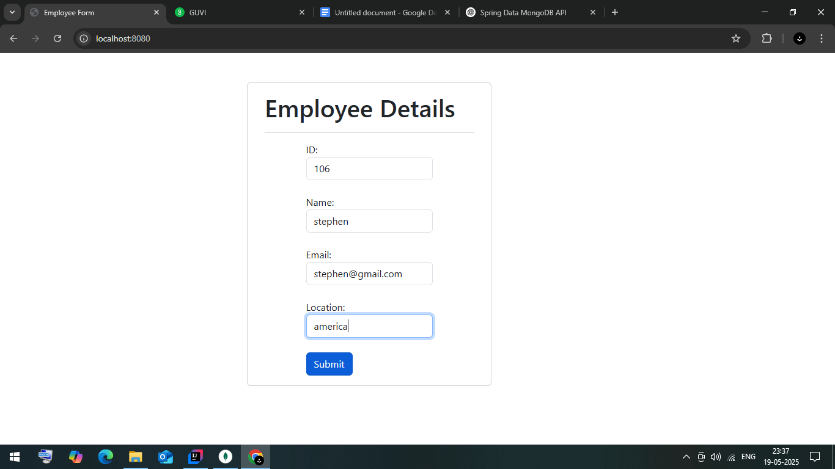

**All Employee page:**

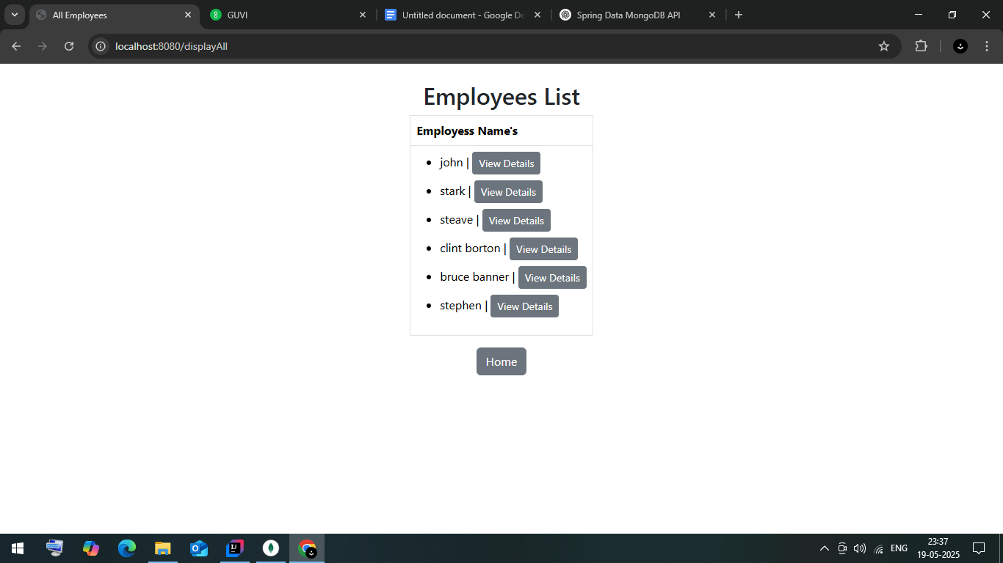

**One Employee Details page:**

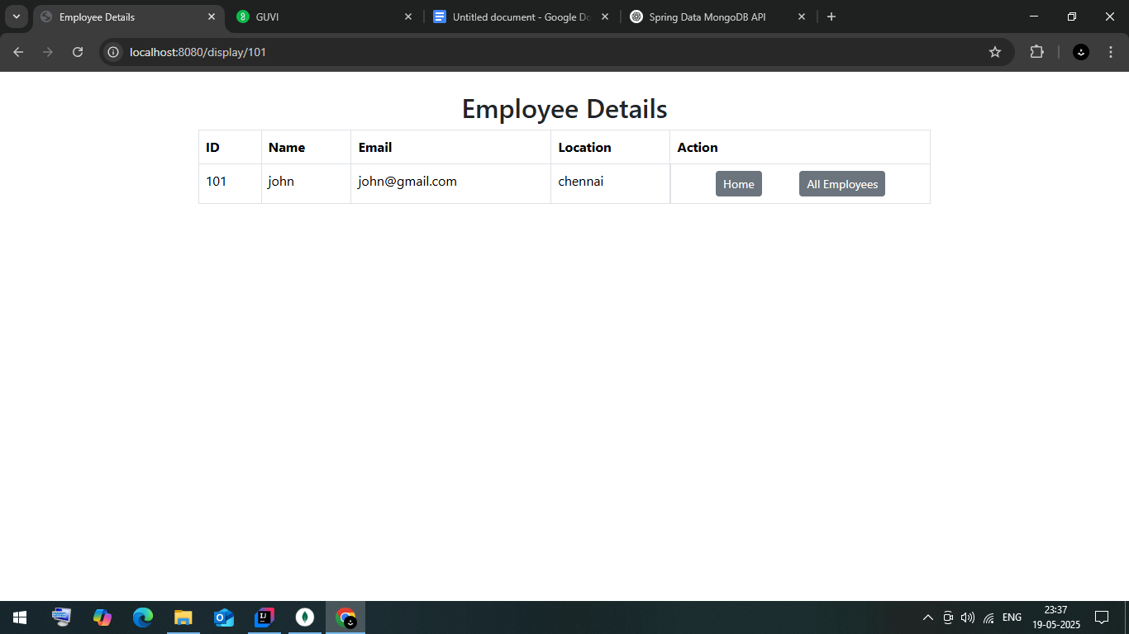

**Database:**

