**Guvi Task 11**

**Spring IOC, Beans, IOC**

**1.The first restful URL should display the html page where two option should be there (Add product Display product)**

**Home page**

**<!DOCTYPE html>**

**<html xmlns:th="http://www.thymeleaf.org">**

**<head>**

**<title>Home</title>**

**<link href="https://cdn.jsdelivr.net/npm/bootstrap@5.3.6/dist/css/bootstrap.min.css" rel="stylesheet"**

**integrity="sha384-4Q6Gf2aSP4eDXB8Miphtr37CMZZQ5oXLH2yaXMJ2w8e2ZtHTl7GptT4jmndRuHDT" crossorigin="anonymous">**

**<script src="https://cdn.jsdelivr.net/npm/bootstrap@5.3.6/dist/js/bootstrap.bundle.min.js"**

**integrity="sha384-j1CDi7MgGQ12Z7Qab0qlWQ/Qqz24Gc6BM0thvEMVjHnfYGF0rmFCozFSxQBxwHKO" crossorigin="anonymous">**

**</script>**

**</head>**

**<body>**

**<div class="container mt-4 d-flex justify-content-center">**

**<div class="row col-6 ">**

**<div class="card" style="width:25rem;">**

**<div class="card-body">**

**<h1 class="card-title">Product Catalog</h1>**

**<hr>**

**<div class="btn-group d-inline-flex justify-content-center gap-1">**

**<a class="btn btn-primary d-flex justify-content-center float-start" href="/add">Add**

**Product</a><br/>**

**<a class="btn btn-primary d-flex justify-content-center float-end" href="/display">Display**

**Products</a>**

**</div>**

**</div>**

**</div>**

**</div>**

**</div>**

**</body>**

**</html>**

**Add product page:**

**<!DOCTYPE html>**

**<html xmlns:th="http://www.thymeleaf.org">**

**<head><title>Add Product</title>**

**<link href="https://cdn.jsdelivr.net/npm/bootstrap@5.3.6/dist/css/bootstrap.min.css" rel="stylesheet"**

**integrity="sha384-4Q6Gf2aSP4eDXB8Miphtr37CMZZQ5oXLH2yaXMJ2w8e2ZtHTl7GptT4jmndRuHDT" crossorigin="anonymous">**

**<script src="https://cdn.jsdelivr.net/npm/bootstrap@5.3.6/dist/js/bootstrap.bundle.min.js"**

**integrity="sha384-j1CDi7MgGQ12Z7Qab0qlWQ/Qqz24Gc6BM0thvEMVjHnfYGF0rmFCozFSxQBxwHKO"**

**crossorigin="anonymous"></script>**

**</head>**

**<body>**

**<div class="container mt-4 d-flex justify-content-center">**

**<div class="row col-6 ">**

**<div class="card" style="width:25rem;">**

**<div class="card-body">**

**<h1 class="card-title">Add Product</h1>**

**<hr>**

**<form th:action="@{/add}" th:object="${product}" method="post">**

**Name: <input type="text" th:field="*{name}"/><br/><br/>**

**Price: <input type="number" step="0.01" th:field="*{price}"/><br/><br/>**

**Category: <input type="text" th:field="*{category}"/><br/><br/>**

**<div class="d-grid gap-2">**

**<button class="btn btn-primary mt-2 d-flex justify-content-center" type="submit">Add</button>**

**</div>**

**</form>**

**</div>**

**</div>**

**</div>**

**</div>**

**</body>**

**</html>**

**Display product page:**

**<!DOCTYPE html>**

**<html xmlns:th="http://www.thymeleaf.org">**

**<head><title>Products</title>**

**<link href="https://cdn.jsdelivr.net/npm/bootstrap@5.3.6/dist/css/bootstrap.min.css" rel="stylesheet"**

**integrity="sha384-4Q6Gf2aSP4eDXB8Miphtr37CMZZQ5oXLH2yaXMJ2w8e2ZtHTl7GptT4jmndRuHDT" crossorigin="anonymous">**

**<script src="https://cdn.jsdelivr.net/npm/bootstrap@5.3.6/dist/js/bootstrap.bundle.min.js"**

**integrity="sha384-j1CDi7MgGQ12Z7Qab0qlWQ/Qqz24Gc6BM0thvEMVjHnfYGF0rmFCozFSxQBxwHKO"**

**crossorigin="anonymous"></script>**

**</head>**

**<body>**

**<div class="container mt-4 col-8">**

**<h2 class="d-flex justify-content-center">All Products</h2>**

**<table class="table table-bordered">**

**<tr>**

**<th>ID</th>**

**<th>Name</th>**

**<th>Price</th>**

**<th>Category</th>**

**</tr>**

**<tr th:each="product : ${products}">**

**<td th:text="${product.id}"></td>**

**<td th:text="${product.name}"></td>**

**<td th:text="${product.price}"></td>**

**<td th:text="${product.category}"></td>**

**</tr>**

**</table>**

**<a class="btn btn-secondary d-flex justify-content-center float-start" href="/">Home</a>**

**</div>**

**</body>**

**</html>**

**Entity class**

**package com.example.product_Catlog.Entity;**

**import jakarta.persistence.*;**

**import lombok.*;**

**@Data**

**@NoArgsConstructor**

**@AllArgsConstructor**

**@Entity**

**@Table(name="product")**

**public class Product {**

**@Id**

**@GeneratedValue(strategy = GenerationType.*IDENTITY*)**

**private Long id;**

**@Column(nullable = false)**

**private String name;**

**@Column(nullable = false)**

**private double price;**

**@Column(nullable = false)**

**private String category;**

**}**

**Repository class:**

**package com.example.product_Catlog.Repository;**

**import com.example.product_Catlog.Entity.Product;**

**import org.springframework.data.jpa.repository.JpaRepository;**

**import java.util.List;**

**public interface ProductRepository extends JpaRepository<Product, Long> {**

**List<Product> findByCategory(String category);**

**}**

**Service class:**

**package com.example.product_Catlog.Service;**

**import com.example.product_Catlog.Entity.Product;**

**import com.example.product_Catlog.Repository.ProductRepository;**

**import org.springframework.beans.factory.annotation.Autowired;**

**import org.springframework.stereotype.Service;**

**import java.util.List;**

**@Service**

**public class ProductService {**

**@Autowired**

**private ProductRepository productRepository;**

**public void addProduct(Product product) {**

**productRepository.save(product);**

**}**

**public List<Product> getAllProducts() {**

**return productRepository.findAll();**

**}**

**public List<Product> getProductsByCategory(String category) {**

**return productRepository.findByCategory(category);**

**}**

**}**

**Controller class:**

**package com.example.product_Catlog.Controller;**

**import org.springframework.ui.Model;**

**import com.example.product_Catlog.Entity.Product;**

**import com.example.product_Catlog.Service.ProductService;**

**import org.springframework.beans.factory.annotation.Autowired;**

**import org.springframework.stereotype.Controller;**

**import org.springframework.web.bind.annotation.GetMapping;**

**import org.springframework.web.bind.annotation.ModelAttribute;**

**import org.springframework.web.bind.annotation.PostMapping;**

**@Controller**

**public class ProductController {**

**@Autowired**

**private ProductService productService;**

**@GetMapping("/")**

**public String home() {**

**return "home";**

**}**

**@GetMapping("/add")**

**public String showAddForm(Model model) {**

**model.addAttribute("product", new Product());**

**return "addProduct";**

**}**

**@PostMapping("/add")**

**public String addProduct(@ModelAttribute Product product) {**

**productService.addProduct(product);**

**return "redirect:/";**

**}**

**@GetMapping("/display")**

**public String displayProducts(Model model) {**

**model.addAttribute("products", productService.getAllProducts());**

**return "displayProducts";**

**}**

**}**

**Output:**

**Home**

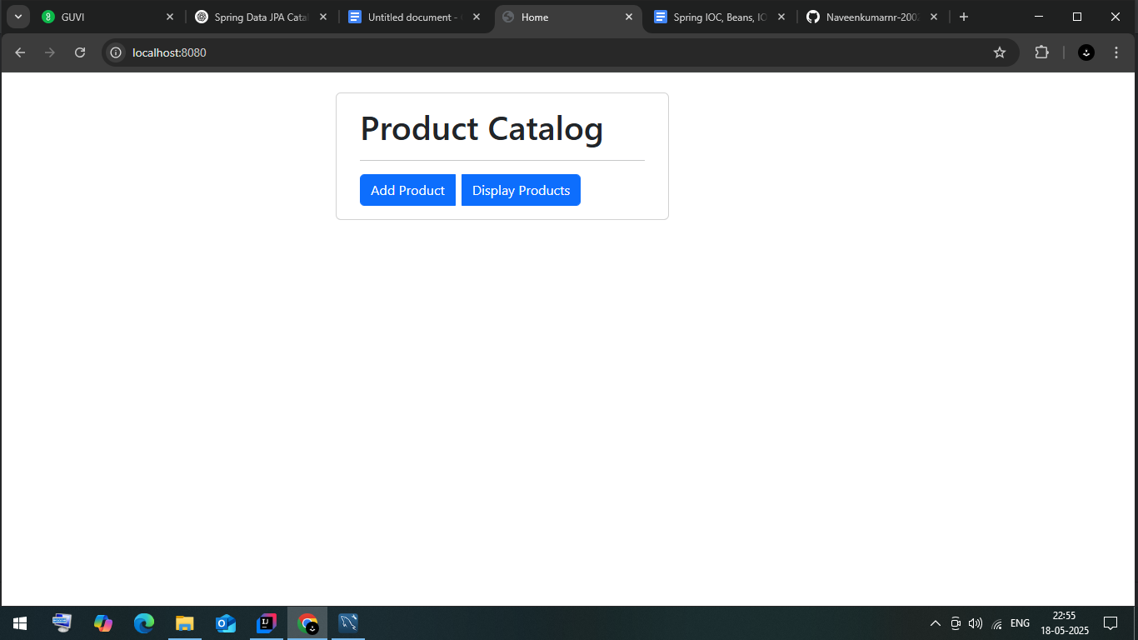

**Add products**

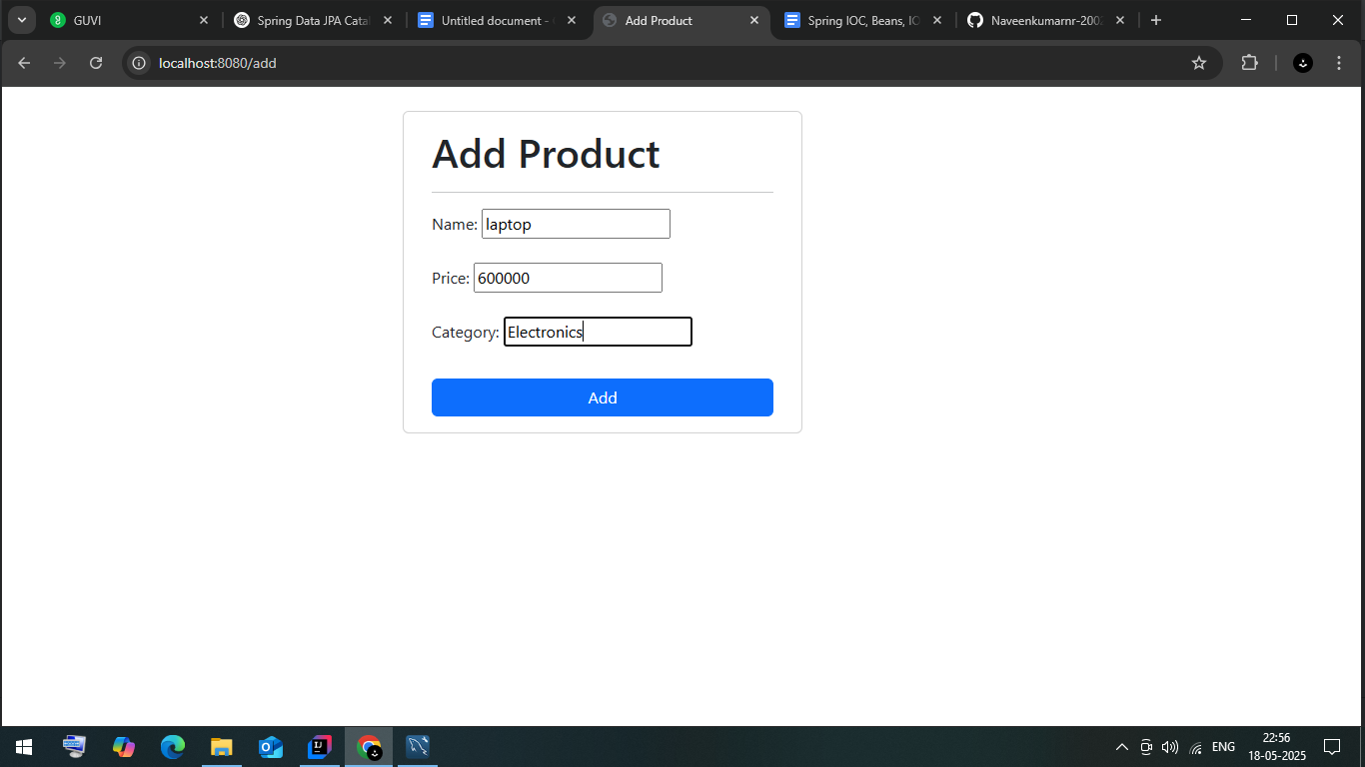

**All products:**

