**GUVI TASK 6**

1.Fix the bugs in below snippet Body and div tag changed into its corresponding places

<html lang="en">

<head>

<title>Document guvi</title>

</head>

<body>

<div>

Lorem ipsum dolor sit amet consectetur adipisicing elit.

<div>

<div>

Guvi Geek Network

</div>

</div>

</div>

</body>

</html>

**OUTPUT :**

Lorem ipsum dolor sit amet consectetur adipisicing elit.

Guvi Geek Network

**2.**Fix the bugs in below snippet Body and div tag changed into its corresponding places

<html lang="en">

<head>

<title>Document guvi </title>

</head>

<body>

<div>

Lorem ipsum dolor sit amet consectetur adipisicing elit.

<div>

<div>

Guvi Geek Network

</div>

</div>

</div>

</body>

</html>

**OUTPUT :**

Lorem ipsum dolor sit amet consectetur adipisicing elit.

Guvi Geek Network

3.Design a contact us form with all fields as required.

<!-- Contact us form -->

<html lang="en">

<head>

<meta charset="UTF-8">

<meta name="viewport" content="width=device-width, initial-scale=1.0">

<title>Document</title>

</head>

<body>

<form action="" method="post">

<label for="name">Name: </label>

<input type="text" name="name" id="name" required>

<br>

<br>

<label for="age">Age: </label>

<input type="age" name="age" id="age" required>

<br>

<br>

<label for="Phone">Phone Number: </label>

<input type="phone" name="number" id="number" maxlength="10" required>

<br>

<br>

<label for="E-mail">E-mail: </label>

<input type="email" name="email" id="email" required>

<br>

<br>

<label for="about">About: </label>

<textarea name="about" id="about"></textarea>

<br>

<br>

<input type="Submit">

</form>

</body>

</html>

OUTPUT :

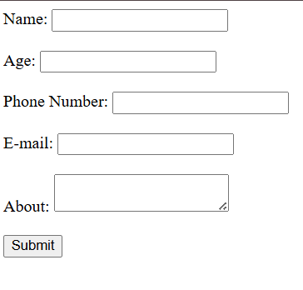

4.Use certain HTML elements to display the following in a HTML page.

<html lang="en">

<head>

<meta charset="UTF-8">

<meta name="viewport" content="width=device-width, initial-scale=1.0">

<title>Document</title>

</head>

<body>

<ul>

<li>

Programming Language

</li>

<ul>

<li>

JavaScript

</li>

<ol type="a">

<li>Angular</li>

<li>React</li>

<li>Vue.js</li>

</ol>

<li>

Python

</li>

<ol type="a">

<li>Django Framework</li>

<li>Flask Framework</li>

</ol>

<li>

Java

</li>

<ol type="a">

<li>Spring</li>

<li>Maven</li>

<li>Hibernate</li>

</ol>

<li>

Database

</li>

<ul >

<li>MySQL</li>

<li>MongoDB</li>

<li>Cansandra</li>

</ul>

</ul>

</ul>

</body>

</html>

OUTPUT :

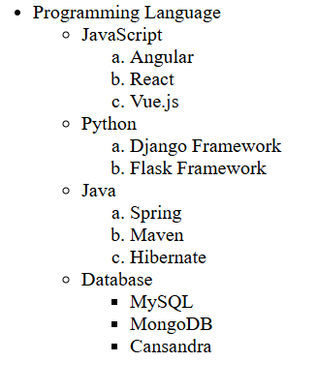

5.Create an element that helps you to open the “https://google.com” in separate new tab.

<html lang="en">

<head>

<meta charset="UTF-8">

<meta name="viewport" content="width=device-width, initial-scale=1.0">

<title>Document</title>

</head>

<body>

<a href="https://google.com" target="_blank">Google Link</a>

</body>

</html>

OUTPUT :

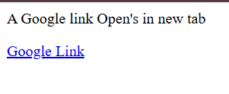

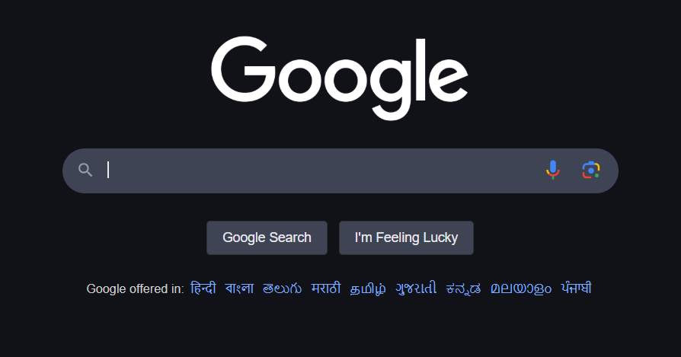

6. In the form, add two radio buttons with grouping them for employee type(Salaried and own business)

<!-- Contact us form -->

<html lang="en">

<head>

<meta charset="UTF-8">

<meta name="viewport" content="width=device-width, initial-scale=1.0">

<title>Document</title>

</head>

<body>

<form action="" method="post">

<label for="name">Name: </label>

<input type="text" name="name" id="name" required>

<br>

<br>

<label for="age">Age: </label>

<input type="age" name="age" id="age" required>

<br>

<br>

<label for="Phone">Phone Number: </label>

<input type="phone" name="number" id="number" maxlength="10" required>

<br>

<br>

<label for="E-mail">E-mail: </label>

<input type="email" name="email" id="email" required>

<br>

<br>

<label for="about">About: </label>

<textarea name="about" id="about"></textarea>

<br>

<br>

<P>employee type</P>

<input type="radio" id="Salaried " name="employee" value="HTML">

<label for="Salaried ">Salaried </label><br>

<input type="radio" id="own business" name="employee" value="own business">

<label for="own business">Own Business</label><br><br>

<input type="Submit">

</form>

</body>

</html>

**OUTPUT :**

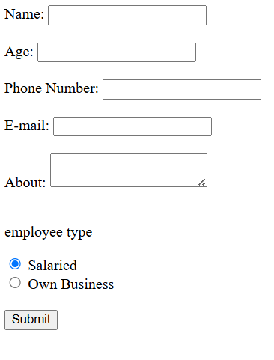

9. Write HTML input tags snippet to show default values for all Form elements.

<html lang="en">

<head>

<meta charset="UTF-8">

<meta name="viewport" content="width=device-width, initial-scale=1.0">

<title>Document</title>

</head>

<body>

<form>

<!-- Text Input -->

<label>Text:

<input type="text" name="username" value="Stark">

</label><br><br>

<!-- Password -->

<label>Password:

<input type="password" name="password" value="tony">

</label><br><br>

<!-- Email -->

<label>Email:

<input type="email" name="email" value="stark@gmail.com">

</label><br><br>

<!-- Number -->

<label>Number:

<input type="number" name="age" value="100">

</label><br><br>

<!-- Date -->

<label>Date:

<input type="date" name="dob" value="1990-01-01">

</label><br><br>

<!-- Checkbox -->

<label>

<input type="checkbox" name="subscribe" checked>

Subscribe

</label><br><br>

<!-- Radio Buttons -->

Gender:<br>

<label><input type="radio" name="gender" value="male" checked> Male</label><br>

<label><input type="radio" name="gender" value="female"> Female</label><br><br>

<!-- Color -->

<label>Favorite Color:

<input type="color" name="favcolor" value="#fff">

</label><br><br>

<!-- Range -->

<label>Volume:

<input type="range" name="volume" min="0" max="100" value="50">

</label><br><br>

<!-- File -->

<label>Upload File:

<input type="file" name="resume">

</label><br><br>

<!-- Hidden -->

<input type="hidden" name="userId" value="12345">

<!-- Search -->

<label>Search:

<input type="search" name="search" value="Search">

</label><br><br>

<!-- Tel -->

<label>Phone:

<input type="tel" name="phone" value="1234567890" maxlength="10">

</label><br><br>

<!-- URL -->

<label>Website:

<input type="url" name="website" value=" https://google.com">

</label><br><br>

<!-- Submit Button -->

<input type="submit" value="Submit">

</form>

</body>

</html>

**OUTPUT :**

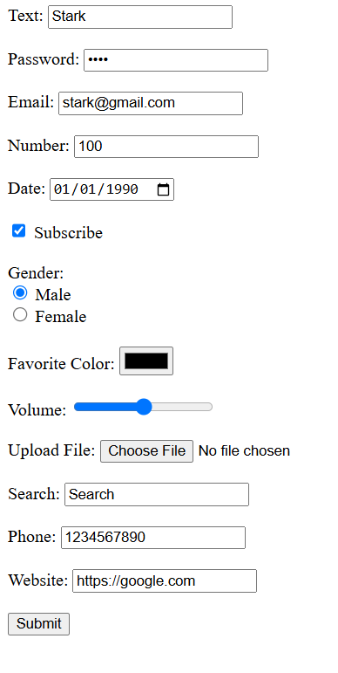

10. In your, HTML page add the below line and Highlight it without using any CSS.

"HTML & CSS is awesome"

<html lang="en">

<head>

<meta charset="UTF-8">

<meta name="viewport" content="width=device-width, initial-scale=1.0">

<title>Document</title>

</head>

<body>

<h1>Line with Highlight</h1>

<p><mark>HTML & CSS is awesome</mark></p>

</body>

</html>

OUTPUT :

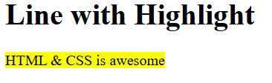

11. Create an HTML page, which should contain all types of input elements.

<!DOCTYPE html>

<html lang="en">

<head>

<meta charset="UTF-8">

<meta name="viewport" content="width=device-width, initial-scale=1.0">

<title>Document</title>

</head>

<body>

<h1>All HTML Tags</h1>

<form>

<!-- Text Input -->

<label>Text:

<input type="text" name="textInput" value="Stark">

</label><br><br>

<!-- Password -->

<label>Password:

<input type="password" name="password" value="tony">

</label><br><br>

<!-- Email -->

<label>Email:

<input type="email" name="email" value="stark@gmail.com">

</label><br><br>

<!-- Number -->

<label>Number:

<input type="number" name="number" value="100">

</label><br><br>

<!-- Date -->

<label>Date:

<input type="date" name="date" value="2025-04-04">

</label><br><br>

<!-- Time -->

<label>Time:

<input type="time" name="time" value="12:30">

</label><br><br>

<!-- Month -->

<label>Month:

<input type="month" name="month" value="2025-04">

</label><br><br>

<!-- Week -->

<label>Week:

<input type="week" name="week" value="2025-W14">

</label><br><br>

<!-- Checkbox -->

<label>

<input type="checkbox" name="agree" checked>

I agree to the terms and conditions

</label><br><br>

<!-- Radio Buttons -->

Gender:<br>

<label><input type="radio" name="gender" value="male" checked> Male</label><br>

<label><input type="radio" name="gender" value="female"> Female</label><br><br>

<!-- Color -->

<label>Favorite Color:

<input type="color" name="color" value="#00ffcc">

</label><br><br>

<!-- Range -->

<label>Volume:

<input type="range" name="volume" min="0" max="100" value="50">

</label><br><br>

<!-- File -->

<label>Upload File:

<input type="file" name="fileUpload">

</label><br><br>

<!-- Hidden -->

<input type="hidden" name="hiddenValue" value="12345">

<!-- Search -->

<label>Search:

<input type="search" name="search" value="Search">

</label><br><br>

<!-- Tel -->

<label>Phone:

<input type="tel" name="phone" value="1234567890" maxlength="10">

</label><br><br>

<!-- URL -->

<label>Website:

<input type="url" name="url" value="https://google.com">

</label><br><br>

<!-- Submit -->

<input type="submit" value="Submit">

<!-- Reset -->

<input type="reset" value="Reset">

<!-- Button -->

<input type="button" value="Click Me" onclick="alert('Button clicked!')">

</form>

</body>

</html>

OUTPUT :

