**MYSQL TASK**

**Task 1**

**creating a table employee to store employee details like empno, empname, job, mgr, hiredate, salery, comm, deptno using java maven**

package org.example;

import java.sql.Connection;

import java.sql.DriverManager;

import java.sql.SQLException;

import java.sql.Statement;

public class Main {

public static void main(String[] args) {

String url = "jdbc:mysql://localhost:3306/";

String user = "root";

String password = "Naveen-2002";

try (Connection connection = DriverManager.*getConnection*(url, user, password);

Statement statement = connection.createStatement()) {

statement.executeUpdate("CREATE DATABASE IF NOT EXISTS employees");

System.*out*.println("Database created ");

statement.execute("USE employees");

String createTableemployee = """

CREATE TABLE IF NOT EXISTS employee (

empNo INT PRIMARY KEY,

empName VARCHAR(100),

job VARCHAR(50),

mgr INT,

hireDate DATE,

salery DECIMAL(10, 2),

comm DECIMAL(10, 2),

deptNo INT

)

""";

statement.executeUpdate(createTableemployee);

System.*out*.println("Table Created");

String insertData = """

INSERT INTO employee (empNo, empName, job, mgr, hireDate, salery, comm, deptNo) VALUES

(8369, 'SMITH', 'CLERK', 8902, '1990-12-18', 800.00, NULL, 20),

(8499, 'ANYA', 'SALESMAN', 8698, '1991-02-20', 1600.00, 300.00, 30),

(8521, 'SETH', 'SALESMAN', 8698, '1991-02-22', 1250.00, 500.00, 30),

(8566, 'MAHADEVAN', 'MANAGER', 8839, '1991-04-02', 2985.00, NULL, 20),

(8654, 'MOMIN', 'SALESMAN', 8698, '1991-09-28', 1250.00, 1400.00, 30),

(8698, 'BINA', 'MANAGER', 8839, '1991-05-01', 2850.00, NULL, 30),

(8882, 'SHIVANSH', 'MANAGER', 8839, '1991-06-09', 2450.00, NULL, 10),

(8888, 'SCOTT', 'ANALYST', 8566, '1992-12-09', 3000.00, NULL, 20),

(8839, 'AMIR', 'PRESIDENT', NULL, '1991-11-18', 5000.00, NULL, 10),

(8844, 'KULDEEP', 'SALESMAN', 8698, '1991-09-08', 1500.00, 0.00, 30)

""";

statement.executeUpdate(insertData);

System.*out*.println("Data inserted");

} catch (SQLException e) {

e.printStackTrace();

}

}

}

Maven codes;

<?xml version="1.0" encoding="UTF-8"?>

<project xmlns="http://maven.apache.org/POM/4.0.0"

xmlns:xsi="http://www.w3.org/2001/XMLSchema-instance"

xsi:schemaLocation="http://maven.apache.org/POM/4.0.0 http://maven.apache.org/xsd/maven-4.0.0.xsd">

<modelVersion>4.0.0</modelVersion>

<groupId>org.example</groupId>

<artifactId>MySqlTask1</artifactId>

<version>1.0-SNAPSHOT</version>

<properties>

<maven.compiler.source>24</maven.compiler.source>

<maven.compiler.target>24</maven.compiler.target>

<project.build.sourceEncoding>UTF-8</project.build.sourceEncoding>

</properties>

<dependencies>

<dependency>

<groupId>com.mysql</groupId>

<artifactId>mysql-connector-j</artifactId>

<version>8.0.33</version> <!-- Make sure version is up-to-date -->

</dependency>

</dependencies>

</project>

**SQL Queries :**

**A.Write a query to display EName and Sal of employees whose salary are greater than or equal to 2200?**

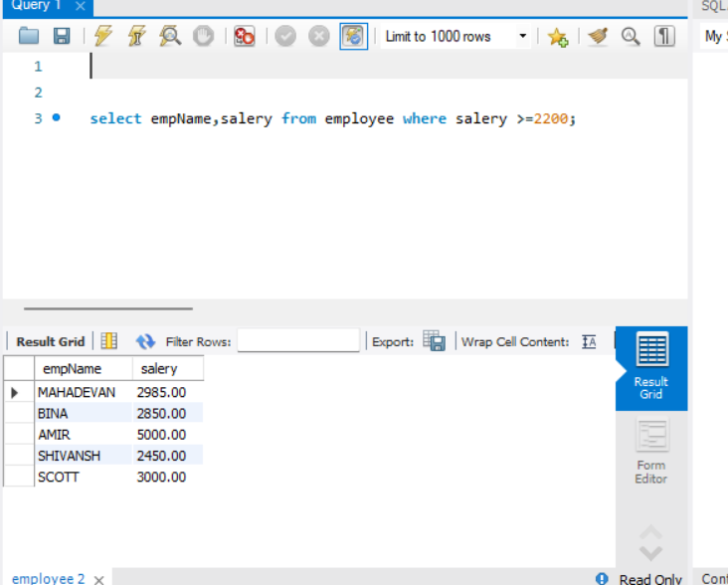

**B. Write a query to display details of employees who are not getting commission?**

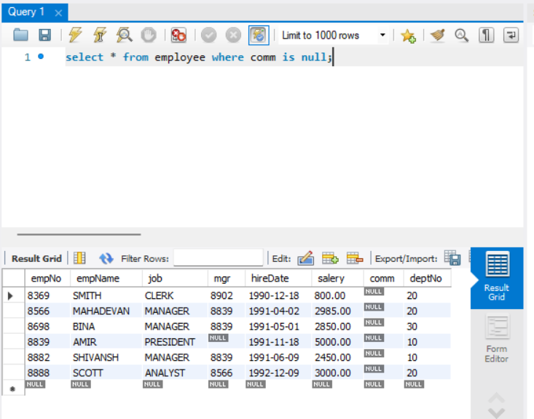

**C. Write a query to display employee name and salary of those employees who don’t have their salary in the range of 2500 to 4000?**

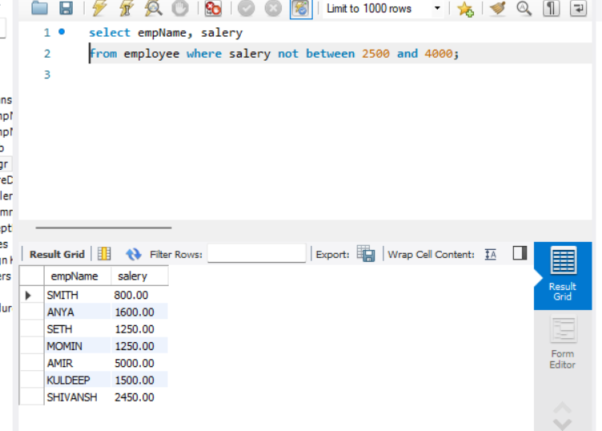

**D. Write a query to display the name, job title and salary of employees who don’t have a manager?**

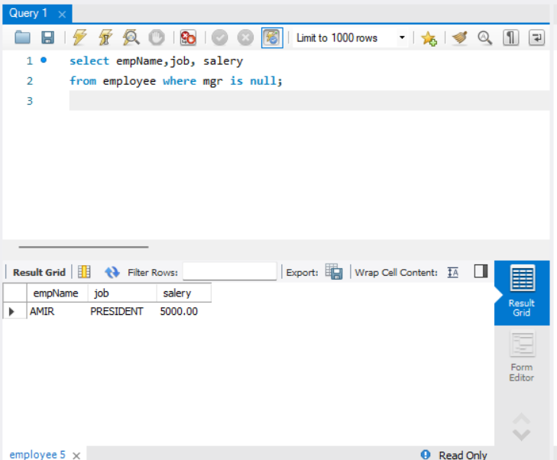

**E. Write a query to display the name of an employee whose name contains “A” as third alphabet?**

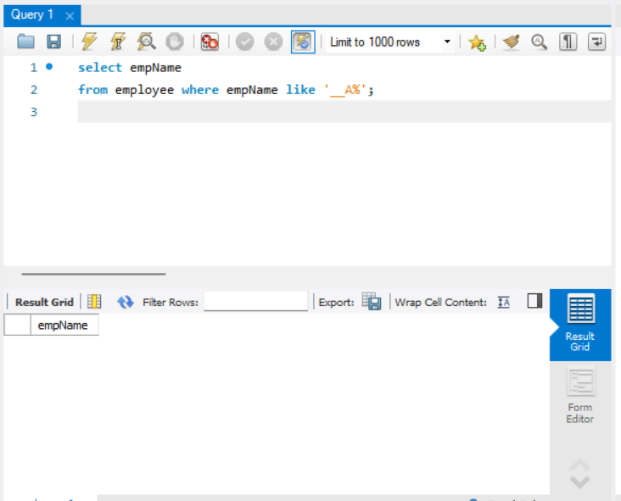

**F. Write a query to display the name of an employee whose name contains “T” as the last alphabet?**

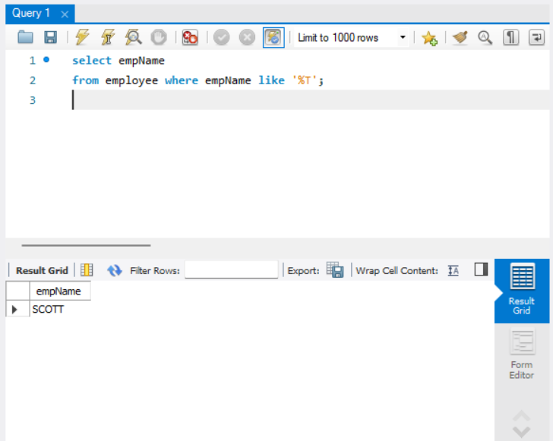

**Task 2:**

**JDBC code:**

**package org.example;**

**import java.sql.Connection;**

**import java.sql.DriverManager;**

**import java.sql.SQLException;**

**import java.sql.Statement;**

**public class Main1 {**

**public static void main(String[] args) {**

**String url = "jdbc:mysql://localhost:3306/";**

**String user = "root";**

**String password = "Naveen-2002";**

**try (Connection connection = DriverManager.*getConnection*(url, user, password);**

**Statement statement = connection.createStatement()) {**

**statement.executeUpdate("CREATE DATABASE IF NOT EXISTS emps");**

**System.*out*.println("Database created ");**

**statement.execute("USE emps");**

**String createTableemployees = """**

**CREATE TABLE IF NOT EXISTS emp (**

**empCode INT PRIMARY KEY,**

**empName VARCHAR(100),**

**empAge INT,**

**empSalery DECIMAL(10, 2)**

**)**

**""";**

**statement.executeUpdate(createTableemployees);**

**System.*out*.println("Table Created");**

**String insertDatas = """**

**INSERT INTO emp (empCode,empName,empAge,empSalery) VALUES**

**(101,'Jenny',25,10000.00),**

**(102,'Jacky',30,20000.00),**

**(103,'Joe',20,40000.00),**

**(104,'John',40,80000.00),**

**(105,'Shameer',25,90000.00)**

**""";**

**statement.executeUpdate(insertDatas);**

**System.*out*.println("Data inserted");**

**} catch (SQLException e) {**

**e.printStackTrace();**

**}**

**}**

**}**

**Maven code:**

**<?xml version="1.0" encoding="UTF-8"?>**

**<project xmlns="http://maven.apache.org/POM/4.0.0"**

**xmlns:xsi="http://www.w3.org/2001/XMLSchema-instance"**

**xsi:schemaLocation="http://maven.apache.org/POM/4.0.0 http://maven.apache.org/xsd/maven-4.0.0.xsd">**

**<modelVersion>4.0.0</modelVersion>**

**<groupId>org.example</groupId>**

**<artifactId>MySqlTask1</artifactId>**

**<version>1.0-SNAPSHOT</version>**

**<properties>**

**<maven.compiler.source>24</maven.compiler.source>**

**<maven.compiler.target>24</maven.compiler.target>**

**<project.build.sourceEncoding>UTF-8</project.build.sourceEncoding>**

**</properties>**

**<dependencies>**

**<dependency>**

**<groupId>com.mysql</groupId>**

**<artifactId>mysql-connector-j</artifactId>**

**<version>8.0.33</version> <!-- Make sure version is up-to-date -->**

**</dependency>**

**</dependencies>**

**</project>**

**The Table:**

