

**SDM College of Engineering and Technology**

**Department of Computer Science & Engineering**

**CTA Activity REPORT**

**On**

**______________________________________**

**Web Technology - 18UCSO707**

**__________________________________________________**

|  |  |  |  |  |
| --- | --- | --- | --- | --- |
| **Activity. No** | **Title** | **Max.**  **Marks** | **Marks**  **Scored** | **Out of 10 M** |
| 1 | Design and Development of web application to produce placement reports | 10 |  |  |
| 2 | Integration of CSS and JavaScript to activity-1. | 10 |  |
| 3 | Integration of business logic using PHP, and MySQL to activity-1 & 2. | 10 |  |
| 4 | Integration of AJAX to the activities -1, 2, 3. | 10 |  |
| **Total Marks** | | 50 |  |

**Note: The total scored mark will be scaled down to 10M.**

**Submitted**

**By**

**Name: Naveen M Madiwalar USN: 2SD19CS064**

**VII Semester, B-Division Academic Year:2022-23**

**Course Teacher**

**Prathap Kumar M.K.**

**Contents**

|  |  |  |
| --- | --- | --- |
| **Sl. No** | **Problem Definition** | **PageNo** |
| **1** | **Activity-1:** Design and Development of web application to produce placement reports | **3** |
| **2** | **Activity-2:** Integration of CSS and JavaScript to activity-1. | **5** |
| **3** | **Activity-3:** Integration of business logic using PHP, and MySQL to activity-1 & 2 | **7** |
| **4** | **Activity-4:** Integration of AJAX to the activities -1, 2, 3 | **10** |

**Activity – 1**

**(Designing of static web pages)**

1. **Problem statement**

Design and Development of web application to produce placement reports

**Implementation:**

1. Designing of Web page(s) using HTML/XHTML/HTML5.
2. Creation of XML file for the identified problem statement
3. Creation of DTD file for the identified problem statement
4. Creation of XSD file for the identified problem statement

**Solution:**

**Index.html**

<! DOCTYPE html>

<html lang="en">

<head>

<meta charset="UTF-8">

<title>Login Page</title>

</head>

<body>

<form action="report.html" method="" target="_blank">

<center>

<img src="OIP.jpg" breadth="150" width="150">

<h3>SDM COLLEGE OF ENGINEERING AND TECHNOLOGY,DHARWAD-580002 </h3>

<h4>DEPARTMENT OF COMPUTER SCIENCE AND ENGINEERING</h4>

</center>

<center>

<fieldset >

<legend>Login</legend>

<table>

<tr>

<td>

<label>User Name:</label>

</td>

<td>

<input type="text" name="usrname" id="usrname" placeholder="Enter the user name" >

</td>

</tr>

<tr>

<td>

<lable >Password:</lable>

</td>

<td>

<input type="password" name="passw" id="passw" placeholder="*****">

</td>

</tr>

<tr>

<td><input type="Submit" name="btnsubmit" value="Submit" id="btnsubmit"></td>

<td><input type="reset" name="btnclear" value="Clear" id="btnclear"></td>

**</tr>**

</table>

</fieldset>

</center>

</form>

</body>

</html>

**XML Source code**

<?xml version="1.0" encoding="UTF-8"?>

<!DOCTYPE users SYSTEM "login.dtd">

<users>

<user>

<uid uid="admin">admin</uid>

<password>admin</password>

</user>

</users>

**DTD Source code**

<?xml version="1.0" encoding="UTF-8"?>

<!ELEMENT users (user*)>

<!ELEMENT user (uid,password)>

<!ELEMENT uid (#PCDATA)>

<!ELEMENT password (#PCDATA)>

<!ATTLIST uid uid CDATA #REQUIRED>

**XSD Source code**

<?xml version="1.0" encoding="utf-8"?>

<xs:schema attributeFormDefault="unqualified" elementFormDefault="qualified" xmlns:xs="http://www.w3.org/2001/XMLSchema">

<xs:element name="users">

<xs:complexType>

<xs:sequence>

<xs:element name="user">

<xs:complexType>

<xs:sequence>

<xs:element name="uid">

<xs:complexType>

<xs:simpleContent>

<xs:extension base="xs:string">

<xs:attribute name="uid" type="xs:string" use="required" />

</xs:extension>

</xs:simpleContent>

</xs:complexType>

</xs:element>

<xs:element name="password" type="xs:string" />

</xs:sequence>

</xs:complexType>

</xs:element>

</xs:sequence>

</xs:complexType>

</xs:element>

</xs:schema>

**addStudent.html**

<!DOCTYPE html>

<html lang="en">

<head>

<meta charset="UTF-8">

<title>Add Student</title>

</head>

<body>

<fieldset>

<legend>Add Student</legend>

<table>

<tr>

<td><label><b>USN:</b></label></td>

<td>

<input type="text" name="stdusn" id="stdusn" placeholder="Ex:2SD19CS064">

</td>

</tr>

<tr>

<td>

<label><b>Name:</b></label>

</td>

<td>

<input type="text" name="stdname" id="stdname">

</td>

</tr>

<tr>

<td><label><b>Branch:</b></label></td>

<td>

<select name="branch">

<option value="CSE">Computer Science and Engineering</option>

<option value="EEE">Electrical and Electronics Engimeering</option>

<option value="ECE">Electronic and Communication Engineering</option>

<option value="MECH">Mechanical Engineering</option>

</select>

</td>

</tr>

<tr>

<td><b><label>Semester:</label></b></td>

<td><input type="text" name="sem" id="sem"></td>

</tr>

<tr>

<td><b><label>Company:</label></b></td>

<td><input type="text" name="cmp" id="cmp"></td>

</tr>

<tr>

<td><b><label>Package:(lpa)</label></b></td>

<td><input type="text" name="pkg" id="pkg"></td>

</tr>

</table>

</fieldset>

</body>

</html>

**XML source code**

<?xml version="1.0" encoding="UTF-8"?>

<!DOCTYPE students SYSTEM "addstd.dtd">

<students>

<student>

<usn usn="1">1</usn>

<name>xyz</name>

<branch>cs</branch>

<sem>7</sem>

<comp>xyz</comp>

<pack>10</pack>

</student>

</students>

**DTD source code**

<?xml version="1.0" encoding="UTF-8"?>

<!ELEMENT students (student*)>

<!ELEMENT student (usn,name,branch,sem,comp,pack)>

<!ELEMENT usn (#PCDATA)>

<!ELEMENT name (#PCDATA)>

<!ELEMENT branch (#PCDATA)>

<!ELEMENT sem (#PCDATA)>

<!ELEMENT comp (#PCDATA)>

<!ELEMENT pack (#PCDATA)>

<!ATTLIST usn usn CDATA #REQUIRED>

**XSD source code**

<?xml version="1.0" encoding="utf-8"?>

<xs:schema attributeFormDefault="unqualified" elementFormDefault="qualified" xmlns:xs="http://www.w3.org/2001/XMLSchema">

<xs:element name="students">

<xs:complexType>

<xs:sequence>

<xs:element name="student">

<xs:complexType>

<xs:sequence>

<xs:element name="usn">

<xs:complexType>

<xs:simpleContent>

<xs:extension base="xs:unsignedByte">

<xs:attribute name="usn" type="xs:unsignedByte" use="required" />

</xs:extension>

</xs:simpleContent>

</xs:complexType>

</xs:element>

<xs:element name="name" type="xs:string" />

<xs:element name="branch" type="xs:string" />

<xs:element name="sem" type="xs:unsignedByte" />

<xs:element name="comp" type="xs:string" />

<xs:element name="pack" type="xs:unsignedByte" />

</xs:sequence>

</xs:complexType>

</xs:element>

</xs:sequence>

</xs:complexType>

</xs:element>

</xs:schema>

**Report.html**

<!DOCTYPE html>

<html lang="en">

<head>

<meta charset="UTF-8">

<title>Report page</title>

</head>

<body>

<center>

<h1><b>Placement Reports</b></h1>

</center>

<fieldset>

<legend>Department</legend>

<!-- <label>Computer Science and Engineering</label>-->

<ol>

<li><a href="CSE.html" >Computer Science and Engineering</a></li>

<li><a href="ECE.html">Electronics and Comunication Engineering</a> </li>

<li><a href="ISE.html">Information Science and Engineering</a> </li>

<li><a href="EEE.html">Electrical and Electronics Engineering</a> </li>

<li><a href="MECH.html">Mechanical Engineering </a></li>

</ol>

</fieldset>

</body>

</html>

**CSE.html**

<!DOCTYPE html>

<html lang="en">

<head>

<meta charset="UTF-8">

<title>CSE Dept Report</title>

</head>

<body>

<center>

<h1><b>Computer Science and Engineering</b></h1>

</center>

<fieldset>

<legend>Overview</legend>

<table>

<tr>

<td><b>Number of students:</b></td>

<td><b>20</b></td>

</tr>

<tr>

<td><b>Number of Eligible Students:</b></td>

<td><b>20</b></td>

</tr>

<tr>

<td><b>Number of Student Placed:</b></td>

<td><b>17</b></td>

</tr>

<tr>

<td><b>Number of students not placed:</b></td>

<td><b>3</b></td>

</tr>

<tr>

<td><b>Percentage of Placement:</b></td>

<td><b>85%</b></td>

</tr>

<tr>

<td><b>Number of Multiple Offers:</b></td>

<td><b>10</b></td>

</tr>

<tr>

<td><b>Number of Companies Visited:</b></td>

<td><b>12</b></td>

</tr>

</table>

</fieldset>

<fieldset>

<legend>Placed Student Details</legend>

<table border="1">

<tr>

<th><b>Sl.No</b></th>

<th><b>USN</b></th>

<th><b>Name</b></th>

<th><b>Branch</b></th>

<th><b>Sem</b></th>

<th><b>Company</b></th>

<th><b>Package(lpa)</b></th>

</tr>

<tr>

<td>1</td>

<td>2SD19CS064</td>

<td>Naveen M Madiwalar</td>

<td>CSE</td>

<td>7th</td>

<td>Tata Elxsi</td>

<td>3.5</td>

</tr>

<tr>

<td>2</td>

<td>2SD19CS064</td>

<td>Naveen M Madiwalar</td>

<td>CSE</td>

<td>7th</td>

<td>Cognizant</td>

<td>4.0</td>

</tr>

<tr>

<td>3</td>

<td>2SD19CS066</td>

<td>Ninad</td>

<td>CSE</td>

<td>7th</td>

<td>Cognizant</td>

<td>4.0</td>

</tr>

<tr>

<td >

<a href="Add%20Student.html"><button>Add Student</button></a>

</td>

</tr>

</table>

</fieldset>

</body>

</html>

**ECE.html**

<!DOCTYPE html>

<html lang="en">

<head>

<meta charset="UTF-8">

<title>ECE Dept Report</title>

</head>

<body>

<center>

<h1><b>Electronics and Communication Engineering</b></h1>

</center>

<fieldset>

<legend>Overview</legend>

<table>

<tr>

<td><b>Number of students:</b></td>

<td><b>20</b></td>

</tr>

<tr>

<td><b>Number of Eligible Students:</b></td>

<td><b>20</b></td>

</tr>

<tr>

<td><b>Number of Student Placed:</b></td>

<td><b>17</b></td>

</tr>

<tr>

<td><b>Number of students not placed:</b></td>

<td><b>3</b></td>

</tr>

<tr>

<td><b>Percentage of Placement:</b></td>

<td><b>85%</b></td>

</tr>

<tr>

<td><b>Number of Multiple Offers:</b></td>

<td><b>10</b></td>

</tr>

<tr>

<td><b>Number of Companies Visited:</b></td>

<td><b>12</b></td>

</tr>

</table>

</fieldset>

<fieldset>

<legend>Placed Student Details</legend>

<table border="1">

<tr>

<th><b>Sl.No</b></th>

<th><b>USN</b></th>

<th><b>Name</b></th>

<th><b>Branch</b></th>

<th><b>Sem</b></th>

<th><b>Company</b></th>

<th><b>Package(lpa)</b></th>

</tr>

<tr>

<td>1</td>

<td>2SD19EC013</td>

<td>Akshay G</td>

<td>ECE</td>

<td>7th</td>

<td>Quest Global</td>

<td>3.2</td>

</tr>

<tr>

<td>2</td>

<td>2SD19EC064</td>

<td>Shashi</td>

<td>ECE</td>

<td>7th</td>

<td>Cognizant</td>

<td>4.0</td>

</tr>

</table>

</fieldset>

</body>

</html>

**ISE.html**

<!DOCTYPE html>

<html lang="en">

<head>

<meta charset="UTF-8">

<title>ISE Dept Report</title>

</head>

<body>

<center>

<h1><b>Information Science and Engineering</b></h1>

</center>

<fieldset>

<legend>Overview</legend>

<table>

<tr>

<td><b>Number of students:</b></td>

<td><b>20</b></td>

</tr>

<tr>

<td><b>Number of Eligible Students:</b></td>

<td><b>20</b></td>

</tr>

<tr>

<td><b>Number of Student Placed:</b></td>

<td><b>17</b></td>

</tr>

<tr>

<td><b>Number of students not placed:</b></td>

<td><b>3</b></td>

</tr>

<tr>

<td><b>Percentage of Placement:</b></td>

<td><b>85%</b></td>

</tr>

<tr>

<td><b>Number of Multiple Offers:</b></td>

<td><b>10</b></td>

</tr>

<tr>

<td><b>Number of Companies Visited:</b></td>

<td><b>12</b></td>

</tr>

</table>

</fieldset>

<fieldset>

<legend>Placed Student Details</legend>

<table border="1">

<tr>

<th><b>Sl.No</b></th>

<th><b>USN</b></th>

<th><b>Name</b></th>

<th><b>Branch</b></th>

**<**th><b>Sem</b></th>

<th><b>Company</b></th>

<th><b>Package(lpa)</b></th>

</tr>

<tr>

<td>1</td>

<td>2SD19IS064</td>

<td>XYZ</td>

<td>CSE</td>

<td>7th</td>

<td>Tata Elxsi</td>

<td>3.5</td>

</tr>

<tr>

<td >

<a href="Add%20Student.html"><button>Add Student</button></a>

</td>

</tr>

</table>

</fieldset>

</body>

</html>

**EEE.html**

<!DOCTYPE html>

<html lang="en">

<head>

<meta charset="UTF-8">

<title>ISE Dept Report</title>

</head>

<body>

<center>

<h1><b>Information Science and Engineering</b></h1>

</center>

<fieldset>

<legend>Overview</legend>

<table>

<tr>

<td><b>Number of students:</b></td>

<td><b>20</b></td>

</tr>

<tr>

<td><b>Number of Eligible Students:</b></td>

<td><b>20</b></td>

</tr>

<tr>

<td><b>Number of Student Placed:</b></td>

<td><b>17</b></td>

</tr>

<tr>

<td><b>Number of students not placed:</b></td>

<td><b>3</b></td>

</tr>

<tr>

<td><b>Percentage of Placement:</b></td>

<td><b>85%</b></td>

</tr>

<tr>

<td><b>Number of Multiple Offers:</b></td>

<td><b>10</b></td>

</tr>

<tr>

<td><b>Number of Companies Visited:</b></td>

<td><b>12</b></td>

</tr>

</table>

</fieldset>

<fieldset>

<legend>Placed Student Details</legend>

<table border="1">

<tr>

<th><b>Sl.No</b></th>

<th><b>USN</b></th>

<th><b>Name</b></th>

<th><b>Branch</b></th>

<th><b>Sem</b></th>

<th><b>Company</b></th>

<th><b>Package(lpa)</b></th>

</tr>

<tr>

<td>1</td>

<td>2SD19IS064</td>

<td>XYZ</td>

<td>CSE</td>

<td>7th</td>

<td>Tata Elxsi</td>

<td>3.5</td>

</tr>

<tr>

<td >

<a href="Add%20Student.html"><button>Add Student</button></a>

</td>

</tr>

</table>

</fieldset>

</body>

</html>

**MECH.html**

<!DOCTYPE html>

<html lang="en">

<head>

<meta charset="UTF-8">

<title>MECH Dept Report</title>

</head>

<body>

<center>

<h1><b>Mechanical Engineering</b></h1>

</center>

<fieldset>

<legend>Overview</legend>

<table>

<tr>

<td><b>Number of students:</b></td>

<td><b>20</b></td>

</tr>

<tr>

<td><b>Number of Eligible Students:</b></td>

<td><b>20</b></td>

</tr>

<tr>

<td><b>Number of Student Placed:</b></td>

<td><b>17</b></td>

</tr>

<tr>

<td><b>Number of students not placed:</b></td>

<td><b>3</b></td>

</tr>

<tr>

<td><b>Percentage of Placement:</b></td>

<td><b>85%</b></td>

</tr>

<tr>

<td><b>Number of Multiple Offers:</b></td>

<td><b>10</b></td>

</tr>

<tr>

<td><b>Number of Companies Visited:</b></td>

<td><b>12</b></td>

</tr>

</table>

</fieldset>

<fieldset>

<legend>Placed Student Details</legend>

<table border="1">

<tr>

<th><b>Sl.No</b></th>

<th><b>USN</b></th>

<th><b>Name</b></th>

<th><b>Branch</b></th>

<th><b>Sem</b></th>

<th><b>Company</b></th>

<th><b>Package(lpa)</b></th>

</tr>

<tr>

<td>1</td>

<td>2SD19ME040</td>

<td>Mahadev</td>

<td>MECH</td>

<td>7th</td>

<td>Quest Global</td>

<td>3.2</td>

</tr>

<tr>

<td>2</td>

<td>2SD19ME080</td>

<td>Vasanth</td>

<td>MECH</td>

<td>7th</td>

<td>Cognizant</td>

<td>4.0</td>

</tr>

</table>

</fieldset>

</body>

</html>

**Results:**

**Login:**

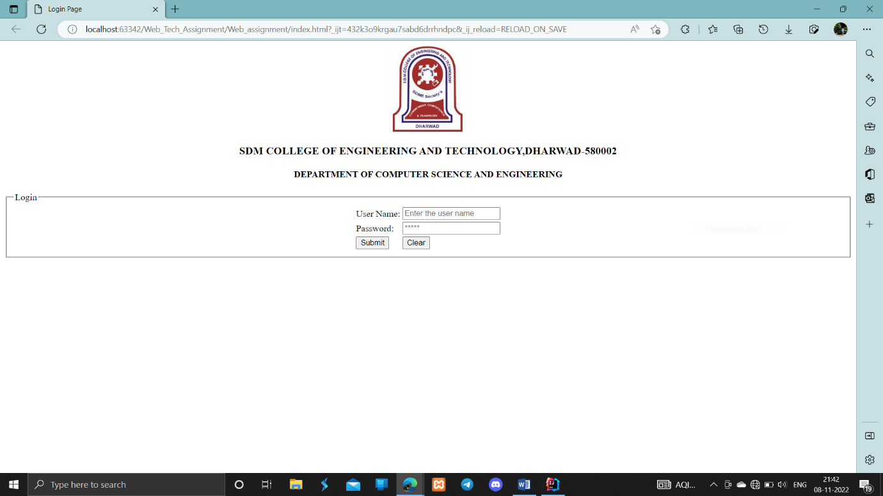

**Report:**

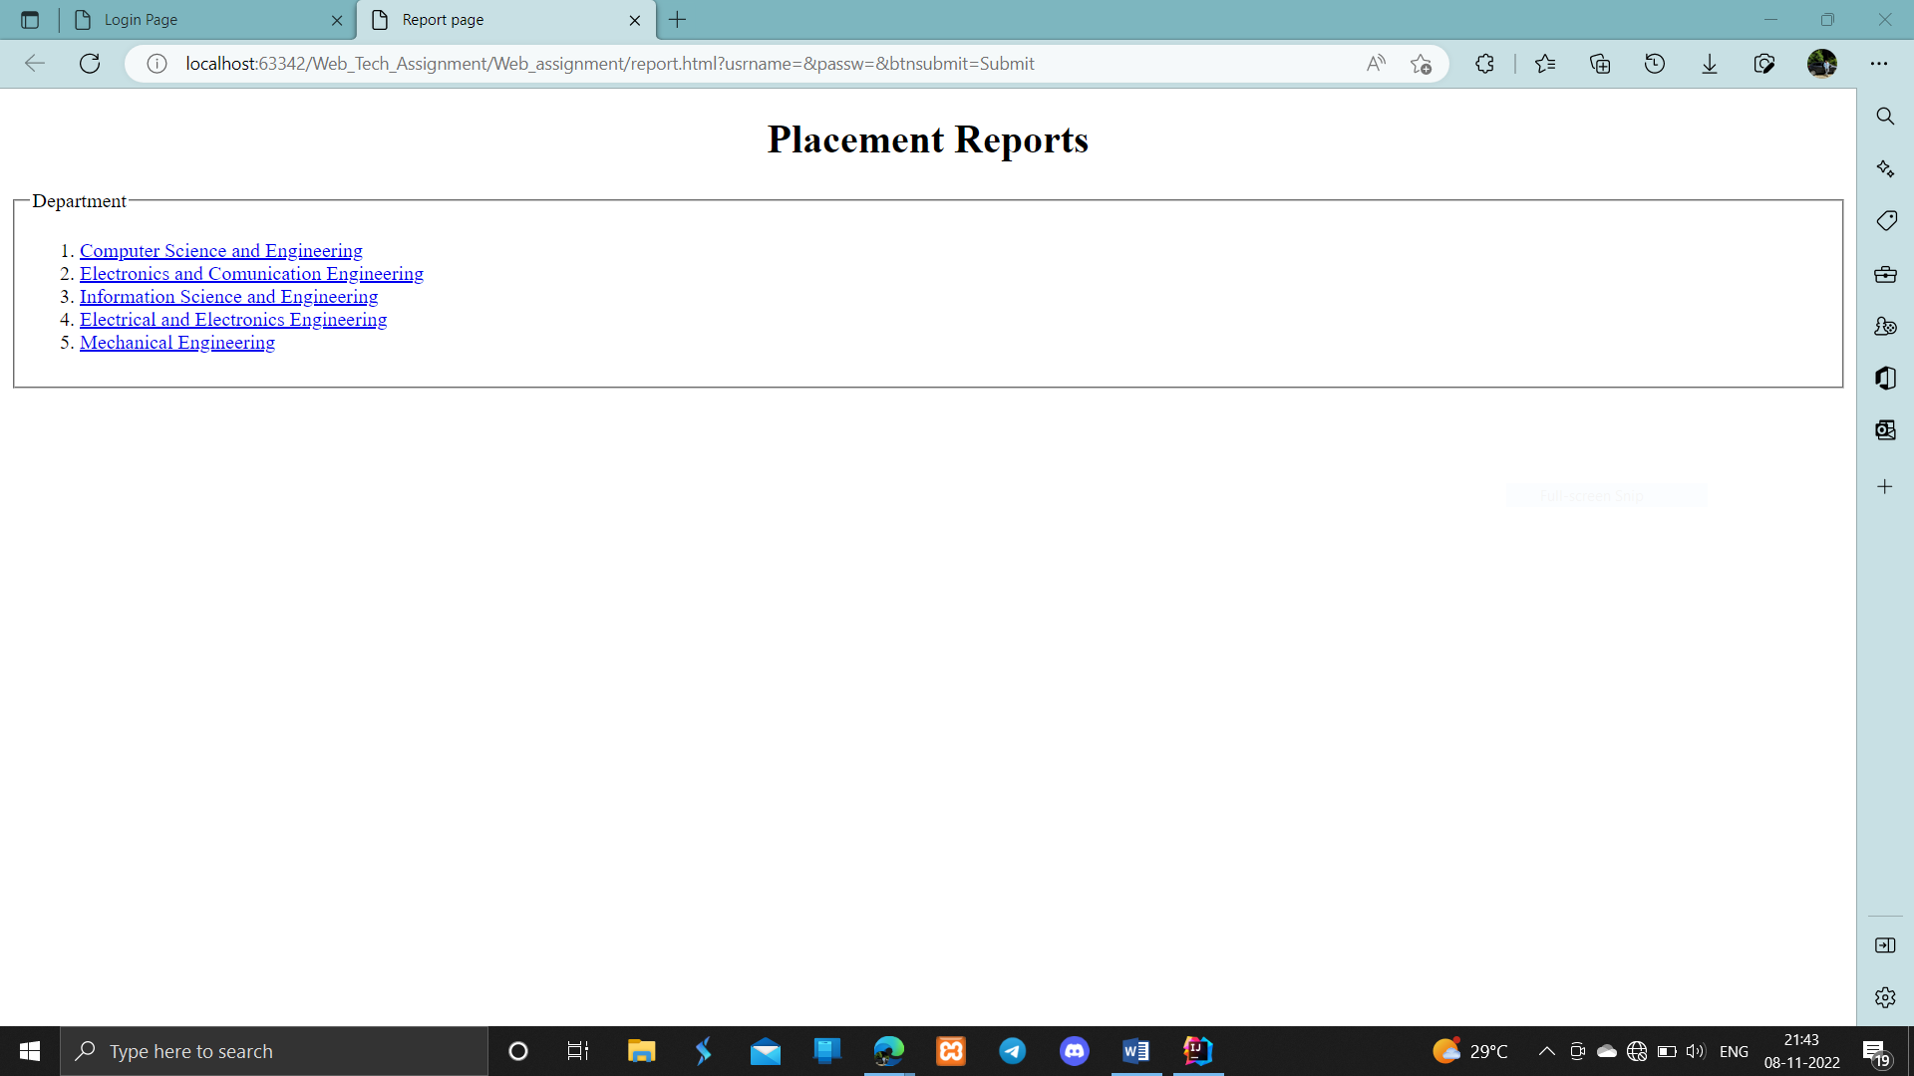**CSE:**

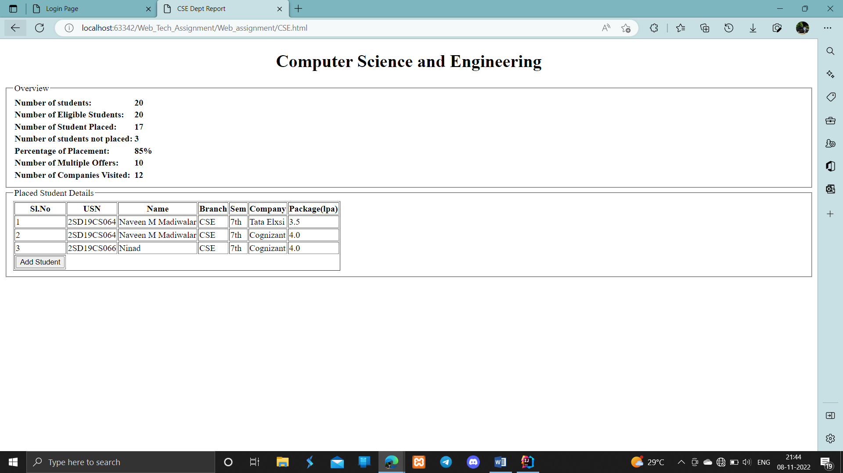

**ECE:**

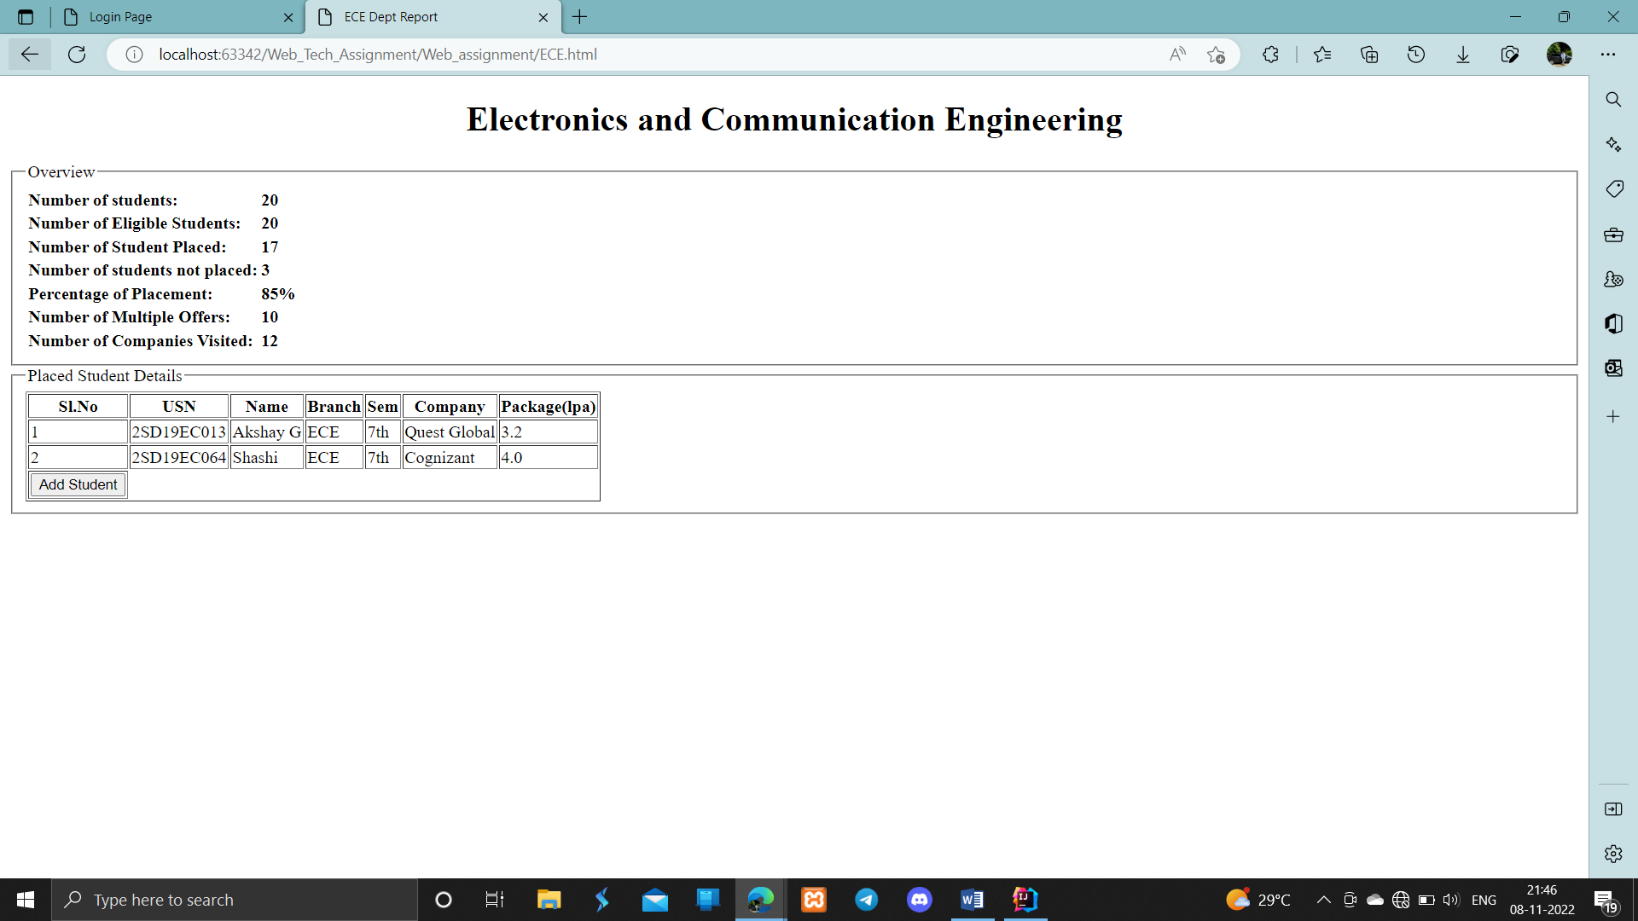

**ISE:**

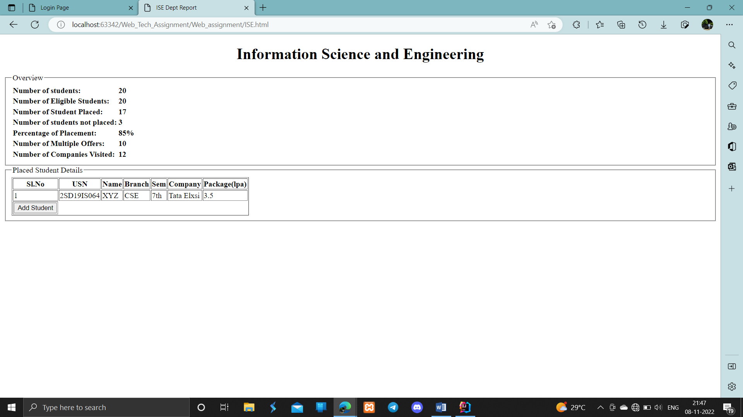

**EEE:**

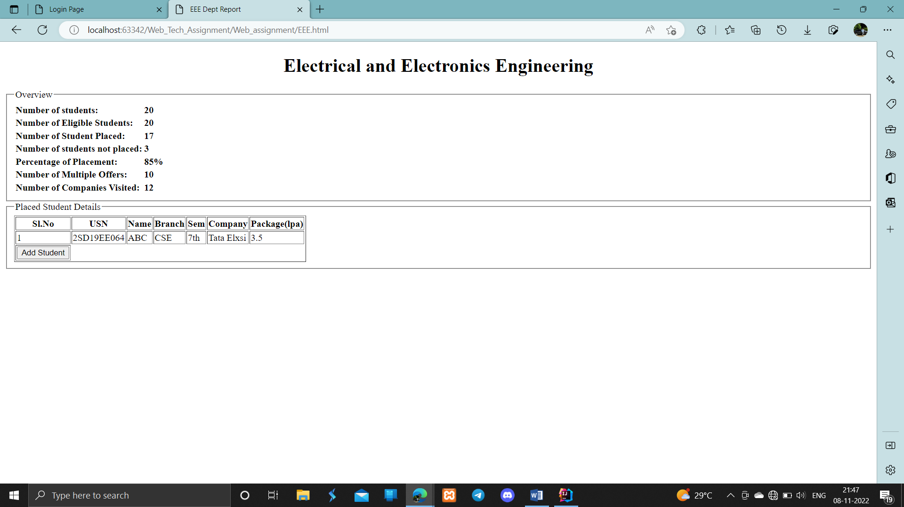

**MECH:**

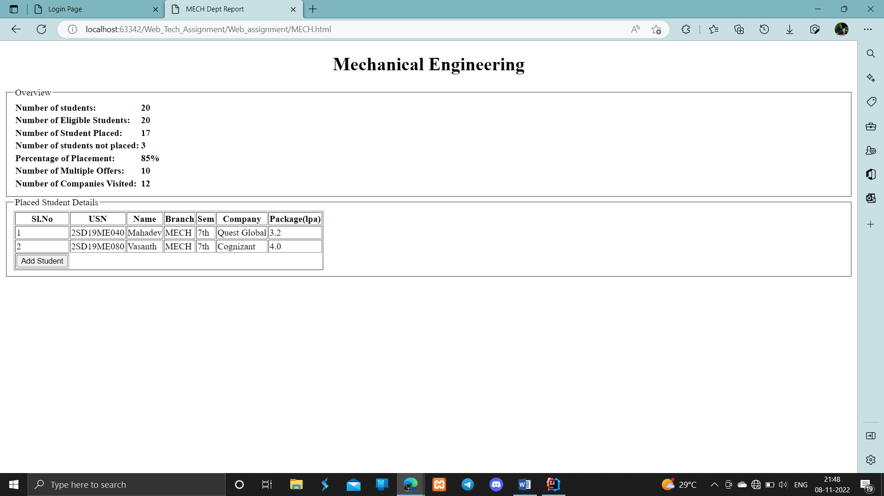

**Add Student:**

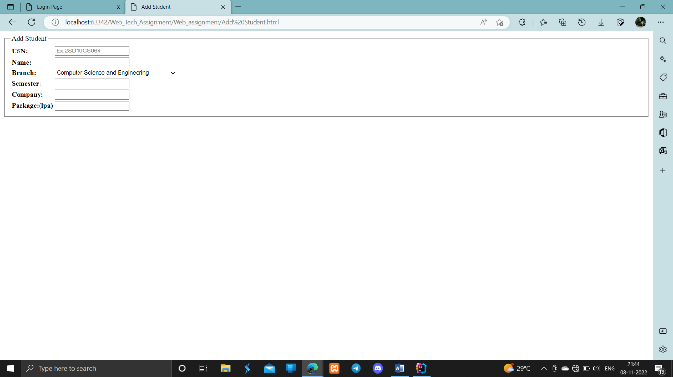

**Activity-2**

**(Implementation of CSS & JavaScript)**

1. **Problem statement**

Integration of CSS and JavaScript to activity-1

**Solution:**

**Login.html**

<!DOCTYPE html>

<html lang="en" >

<head>

  <meta charset="UTF-8">

  <title>Login Page</title>

  <link rel="stylesheet" href="login.css">

</head>

<body>

<div class="login-form">

    <h1>Login</h1>

    <div class="content">

      <div class="input-field">

        <input type="email" id="username" placeholder="Email" autocomplete="nope">

      </div>

      <div class="input-field">

        <input type="password" id="password" placeholder="Password" autocomplete="new-password">

      </div>

    </div>

    <div class="action">

      <button  onclick="login();">Submit</button>

      <button onclick="reset();">reset</button>

    </div>

</div>

</body>

<script src="login.js"></script>

</html>

**Login.css**

* {

    margin: 0;

    padding: 0;

    box-sizing: border-box;

    -webkit-font-smoothing: antialiased;

  }

  body {

    background: #e35869;

    font-family: 'Rubik', sans-serif;

  }

  .login-form {

    background: #fff;

    width: 500px;

    margin: 65px auto;

display: -webkit-box;

    display: flex;

    -webkit-box-orient: vertical;

    -webkit-box-direction: normal;

            flex-direction: column;

    border-radius: 4px;

    box-shadow: 0 2px 25px rgba(0, 0, 0, 0.2);

  }

  .login-form h1 {

    padding: 35px 35px 0 35px;

    font-weight: 300;

  }

  .login-form .content {

    padding: 35px;

    text-align: center;

  }

  .login-form .input-field {

    padding: 12px 5px;

  }

  .login-form .input-field input {

    font-size: 16px;

    display: block;

    font-family: 'Rubik', sans-serif;

    width: 100%;

    padding: 10px 1px;

    border: 0;

    border-bottom: 1px solid #747474;

    outline: none;

    -webkit-transition: all .2s;

    transition: all .2s;

  }

  .login-form .input-field input::-webkit-input-placeholder {

    text-transform: uppercase;

  }

  .login-form .input-field input::-moz-placeholder {

    text-transform: uppercase;

  }

  .login-form .input-field input:-ms-input-placeholder {

    text-transform: uppercase;

  }

  .login-form .input-field input::-ms-input-placeholder {

    text-transform: uppercase;

  }

  .login-form .input-field input::placeholder {

    text-transform: uppercase;

  }

  .login-form .input-field input:focus {

    border-color: #222;

  }

  .login-form a.link {

    text-decoration: none;

    color: #747474;

  letter-spacing: 0.2px;

    text-transform: uppercase;

    display: inline-block;

    margin-top: 20px;

  }

  .login-form .action {

    display: -webkit-box;

    display: flex;

    -webkit-box-orient: horizontal;

    -webkit-box-direction: normal;

            flex-direction: row;

  }

  .login-form .action button {

    width: 100%;

    border: none;

    padding: 18px;

    font-family: 'Rubik', sans-serif;

    cursor: pointer;

    text-transform: uppercase;

    background: #e8e9ec;

    color: #777;

    border-bottom-left-radius: 4px;

    border-bottom-right-radius: 0;

    letter-spacing: 0.2px;

    outline: 0;

    -webkit-transition: all .3s;

    transition: all .3s;

  }

  .login-form .action button:hover {

    background: #d8d8d8;

  }

  .login-form .action button:nth-child(2) {

    background: #2d3b55;

    color: #fff;

    border-bottom-left-radius: 0;

    border-bottom-right-radius: 4px;

  }

  .login-form .action button:nth-child(2):hover {

    background: #3c4d6d;

  }

**Style.css**

body{

        border-radius: 5px;

        background-color: #f2f2f2;

        padding: 20px;

}

table, th, tr, td{

  border: 1px solid #ddd;

  padding: 8px;

  border-collapse: collapse**;**

}

#nav tr:hover {

    background-color: #ddd;

}

.p1 tr:hover {

    background-color: #ddd;

}

th{

    padding-top: 12px;

  padding-bottom: 12px;

  text-align: left;

  background-color: #04AA6D;

  color: white;

}

nav{

width: 100%;

}

h1{

color: rgb(248, 69, 4);

}

button{

background-color: #4CAF50;

            color: white;

            padding: 10px 20px;

            margin: 8px 0;

            border: none;

            border-radius: 4px;

            cursor: pointer

}

button:hover {

    background-color: #45a049;

}

.a1 tr td{

    border: 1px solid #ddd;

    padding: 8px;

    border-collapse: collapse;

}

.a1 label{

    font-family: "Times New Roman", Times, serif;;

}

.a1 input[type=text], select {

    width: 100%;

    padding: 12px 20px;

    margin: 8px 0;

    display: inline-block;

    border: 1px solid #ccc;

    border-radius: 4px;

    box-sizing: border-box;

    }

.a1 button{

width: 33%;

    background-color: #4CAF50;

    color: white;

    padding: 14px 20px;

    margin: 8px 0;

    border: none;

    border-radius: 4px;

    cursor: pointer

    }

.a1 button:hover {

        background-color: #45a049;

    }

.a1 {

    border-radius: 5px;

    background-color: #f2f2f2;

    padding: 20px;

    }

**Report.html**

<!DOCTYPE html>

<html lang="en">

<head>

    <meta charset="UTF-8">

    <title>Report page</title>

    <style>

        body{

            background-image: url(header.jpg);

        }

        h1{

            margin-top: 200px;

            margin-left: 500px;

            font-size: 50px;

        }

        h2{

            margin-left: 600px;

        }

        .p1{

            margin-left: 500px;

            font-size: 25px;

        }

        legend{

            font-size: 30px;

            font-weight: bold;

        }

        a:link {

        color: black;

        text-decoration: none;

        }

        a:visited {

        color: green;

        text-decoration: none;

        }

        a:hover {

        color: blue;

        text-decoration: underline;

        }

        a:active {

        color: gray;

        text-decoration: underline;

        }

</style>

</head>

<body>

    <h1><b>Placement Reports</b></h1>

         <center>

        <h3>We are here to Build your Skills and Career with our Driven Passion and Reality.

            </h3>

   </center>

   <br>

<h2>Departments</h2>

<div class="p1">

        <ol>

            <li><a href="CSE.html" >Computer Science and Engineering</a></li>

            <li><a href="ECE.html">Electronics and Comunication Engineering</a> </li>

            <li><a href="ISE.html">Information Science and Engineering</a> </li>

            <li><a href="EEE.html">Electrical and Electronics Engineering</a> </li>

            <li><a href="MECH.html">Mechanical Engineering </a></li>

        </ol>

    </div>

</body>

</html>

**CSE.html**

<!DOCTYPE html>

<html lang="en">

<head>

    <meta charset="UTF-8">

    <title>CSE Dept Report</title>

    <link rel="stylesheet" href="style.css">

</head>

<body id="body">

    <center>

        <h1><b>Computer Science and Engineering</b></h1>

    </center>

        <legend><h3>Overview</h3></legend>

        <table class="p1" id="nav">

            <tr>

                <td><b>Number of students:</b></td>

                <td><b>20</b></td>

            </tr>

            <tr>

                <td><b>Number of Eligible Students:</b></td>

                <td><b>20</b></td>

            </tr>

            <tr>

                <td><b>Number of Student Placed:</b></td>

                <td><b>17</b></td>

            </tr>

            <tr>

                <td><b>Number of students not placed:</b></td>

                <td><b>3</b></td>

            </tr>

            <tr>

                <td><b>Percentage of Placement:</b></td>

                <td><b>85%</b></td>

            </tr>

            <tr>

                <td><b>Number of Multiple Offers:</b></td>

                <td><b>10</b></td>

            </tr>

            <tr>

                <td><b>Number of Companies Visited:</b></td>

                <td><b>12</b></td>

            </tr>

        </table>

        <hr>

        <legend><h3>Placed Student Details</h3></legend>

        <table class="p1" >

            <tr>

                <th><b>Sl.No</b></th>

                <th><b>USN</b></th>

                <th><b>Name</b></th>

                <th><b>Phone no</b></th>

                <th><b>Email</b></th>

                <th><b>Branch</b></th>

                <th><b>Sem</b></th>

                <th><b>Company</b></th>

                <th><b>Package(lpa)</b></th>

            </tr>

        <tbody id="tbody"> </tbody>

        </table>

        <br>

            <a href="Add%20Student.html"><button >Add Student</button></a>

            <button onclick="Delete();">Remove Student</button>

        </tr>

</body>

<script src="CSE.js">

</script>

</html>

ECE.html

<!DOCTYPE html>

<html lang="en">

  <head>

    <meta charset="UTF-8" />

    <title>ECE Dept Report</title>

    <link rel="stylesheet" href="style.css" />

  </head>

  <body>

    <center>

      <h1><b>Electronics and Communication Engineering</b></h1>

    </center>

<legend><h3>Overview</h3></legend>

    <table class="p1" id="nav">

      <tr>

        <td><b>Number of students:</b></td>

        <td><b>20</b></td>

      </tr>

      <tr>

        <td><b>Number of Eligible Students:</b></td>

        <td><b>20</b></td>

      </tr>

      <tr>

        <td><b>Number of Student Placed:</b></td>

        <td><b>17</b></td>

      </tr>

      <tr>

        <td><b>Number of students not placed:</b></td>

        <td><b>3</b></td>

      </tr>

      <tr>

        <td><b>Percentage of Placement:</b></td>

        <td><b>85%</b></td>

      </tr>

      <tr>

        <td><b>Number of Multiple Offers:</b></td>

        <td><b>10</b></td>

      </tr>

      <tr>

        <td><b>Number of Companies Visited:</b></td>

        <td><b>12</b></td>

      </tr>

    </table>

    <hr />

    <legend><h3>Placed Student Details</h3></legend>

    <table class="p1">

      <tr>

        <th><b>Sl.No</b></th>

        <th><b>USN</b></th>

        <th><b>Name</b></th>

        <th><b>Phone no</b></th>

        <th><b>Email</b></th>

        <th><b>Branch</b></th>

        <th><b>Sem</b></th>

        <th><b>Company</b></th>

        <th><b>Package(lpa)</b></th>

      </tr>

      <tbody id="tbody"></tbody>

    </table>

    <br />

    <a href="Add%20Student.html"><button>Add Student</button></a>

    <button onclick="Delete();">Remove Student</button>

  </body>

  <script src="ECE.js"></script>

</html**>**

**EEE.html**

<!DOCTYPE html>

<html lang="en">

<head>

    <meta charset="UTF-8">

    <title>EEE Dept Report</title>

    <link rel="stylesheet" href="style.css">

</head>

<body>

<center>

    <h1><b>Electrical and Electronics Engineering</b></h1>

</center>

<legend><h3>Overview</h3></legend>

    <table class="p1" id="nav">

        <tr>

            <td><b>Number of students:</b></td>

            <td><b>20</b></td>

        </tr>

        <tr>

            <td><b>Number of Eligible Students:</b></td>

            <td><b>20</b></td>

        </tr>

        <tr>

            <td><b>Number of Student Placed:</b></td>

            <td><b>17</b></td>

        </tr>

        <tr>

            <td><b>Number of students not placed:</b></td>

            <td><b>3</b></td>

        </tr>

        <tr>

            <td><b>Percentage of Placement:</b></td>

            <td><b>85%</b></td>

        </tr>

        <tr>

            <td><b>Number of Multiple Offers:</b></td>

            <td><b>10</b></td>

        </tr>

        <tr>

            <td><b>Number of Companies Visited:</b></td>

            <td><b>12</b></td>

        </tr>

    </table>

    <hr>

    <legend><h3>Placed Student Details</h3></legend>

    <table class="p1">

        <tr>

            <th><b>Sl.No</b></th>

            <th><b>USN</b></th>

            <th><b>Name</b></th>

            <th><b>Phone no</b></th>

            <th><b>Email</b></th>

            <th><b>Branch</b></th>

            <th><b>Sem</b></th>

            <th><b>Company</b></th>

            <th><b>Package(lpa)</b></th>

        </tr>

        <tbody id="tbody"> </tbody>

    </table>

    <br>

         <a href="Add%20Student.html"><button >Add Student</button></a>

         <button onclick="Delete();">Remove Student</button>

</body>

<script src="EEE.js">

</script>

</html>

**ISE.html**

<!DOCTYPE html>

<html lang="en">

<head>

    <meta charset="UTF-8">

    <title>ISE Dept Report</title>

    <link rel="stylesheet" href="style.css">

</head>

<body>

<center>

    <h1><b>Information Science and Engineering</b></h1>

</center>

    <legend><h3>Overview</h3></legend>

    <table class="p1" id="nav">

        <tr>

            <td><b>Number of students:</b></td>

            <td><b>20</b></td>

        </tr>

        <tr>

            <td><b>Number of Eligible Students:</b></td>

            <td><b>20</b></td>

        </tr>

        <tr>

            <td><b>Number of Student Placed:</b></td>

            <td><b>17</b></td>

        </tr>

        <tr>

            <td><b>Number of students not placed:</b></td>

            <td><b>3</b></td>

        </tr>

        <tr>

            <td><b>Percentage of Placement:</b></td>

            <td><b>85%</b></td>

        </tr>

        <tr>

            <td><b>Number of Multiple Offers:</b></td>

            <td><b>10</b></td>

        </tr>

        <tr>

            <td><b>Number of Companies Visited:</b></td>

            <td><b>12</b></td>

        </tr>

    </table>

    <hr>

    <legend><h3>Placed Student Details</h3></legend>

    <table class="p1">

        <tr>

            <th><b>Sl.No</b></th>

            <th><b>USN</b></th>

            <th><b>Name</b></th>

            <th><b>Phone no</b></th>

            <th><b>Email</b></th>

            <th><b>Branch</b></th>

            <th><b>Sem</b></th>

            <th><b>Company</b></th>

            <th><b>Package(lpa)</b></th>

        </tr>

        <tbody id="tbody">

</tbody>

    </table>

    <br>

         <a href="Add%20Student.html"><button >Add Student</button></a>

            <button onclick="Delete();">Remove Student</button>

</body>

<script src="ISE.js">

</script>

</html>

**MECH.html**

<!DOCTYPE html>

<html lang="en">

<head>

    <meta charset="UTF-8">

    <title>MECH Dept Report</title>

    <link rel="stylesheet" href="style.css">

</head>

<body>

<center>

    <h1><b>Mechanical Engineering</b></h1>

</center>

    <legend><h3>Overview</h3></legend>

    <table class="p1" id="nav">

        <tr>

            <td><b>Number of students:</b></td>

            <td><b>20</b></td>

        </tr>

        <tr>

            <td><b>Number of Eligible Students:</b></td>

            <td><b>20</b></td>

        </tr>

        <tr>

            <td><b>Number of Student Placed:</b></td>

            <td><b>17</b></td>

        </tr>

        <tr>

            <td><b>Number of students not placed:</b></td>

            <td><b>3</b></td>

        </tr>

        <tr>

            <td><b>Percentage of Placement:</b></td>

            <td><b>85%</b></td>

        </tr>

        <tr>

            <td><b>Number of Multiple Offers:</b></td>

            <td><b>10</b></td>

        </tr>

        <tr>

            <td><b>Number of Companies Visited:</b></td>

            <td><b>12</b></td>

        </tr>

    </table>

    <hr>

    <legend><h3>Placed Student Details</h3></legend>

    <table class="p1">

        <tr>

            <th><b>Sl.No</b></th>

            <th><b>USN</b></th>

            <th><b>Name</b></th>

            <th><b>Phone no</b></th>

            <th><b>Email</b></th>

            <th><b>Branch</b></th>

            <th><b>Sem</b></th>

            <th><b>Company</b></th>

            <th><b>Package(lpa)</b></th>

        </tr>

        <tbody id="tbody">

  </tbody>

</table>

    <br>

         <a href="Add%20Student.html"><button >Add Student</button></a>

         <button onclick="Delete();">Remove Student</button>

</body>

<script src="MECH.js">

</script>

</html>

**addstd.html**

<!DOCTYPE html>

<html lang="en">

<head>

    <meta charset="UTF-8">

    <title>Add Student</title>

    <link rel="stylesheet" href="style.css">

</head>

<body>

    <div class="a1">

    <center>

            <div>

                <legend><h1>Add Student</h1></legend>

            <table>

                <tr>

                    <td><label><b>USN:</b></label></td>

                    <td>

                        <input type="text" name="stdusn" id="stdusn" placeholder="Ex:2SD19CS064">

                    </td>

                </tr>

                <tr>

                    <td>

                        <label><b>Name:</b></label>

                    </td>

                    <td>

                        <input type="text" name="stdname" id="stdname">

                    </td>

                </tr>

                <tr>

                    <td>

                        <label><b>Phone No:</b></label>

                    </td>

                    <td>

                        <input type="text" name="phno" id="phno">

                    </td>

                </tr>

                <tr>

                    <td>

                        <label><b>Email:</b></label>

                    </td>

                    <td>

                        <input type="text" name="email" id="email">

                    </td>

                </tr>

                <tr>

                    <td><label><b>Branch:</b></label></td>

                    <td>

                        <select id="branch">

                            <option value="cse">Computer Science and Engineering</option>

                            <option value="ise">Information Science and Engineering</option>

                            <option value="eee">Electrical and Electronics Engimeering</option>

                            <option value="ece">Electronic and Communication Engineering</option>

                            <option value="mech">Mechanical Engineering</option>

                        </select>

                    </td>

                </tr>

                <tr>

                    <td><b><label>Semester:</label></b></td>

                    <td><input type="text" name="sem" id="sem"></td>

                </tr>

                <tr>

                    <td><b><label>Company:</label></b></td>

                    <td><input type="text" name="cmp" id="cmp"></td>

                </tr>

                <tr>

                    <td><b><label>Package:(lpa)</label></b></td>

                    <td><input type="text" name="pkg" id="pkg"></td>

                </tr>

            </table><br>

            <button onclick="addStd();">Submit</button>

            </div>

    </center>

</div>

</body>

<script src="addstd.js">

</script>

</html>

**update.css**

<!DOCTYPE html>

<html lang="en">

<head>

    <meta charset="UTF-8">

    <title>Update Student</title>

    <link rel="stylesheet" href="style.css">

</head>

<body>

    <div class="a1">

    <center>

            <div>

                <legend><h1>Update Student</h1></legend>

            <table>

                <tr>

                    <td><label><b>USN:</b></label></td>

                    <td>

                        <input type="text" name="stdusn" id="stdusn" placeholder="Ex:2SD19CS064" disabled>

                    </td>

                </tr>

                <tr>

                    <td>

                      <label><b>Name:</b></label>

                    </td>

                    <td>

                        <input type="text" name="stdname" id="stdname">

                    </td>

                </tr>

                <tr>

                    <td>

                        <label><b>Phone No:</b></label>

                    </td>

                    <td>

                        <input type="text" name="phno" id="phno">

                    </td>

                </tr>

                <tr>

                    <td>

                        <label><b>Email:</b></label>

                    </td>

                    <td>

                        <input type="text" name="email" id="email">

                    </td>

                </tr>

                <tr>

                    <td><label><b>Branch:</b></label></td>

                    <td>

                        <select id="branch" disabled>

                            <option value="cse">Computer Science and Engineering</option>

                            <option value="ise">Information Science and Engineering</option>

                            <option value="eee">Electrical and Electronics Engimeering</option>

                            <option value="ece">Electronic and Communication Engineering</option>

                            <option value="mech">Mechanical Engineering</option>

                        </select>

                    </td>

                </tr>

                <tr>

                    <td><b><label>Semester:</label></b></td>

                    <td><input type="text" name="sem" id="sem"></td>

                </tr>

                <tr>

                    <td><b><label>Company:</label></b></td>

                    <td><input type="text" name="cmp" id="cmp" disabled></td>

                </tr>

                <tr>

                    <td><b><label>Package:(lpa)</label></b></td>

                    <td><input type="text" name="pkg" id="pkg"></td>

                </tr>

            </table><br>

            <button onclick="addStd();">Submit</button>

            </div>

    </center>

</div>

</body>

<script src="update.js">

</script>

</html>

**Results:**

**Login:**

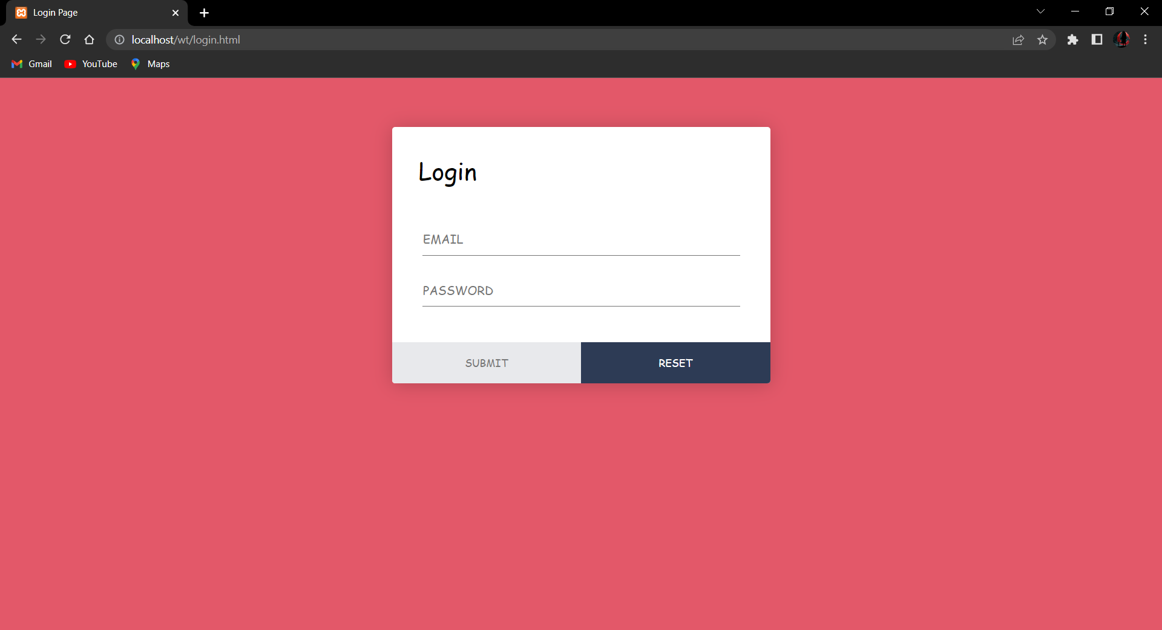

**Report:**



**CSE:**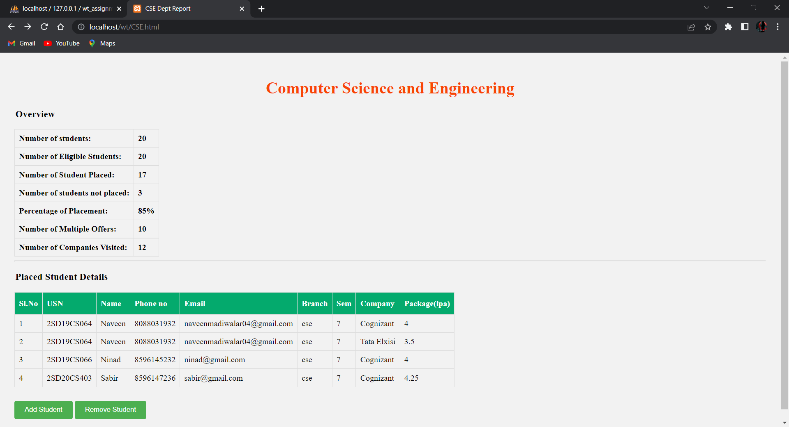

**ECE:**

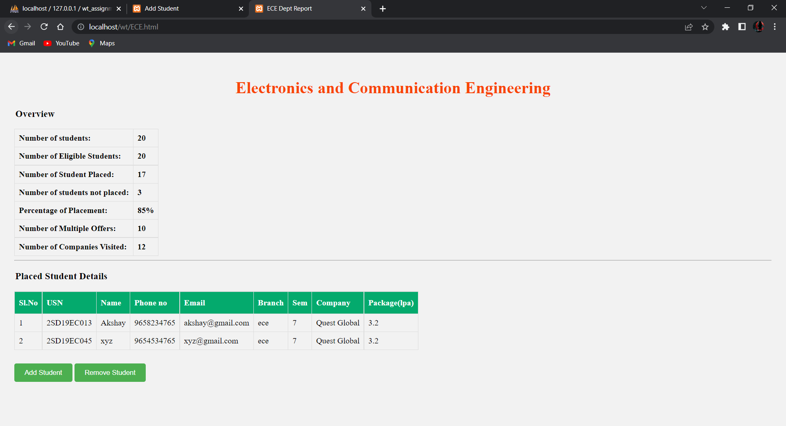

**EEE:**

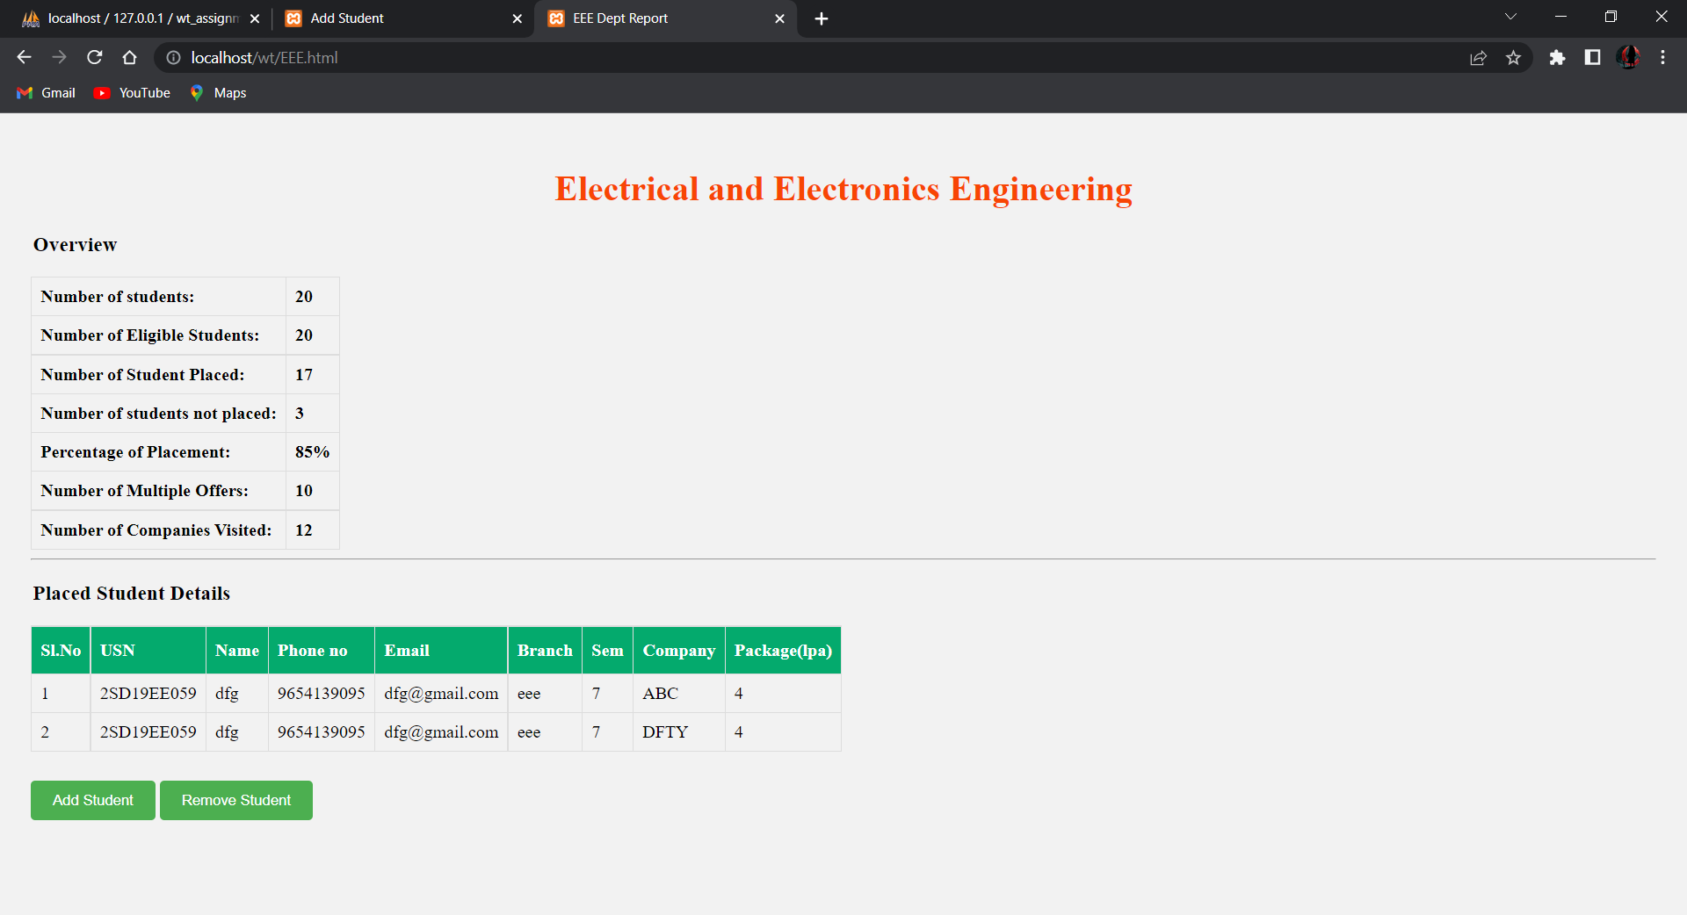

**ISE:**

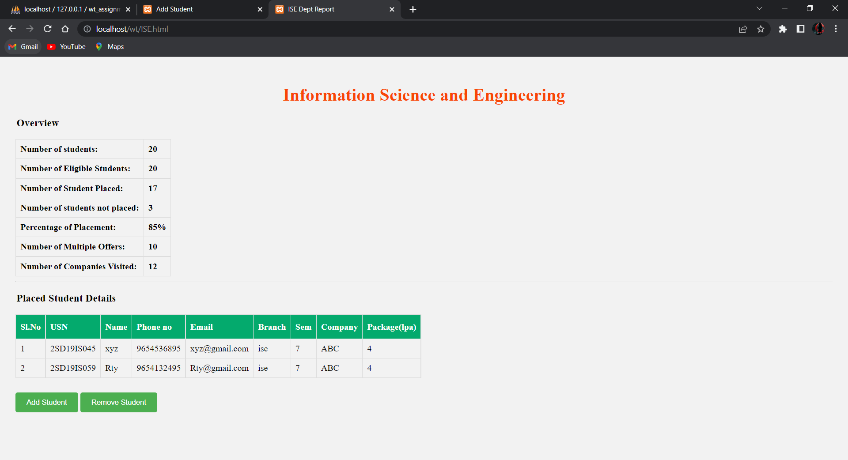

**Addstd:**

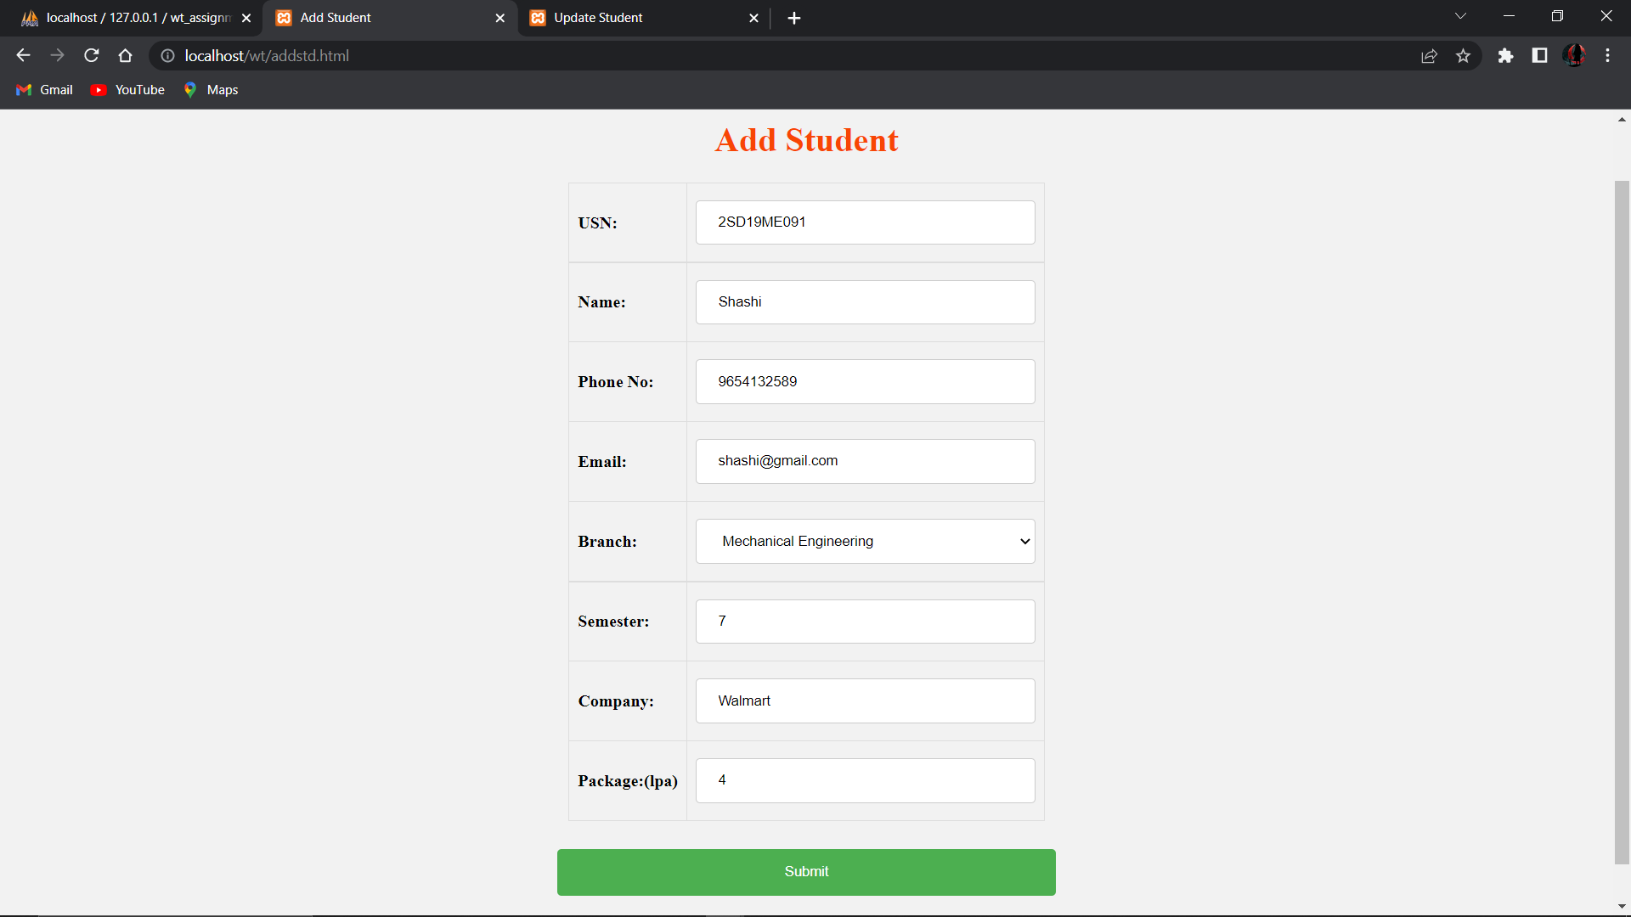

**Update:**

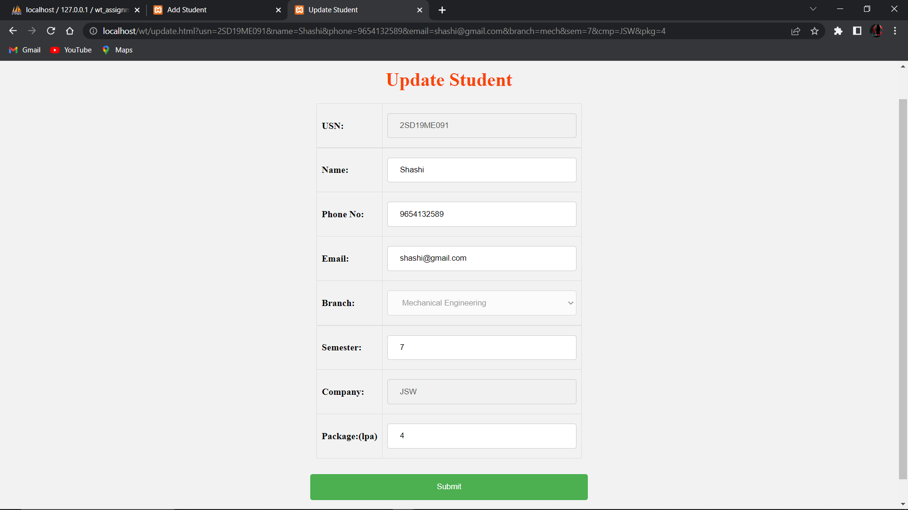

**MECH:**

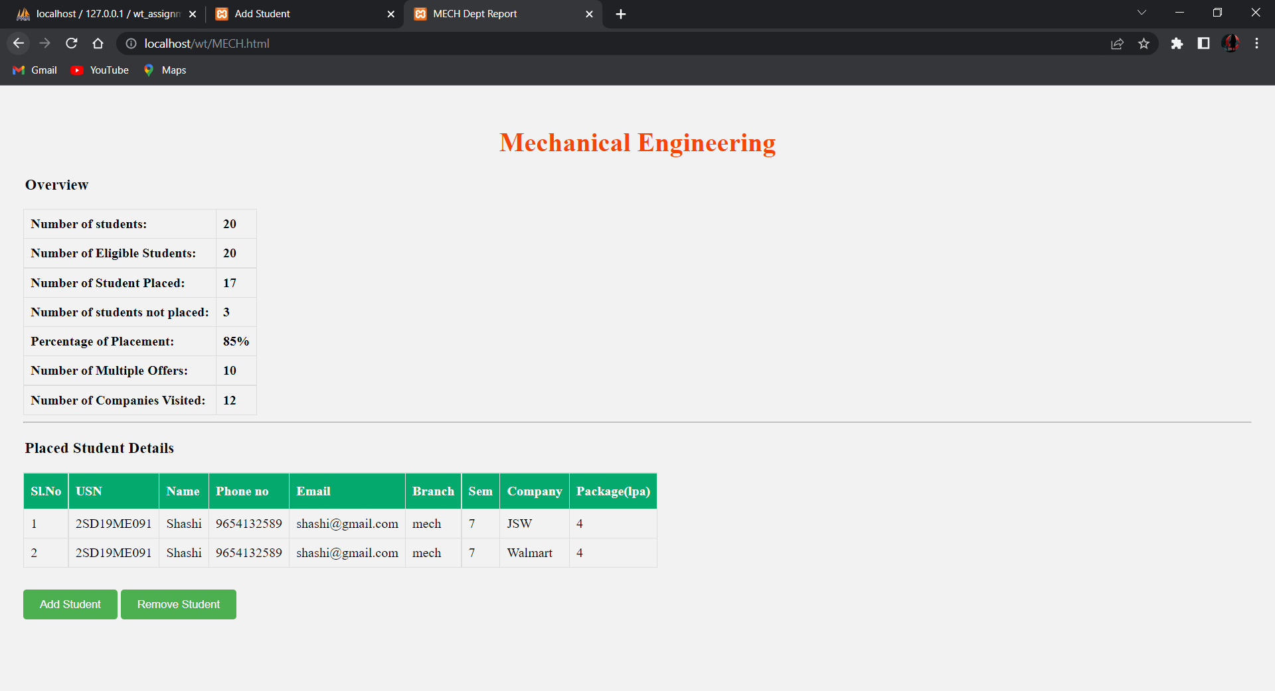

**Delete std:**

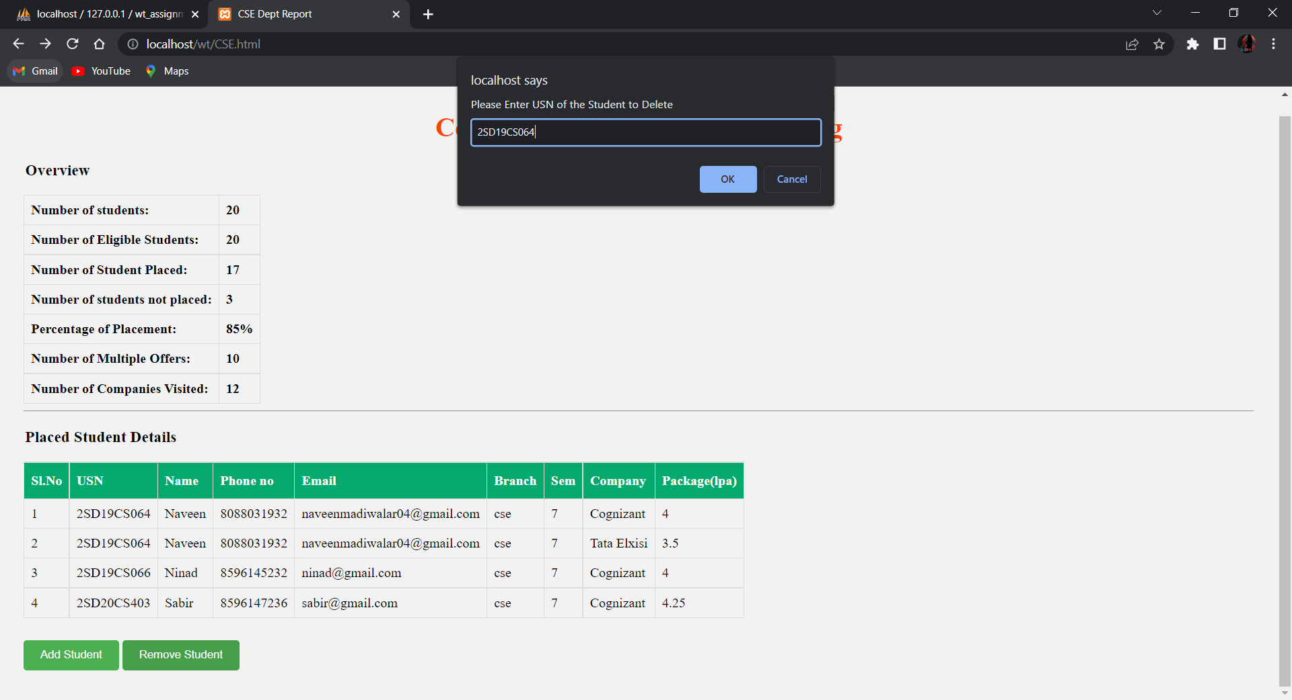

**Activity-III**

1. **Problem statement**

Integration of business logic using PHP, and MySQL to activity-1 & 2.

**Solution:**

**Login.php**

<?php

    $requestData = file_get_contents("php://input");

    $data = json_decode($requestData,true);

    $query = "SELECT * FROM `login` WHERE `username` = '".$data["user"]."';";

    try{

        $connection = mysqli_connect('localhost','root','','wt_assignment');

        $exequery = mysqli_query($connection,  $query);

        $row = mysqli_fetch_assoc($exequery);

        if($row == null){

            print("false");

        }else{

            if($row["username"] == $data["user"] && $row["password"] == $data["password"]){

                print(json_encode(array("status"=>"true","error"=>"false","location"=>"report.html")));

            }else{

                print(json_encode(array("status"=>"false","Message"=>"Please Enter Valid Data","error"=>"false")));

            }

        }

    }

    catch(Exception $e){

        print(json_encode(array("error"=>"true","Message"=>"Something went Wrong...!")));

    }

?>

**addstd.php**

<?php

    $requestData = file_get_contents("php://input");

$data = json_decode($requestData,true);

$tag = array(

        'stdusn',

        'stdname',

        'phno',

        'email',

        'branch',

        'sem',

        'cmp',

        'pkg'

    );

    $connection = mysqli_connect('localhost','root','','wt_assignment');

    $query = "INSERT INTO `"

    .$data['branch']."` (`USN`, `Name`, `Phone no`, `Email`, `Branch`, `Semester`, `Company`, `Package`) VALUES ('"

    .$data['stdusn']."', '".$data['stdname']."', '".$data['phno']."', '"

    .$data['email']."', '".$data['branch']."', '".$data['sem']."', '"

    .$data['cmp']."', '".$data['pkg']."');";

    $exequery = mysqli_query($connection,  $query) or die("Data Doesn't Exist");

    if($exequery >= 1){

        print("Data Added in ".$data["branch"]." Successfully");

    }else{

        print("Something went wrong........!");

    }

?>

**display.php**

<?php

    $table = $_GET["name"];

    $connection = mysqli_connect('localhost','root','','wt_assignment');

    $exequery = mysqli_query($connection, "SELECT * FROM `$table`");

    $jarray = array();

    while ($row = mysqli_fetch_assoc($exequery)){

        $jarray[] = $row;

    }

    print(json_encode($jarray))

?>

**delete.php**

<?php

    $requestData = file_get_contents("php://input");

    $data = json_decode($requestData,true);

    $query = "DELETE FROM `".$data["table"]."` WHERE `USN` = '".$data["usn"]."' and `Company` = '".$data["cmp"]."';";

    $connection = mysqli_connect('localhost','root','','wt_assignment');

    $exequery = mysqli_query($connection,  $query) or die("Data Doesn't Exist");

    if($exequery >= 1){

        print("Data Deleted Successfully");

    }else{

        print("Something went wrong........!");

    }

?>

**update.php**

<?php

    $requestData = file_get_contents("php://input");

    $data = json_decode($requestData,true);

    $tag = array(

        'stdname',

        'phno',

        'email',

        'sem',

        'pkg'

    );

    $tags = array( "Name", "Phone no", "Email", "Semester", "Package");

    $connection = mysqli_connect('localhost','root','','wt_assignment');

    $query = "UPDATE `".$data['branch']."` SET ";

    for($i=0;$i<count($tag);$i++){

        if($i+1 == count($tag)){

            $query.= "`".$tags[$i]."`='".$data[$tag[$i]]."' ";

        }else{

            $query.= "`".$tags[$i]."`='".$data[$tag[$i]]."', ";

        }

    }

    $query.="WHERE `USN` = '".$data['stdusn']."' AND `Company` = '".$data['cmp']."';";

    $exequery = mysqli_query($connection,  $query) or die("Data Doesn't Exist");

    if($exequery >= 1){

        print("Data Updated in ".$data["branch"]." Successfully");

    }else{

        print("Something went wrong........!");

    }

?>

**Result Screenshots:**

**Login DB:**

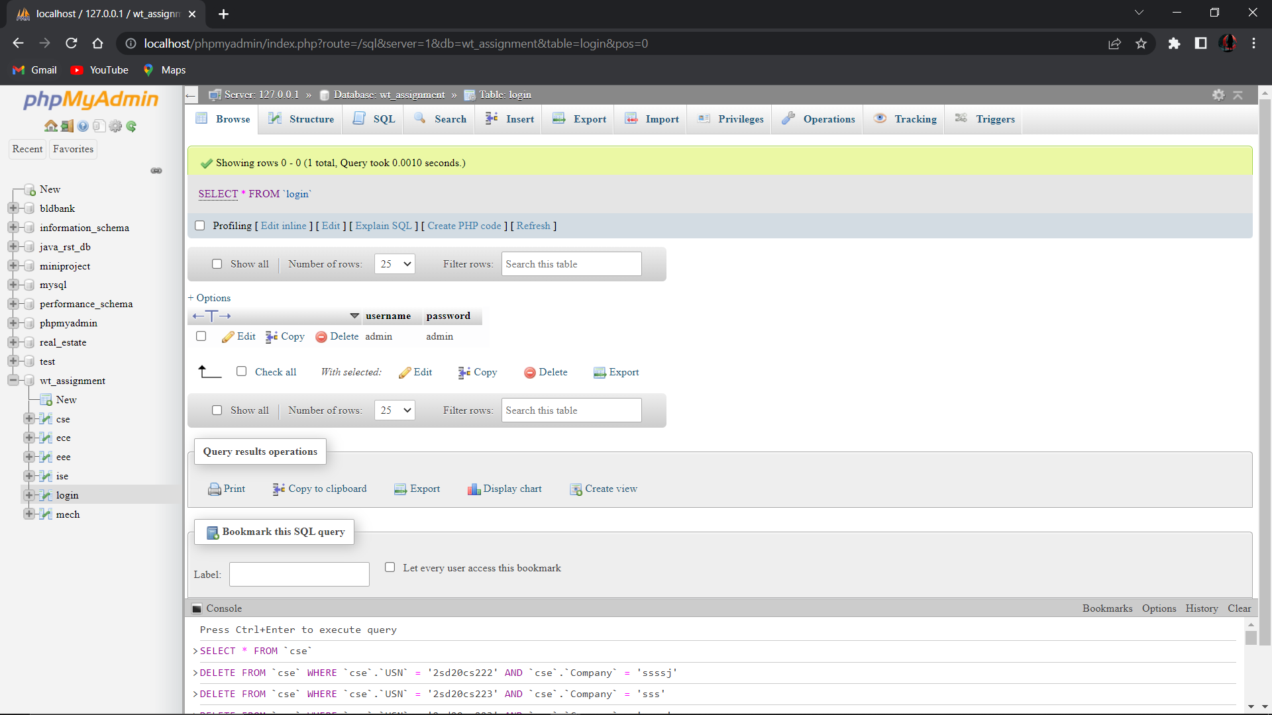

**CSE DB:**

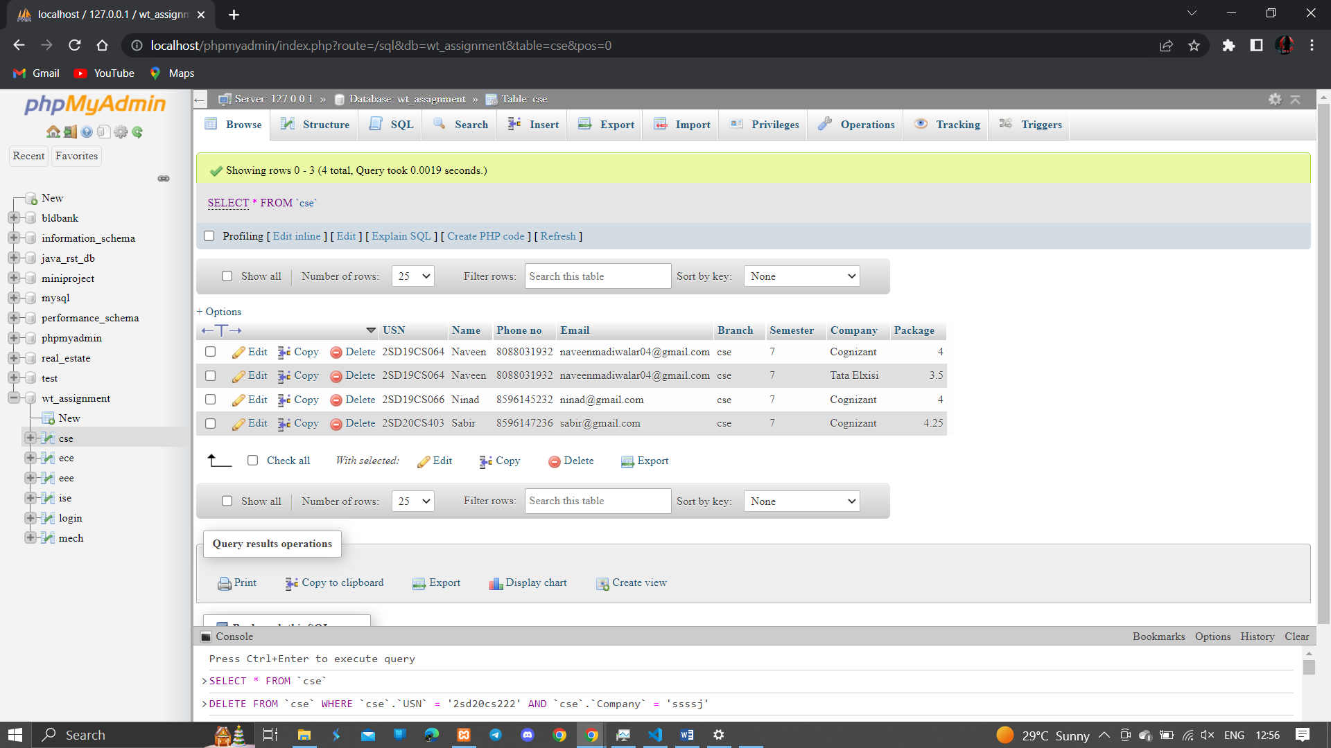

**ECE DB:**

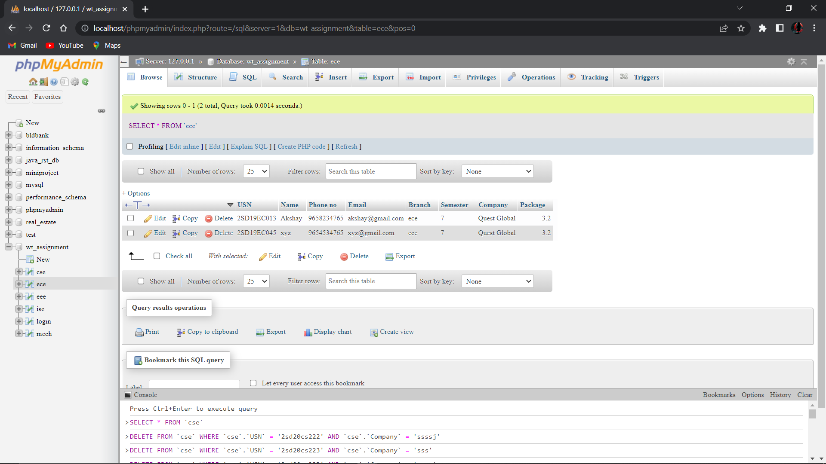

**EEE DB:**

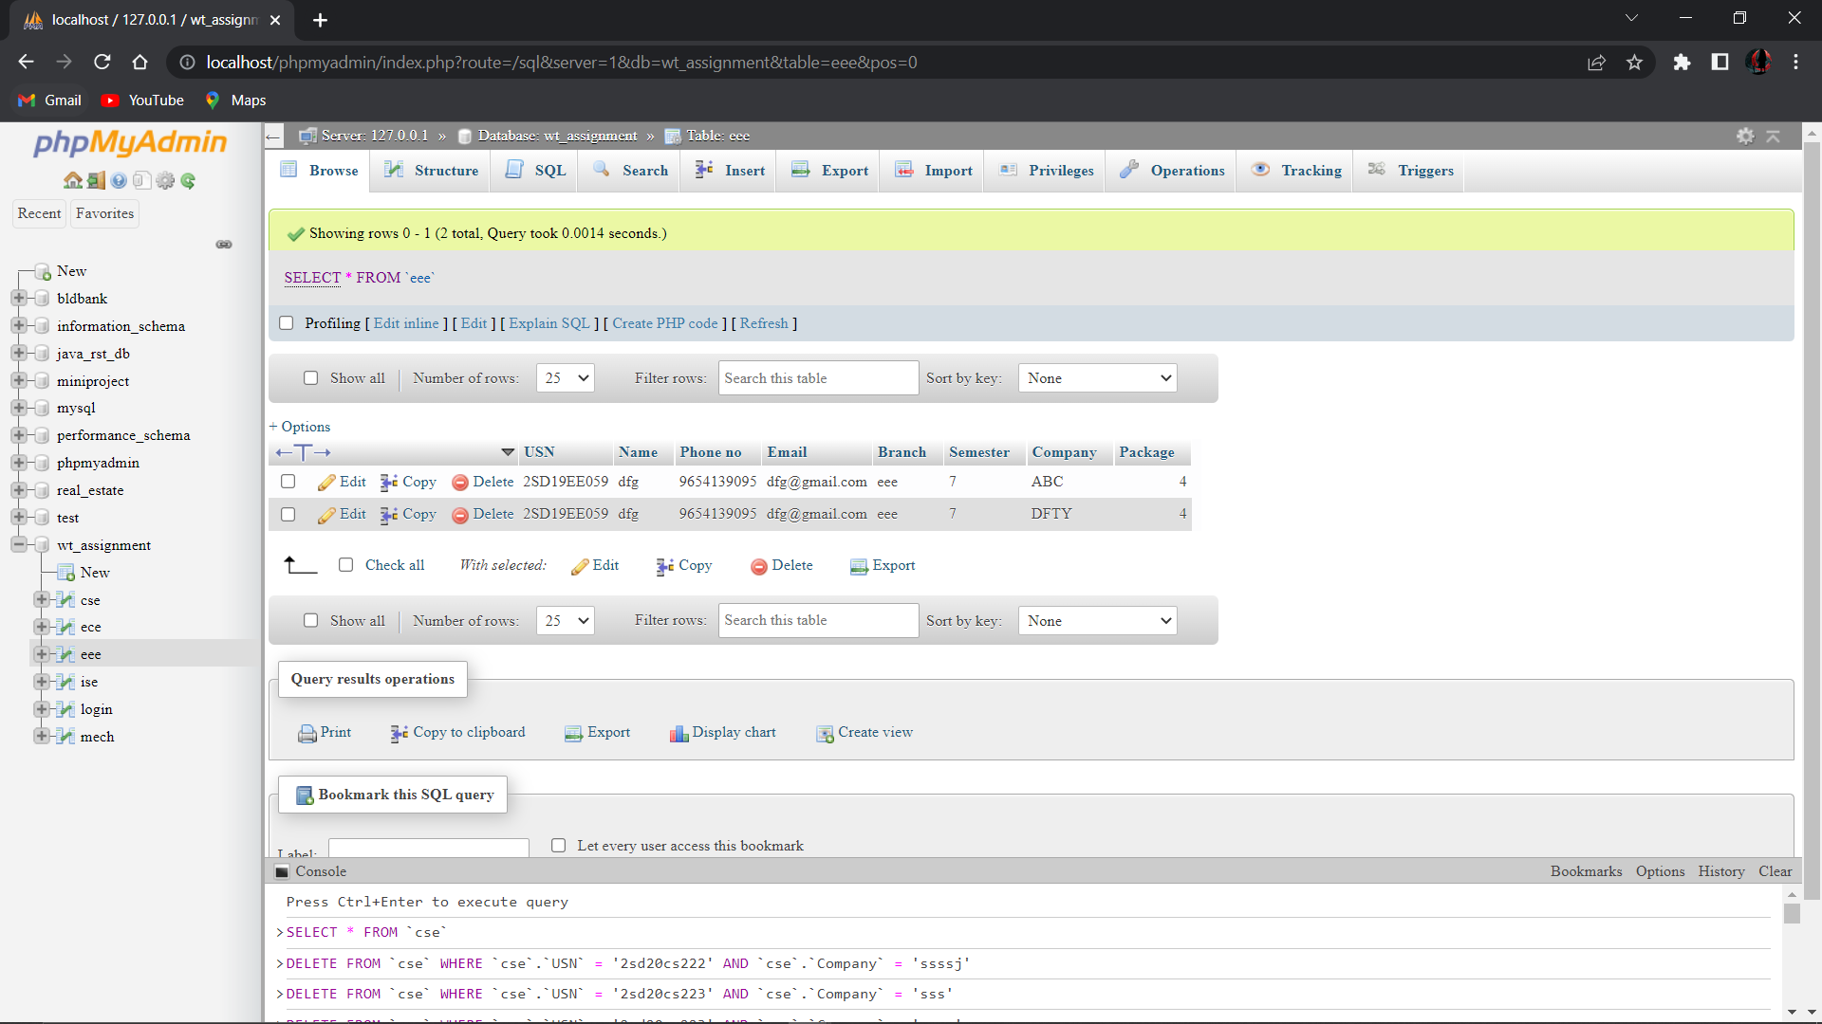

**ISE DB:**

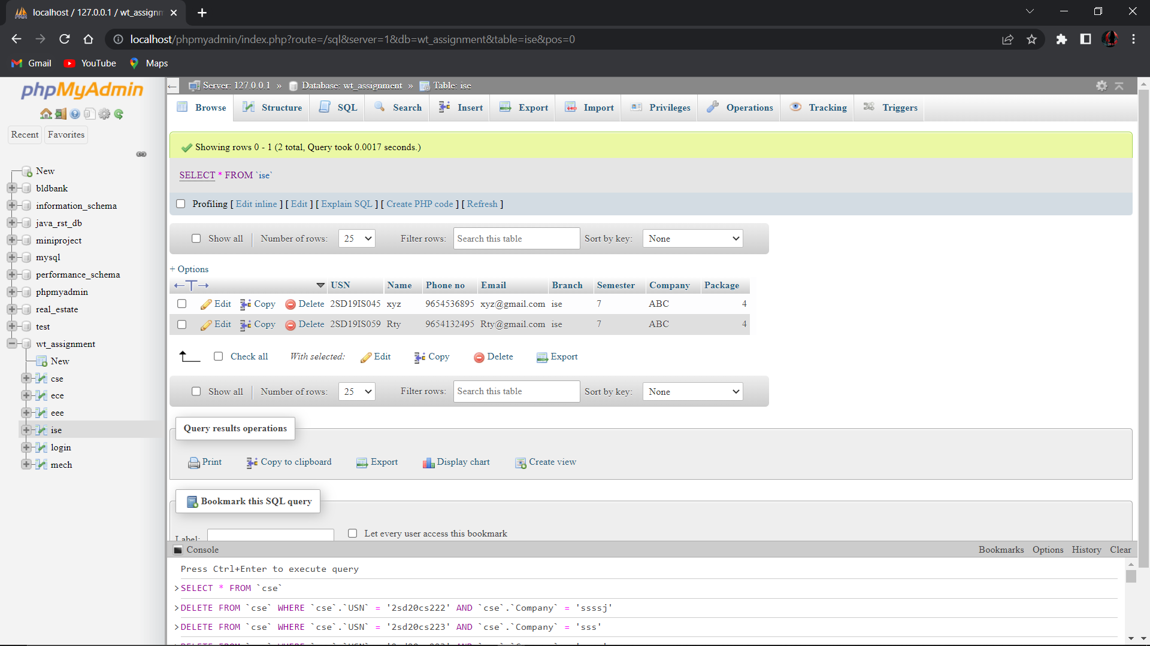

**MECH DB:**

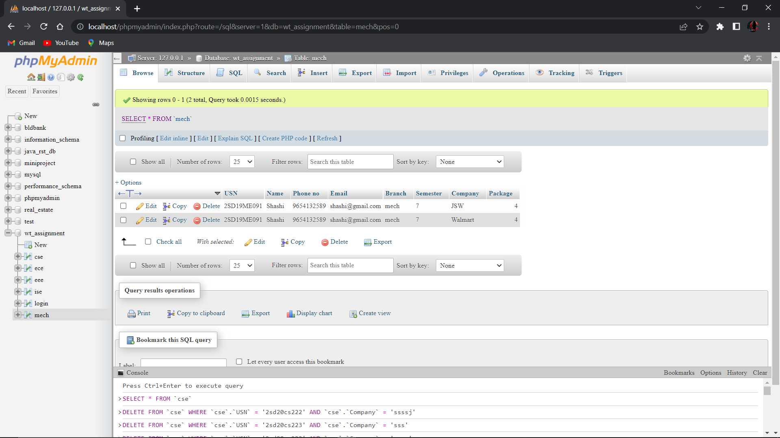

**Activity-IV**

**1.Problem statement**

Integration of AJAX to the activities -1, 2, 3.

**Solution:**

**Login.js**

function login() {

    let usr = document.getElementById("username").value;

    let psw = document.getElementById("password").value;

    if(usr.length == 0 || usr == null || psw.length == 0 || psw == null ){

        alert("Please enter Data...!");

        return;

    }

    var xhttp = new XMLHttpRequest();

      xhttp.onreadystatechange = function () {

        if (this.readyState == 4 && this.status == 200) {

          console.log(this.responseText);

          let dt = JSON.parse(this.responseText);

          if(dt.error == "true"){

            alert(dt.Message);

          }else{

            if(dt.status == "false"){

              alert(dt.Message);

            }else{

              location.href = dt.location;

            }

          }

        }

      };

      xhttp.open("POST", "login.php");

      xhttp.setRequestHeader("Content-Type", "application/json");

      xhttp.send(JSON.stringify({"user" : usr, "password" : psw}));

}

function reset(){

    location.reload();

}

**CSE.js**

document.getElementById("body").onload = () => {

    var place = document.getElementById("tbody");

    var tag = ["USN", "Name", "Phone no", "Email", "Branch", "Semester", "Company", "Package"];

    let counter = 1;

    var place = document.getElementById("tbody");

    var xhttp = new XMLHttpRequest();

    xhttp.onreadystatechange = function () {

        if (this.readyState == 4 && this.status == 200) {

            for (let item of JSON.parse(this.responseText)) {

                let row = document.createElement("tr");

                row.setAttribute('id',counter);

                row.setAttribute('onclick','rowChange(this)');

                // row.addEventListener('click',rowChange(counter));

                let count = document.createElement("td");

                count.innerText = counter;

                row.appendChild(count);

                for (let x of tag) {

                    let td = document.createElement("td");

                    td.innerText = item[x];

                    row.appendChild(td);

                }

counter++;

            }

        }

    };

    xhttp.open("GET", "display.php?name=cse", true);

    xhttp.send();

}

function rowChange(node){

    location.href = "update.html?usn="+node.childNodes[1].childNodes[0].nodeValue

    +"&name="+node.childNodes[2].childNodes[0].nodeValue

    +"&phone="+node.childNodes[3].childNodes[0].nodeValue

    +"&email="+node.childNodes[4].childNodes[0].nodeValue

    +"&branch="+node.childNodes[5].childNodes[0].nodeValue

    +"&sem="+node.childNodes[6].childNodes[0].nodeValue

    +"&cmp="+node.childNodes[7].childNodes[0].nodeValue

    +"&pkg="+node.childNodes[8].childNodes[0].nodeValue;

    ;

}

function Delete() {

    var usn = prompt("Please Enter USN of the Student to Delete", "0");

    var cmp = prompt("Please Enter Company of the Student to Delete", "xyz");

    if (usn != null && cmp != null) {

        var cn = confirm("Are you confirm to delete studen data with  USN = " + usn+" Company = "+cmp);

        if (cn) {

            var xhttp = new XMLHttpRequest();

            xhttp.onreadystatechange = function () {

                if (this.readyState == 4 && this.status == 200) {

                    alert(this.responseText);

                    location.reload();

                }

            };

            xhttp.open("POST", "delete.php");

            xhttp.setRequestHeader("Content-Type", "application/json");

            xhttp.send(JSON.stringify({ "usn": usn,"cmp":cmp, "table":"cse" }));

        }

    }

}

**ECE.js**

window.onload = () => {

    var place = document.getElementById("tbody");

    var tag = ["USN", "Name", "Phone no", "Email", "Branch", "Semester", "Company", "Package"];

    let counter = 1;

    var place = document.getElementById("tbody");

    var xhttp = new XMLHttpRequest();

    xhttp.onreadystatechange = function () {

        if (this.readyState == 4 && this.status == 200) {

            console.log(this.responseText);

            for (let item of JSON.parse(this.responseText)) {

                let row = document.createElement("tr");

                row.setAttribute('id',counter);

                row.setAttribute('onclick','rowChange(this)');

                let count = document.createElement("td");

                count.innerText = counter;

                row.appendChild(count);

                for (let x of tag) {

                    let td = document.createElement("td");

                    td.innerText = item[x];

                    row.appendChild(td);

                }

                place.appendChild(row);

                counter++;

            }

        }

    };

    xhttp.open("GET", "display.php?name=ece", true);

    xhttp.send();

}

function rowChange(node){

    location.href = "update.html?usn="+node.childNodes[1].childNodes[0].nodeValue

    +"&name="+node.childNodes[2].childNodes[0].nodeValue

    +"&phone="+node.childNodes[3].childNodes[0].nodeValue

    +"&email="+node.childNodes[4].childNodes[0].nodeValue

    +"&branch="+node.childNodes[5].childNodes[0].nodeValue

    +"&sem="+node.childNodes[6].childNodes[0].nodeValue

    +"&cmp="+node.childNodes[7].childNodes[0].nodeValue

    +"&pkg="+node.childNodes[8].childNodes[0].nodeValue;

    ;

}

function Delete() {

    var usn = prompt("Please Enter USN of the Student to Delete", "0");

    var cmp = prompt("Please Enter Company of the Student to Delete", "xyz");

    if (usn != null && cmp != null) {

        var cn = confirm("Are you confirm to delete studen data with  USN = " + usn+" Company = "+cmp);

        if (cn) {

            var xhttp = new XMLHttpRequest();

            xhttp.onreadystatechange = function () {

                if (this.readyState == 4 && this.status == 200) {

                    alert(this.responseText);

                    // console.log(this.responseText);

                    location.reload();

                }

            };

            xhttp.open("POST", "delete.php");

            xhttp.setRequestHeader("Content-Type", "application/json");

            xhttp.send(JSON.stringify({ "usn": usn,"cmp":cmp, "table":"ece" }));

        }

    }

}

**EEE.js**

window.onload = () => {

    var place = document.getElementById("tbody");

    var tag = ["USN", "Name", "Phone no", "Email", "Branch", "Semester", "Company", "Package"];

    let counter = 1;

var place = document.getElementById("tbody");

    var xhttp = new XMLHttpRequest();

    xhttp.onreadystatechange = function () {

        if (this.readyState == 4 && this.status == 200) {

            console.log(this.responseText);

            for (let item of JSON.parse(this.responseText)) {

                let row = document.createElement("tr");

                row.setAttribute('id',counter);

                row.setAttribute('onclick','rowChange(this)');

                let count = document.createElement("td");

                count.innerText = counter;

                row.appendChild(count);

                for (let x of tag) {

                    let td = document.createElement("td");

                    td.innerText = item[x];

                    row.appendChild(td);

                }

                place.appendChild(row);

                counter++;

            }

        }

    };

    xhttp.open("GET", "display.php?name=eee", true);

    xhttp.send();

}

function rowChange(node){

    location.href = "update.html?usn="+node.childNodes[1].childNodes[0].nodeValue

    +"&name="+node.childNodes[2].childNodes[0].nodeValue

    +"&phone="+node.childNodes[3].childNodes[0].nodeValue

    +"&email="+node.childNodes[4].childNodes[0].nodeValue

    +"&branch="+node.childNodes[5].childNodes[0].nodeValue

    +"&sem="+node.childNodes[6].childNodes[0].nodeValue

    +"&cmp="+node.childNodes[7].childNodes[0].nodeValue

    +"&pkg="+node.childNodes[8].childNodes[0].nodeValue;

    ;

}

function Delete() {

    var usn = prompt("Please Enter USN of the Student to Delete", "0");

    var cmp = prompt("Please Enter Company of the Student to Delete", "xyz");

    if (usn != null && cmp != null) {

        var cn = confirm("Are you confirm to delete studen data with  USN = " + usn+" Company = "+cmp);

        if (cn) {

            var xhttp = new XMLHttpRequest();

            xhttp.onreadystatechange = function () {

                if (this.readyState == 4 && this.status == 200) {

                    alert(this.responseText);

                    // console.log(this.responseText);

                    location.reload();

                }

            };

            xhttp.open("POST", "delete.php");

            xhttp.setRequestHeader("Content-Type", "application/json");

            xhttp.send(JSON.stringify({ "usn": usn,"cmp":cmp, "table":"eee" }));

        }

    }

}

**ISE.js**

window.onload = () => {

    var place = document.getElementById("tbody");

    var tag = ["USN", "Name", "Phone no", "Email", "Branch", "Semester", "Company", "Package"];

    let counter = 1;

    var place = document.getElementById("tbody");

    var xhttp = new XMLHttpRequest();

    xhttp.onreadystatechange = function () {

        if (this.readyState == 4 && this.status == 200) {

            console.log(this.responseText);

            for (let item of JSON.parse(this.responseText)) {

                let row = document.createElement("tr");

                row.setAttribute('id',counter);

                row.setAttribute('onclick','rowChange(this)');

                let count = document.createElement("td");

                count.innerText = counter;

                row.appendChild(count);

                for (let x of tag) {

                    let td = document.createElement("td");

                    td.innerText = item[x];

                    row.appendChild(td);

                }

                place.appendChild(row);

                counter++;

            }

        }

    };

    xhttp.open("GET", "display.php?name=ise", true);

    xhttp.send();

}

function rowChange(node){

    location.href = "update.html?usn="+node.childNodes[1].childNodes[0].nodeValue

    +"&name="+node.childNodes[2].childNodes[0].nodeValue

    +"&phone="+node.childNodes[3].childNodes[0].nodeValue

    +"&email="+node.childNodes[4].childNodes[0].nodeValue

    +"&branch="+node.childNodes[5].childNodes[0].nodeValue

    +"&sem="+node.childNodes[6].childNodes[0].nodeValue

    +"&cmp="+node.childNodes[7].childNodes[0].nodeValue

    +"&pkg="+node.childNodes[8].childNodes[0].nodeValue;

;

console.log(node.childNodes[0].childNodes[0])

}

function Delete() {

    var usn = prompt("Please Enter USN of the Student to Delete", "0");

    var cmp = prompt("Please Enter Company of the Student to Delete", "xyz");

    if (usn != null && cmp != null) {

        var cn = confirm("Are you confirm to delete studen data with  USN = " + usn+" Company = "+cmp);

        if (cn) {

            var xhttp = new XMLHttpRequest();

            xhttp.onreadystatechange = function () {

                if (this.readyState == 4 && this.status == 200) {

                    alert(this.responseText);

                    // console.log(this.responseText);

                    location.reload();

                }

            };

            xhttp.open("POST", "delete.php");

            xhttp.setRequestHeader("Content-Type", "application/json");

            xhttp.send(JSON.stringify({ "usn": usn,"cmp":cmp, "table":"ise" }));

        }

    }

}

**MECH.js**

window.onload = () => {

    var place = document.getElementById("tbody");

    var tag = ["USN", "Name", "Phone no", "Email", "Branch", "Semester", "Company", "Package"];

    var place = document.getElementById("tbody");

    let counter = 1;

    var xhttp = new XMLHttpRequest();

    xhttp.onreadystatechange = function () {

        if (this.readyState == 4 && this.status == 200) {

            console.log(this.responseText);

            for (let item of JSON.parse(this.responseText)) {

                let row = document.createElement("tr");

                row.setAttribute('id',counter);

                row.setAttribute('onclick','rowChange(this)');

                let count = document.createElement("td");

                count.innerText = counter;

                row.appendChild(count);

                for (let x of tag) {

                    let td = document.createElement("td");

                    td.innerText = item[x];

                    row.appendChild(td);

                }

                place.appendChild(row);

                counter++;

            }

        }

    };

    xhttp.open("GET", "display.php?name=mech", true);

    xhttp.send();

}

function rowChange(node){

    location.href = "update.html?usn="+node.childNodes[1].childNodes[0].nodeValue

    +"&name="+node.childNodes[2].childNodes[0].nodeValue

    +"&phone="+node.childNodes[3].childNodes[0].nodeValue

    +"&email="+node.childNodes[4].childNodes[0].nodeValue

    +"&branch="+node.childNodes[5].childNodes[0].nodeValue

    +"&sem="+node.childNodes[6].childNodes[0].nodeValue

    +"&cmp="+node.childNodes[7].childNodes[0].nodeValue

    +"&pkg="+node.childNodes[8].childNodes[0].nodeValue;

    ;

   }

function Delete() {

    var usn = prompt("Please Enter USN of the Student to Delete", "0");

    var cmp = prompt("Please Enter Company of the Student to Delete", "xyz");

    if (usn != null && cmp != null) {

        var cn = confirm("Are you confirm to delete studen data with  USN = " + usn+" Company = "+cmp);

        if (cn) {

            var xhttp = new XMLHttpRequest();

            xhttp.onreadystatechange = function () {

                if (this.readyState == 4 && this.status == 200) {

                    alert(this.responseText);

location.reload();

}

            };

  xhttp.open("POST", "delete.php");

            xhttp.setRequestHeader("Content-Type", "application/json");

            xhttp.send(JSON.stringify({ "usn": usn,"cmp":cmp, "table":"mech" }));

        }

    }

}

**addstd.js**

function addStd() {

    var tag = [

        'stdusn',

        'stdname',

        'phno',

        'email',

        'branch',

        'sem',

        'cmp',

        'pkg'

    ];

    let data = new Object();

    for (let x of tag) {

        let d = document.getElementById(x).value;

        if (d.length == 0 || d == null) {

            alert(x + " Field required");

            return;

        }

        else {

            data[x] = d;

        }

    }

    console.log(data);

    var xhttp = new XMLHttpRequest();

    xhttp.onreadystatechange = function () {

        if (this.readyState == 4 && this.status == 200) {

            alert(this.responseText);

            console.log(this.responseText);

        }

    };

    xhttp.open("POST", "addstd.php");

    xhttp.setRequestHeader("Content-Type", "application/json");

    xhttp.send(JSON.stringify(data));

}

**update.js**

var usn;

var cmp;

var tag = [

    'stdusn',

    'stdname',

    'phno',

    'email',

    'branch',

    'sem',

    'cmp',

    'pkg'

];

window.onload = () => {

    var prms = [

        "usn",

        "name",

        "phone",

        "email",

        "branch",

        "sem",

        "cmp",

        "pkg"

    ];

    const queryString = window.location.search;

    const urlParams = new URLSearchParams(queryString);

    const usn1 = urlParams.get('usn')

    const cmp1 = urlParams.get('cmp')

    for(let i in prms){

        document.getElementById(tag[i]).value = urlParams.get(prms[i]);

    }

}

function addStd() {

    var tag = [

        'stdusn',

        'stdname',

        'phno',

        'email',

        'branch',

        'sem',

        'cmp',

        'pkg'

    ];

    let data = new Object();

    for (let x of tag) {

        let d = document.getElementById(x).value;

        if (d.length == 0 || d == null) {

            alert(x + " Field required");

            return;

        }

        else {

            data[x] = d;

        }

    }

console.log(data);

    var xhttp = new XMLHttpRequest();

    xhttp.onreadystatechange = function () {

        if (this.readyState == 4 && this.status == 200) {

            alert(this.responseText);

            console.log(this.responseText);

        }

    };

xhttp.open("POST", "update.php");

    xhttp.setRequestHeader("Content-Type", "application/json");

    xhttp.send(JSON.stringify(data));

}

**Results:**

**Login:**



**Report:**



**CSE:**



**ECE:**



**EEE:**



**ISE:**



**MECH:**



**Addstd:**



**Update:**



**Delete std:**

