**Python Programming for Machine Learning**

**Name: Naveen M**

**Class: ECE ’C’**

**Roll Number: 220801508**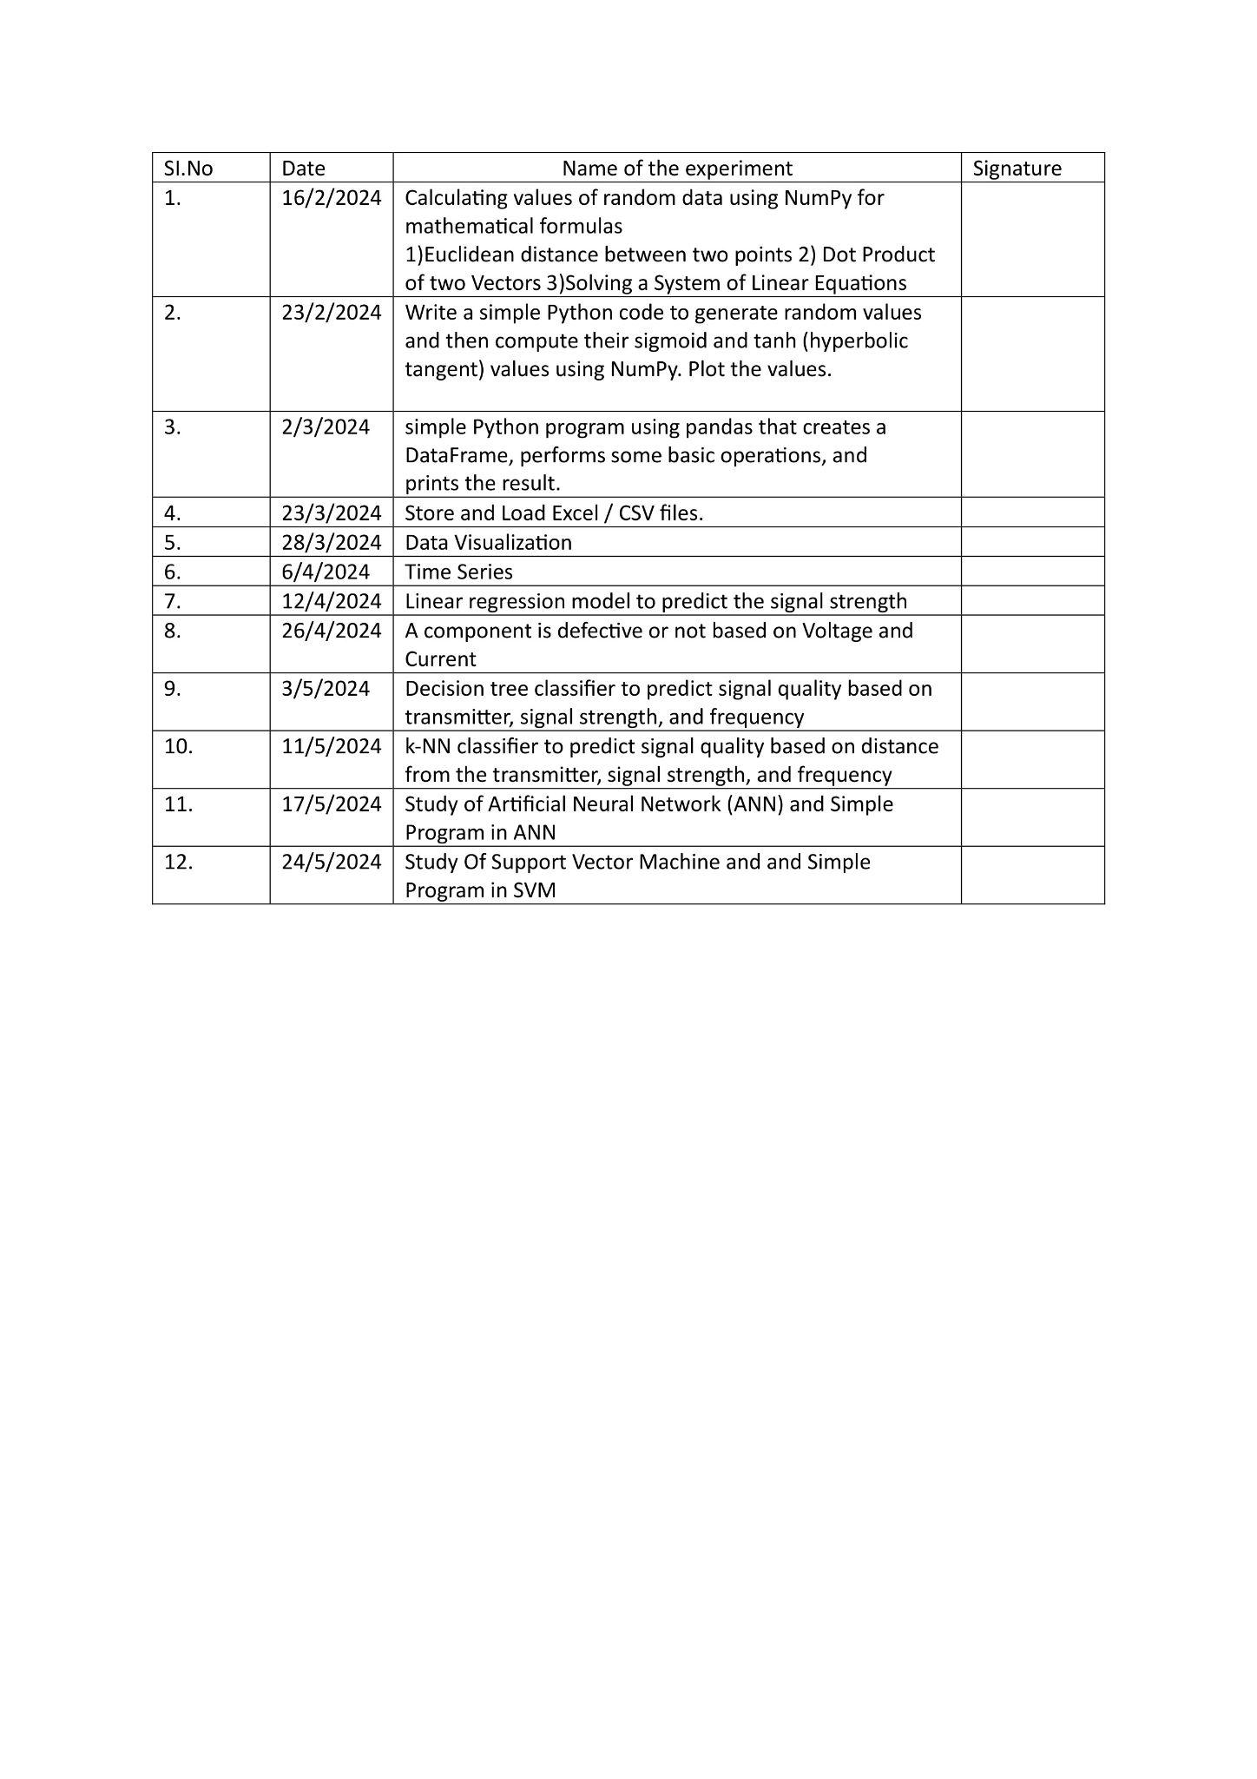

**Ex.no 1 Calculating values of random data using NumPy for 220801508**

**Date: 16.2.2024 mathematical formulas**

**Aim:**

Calculating values of random data using NumPy for mathematical formulas

1)Euclidean distance between two points 2) Dot Product of two Vectors 3)Solving a System of Linear Equations

**Program:**

#euclidean distance between 2 points

point1=np.array([3,2])

point2=np.array([1,1])

d=(((point1[0]-point2[0])**2)+((point1[1]-point2[1])**2))

print(math.sqrt(d))

#dot product

def dot(x,y):

dot_prod=x.dot(y)

print(dot_prod)

dot(point1, point2)

#Linear equation

a np.array([[4,3], [5, 9]])

b=np.array([2,1])

print(np.linalg.solve(a,b))

**Output:**

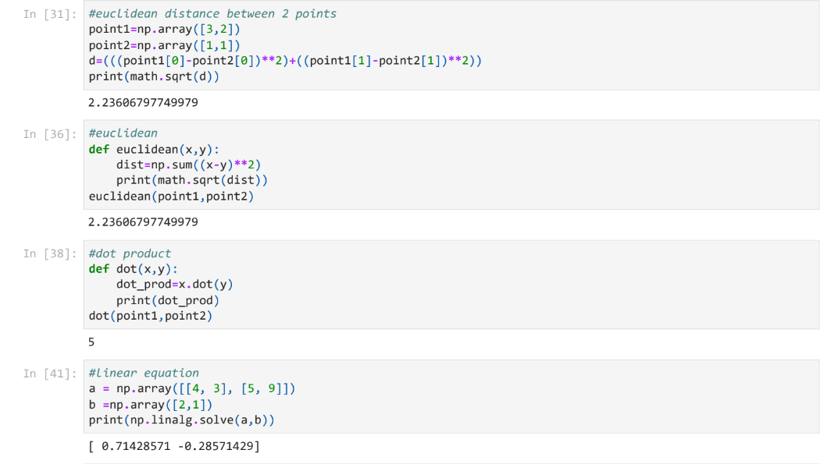

**Result:**

Thus the program has been done and executed and output has been verified successfully.

**Ex.no 2 Sigmoid and Tanh 220801508**

**Date: 23/2/2024**

**Aim:**

Write a simple Python code to generate random values and then compute their sigmoid and tanh (hyperbolic tangent) values using NumPy. Plot the values.

**Program:**

def sigmoid(x):

return 1 / (1 + np.exp(-x))

def tanh(x):

return np.tanh(x)

random_values=np.random.randn(100)

sigmoid_values=sigmoid(random_values)

tanh_values=tanh(random_values)

#plotting

indices=np.arange(len(random_values))

plt.figure(figsize=(14, 6))

plt.subplot(1,2,1)

plt.scatter(indices, sigmoid_values, color='r', label='Sigmoid') plt.plot(indices,sigmoid_values,'g',linestyle='-')

plt.title('Sigmoid Function')

plt.xlabel('Random Values')

plt.ylabel('Sigmoid Output')

plt.grid()

plt.subplot(1,2,2)

plt.scatter(indices, tanh_values, color='b', label='Tanh') plt.plot(indices,tanh_values,'g',linestyle='-')

plt.title('Hyperbolic Tangent (tanh) Function')

plt.xlabel('Random Values')

plt.ylabel('Tanh Output')

plt.grid()

plt.tight_layout()

plt.show()

**Output:**

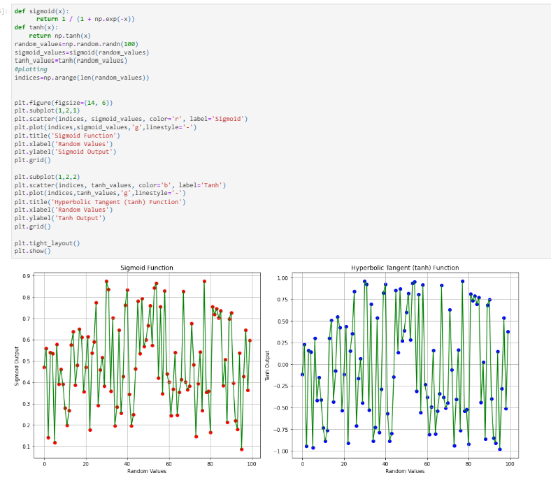

**Result:**

Thus the program has been done and executed and output has been verified successfully.

**Ex.no 3 Simple Program using Pandas 220801508**

**Date: 2/3/2024**

**Aim:**

Simple Python program using pandas that creates a DataFrame, performs some basic operations, and prints the result.

**Steps:**

1. Imports the pandas library as pd.

2. Creates two lists: data containing fruit names and prices containing their corresponding prices.

3. Zips these lists together and creates a DataFrame named fruits_df with columns named ‘Fruit’ and ‘Price’

4. Uses info() to get information about the DataFrame, including data types and number of entries.

5. Prints the entire DataFrame using to_string().

6. Calculates descriptive statistics (mean, standard deviation, etc.) for the ‘Price’ column and prints the results.

**Program Code:**

import pandas as pd

# Create a list of data

data = ["Apple", "Banana", "Cherry", "Orange", "Grape"]

prices = [1.25, 0.79, 2.00, 1.50, 0.99]

# Create a DataFrame

fruits_df = pd.DataFrame(list(zip(data, prices)), columns=['Fruit', 'Price'])

# Get basic information about the DataFrame

print(fruits_df.info())

# Print the DataFrame

print(fruits_df.to_string())

# Get descriptive statistics of the 'Price' column

print(fruits_df['Price'].describe())

**Output:**

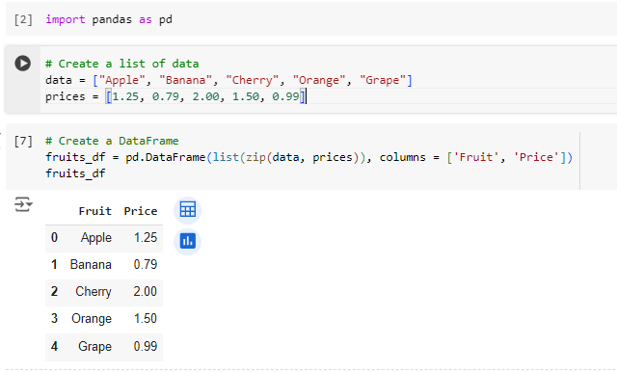

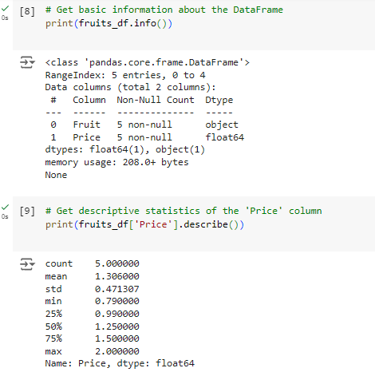

**Result:**

Thus the program has been done and executed and output has been verified successfully.

**Ex.no 4 Store and Load Excel / CSV files. 220801508**

**Date: 23/3/2024**

**Aim:**

To store (save) and load data from Excel and CSV files using pandas.

**Steps:**

**To Store:**

* import pandas as pd.
* Create a sample DataFrame df.
* Use the to_csv function to save the DataFrame to a CSV file.
* ‘people.csv’ is the filename.
* index=True (default) saves the row index as a column. Set it to False to skip it.

**To Load:**

* Import pandas as pd.
* Use read_csv to load data from a CSV file.
* Use read_excel to load data from an Excel file. By default, it reads the first sheet.
* Specify the sheet name with the sheet_name argument for loading data from a specific
* Sheet.

**Program Code:**

**To store:**

import pandas as pd

# Sample data

data = {"Name": ["Alice", "Bob", "Charlie"], "Age": [25, 30, 22]}

df = pd.DataFrame(data)

# Save to CSV file (with index)

df.to_csv("people.csv", index=True)

# Save to CSV file (without index)

df.to_csv("people_no_index.csv", index=False)

**To Load:**

# Load CSV data (assuming it has a header row)

df_csv = pd.read_csv(‘people.csv’)

print(df_csv)

**Output:**

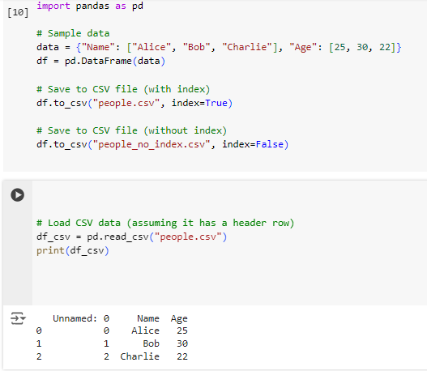

**Result:**

Thus the program has been done and executed and output has been verified successfully.

**Ex.no:5 Data Visualization 220801508**

**Date: 28/3/2024**

**Aim:**

To visualize the given data using the matplotlib library in python

**Algorithm**:

* Import the matplotlib.pyplot library for plotting.
* Prepare Data
* Use the plt.plot() function to create a line plot with cities on the x-axis and temperatures on the y-axis.
* Customize the plot by adding markers and setting the line style
* Add Labels and Title
* Use plt.show() to display the plot.

**Program:**

import matplotlib.pyplot as plt

import pandas as pd # Optional for data manipulation

# Sample data (replace with your data or use pandas to read a CSV)

temperatures = [15, 18, 22, 20, 17, 24, 21, 19]

cities = ["New York", "Los Angeles", "Chicago", "Denver", "Seattle", "Miami", "Houston", "San Francisco"]

# Line plot

plt.plot(cities, temperatures, marker='o', linestyle='-') # Customize markers and line style

# Labels and title

plt.xlabel("City")

plt.ylabel("Temperature (°C)")

plt.title("Average Temperatures in Major US Cities")

# Display the plot

plt.xticks(rotation=45) # Rotate city names for better readability (optional)

plt.grid(True) # Add gridlines (optional)

plt.show()

**Output:**

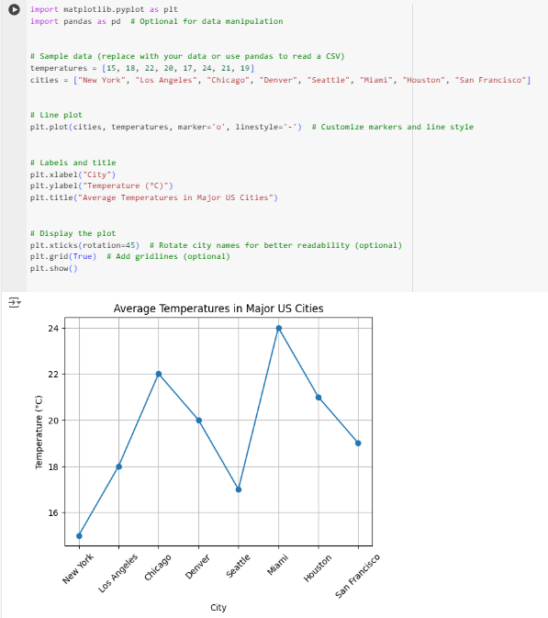

**Result:**

Thus the program has been done and executed and output has been verified successfully.

**Ex.no: 7 Time Series 220801508**

**Date: 12/4/2024**

**Aim:**

To write a python program to analyze time series data with the help of pandas and matplotlib.

**Algorithm**:

* Import the pandas library for data manipulation
* Import the matplotlib.pyplot library for plotting.
* Create a dictionary data containing the date strings and corresponding values.
* Create a DataFrame df from the dictionary.
* Plot the Time Series:
* Add Labels and Title:
* Use plt.show() to display the plot.
* Calculate Daily Change (Optional):

**Program:**

import pandas as pd

import matplotlib.pyplot as plt

data = {

"Date": pd.to_datetime(["2023-01-01", "2023-02-01", "2023-03-01", "2023-04-01", "2023-05-01"]),

"Value": [100, 120, 135, 110, 145]

}

# Create DataFrame with Date as index

df = pd.DataFrame(data).set_index("Date")

# Plot the time series

plt.figure(figsize=(10, 6)) # Adjust figure size for better viewing

plt.plot(df["Value"], marker='o', linestyle='-')

plt.xlabel("Date")

plt.ylabel("Value")

plt.title("Time Series Data")

plt.grid(True)

plt.show()

# Calculate daily change (optional)

df["Daily Change"] = df["Value"].diff() # Calculate difference between consecutive values

print(df["Daily Change"].describe())

**Output:**

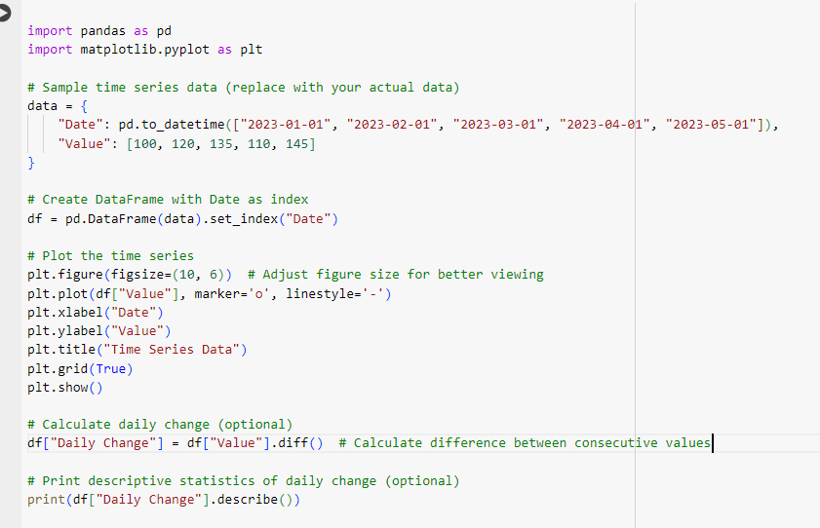

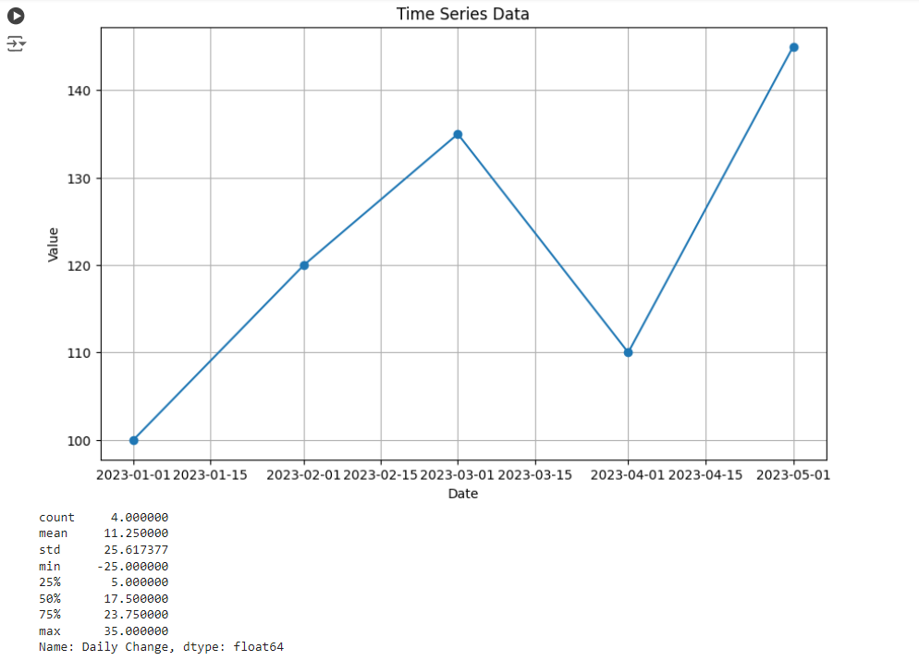

**Result:**

Thus the program has been done and executed and output has been verified successfully.

**Ex.no: 8 Linear regression model to predict the signal strength 220801508**

**Date: 26/4/2024**

**Aim:**

To develop a linear regression model to predict the signal strength based on the distance.

**Problem Statement:**

We have a dataset that records the signal strength (in dBm) at various distances (in meters) from a transmitter. The goal is to develop a linear regression model to predict the signal strength based on the distance.

**Algorithm:**

* Import the necessary libraries
* Prepare the dataset
* Split the dataset into training and testing sets a. Use train_test_split from sklearn.model_selection to split X and y into training and testing sets
* Initialize the linear regression model
* Train the model on the training data.
* Make predictions on the testing data
* Evaluate the model
* Plot the results

**Program:**

import numpy as np

import pandas as pd

import matplotlib.pyplot as plt

from sklearn.model_selection import train_test_split

from sklearn.linear_model import LinearRegression

from sklearn.metrics import mean_squared_error, r2_score

# Example dataset: Distance (meters) vs. Signal Strength (dBm)

data = {

'Distance': [1, 2, 3, 4, 5, 6, 7, 8, 9, 10],

'Signal_Strength': [-30, -35, -40, -45, -50, -55, -60, -65, -70, -75]

}

# Convert the data into a DataFrame

df = pd.DataFrame(data)

# Separate features and target variable

X = df[['Distance']].values # Feature: Distance

y = df['Signal_Strength'].values # Target: Signal Strength

# Split the data into training and testing sets

X_train, X_test, y_train, y_test = train_test_split(X, y, test_size=0.2, random_state=42)

# Create and train the linear regression model

model = LinearRegression()

model.fit(X_train, y_train)

# Make predictions

y_pred = model.predict(X_test)

# Evaluate the model

mse = mean_squared_error(y_test, y_pred)

r2 = r2_score(y_test, y_pred)

print(f'Mean Squared Error: {mse:.2f}')

print(f'R^2 Score: {r2:.2f}')

# Visualize the results

plt.scatter(X, y, color='blue', label='Actual Data')

plt.plot(X, model.predict(X), color='red', label='Fitted Line')

plt.xlabel('Distance (meters)')

plt.ylabel('Signal Strength (dBm)')

plt.title('Linear Regression: Distance vs. Signal Strength')

plt.legend()

plt.show()

**Output:**

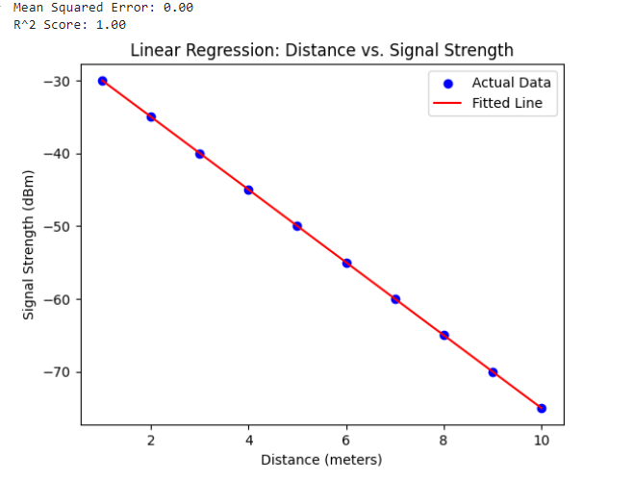

**Result:**

Thus the program has been done and executed and output has been verified successfully.

**Ex.no: 9 Decision tree classifier to predict signal quality based on transmitter, signal strength, and frequency 220801508**

**Date: 3/5/2024**

**Aim:**

Create a simple dataset to classify signal quality based on various parameters such as distance from the transmitter, signal strength, and frequency.

**Problem Statement:**

Dataset that records various parameters affecting the signal quality (Good or Bad). The goal is to develop a decision tree classifier to predict signal quality based on these parameters.

**Algorithm:**

1. Dataset:
   * We create a simple dataset with distance from the transmitter, signal strength, frequency, and corresponding signal qua lity (Good or Bad). The dataset is stored in a dictionary and then converted into a pandas DataFrame.
2. Data Prepa ration:
   * Separate the dataset into features (X) and the target variable (y).
   * Encode the target variable Signal_Quality from categorical values ('Good', 'Bad') to numerical values using LabelEncoder.
3. Model Training:
   * Split the data into training and testing sets using train_test_split.
   * Create an instance of DecisionTreeClassifier and train the model on the training data using the fit method.
4. Prediction and Evaluation:
   * Use the trained model to make predictions on the test data.
   * Calculate the accuracy score and generate a classification report to evaluate the model's performance.
5. Visualization:
   * Visualize the decision tree using plot_tree to understand how the model makes decisions based on the input features.

**Program:**

import numpy as np

import pandas as pd

import matplotlib.pyplot as plt

from sklearn.model_selection import train_test_split

from sklearn.tree import DecisionTreeClassifier, plot_tree

from sklearn.metrics import accuracy_score, classification_report

# Example dataset: Distance (meters), Signal Strength (dBm), Frequency (MHz) vs. Signal Quality

data = {

'Distance': [1, 2, 3, 4, 5, 6, 7, 8, 9, 10, 2, 3, 4, 5, 6],

'Signal_Strength': [-30, -35, -40, -45, -50, -55, -60, -65, -70, -75, -33, -38, -43, -48, -53],

'Frequency': [850, 850, 850, 850, 850, 1900, 1900, 1900, 1900, 1900, 850, 850, 1900, 1900, 1900],

'Signal_Quality': ['Good', 'Good', 'Good', 'Good', 'Bad', 'Bad', 'Bad', 'Bad', 'Bad', 'Bad', 'Good', 'Good', 'Bad', 'Bad', 'Bad']

}

# Convert the data into a DataFrame

df = pd.DataFrame(data)

# Separate features and target variable

X = df[['Distance', 'Signal_Strength', 'Frequency']].values # Features

y = df['Signal_Quality'].values # Target

# Encode the target variable

from sklearn.preprocessing import LabelEncoder

le = LabelEncoder()

y = le.fit_transform(y) # 'Good' -> 1, 'Bad' -> 0

# Split the data into training and testing sets

X_train, X_test, y_train, y_test = train_test_split(X, y, test_size=0.2, random_state=42)

# Create and train the decision tree classifier

model = DecisionTreeClassifier(random_state=42)

model.fit(X_train, y_train)

# Make predictions

y_pred = model.predict(X_test)

# Evaluate the model

accuracy = accuracy_score(y_test, y_pred)

report = classification_report(y_test, y_pred, target_names=['Bad', 'Good'])

print(f'Accuracy: {accuracy:.2f}')

print('Classification Report:')

print(report)

# Visualize the decision tree

plt.figure(figsize=(20,10))

plot_tree(model, feature_names=['Distance', 'Signal_Strength', 'Frequency'], class_names=['Bad', 'Good'], filled=True)

plt.show()

**Output:**

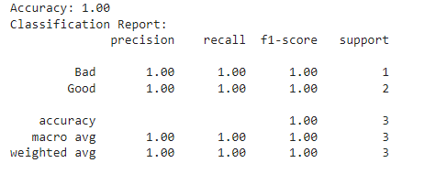

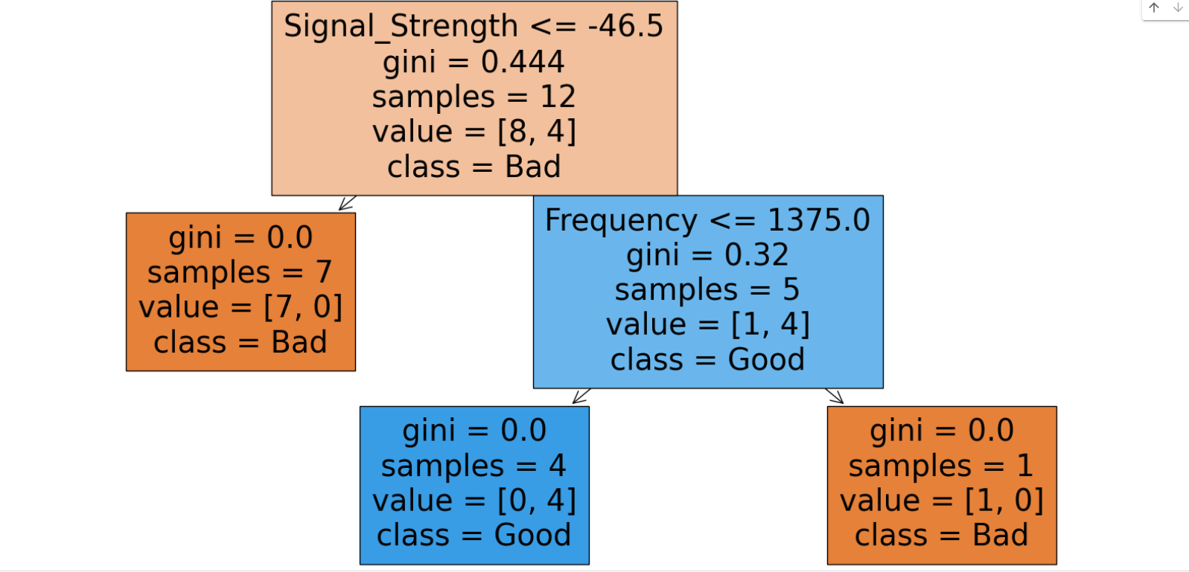

**Result:**

Thus the program has been done and executed and output has been verified successfully.

**Ex.no: 10 k-NN classifier to predict signal quality based on distance from the transmitter, signal strength, and frequency**

**Date: 11/5/2024 220801508**

**Aim:**

To classify signal quality based on various parameters such as distance from the transmitter, signal strength, and frequency.

**Prerequisite:**

pip install numpy pandas scikit-learn matplotlib

**Problem Statement**

A dataset that records various parameters affecting the signal quality (Good or Bad). The goal is to develop a k-NN classifier to predict signal quality based on these parameters.

**Algorithm:**

* Import the necessary libraries
* Prepare the dataset
* Split the dataset into training and testing sets a. Use train_test_split from sklearn.model_selection to split X and y into training and testing sets
* Initialize the KNN model
* Train the model on the training data.
* Make predictions on the testing data
* Evaluate the model
* Plot the results

**Program:**

import numpy as np

import pandas as pd

import matplotlib.pyplot as plt

from sklearn.model_selection import train_test_split

from sklearn.neighbors import KNeighborsClassifier

from sklearn.preprocessing import StandardScaler

from sklearn.metrics import accuracy_score, classification_report, confusion_matrix

import seaborn as sns

# Example dataset: Distance (meters), Signal Strength (dBm), Frequency (MHz) vs. Signal Quality

data = {

'Distance': [1, 2, 3, 4, 5, 6, 7, 8, 9, 10, 2, 3, 4, 5, 6],

'Signal_Strength': [-30, -35, -40, -45, -50, -55, -60, -65, -70, -75, -33, -38, -43, -48, -53],

'Frequency': [850, 850, 850, 850, 850, 1900, 1900, 1900, 1900, 1900, 850, 850, 1900, 1900, 1900],

'Signal_Quality': ['Good', 'Good', 'Good', 'Good', 'Bad', 'Bad', 'Bad', 'Bad', 'Bad', 'Bad', 'Good', 'Good', 'Bad', 'Bad', 'Bad']

}

# Convert the data into a DataFrame

df = pd.DataFrame(data)

# Separate features and target variable

X = df[['Distance', 'Signal_Strength', 'Frequency']].values # Features

y = df['Signal_Quality'].values # Target

# Encode the target variable

from sklearn.preprocessing import LabelEncoder

le = LabelEncoder()

y = le.fit_transform(y) # 'Good' -> 1, 'Bad' -> 0

# Split the data into training and testing sets

X_train, X_test, y_train, y_test = train_test_split(X, y, test_size=0.2, random_state=42)

# Standardize the features

scaler = StandardScaler()

X_train = scaler.fit_transform(X_train)

X_test = scaler.transform(X_test)

# Create and train the k-NN classifier

k = 3 # Number of neighbors

model = KNeighborsClassifier(n_neighbors=k)

model.fit(X_train, y_train)

# Make predictions

y_pred = model.predict(X_test)

# Evaluate the model

accuracy = accuracy_score(y_test, y_pred)

report = classification_report(y_test, y_pred, target_names=['Bad', 'Good'])

print(f'Accuracy: {accuracy:.2f}')

print('Classification Report:')

print(report)

# Confusion Matrix

conf_matrix = confusion_matrix(y_test, y_pred)

sns.heatmap(conf_matrix, annot=True, fmt='d', cmap='Blues', xticklabels=['Bad', 'Good'], yticklabels=['Bad', 'Good'])

plt.xlabel('Predicted')

plt.ylabel('Actual')

plt.title('Confusion Matrix')

plt.show()

**Output:**

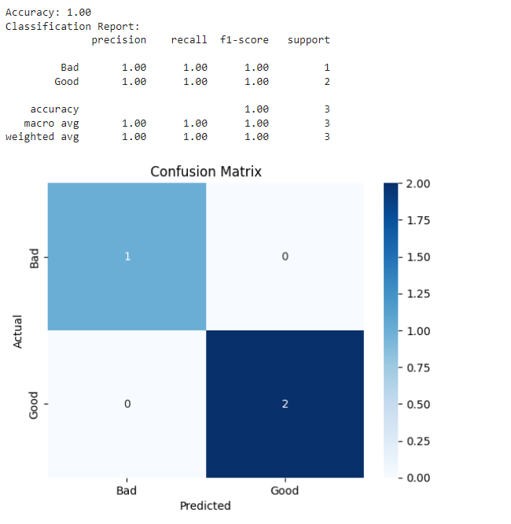

**Result:**

Thus the program has been done and executed and output has been verified successfully.

**Ex.no: 11 Study of Artificial Neural Network (ANN) and Simple Program in ANN 220801508**

**Date: 17/5/2024**

**Aim:**

To study Artificial Neural Network (ANN) using a simple program in ANN

**Prerequisite:**

pip install numpy scikit-learn

**Algorithm:**

* Import the necessary libraries
* Prepare the dataset
* Split the dataset into training and testing sets a. Use train_test_split from sklearn.model_selection to split X and y into training and testing sets
* Initialize the neural network model
* Train the model on the training data.
* Make predictions on the testing data
* Evaluate the model
* Plot the results

**Program:**

import numpy as np

from sklearn import datasets

from sklearn.model_selection import train_test_split

from sklearn.preprocessing import StandardScaler

from sklearn.neural_network import MLPClassifier

from sklearn.metrics import classification_report, accuracy_score

iris = datasets.load_iris()

X = iris.data

y = iris.target

X_train, X_test, y_train, y_test = train_test_split(X, y, test_size=0.3, random_state=42)

scaler = StandardScaler()

X_train = scaler.fit_transform(X_train)

X_test = scaler.transform(X_test)

# We'll use a Multi-layer Perceptron classifier

mlp = MLPClassifier(hidden_layer_sizes=(10,), max_iter=1000, random_state=42)

mlp.fit(X_train, y_train)

y_pred = mlp.predict(X_test)

print("Classification Report:")

print(classification_report(y_test, y_pred))

print("Accuracy:", accuracy_score(y_test, y_pred))

**Output:**

Classification Report:

Precision recall f1-score support

0 1.00 1.00 1.00 19

1 1.00 1.00 1.00 13

2 1.00 1.00 1.00 13

accuracy 1.00 45

macro avg 1.00 1.00 1.00 45

weighted avg 1.00 1.00 1.00 45

Accuracy: 1.0

**Result:**

Thus the program has been done and executed and output has been verified successfully.

**Ex. No: 12 Study Of Support Vector Machine and and Simple Program in SVM 220801508**

**Date: 24/5/2024**

**Aim:**

To demonstrate the application of SVM for classification, showcasing its strengths in handling high-dimensional spaces and providing a clear understanding of its working mechanism.

**Prerequisite:**

pip install scikit-learn

**Algorithm:**

* Import the necessary libraries
* Prepare the dataset
* Split the dataset into training and testing sets a. Use train_test_split from sklearn.model_selection to split X and y into training and testing sets
* Initialize SVC model
* Train the model on the training data.
* Make predictions on the testing data
* Evaluate the model

**Program:**

from sklearn import datasets

from sklearn.model_selection import train_test_split

from sklearn.svm import SVC

from sklearn.metrics import accuracy_score

iris = datasets.load_iris()

X = iris.data

y = iris.target

X_train, X_test, y_train, y_test = train_test_split(X, y, test_size=0.3, random_state=42)

clf = SVC(kernel=’linear’, C=1)

clf.fit(X_train, y_train)

y_pred = clf.predict(X_test)

accuracy = accuracy_score(y_test, y_pred)

print(‘Accuracy: {accuracy:.2f}’)

**Output**:

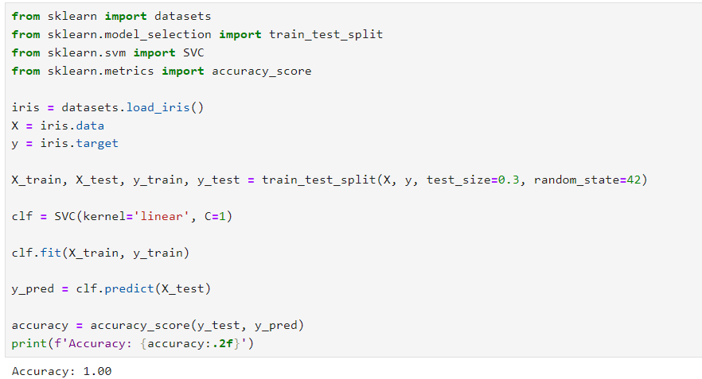

**Result:**

Thus the program has been done and executed and output has been verified successfully.