BoomGrid Handshake submission
Ready to paste into the Create a Multiplayer Game mission. The required entry consists of the title, cover image, description, and public game link.
Project title BoomGrid
Project URL https://boomgrid.vercel.app/

Project description
BoomGrid is a browser party game for 2–6 players built around one simple idea: hide three numbers and hunt everyone else's. Each hidden number is a life. On your turn, choose any surviving opponent, aim at a number, and fire. The blast resolves before the next player acts; the last player alive wins.
The strategy comes from limited powers: Double Shot attacks two numbers, Suicide Bomb trades one of your lives for an opponent's, Invincibility protects you until your next turn, and Radar scans a row or column. Every board stays visible, so players can follow the action and choose their next target. Arcade explosions, original synthesized music, scrollable highlights, and table chat with typing indicators give the match its personality.
Friends join with a room code, without an account or app install. A visual guided tour and bot practice help new players learn before joining friends on a phone or laptop.
I used ChatGPT Work to build and iterate on BoomGrid, directing the rules, arcade style, tutorial, mobile layout, and attack timing through repeated feedback. The game uses React, TypeScript, Next.js, and Tailwind CSS, with a Vercel frontend and a shared game backend. Validation includes 31 automated tests and two-player production checks for joining, turn order, and synchronized hits.
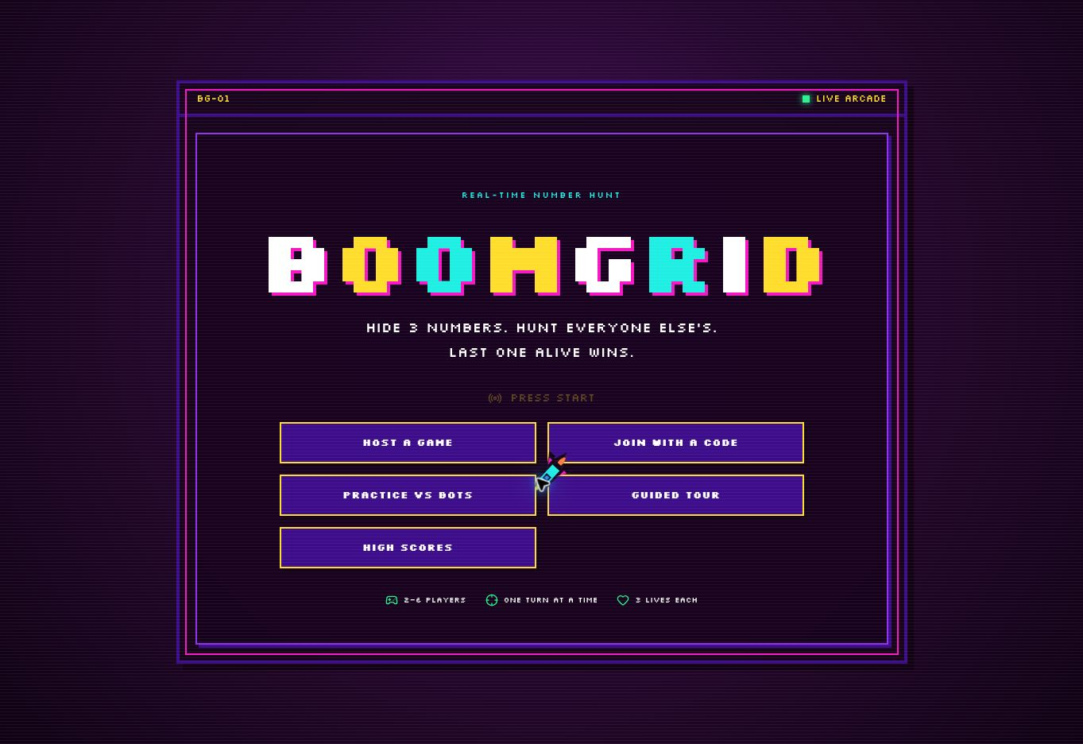
Cover image BoomGrid-Cover.jpg

Demo and submission guide

Short description option
BoomGrid is a turn-based browser party game for 2–6 players. Hide three numbers, hunt your rivals, and use limited powers to stay alive. Friends join by room code with no account or install. A visual tutorial, bot practice, arcade explosions, music, live highlights, and table chat make it easy to learn and replay. Built with ChatGPT Work and published on Vercel.

Quick demo
- Open the public game and choose Guided tour to learn the controls.
- Try Practice vs bots, or host a live game and have a friend join the room code on another device or browser profile.
- Hide three different numbers and lock them in. Each number is one life.
- On your turn, select any surviving opponent and a number, then press Fire. The blast resolves before the next player acts.
- Try a power-up and follow the highlights. Eliminated seats are skipped; the last surviving player wins.

What was verified
All 31 automated engine tests passed, and the Next.js production build completed on Vercel. A two-player production API check confirmed room joining, turn-based play, hit resolution, and the same hit result for both players. The immediate post-deployment runtime error scan returned no errors.
The Vercel frontend uses the existing authoritative room service and database, which must stay online. The game has not been load-tested with 100–200 concurrent players.

Submit the entry
Open the Handshake mission
Enter the four required fields from page one, upload the supplied cover image, and review the entry and contest terms before submitting through your Handshake account. The text file includes both description lengths for easy copying.
The official PDF specifies October 30, 2026 at 11:59 p.m. Pacific, equivalent to October 31 at 2:59 a.m. Eastern. The overview says October 31; follow the earlier, precise deadline in the official rules.
Official contest rules | Mission overview

