**Customer Churn Prediction**

**Project Definition:**

The project involves using IBM Cognos to predict customer churn and identify factors influencing customer retention. The goal is to help businesses reduce customer attrition by understanding the patterns and reasons behind customers leaving. This project includes defining analysis objectives, collecting customer data, designing relevant visualizations in IBM Cognos, and building a predictive model.

**Design Thinking:**

**Analysis Objectives:**

**1.Identify Potential Churners :**

Develop a predictive model that can accurately identify customers who are at high risk of churning. The objective is to assign a churn probability score to each customer.

**2. Understand Key Factors Contributing to Churn:**

Perform an in-depth analysis to identify and rank the key factors and variables that significantly contribute to customer churn. This should provide insights into why customers are leaving.

**3. Segmentation for Targeted Retention Strategies:**

Segment the customer base based on their churn risk and characteristics. This will enable the development of targeted retention strategies for different customer groups.

**Data Collection :**

**1.Customer Demographics:**

Collect demographic data such as age, gender, location, and income to understand if these factors influence churn.

**2. Usage Behaviour:**

Gather data on how frequently customers use the product or service, what features they use most, and their overall engagement**.**

**3. Historical Interactions:**

Collect historical data on customer interactions, including customer support tickets, feedback, and complaints**.**

**4. Billing and Subscription Data:**

Include information on subscription plans, billing history, and payment patterns.

**5. Customer Feedback and Surveys:**

If available, incorporate qualitative data from customer surveys or feedback forms to gain deeper insights**.**

**Visualization Strategy:**

**1.Churn Dashboard:**

Create an interactive dashboard in IBM Cognos that displays real-time churn predictions. Include visualizations such as line charts showing historical churn rates and pie charts illustrating the distribution of churners vs. non-churners.

**2. Factor Analysis Visualization:**

Use bar charts or heatmaps to visually represent the importance of different factors contributing to churn. Create interactive visualizations that allow stakeholders to explore how each factor impacts churn.

**3. Segmentation Visualizations:**

Develop scatter plots or bubble charts to show customer segmentation based on churn risk and demographics. Use colour coding to differentiate segments.

**4. Retention Strategies Heatmap:**

Visualize the effectiveness of different retention strategies over time using a heatmap. This can help in identifying which strategies are most successful in reducing churn.

**Predictive Modelling:**

**1.Algorithm Selection:**

Choose machine learning algorithms suitable for classification tasks, such as Logistic Regression, Random Forest, Gradient Boosting, or Neural Networks. Experiment with multiple algorithms to find the best-performing one.

**2. Feature Selection:**

Select relevant features for the predictive model. This may include demographic variables, usage patterns, historical interactions, and customer feedback.

**3. Data Split:**

Split the data into training and testing sets for model development and evaluation, ensuring that the data is representative and balanced.

**4. Model Evaluation:**

Use appropriate evaluation metrics such as accuracy, precision, recall, F1-score, and ROC-AUC to assess the model's performance. Implement cross-validation techniques to ensure robustness.

**5. Hyperparameter Tuning:**

Optimize the hyperparameters of the selected model to achieve the best predictive accuracy**.**

**6. Model Deployment:**

Once the model is trained and evaluated, deploy it in a production environment integrated with IBM Cognos for real-time or batch predictions.

By defining these objectives, data collection methods, visualization strategies, and predictive modelling approaches, you will be well-prepared to tackle the challenge of predicting customer churn and understanding the factors influencing it using IB Cognos as a powerful analytics tool

**Diagrams for phases of Customer Churn Prediction:**

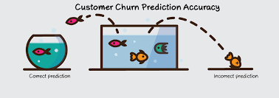**a)Analysis:**

Churn analysis is the evaluation of a company’s customer loss rate in order to reduce it. Also referred to as customer attrition rate, churn can be minimized by assessing your product and how people use it.

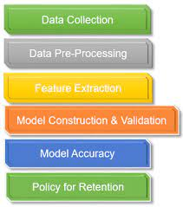**b)Data Collection:**

Data collection is a crucial step in building a customer churn prediction model. To accurately predict customer churn, you need to gather relevant data that provides insights into customer behaviour and characteristics.

**c)Visualization Strategy:**

Data visualization is a powerful way to communicate information, discover insights, and present data in a more understandable and engaging manner. Effective visualization can help you convey complex information, identify trends, patterns, and outliers, and make data-driven decisions.

**d)Prediction:**

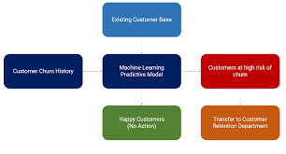 Predicting customer churn is a common and valuable application of data analytics and machine learning. Customer churn prediction helps businesses identify customers who are likely to stop using their products or services, enabling proactive retention efforts.

**Dataset Link:**

[**https://www.kaggle.com/datasets/blastcher/teleco-customer-churn**](https://www.kaggle.com/datasets/blastcher/teleco-customer-churn)

**Innovation of Customer Churn Prediction:**

Innovation in customer churn prediction involves leveraging emerging technologies and novel approaches to enhance the accuracy, efficiency, and effectiveness of churn prediction models.

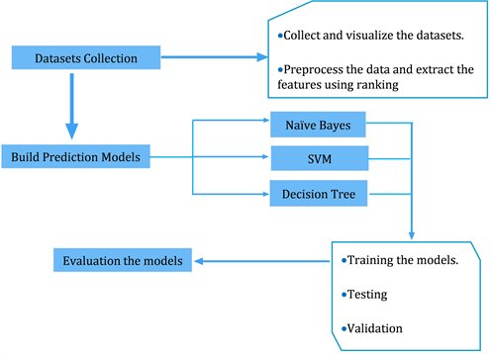

**Machine Learning Model Evaluations and Predictions:**

There are some ways to predicted the evaluations that are listed below,

1. KNN.
2. Random Forest.
3. Logistic Regression.
4. Decision Tree Classifier.
5. Ada Boost Classifier.

**Data Acquisition and Integration:**

Utilized advanced data acquisition ,such as web scraping,sentiment analysis of social media data, or IoT device data, to gather additional sources of information about customer behaviour and sentiment.

Implement real-time data integration techniques to ensures that the churn prediction model is continously updated with the latest data.

**Unstructured Data Analysis:**

Levarage natural language processing (NLP) techniques to analyze unstructured data sources, such as customer feedback, reviews,and social media comments. Extract sentient, topics,and key phraces that may indicate dissatisfaction or potential churn.

**Advanced Feature Engineering:**

Create innovative features based on customer churn behaviour, such as user engagement patterns,product usage sequences, or network analysis of customer connections within a platform.

**Time-Series Analysis:**

Apply time-series analysis techniques,such as customer behaviour overtime. This can help identity seasonally,trends and anomalies in customer activity that may impact churn.

**Explainable AI:**

Employ innovative explainable AI techniques to provide insights into why the model makes certain churn predictions. This can help businesses understand the driving factors behind customer churn and take proactive measures.

**Customer Segmentation:**

Use Advanced clustering and segmentation techniques to group customers based on their behaviours,preferences,and characteristics. Tailor retention strategies to each segments unique needs.

**Ethical Considerations:**

Ensure that innovative analytics approaches adhere to ethical standards and data privacy regulations ,protecting customer data while delevering value.

**Continuous Improvement:**

Establish a feedback loop to continuously asses and refine the churn prediction models performance, incorporating new data sources and innovation.

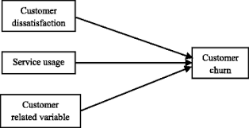

**Conclusion:**

At the end we can predict the churn by using the above given methods and the innovation is to build the complete customer churn prediction model in telecom industry. We use many ML algorithms and using the methods to predict the customer churn.