**Customer Churn Prediction**

**Project Definition:**

The project involves using IBM Cognos to predict customer churn and identify factors influencing customer retention. The goal is to help businesses reduce customer attrition by understanding the patterns and reasons behind customers leaving. This project includes defining analysis objectives, collecting customer data, designing relevant visualizations in IBM Cognos, and building a predictive model.

**Design Thinking:**

**Analysis Objectives:**

**1.Identify Potential Churners :**

Develop a predictive model that can accurately identify customers who are at high risk of churning. The objective is to assign a churn probability score to each customer.

**2. Understand Key Factors Contributing to Churn:**

Perform an in-depth analysis to identify and rank the key factors and variables that significantly contribute to customer churn. This should provide insights into why customers are leaving.

**3. Segmentation for Targeted Retention Strategies:**

Segment the customer base based on their churn risk and characteristics. This will enable the development of targeted retention strategies for different customer groups.

**Data Collection :**

**1.Customer Demographics:**

Collect demographic data such as age, gender, location, and income to understand if these factors influence churn.

**2. Usage Behaviour:**

Gather data on how frequently customers use the product or service, what features they use most, and their overall engagement**.**

**3. Historical Interactions:**

Collect historical data on customer interactions, including customer support tickets, feedback, and complaints**.**

**4. Billing and Subscription Data:**

Include information on subscription plans, billing history, and payment patterns.

**5. Customer Feedback and Surveys:**

If available, incorporate qualitative data from customer surveys or feedback forms to gain deeper insights**.**

**Visualization Strategy:**

**1.Churn Dashboard:**

Create an interactive dashboard in IBM Cognos that displays real-time churn predictions. Include visualizations such as line charts showing historical churn rates and pie charts illustrating the distribution of churners vs. non-churners.

**2. Factor Analysis Visualization:**

Use bar charts or heatmaps to visually represent the importance of different factors contributing to churn. Create interactive visualizations that allow stakeholders to explore how each factor impacts churn.

**3. Segmentation Visualizations:**

Develop scatter plots or bubble charts to show customer segmentation based on churn risk and demographics. Use colour coding to differentiate segments.

**4. Retention Strategies Heatmap:**

Visualize the effectiveness of different retention strategies over time using a heatmap. This can help in identifying which strategies are most successful in reducing churn.

**Predictive Modelling:**

**1.Algorithm Selection:**

Choose machine learning algorithms suitable for classification tasks, such as Logistic Regression, Random Forest, Gradient Boosting, or Neural Networks. Experiment with multiple algorithms to find the best-performing one.

**2. Feature Selection:**

Select relevant features for the predictive model. This may include demographic variables, usage patterns, historical interactions, and customer feedback.

**3. Data Split:**

Split the data into training and testing sets for model development and evaluation, ensuring that the data is representative and balanced.

**4. Model Evaluation:**

Use appropriate evaluation metrics such as accuracy, precision, recall, F1-score, and ROC-AUC to assess the model's performance. Implement cross-validation techniques to ensure robustness.

**5. Hyperparameter Tuning:**

Optimize the hyperparameters of the selected model to achieve the best predictive accuracy**.**

**6. Model Deployment:**

Once the model is trained and evaluated, deploy it in a production environment integrated with IBM Cognos for real-time or batch predictions.

By defining these objectives, data collection methods, visualization strategies, and predictive modelling approaches, you will be well-prepared to tackle the challenge of predicting customer churn and understanding the factors influencing it using IB Cognos as a powerful analytics tool

**Diagrams for phases of Customer Churn Prediction:**

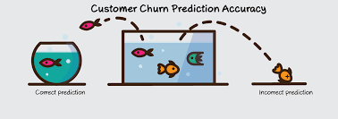**a)Analysis:**

Churn analysis is the evaluation of a company’s customer loss rate in order to reduce it. Also referred to as customer attrition rate, churn can be minimized by assessing your product and how people use it.

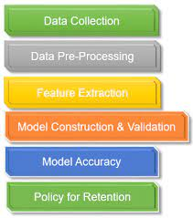**b)Data Collection:**

Data collection is a crucial step in building a customer churn prediction model. To accurately predict customer churn, you need to gather relevant data that provides insights into customer behaviour and characteristics.

**c)Visualization Strategy:**

Data visualization is a powerful way to communicate information, discover insights, and present data in a more understandable and engaging manner. Effective visualization can help you convey complex information, identify trends, patterns, and outliers, and make data-driven decisions.

**d)Prediction:**

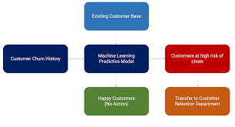 Predicting customer churn is a common and valuable application of data analytics and machine learning. Customer churn prediction helps businesses identify customers who are likely to stop using their products or services, enabling proactive retention efforts.

**Dataset Link:**

[**https://www.kaggle.com/datasets/blastcher/teleco-customer-churn**](https://www.kaggle.com/datasets/blastcher/teleco-customer-churn)

**Innovation of Customer Churn Prediction:**

Innovation in customer churn prediction involves leveraging emerging technologies and novel approaches to enhance the accuracy, efficiency, and effectiveness of churn prediction models.

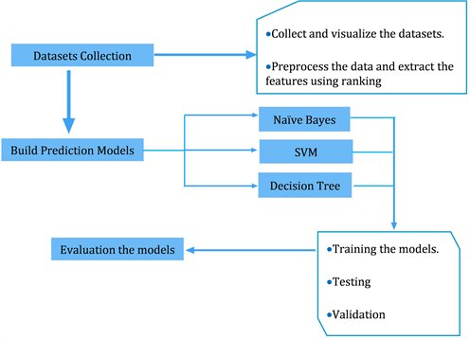

**Machine Learning Model Evaluations and Predictions:**

There are some ways to predicted the evaluations that are listed below,

1. KNN.
2. Random Forest.
3. Logistic Regression.
4. Decision Tree Classifier.
5. Ada Boost Classifier.

**Data Acquisition and Integration:**

Utilized advanced data acquisition ,such as web scraping,sentiment analysis of social media data, or IoT device data, to gather additional sources of information about customer behaviour and sentiment.

Implement real-time data integration techniques to ensures that the churn prediction model is continously updated with the latest data.

**Unstructured Data Analysis:**

Levarage natural language processing (NLP) techniques to analyze unstructured data sources, such as customer feedback, reviews,and social media comments. Extract sentient, topics,and key phraces that may indicate dissatisfaction or potential churn.

**Advanced Feature Engineering:**

Create innovative features based on customer churn behaviour, such as user engagement patterns,product usage sequences, or network analysis of customer connections within a platform.

**Time-Series Analysis:**

Apply time-series analysis techniques,such as customer behaviour overtime. This can help identity seasonally,trends and anomalies in customer activity that may impact churn.

**Explainable AI:**

Employ innovative explainable AI techniques to provide insights into why the model makes certain churn predictions. This can help businesses understand the driving factors behind customer churn and take proactive measures.

**Customer Segmentation:**

Use Advanced clustering and segmentation techniques to group customers based on their behaviours,preferences,and characteristics. Tailor retention strategies to each segments unique needs.

**Ethical Considerations:**

Ensure that innovative analytics approaches adhere to ethical standards and data privacy regulations ,protecting customer data while delevering value.

**Continuous Improvement:**

Establish a feedback loop to continuously asses and refine the churn prediction models performance, incorporating new data sources and innovation.

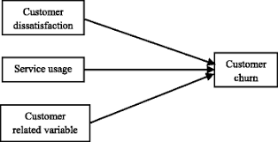

# **Loading libraries and data**

import pandas as pd

import numpy as np

import missingno as msno

import matplotlib.pyplot as plt

import seaborn as sns

import plotly.express as px

import plotly.graph_objects as go

from plotly.subplots import make_subplots

import warnings

from sklearn.preprocessing import StandardScaler

from sklearn.preprocessing import LabelEncoder

from sklearn.tree import DecisionTreeClassifier

from sklearn.ensemble import RandomForestClassifier

from sklearn.naive_bayes import GaussianNB

from sklearn.neighbors import KNeighborsClassifier

from sklearn.svm import SVC

from sklearn.neural_network import MLPClassifier

from sklearn.ensemble import AdaBoostClassifier

from sklearn.ensemble import GradientBoostingClassifier

from sklearn.ensemble import ExtraTreesClassifier

from sklearn.linear_model import LogisticRegression

from sklearn.model_selection import train_test_split

from sklearn.metrics import accuracy_score

from xgboost import XGBClassifier

from catboost import CatBoostClassifier

from sklearn import metrics

from sklearn.metrics import roc_curve

from sklearn.metrics import recall_score, confusion_matrix, precision_score, f1_score, accuracy_score, classification_report

Using this libraries we can deal with Data manipulation and Data visualization

*#loading data*

df = pd.read_csv('Telecom_customer_churn_prediction.csv')

While using the above code we can able to load data from

the dataset

**DATASET LINK:**

https://www.kaggle.com/datasets/blastchar/telco-customer-churn

UNDERSTANDING DATA:

We can understand data by making them visible to us like performing some operation on, we can see them in the following Each row represents a customer, each column contains customer’s attributes described on the column Metadata

**The data set includes information about:**

* **Customers who left within the last month** – the column is called Churn
* **Services that each customer has signed up for** – phone, multiple lines, internet, online security, online backup, device protection, tech support, and streaming TV and movies
* **Customer account information** - how long they’ve been a customer, contract, payment method, paperless billing, monthly charges, and total charges
* **Demographic info about customers** – gender, age range, and if they have partners and dependents

# to print columns

df.columns.values

array (['customer ID', 'gender', 'Senior Citizen', 'Partner', 'Dependents’

,'tenure', 'Phone Service', 'Multiple Lines', 'Internet Service',

'Online Security', 'Online Backup', 'Device Protection',

'Tech Support', 'Streaming TV', 'Streaming Movies', 'Contract',

'Paperless Billing', 'Payment Method', 'Monthly Charges',

'Total Charges', 'Churn']

are the columns present in the dataset



Understanding data is one of the major task in this prediction

**VISUALIZE MISSING VALUES:**

def missing_values_tables(dataframe,na_name=False):

na_columns=[col for col in dataframe.columns if dataframe[col].isnull().sum()>0]

n_miss=dataframe[na_columns].isnull().sum().sort_values(ascending=False)

ratio=(dataframe[na_columns].isnull().sum()/dataframe.shape[0]*100).sort_values(ascending=False)

missing_df=pd.concat([n_miss,np.round(ratio,2)],axis=1,keys=['n_miss','ratio'])

print(missing_df,end="\n")

if na_name:

return na_columns

missing_values_tables(df)

output:

Empty DataFrame

Columns: [n_miss, ratio]

Index: []

*# Visualize missing values as a matrix*

msno.matrix(df);.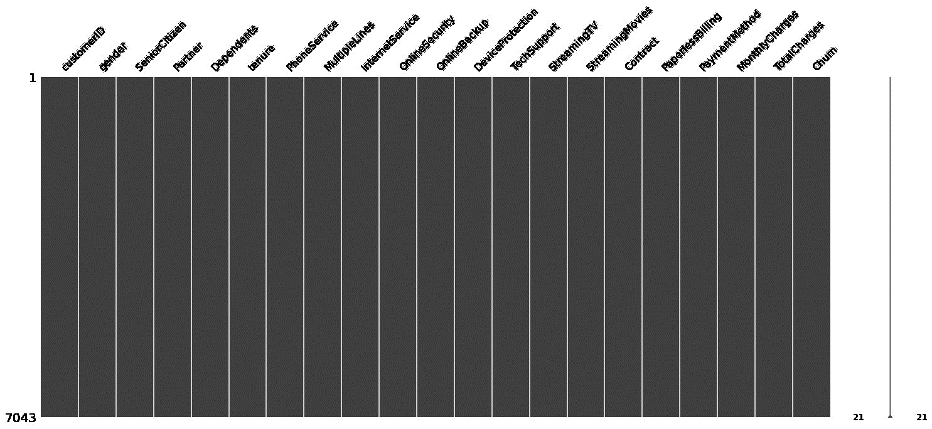

# **Data Manipulation**

df = df.drop(['customerID'], axis = 1)

df.head()

On deep analysis, we can find some indirect missing ness in our data (which can be in form of blank spaces). Let's see that!

df['TotalCharges'] = pd.to_numeric(df.TotalCharges, errors='coerce')

df.isnull().sum()

gender 0

Senior Citizen 0

Partner 0

Dependents 0

tenure 0

Phone Service 0

Multiple Lines 0

Internet Service 0

Online Security 0

Online Backup 0

Device Protection 0

Tech Support 0

Streaming TV 0

Streaming Movies 0

Contract 0

Paperless Billing 0

Payment Method 0

Monthly Charges 0

Total Charges 11

Churn 0

d type: int64

Here we see that the Total Charges has 11 missing values. Let's check this data

It can also be noted that the Tenure column is 0 for these entries even though the Monthly Charges column is not empty

d[df['tenure'] == 0]. index

Int64 Index([488, 753, 936, 1082, 1340, 3331, 3826, 4380, 5218, 6670, 6754], d type='int64')

* There are no additional missing values in the Tenure column.

Let's delete the rows with missing values in Tenure columns since there are only 11 rows and deleting them will not affect the data.

df.drop(labels=df[df['tenure'] == 0].index, axis=0, inplace=True)

df[df['tenure'] == 0].index

Int64Index([], dtype='int64')

To solve the problem of missing values in Total Charges column, I decided to fill it with the mean of Total Charges values.

numerical_cols = ['tenure', 'MonthlyCharges', 'TotalCharges']

df[numerical_cols].describe()

|  | tenure | Monthly Charges | Total Charges |
| --- | --- | --- | --- |
| count | 7032.000000 | 7032.000000 | 7032.000000 |
| mean | 32.421786 | 64.798208 | 2283.300441 |
| std | 24.545260 | 30.085974 | 2266.771362 |
| min | 1.000000 | 18.250000 | 18.800000 |
| 25% | 9.000000 | 35.587500 | 401.450000 |
| 50% | 29.000000 | 70.350000 | 1397.475000 |
| 75% | 55.000000 | 89.862500 | 3794.737500 |
| max | 72.000000 | 118.750000 | 8684.800000 |

df["InternetService"].describe(include=['object', 'bool'])

count 7032

unique 3

top Fiber optic

freq 3096

Name: Internet Service, dtype: object

**Data Visualization**

g_labels = ['Male', 'Female']

c_labels = ['No', 'Yes']

*# Create subplots: use 'domain' type for Pie subplot*

fig = make_subplots(rows=1, cols=2, specs=[[{'type':'domain'}, {'type':'domain'}]])

fig.add_trace(go.Pie(labels=g_labels, values=df['gender'].value_counts(), name="Gender"),

1, 1)

fig.add_trace(go.Pie(labels=c_labels, values=df['Churn'].value_counts(), name="Churn"),

1, 2)

*# Use `hole` to create a donut-like pie chart*

fig.update_traces(hole=.4, hoverinfo="label+percent+name", textfont_size=16)

fig.update_layout(

title_text="Gender and Churn Distributions",

*# Add annotations in the center of the donut pies.*

annotations=[dict(text='Gender', x=0.16, y=0.5, font_size=20, showarrow=False),

dict(text='Churn', x=0.84, y=0.5, font_size=20, showarrow=False)])

fig.show()

As a result

* 26.6 % of customers switched to another firm.
* Customers are 49.5 % female and 50.5 % male

df["Churn"][df["Churn"]=="No"].groupby(by=df["gender"]).count()

gender

Female 2544

Male 2619

Name: Churn, dtype: int64

df["Churn"][df["Churn"]=="Yes"].groupby(by=df["gender"]).count()

gender

Female 939

Male 930

Name: Churn, dtype: int64

plt.figure(figsize=(6, 6))

labels =["Churn: Yes","Churn:No"]

values = [1869,5163]

labels_gender = ["F","M","F","M"]

sizes_gender = [939,930 , 2544,2619]

colors = ['#ff6666', '#66b3ff']

colors_gender = ['#c2c2f0','#ffb3e6', '#c2c2f0','#ffb3e6']

explode = (0.3,0.3)

explode_gender = (0.1,0.1,0.1,0.1)

textprops = {"fontsize":15}

*#Plot*

plt.pie(values, labels=labels,autopct='**%1.1f%%**',pctdistance=1.08, labeldistance=0.8,colors=colors, startangle=90,frame=True, explode=explode,radius=10, textprops =textprops, counterclock = True, )

plt.pie(sizes_gender,labels=labels_gender,colors=colors_gender,startangle=90, explode=explode_gender,radius=7, textprops =textprops, counterclock = True, )

*#Draw circle*

centre_circle = plt.Circle((0,0),5,color='black', fc='white',linewidth=0)

fig = plt.gcf()

fig.gca().add_artist(centre_circle)

plt.title('Churn Distribution w.r.t Gender: Male(M), Female(F)', fontsize=15, y=1.1)

*# show plot*

plt.axis('equal')

plt.tight_layout()

plt.show()

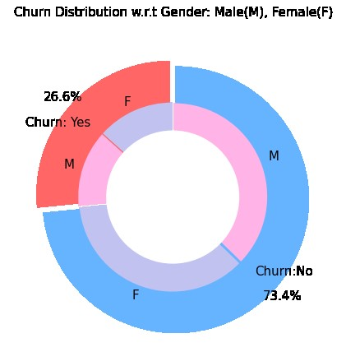

There is negligible difference in customer percentage/ count who changed the service provider. Both genders behaved in similar fashion when it comes to migrating to another service provider/firm

fig = px.histogram(df, x="Churn", color="Contract", barmode="group", title="<b>Customer contract distribution<b>")

fig.update_layout(width=700, height=500, bargap=0.1)

fig.show()

As a result we get

About 75% of customer with Month-to-Month Contract opted to move out as compared to13% of customers with One Year Contract and 3% with Two Year Contract

labels = df['PaymentMethod'].unique()

values = df['PaymentMethod'].value_counts()

fig = go.Figure(data=[go.Pie(labels=labels, values=values, hole=.3)])

fig.update_layout(title_text="<b>Payment Method Distribution</b>")

fig.show()

As a result we get

* Major customers who moved out were having Electronic Check as Payment Method.
* Customers who opted for Credit-Card automatic transfer or Bank Automatic Transfer and Mailed Check as Payment Method were less likely to move out.

#df["InternetService"].unique()

output:

array(['DSL', 'Fiber optic', 'No'], dtype=object)

#df[df["gender"]=="Male"][["InternetService", "Churn"]].value_counts()

output:

InternetService Churn

DSL No 992

Fiber optic No 910

No No 717

Fiber optic Yes 633

DSL Yes 240

No Yes 57

dtype: int64

#sns.set_context("paper",font_scale=1.1)

ax = sns.kdeplot(df.MonthlyCharges[(df["Churn"] == 'No') ],

color="Red", shade = True);

ax = sns.kdeplot(df.MonthlyCharges[(df["Churn"] == 'Yes') ],

ax =ax, color="Blue", shade= True);

ax.legend(["Not Churn","Churn"],loc='upper right');

ax.set_ylabel('Density');

ax.set_xlabel('Monthly Charges');

ax.set_title('Distribution of monthly charges by churn');

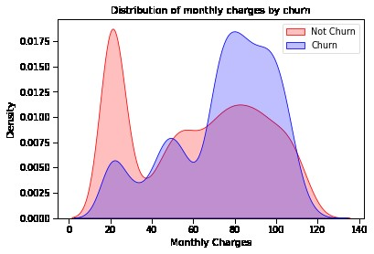

ax = sns.kdeplot(df.TotalCharges[(df["Churn"] == 'No') ],

color="Gold", shade = True);

ax = sns.kdeplot(df.TotalCharges[(df["Churn"] == 'Yes') ],

ax =ax, color="Green", shade= True);

ax.legend(["Not Chu0rn","Churn"],loc='upper right');

ax.set_ylabel('Density');

ax.set_xlabel('Total Charges');

ax.set_title('Distribution of total charges by churn');

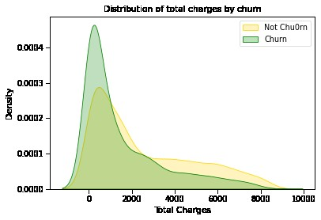

plt.figure(figsize=(25, 10))

corr = df.apply(lambda x: pd.factorize(x)[0]).corr()

mask = np.triu(np.ones_like(corr, dtype=bool))

ax = sns.heatmap(corr, mask=mask, xticklabels=corr.columns, yticklabels=corr.columns, annot=True, linewidths=.2, cmap='coolwarm', vmin=-1, vmax=1)

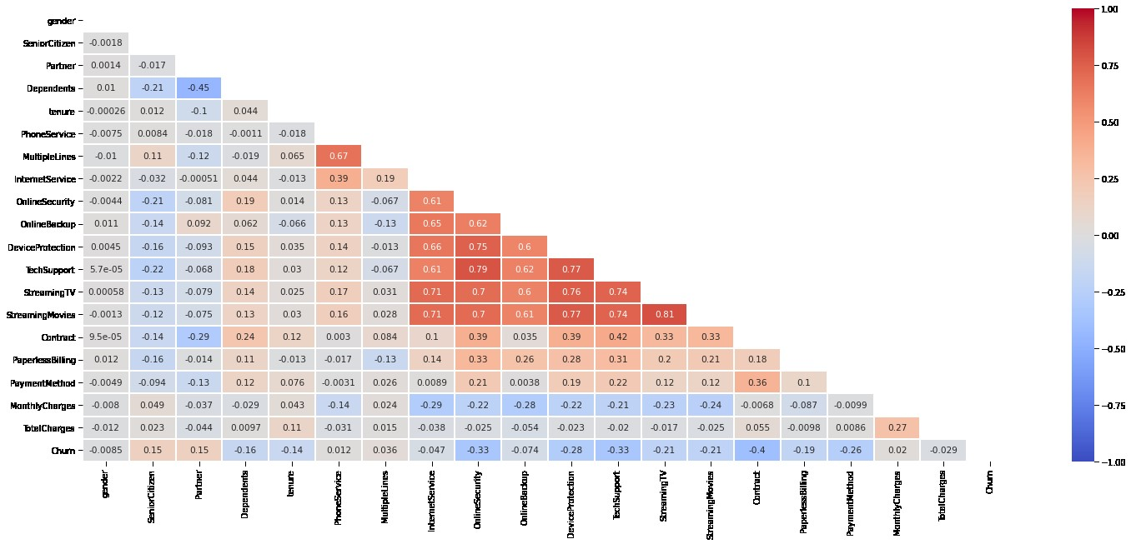

#Distribution of monthly charges

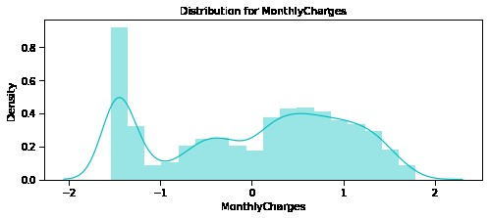

# **Data Pre-processing:**

## What is data pre-processing?

Data pre-processing, a component of [data preparation](https://searchbusinessanalytics.techtarget.com/definition/data-preparation), describes any type of processing performed on [raw data](https://searchdatamanagement.techtarget.com/definition/raw-data) to prepare it for another data processing procedure. It has traditionally been an important preliminary step for the [data mining](https://searchbusinessanalytics.techtarget.com/definition/data-mining) process. More recently, data pre-processing techniques have been adapted for training machine learning models and AI models and for running inferences against them.

Data pre-processing transforms the data into a format that is more easily and effectively processed in data mining, machine learning and other data science tasks. The techniques are generally used at the earliest stages of the [machine learning](https://www.techtarget.com/searchenterpriseai/definition/machine-learning-ML) and AI development pipeline to ensure accurate results.

There are several different tools and methods used for pre-processing data, including the following:

* sampling, which selects a representative subset from a large population of data;
* transformation, which manipulates raw data to produce a single input;
* denoising, which removes [noise](https://whatis.techtarget.com/definition/noise) from data;
* imputation, which synthesizes statistically relevant data for missing values;
* [normalization](https://searchsqlserver.techtarget.com/definition/normalization), which organizes data for more efficient access; and
* feature extraction, which pulls out a relevant feature subset that is significant in a particular context.

These tools and methods can be used on a variety of data sources, including data stored in files or databases and streaming data.

## Why is data pre-processing important?

Virtually any type of data analysis, [data science](https://www.techtarget.com/searchenterpriseai/definition/data-science) or AI development requires some type of data pre-processing to provide reliable, precise and robust results for enterprise applications.

Real-world data is messy and is often created, processed and stored by a variety of humans, business processes and applications. As a result, a data set may be missing individual fields, contain manual input errors, or have duplicate data or different names to describe the same thing. Humans can often identify and rectify these problems in the data they use in the line of business, but [data used to train machine learning](https://searchbusinessanalytics.techtarget.com/feature/Data-preparation-in-machine-learning-6-key-steps) or deep learning algorithms needs to be automatically pre-processed.

# Replace missing values with a specific value (e.g., 0)

df.fillna(0, inplace=True)

# Remove rows with missing values

df.dropna(inplace=True)

# Removing Duplicates

df.drop_duplicates(inplace=True)

**What are the steps involved in data pre-processing?**

* The steps involved in data preprocessing are:
* Data collection, Data cleaning, Data integration, Data transformation, Data reduction, Data discretization, Data normalization or Data standardization, Feature selection, and Data representation.

The insights you gain from your churn prediction models can also be used to enlighten your product teams. The on boarding experience can be fine-tuned and optimized with these key insights.

**Machine Learning Model Evaluations and Predictions:**

* [KNN](https://www.kaggle.com/code/bhartiprasad17/customer-churn-prediction#101)
* [SVC](https://www.kaggle.com/code/bhartiprasad17/customer-churn-prediction#102)
* [Random Forest](https://www.kaggle.com/code/bhartiprasad17/customer-churn-prediction#103)
* [Logistic Regression](https://www.kaggle.com/code/bhartiprasad17/customer-churn-prediction#104)
* [Decision Tree Classifier](https://www.kaggle.com/code/bhartiprasad17/customer-churn-prediction#105)
* [Ada Boost Classifier](https://www.kaggle.com/code/bhartiprasad17/customer-churn-prediction#106)
* [Gradient Boosting Classifier](https://www.kaggle.com/code/bhartiprasad17/customer-churn-prediction#107)
* [Voting Classifier](https://www.kaggle.com/code/bhartiprasad17/customer-churn-prediction#108)

#### **KNN**

knn_model = KNeighborsClassifier(n_neighbors = 11)

knn_model.fit(X_train,y_train)

predicted_y = knn_model.predict(X_test)

accuracy_knn = knn_model.score(X_test,y_test)

print("KNN accuracy:",accuracy_knn)

KNN accuracy: 0.7753554502369668

print(classification_report(y_test, predicted_y))

precision recall f1-score support

0 0.83 0.87 0.85 1549

1 0.59 0.52 0.55 561

accuracy 0.78 2110

macro avg 0.71 0.69 0.70 2110

weighted avg 0.77 0.78 0.77 2110

like this we can use different **Machine Learning Model Evaluations and to Predict the churn**

**ACCURACY:**

y=df['Churn']

X=df.drop(["customerID", "Churn"],axis=1)

from sklearn.model_selection import train_test_split

X_train,X_test,y_train,y_test=train_test_split(X,y,test_size=0.30,random_state=17)

from sklearn.ensemble import RandomForestClassifier

from sklearn.linear_model import SGDClassifier, LogisticRegression

from sklearn.metrics import accuracy_score,precision_score, recall_score,f1_score,roc_auc_score

from sklearn.preprocessing import StandardScaler

rf_model=LogisticRegression()

rf_model.fit(X_train,y_train)

y_pred=rf_model.predict(X_test)

accuracy_score(y_pred,y_test)

**OUTPUT:**

0.7834123222748816

**Missing Values:**

def missing_values_tables(dataframe,na_name=False):

na_columns=[col for col in dataframe.columns if dataframe[col].isnull().sum()>0]

n_miss=dataframe[na_columns].isnull().sum().sort_values(ascending=False)

ratio=(dataframe[na_columns].isnull().sum()/dataframe.shape[0]*100).sort_values(ascending=False)

missing_df=pd.concat([n_miss,np.round(ratio,2)],axis=1,keys=['n_miss','ratio'])

print(missing_df,end="\n")

if na_name:

return na_columns

missing_values_tables(df)

**Output:**

Empty DataFrame

Columns: [n_miss, ratio]

Index: []

**Excited:**

df["Exited"].value_counts()

Out[9]:

0 7963

1 2037

Name: Exited, dtype: int64

**Tenure:**

not_churn["Tenure"].value_counts().sort_values()

Out[12]:

0 318

10 389

6 771

9 771

4 786

3 796

5 803

1 803

8 828

2 847

7 851

Name: Tenure, dtype: int64

**Geography:**

not_churn.Geography.value_counts().sort_values()

Out[20]:

Germany 1695

Spain 2064

France 4204

Name: Geography, dtype: int64

**Estimated Salary:**

not_churn["EstimatedSalary"].describe([0.05,0.25,0.50,0.75,0.90,0.95,0.99])

Out[39]:

count 7963.000000

mean 99738.391772

std 57405.586966

min 90.070000

5% 9773.542000

25% 50783.490000

50% 99645.040000

75% 148609.955000

90% 179453.212000

95% 190107.557000

99% 198131.465200

max 199992.480000

Name: EstimatedSalary, dtype: float64

**Outliers:**

def outlier_thresholds(dataframe, variable, low_quantile=0.05, up_quantile=0.95):

quantile_one = dataframe[variable].quantile(low_quantile)

quantile_three = dataframe[variable].quantile(up_quantile)

interquantile_range = quantile_three - quantile_one

up_limit = quantile_three + 1.5 * interquantile_range

low_limit = quantile_one - 1.5 * interquantile_range

return low_limit, up_limit

CreditScore has None Outliers

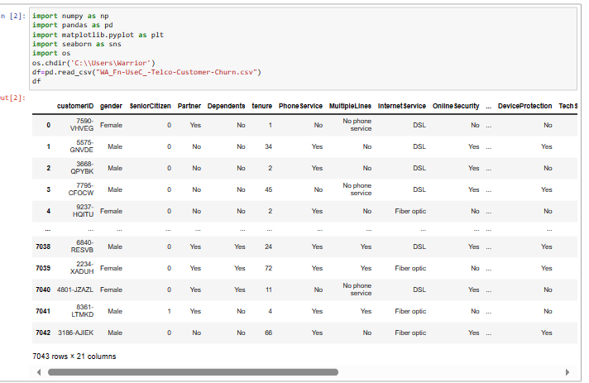

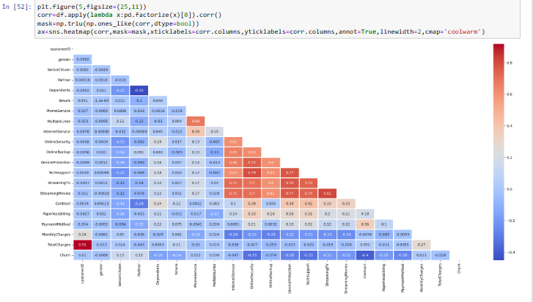

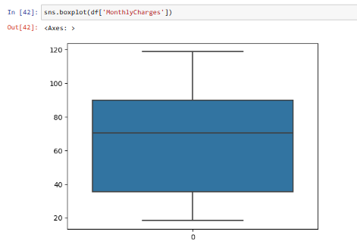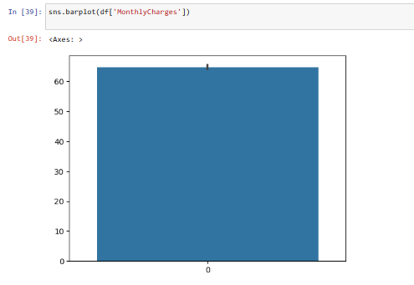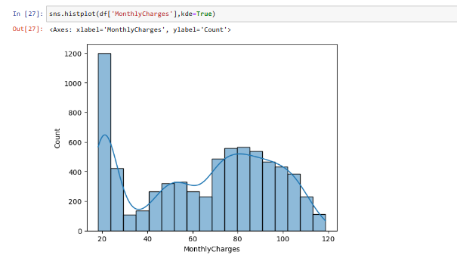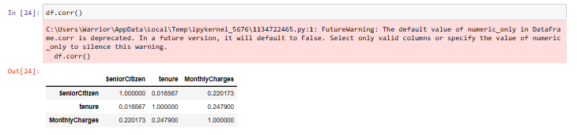 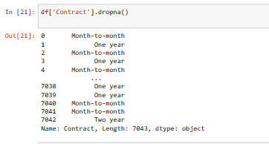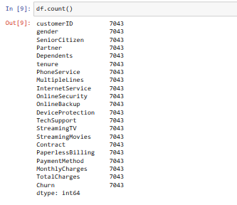

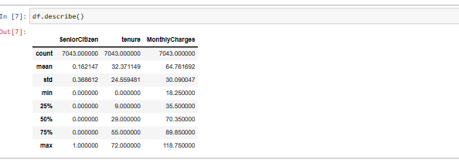

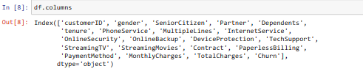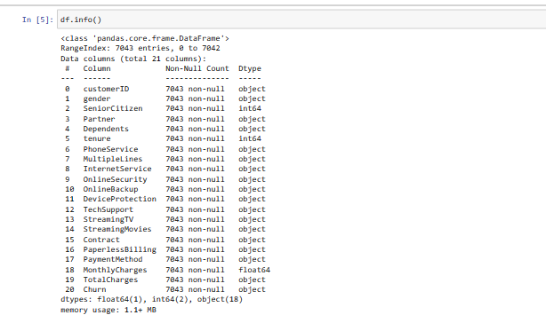

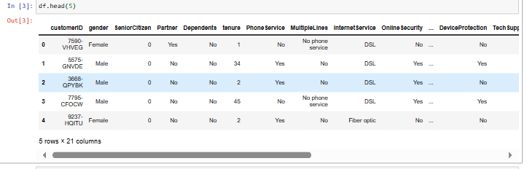

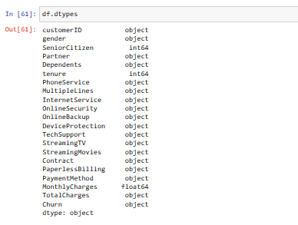

**Building a Predictive Model:**

**Select Model:**

Choose a model based on your problem(e.g,regression,classification, clustering).

**Data Split:**

Divide your data into training and testing sets.

**Model Training:**

Use Scikit-learn to train the selected model on the training data.

**Model Evaluation:**

Evaluate the model’s performance on the test set using appropriate metrics.

**Hyperparameter Tuning:**

Fine-tune the model by adjusting hyperparameters using techniques like cross-validation.

**Predictions:**

Make predictions on new or test data.

**Conclusion:**

At the end we can predict the churn by using the above given methods and the innovation is to build the complete customer churn prediction model in telecom industry. We use many ML algorithms and using the methods to predict the customer churn.