## RESUME

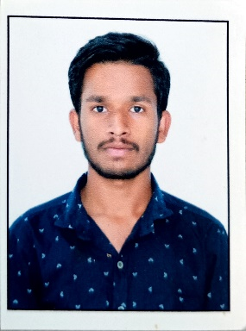**Anil Kumar Poola**

**Burakayalakota [P],**

**Mulakalacheruvu[M],**

**Annamayya [Dist]**

🖂 **panilkumar094@gmail.com**

✆ **+91 6300431868**

# Career Objective:

Secure a responsible career opportunity to fully utilize my training and skills, while making a significant contribution to the success of the company.

# Academic Qualifications:

|  |  |  |  |  |
| --- | --- | --- | --- | --- |
| **Qualification** | **Institution** | **University** | **Year of Passing** | **Percentage** |
| Degree B.COM (C.A) | Vishwa Hitha Degree college | SRI  VENKATESWARA  UNIVERSITY | 2022 | 7.8 CGPA |
| Intermediate  (C.E.C) | Viswasadhana jr college | STATE BOARD  OF  INTERMEDIATE  EDUCATION | 2019 | 7.2 CGPA |
| SSC | Zilla Parishath  High School,  Burakayalakota | STATE BOARD OF  SECONDARY  EDUCATION | 2016 | 7.2 CGPA |

# Technical Skills:

* Programming Language: Python
* Web-Technologies : HTML,CSS and JAVASCRIPT
* Application Software: Microsoft Office 2007
* Data Base : DBMS and MY SQL

# Strength and Abilities:

* Honest and Self-Motivate.
* Positive Attitude and Hard Working Nature.
* Quick Learner.

# Hobbies:

* Playing Games , Listening music and Reading General Knowledge

**Personal Details:**

Name : P.Anil kumar

Father’s Name : P.Venak Ramana

Date of Birth : 07/04/2000

Gender : Male

Nationality : Indian, Hindu,

Marital Status : Un-Married

Languages : English and Telugu

Permanent Address : Burkayalakota [P], Mulakalacheruvu [M], Annamayya [Dist]

# Declaration:

I hereby confirm that to the best of my knowledge, the information I have provided in this application is complete and true.

Thanking you Sir,

Date: Yours Truly

Place: **(Burakayalakota)** **(P.Anil Kumar)**