**Exercise No :** 01 **Reg. No:** 1518102082

**Date :** 15-10-2020

**Aim:**

To write a python program to print calendar of given month.

**Program:**

import calendar

year = int(input())

mon = int(input())

if (year < 10000 and year >= 1000 and mon <=12 and mon >= 1):

print(calendar.month(year,mon))

else:

print("Invalid Input")

**Link:**

<http://103.53.53.18/mod/vpl/forms/edit.php?id=229&userid=1693>

**Output:**

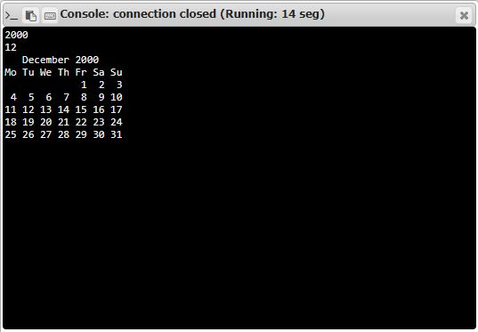

**Result:**

Thus the code was executed successfully and the output is displayed.