**Exercise No :** 10 **Reg. No:** 1518102082

**Date :** 23-11-2020

**Aim:**

To write a python program to calculate number of uppercase letters and lowercase letters.

**Program:**

def string_test(str):

d = {"upper_case":0, "lower_case":0}

for i in str:

if i.isupper():

d["upper_case"] += 1

elif i.islower():

d["lower_case"] += 1

print("No. of Upper case Characters : ", d["upper_case"])

print("No. of Lower case Characters : ", d["lower_case"])

str = input()

string_test(str)

**Link:**

<http://103.53.53.18/mod/vpl/forms/submissionview.php?id=325&userid=1693>

**Output:**

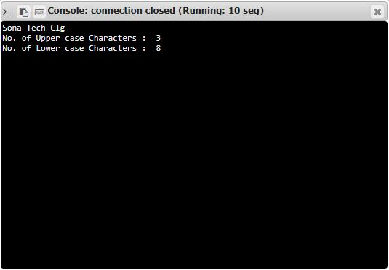

**Result:**

Thus the code was executed successfully and the output is displayed.