**Exercise No :** 11 **Reg. No:** 1518102082

**Date :** 23-11-2020

**Aim:**

To write a python program GCD of two numbers using recursion.

**Program:**

def gcd(a,b):

if b == 0:

return a

return gcd(b, a%b)

a = int(input("Enter first number: "))

b = int(input("Enter second number: "))

gcd = gcd(a,b)

print('GCD is: ',gcd)

**Link:**

<http://103.53.53.18/mod/vpl/forms/submissionview.php?id=326&userid=1693>

**Output:**

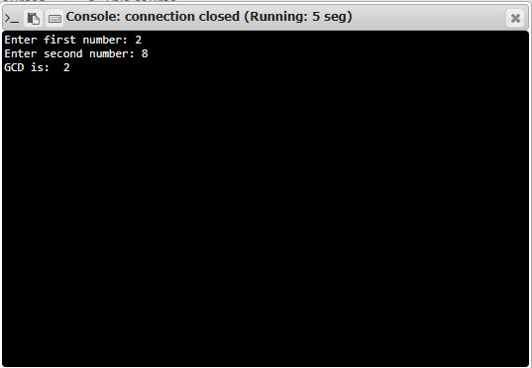

**Result:**

Thus the code was executed successfully and the output is displayed.