**Exercise No :** 13 **Reg. No:** 1518102082

**Date :** 23-11-2020

**Aim:**

To write a python program to implement given class diagram for the Apparel shop.

**Program:**

class Apparel:

counter = 100

def __init__(self, price, item_type):

Apparel.counter += 1

self.__item_id = item_type[0] + str(Apparel.counter)

self.__price = price

self.__item_type = item_type

def calculate_price(self):

self.__price += self.__price*0.05

def get_item_id(self):

return self.__item_id

def get_price(self):

return self.__price

def get_item_type(self):

return self.__item_type

def set_price(self,price):

self.__price = price

return self.__price

class Cotton(Apparel):

def __init__(self, price, discount):

super().__init__(price, 'cotton')

self.__discount = discount

def calculate_price(self):

super().calculate_price()

price = self.get_price()

price -= price*(self.__discount/100)

price += price*0.05

self.set_price(price)

return price

def get_discount(self):

return self.__discount

class Silk(Apparel):

def __init__(self, price):

super().__init__(price,'Silk')

self.__points = None

def calculate_price(self):

super().calculate_price()

if(self.get_price()>10000):

self.__points = 10

else:

self.__points = 3

return self.set_price(self.get_price() + (self.get_price()*0.1))

def get_points(self):

return self.__points

silk = int(input())

cotton = int(input())

discount = int(input())

a = Silk(silk)

print(a.calculate_price())

b = Cotton(cotton, discount)

print(b.calculate_price())

**Link:**

<http://103.53.53.18/mod/vpl/forms/submissionview.php?id=328&userid=1693>

**Output:**

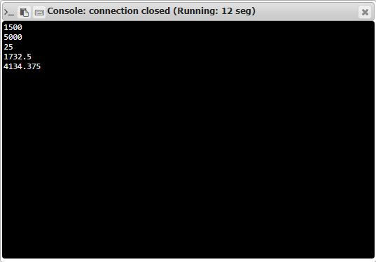

**Result:**

Thus the code was executed successfully and the output is displayed.