**Exercise No :** 14 **Reg. No:** 1518102082

**Date :** 23-11-2020

**Aim:**

To write a python program to find the validity of a string of parentheses.

**Program:**

def areBracketsBalanced(expr):

stack = []

for i in expr:

if i == '(' or i == '[' or i == '{':

stack.append(i)

else:

if not stack:

return False

top = stack.pop()

if(i == ')' and top != '('):

return False

if(i == ']' and top != '['):

return False

if(i == '}' and top != '{'):

return False

if stack:

return False

return True

if __name__=="__main__":

expr = input()

if areBracketsBalanced(expr):

print("valid")

else:

print("invalid")

**Link:**

<http://103.53.53.18/mod/vpl/forms/submissionview.php?id=327&userid=1693>

**Output:**

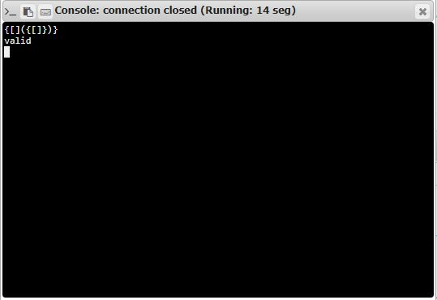

**Result:**

Thus the code was executed successfully and the output is displayed.