**Exercise No :** 02 **Reg. No:** 1518102082

**Date :** 15-10-2020

**Aim:**

To write a python program to count occurrence of x in given list.

**Program:**

def countX(list1,x):

count = 0

for i in range(0,len(list1)):

if(list1[i] == x):

count = count + 1

print(count)

list1=[]

n = int(input())

for i in range(0,n):

list1.append(int(input()))

x = int(input())

countX(list1,x)

**Link:**

<http://103.53.53.18/mod/vpl/forms/edit.php?id=230&userid=1693>

**Output:**

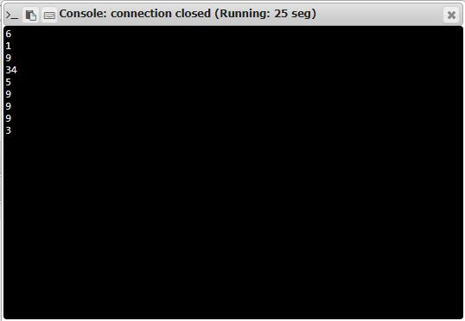

**Result:**

Thus the code was executed successfully and the output is displayed.