**Exercise No :** 03 **Reg. No:** 1518102082

**Date :** 15-10-2020

**Aim:**

To write a python program to remove and print every second number in the list until it becomes empty.

**Program:**

def removeThirdNumber(list1):

templist = []

pos = 1

s = 0

for i in range(0,len(list1)):

s = (pos + s) % len(list1)

rem = list1.pop(s)

templist.append(rem)

return templist

n = int(input())

list1=[]

for i in range(0,n):

list1.append(int(input()))

p = removeThirdNumber(list1)

print(p)

**Link:**

<http://103.53.53.18/mod/vpl/forms/edit.php?id=231&userid=1693>

**Output:**

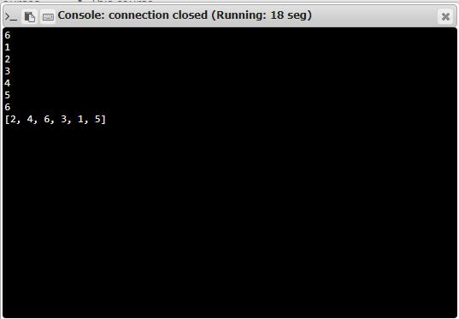

**Result:**

Thus the code was executed successfully and the output is displayed.