**Exercise No :** 04 **Reg. No:** 1518102082

**Date :** 15-10-2020

**Aim:**

To write a python program to swap the first two characters of each string and print as a single string.

**Program:**

def swap_chars(str):

st = ""

for i in str:

st += i

return st

x = input()

y = input()

str1 = x.strip()

str2 = y.strip()

if(len(str1)>=2 and len(str2)>=2):

temp1 = list(str1)

temp2 = list(str2)

cp1 = temp1[0]

cp2 = temp1[1]

temp1[0] = temp2[0]

temp1[1] = temp2[1]

temp2[0] = cp1

temp2[1] = cp2

str1 = swap_chars(temp1)

str2 = swap_chars(temp2)

print(str1," ",str2)

else:

print("Invalid")

**Link:**

<http://103.53.53.18/mod/vpl/forms/edit.php?id=234&userid=1693>

**Output:**

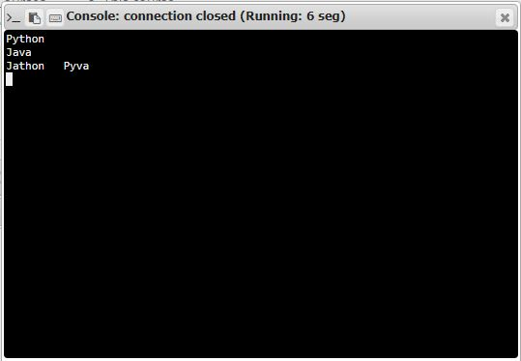

**Result:**

Thus the code was executed successfully and the output is displayed.