**Exercise No :** 05 **Reg. No:** 1518102082

**Date :** 15-10-2020

**Aim:**

To write a python program to print missing characters to make given string a pangram.

**Program:**

str = input()

str = str.lower()

str = str.replace(" ","")

alpha_flag = [0]*26

for char in str:

asci = ord(char) - 97

alpha_flag[asci] = 1

asci = 0

for i in range(0, len(alpha_flag)):

if(alpha_flag[i] == 0):

asci = i + 97

print(chr(asci),end = "")

**Link:**

<http://103.53.53.18/mod/vpl/forms/edit.php?id=235&userid=1693>

**Output:**

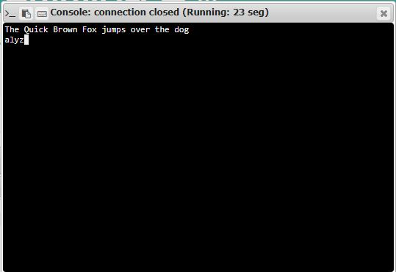

**Result:**

Thus the code was executed successfully and the output is displayed.