**Exercise No :** 06 **Reg. No:** 1518102082

**Date :** 15-10-2020

**Aim:**

To predict output of the given python programs.

**Program:**

# Create a tuple, also called tuple packing.  
numbers = 1, 2  
print(numbers)

**(1, 2)**

# Create tuple with paranthesis.  
numbers = (1, 2, 3)  
print(numbers)

**(1, 2, 3)**

# Create an empty tuple.  
numbers = ()  
print(numbers)

**()**

# Create a tuple with one item. Note that the trailing comma is necessary  
numbers = 1,  
print(numbers)

**(1, )**

# Create a tuple with heterogenous items.  
random_tuple = "Hey", (1, 2), 1, ["you"]  
print(random_tuple)

**('Hey', (1, 2), 1, ['you'])**

# Create tuple with tuple() constructor.  
numbers = tuple()  
print(numbers)

**()**

numbers = tuple([1, 2]) #  Takes any sequence as input  
print(numbers)

**(1, 2)**

#### Methods on tuples #####  
# Get length of list by using len() method.  
numbers = 5, 8, 8  
print(len(numbers))

**3**

# Get index of an element using the index() method.  
numbers = 5, 8, 8  
print(numbers.index(8))

**1**

# Count occurences of an item in a tuple.  
numbers = 5, 8, 8  
print(numbers.count(8))

**2**

eggs = ('hello', 42, 0.5)   
eggs[0]

**hello**

eggs[1:3]

**(42, 0.5)**

len(eggs)

**3**

# Access elements of a tuple by indexing.  
str_tuple = "hey", "there!", "how", "are", "you?"  
print(str_tuple[0])

**Hey**

print(str_tuple[len(str_tuple) - 1])

**you?**

print(str_tuple[-1])

**you?**

# Slicing a tuple.

str_tuple = "hey", "there!", "how", "are", "you?"  
print(str_tuple[2:])

**('how', 'are', 'you?')**

print(str_tuple[:2])

**('hey', 'there!')**

print(str_tuple[-3:])

**('how', 'are', 'you?')**

print(str_tuple[:-3])

**('hey', 'there!')**

print(str_tuple[1:4])

**('there!', 'how', 'are')**

# Get a copy of the tuple by slicing.  
print(str_tuple[:])

**('hey', 'there!', 'how', 'are', 'you?')**

# Concatenate tuples.  
numbers = (1, 2)  
strings = ("Hey", "there")  
print(numbers + strings)

**(1, 2, 'Hey', 'there')**

# Looping through tuple using 'in'.  
numbers = 1, 2  
for number in numbers:  
  print(number)

**1 2**

# Check if element is present in tuple.  
numbers = 1, 2  
print(1 in numbers)

**True**

print(5 in numbers)

**False**

# Tuple packing.  
# We are packing two items 1 and 2 into the tuple.  
numbers = 1, 2  
# Tuple sequence unpacking.   
# Number of variables used has to be same as the number of items in the tuple.  
# Unpacking the tuple and assigning its items to x and y.  
x, y = numbers  
# Note that this is also packing the args as a tuple which gets unpacked as the print method's arguments.  
print(x, y)

**1 2**

**Link:**

<http://103.53.53.18/mod/hvp/view.php?id=238>

**Output:**

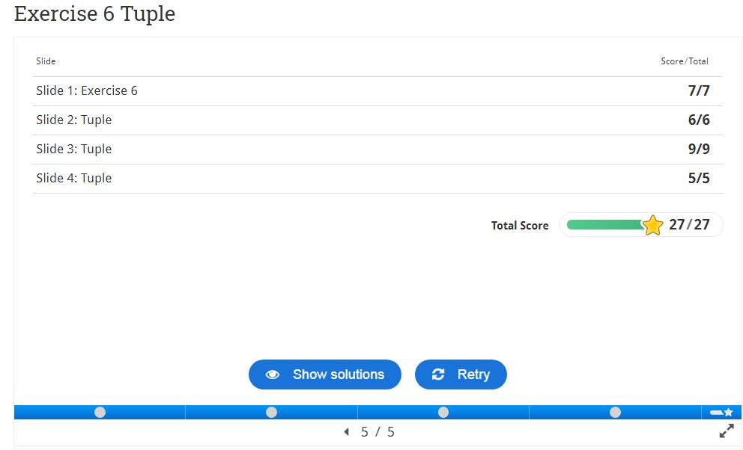

**Result:**

Thus the code was executed successfully and the output is displayed.