**Exercise No :** 08 **Reg. No:** 1518102082

**Date :** 23-11-2020

**Aim:**

To write a python program to sort the given list of tuples in increasing order of last element of each tuple.

**Program:**

n = int(input())

list1 = []

for i in range(0,n):

x = int(input())

list1.append((x, x*x*x))

print(list1)

for i in range(0,len(list1)):

for j in range(i+1,len(list1)):

if(list1[j][-1] < list1[i][-1]):

temp = list1[i]

list1[i] = list1[j]

list1[j] = temp

print(list1)

**Link:**

<http://103.53.53.18/mod/vpl/forms/edit.php?id=317&userid=1693>

**Output:**

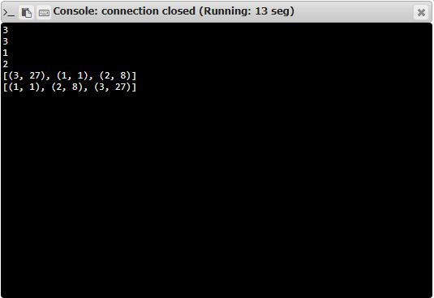

**Result:**

Thus the code was executed successfully and the output is displayed.