Naveen S



**[snaveen1052@gmail.co](mailto:nandhinim29102000@gmail.co)m**

**9566331052**

**Dindigul, Tamil Nadu**

[**Github/naveens.com**](https://github.com/Naveens-alt)

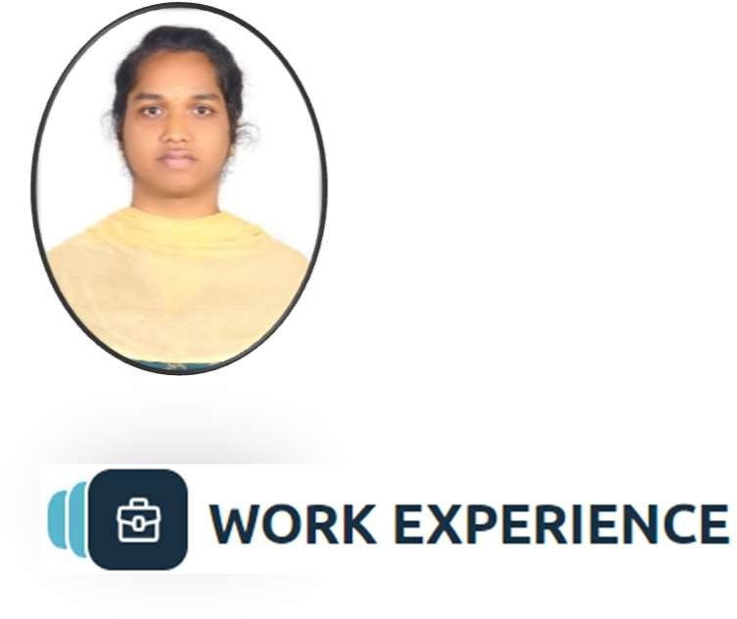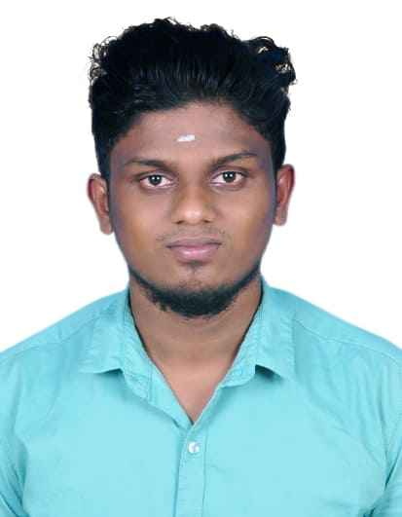

Associate Software Engineer

To obtain a challenging position in a high-quality engineering environment where my resourceful experience and academic skills will add value to organizational operations.

# Associate Software Engineer

MPHASIS LTD

*12/2024 - Present*





MySQL, MS SQL Server,

Mongodb

Talend ETL

PowerBI

Cloud Development with

HTML,CSS and JAVASCRIPT By

IBM – edx

Python Course For Beginners With Certification : Mastering the Essentials - Scaler

Editing

Traveling

Cooking

Python

## **Sales Data Integration and Processing Pipeline**

 The goal of this project was to automate the process of consolidating sales data from multiple regional sources (East, West, and North Sales), perform data transformations, and generate insights to support business decision-making.

 Used the tUnite component to combine these datasets while maintaining merge order and preserving data integrity.

 Implemented the tMap component for cleansing, standardizing, and mapping input data fields to match business rules. This included filtering out invalid rows, normalizing column formats, and ensuring consistent structure across all data sources.

 Leveraged the tAggregateRow component to summarize sales data. Key metrics such as total sales, average revenue, and count of transactions were calculated to create region-specific and global insights.

 Processed data was stored into two separate databases using tDBOutput components.

 By using the results stored in db created various dashboard using powerbi.

## Book Recommendation System Based on User Dynamic information Using DBSCAN Clustering Approach

 Designed and implemented a dynamic book recommendation system utilizing the DBSCAN approach. The system provided personalized recommendations based on dynamic user information, including age, location, and gender.

 Processed and categorized user demographic data (age, location, and gender) to create dynamic user profiles.

 Applied a density-based clustering algorithm to group users with similar demographic and behavioral characteristics, effectively handling noise and outliers.

# B.Tech (IT)

PSNA College of Engineering and Technology, Dindigul

*2023*

# HSC (12th)

MSP Higher Secondary School, Dindigul

*2019*

# SSLC (10th)

MSP Higher Secondary School, Dindigul

*2017*