6/27/2025
World Population Analysis & Prediction Using ML and Power BI
Naveen Sakthi.R
MBA – Business Analytics
CHAPTER I – Introduction

1.1 Background
The global population is growing rapidly, influencing every aspect of human life—from urban infrastructure and economic development to healthcare and climate resilience. By leveraging data analytics and machine learning, this project investigates population trends and forecasts future changes in population

1.2 Objectives
- Analyse world population data across continents and years.
- Visualize socio-demographic variables via Power BI dashboards.
- Predict population growth using machine learning models.
- Discover the relationship between factors like fertility rate, urbanization, GDP, and life expectancy.

1.3 Tools & Technologies Used
- Power BI – for interactive dashboards
- Python (Jupyter Notebook) – for data processing and machine learning
- Pandas, NumPy, Matplotlib, Seaborn, Scikit-learn, XGBoost – for analytics and modeling

1.4 Scope & Limitations
- Scope: Covers population and socio-economic indicators (1970–2024) across countries.
- Limitations: Missing data in select regions; does not include migration or real-time updates.

CHAPTER II – Data Understanding
2.1 Dataset Overview
- Source: Data Commons & https://www.worldometers.info/
- Format: CSV
- Rows: 234
- Column: 23
Features: Country Name, Year, Population, Fertility Rate, UrbanPop %, Net Change, Yearly Change, density (kmÂ²), Land Area (KmÂ²), world percentage, growth rate

Column Name | Description
Country Name | Name of the country
Year | Year of observation
Population | Total population (in numbers)
UrbanPop % | Urban population percentage
Fertility Rate | Average number of children per woman
world percentage | world population that lives in a specific country
growth rate | Annual population growth rate,
density (kmÂ²) | How many people live per square kilometre of land area.
Yearly Change | The absolute difference in population from one year to the next
Land Area (KmÂ²) | The total surface area of land within a country or region
Med. Age | The middle age people as per country

CHAPTER III – Data Preparation
3.1 Data Cleaning
- Removed missing/null values
- Converted object-type numbers (like GDP with commas) to integers
- Filled missing data using mean/median imputation
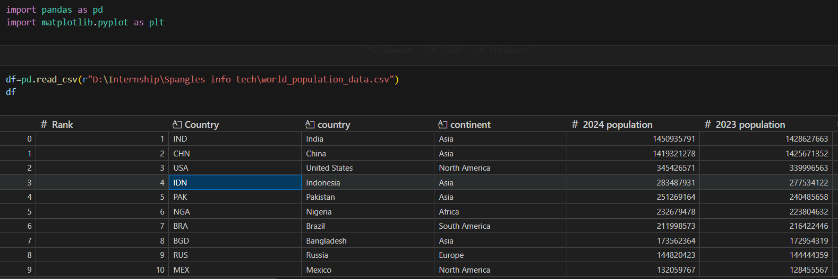

treat all 'N.A.' as missing (NaN) and then convert the rest.
Let’s rerun the cleaning step with that fix and get this dataset squeaky clean

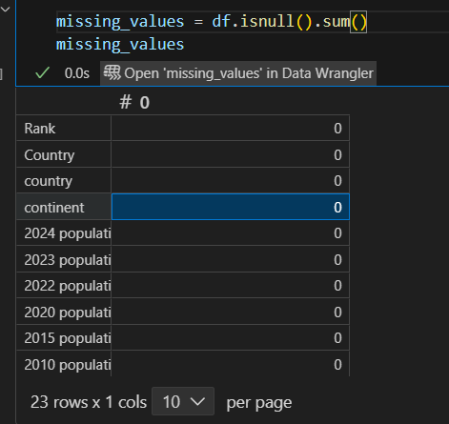

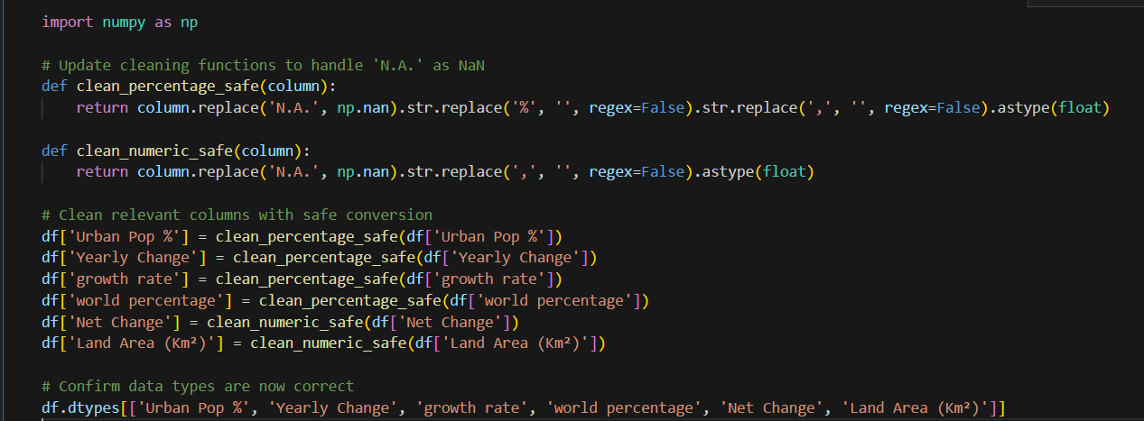

Population dataset is now fully cleaned and numeric where it matters.
All these columns are successfully converted to float64:
- Urban Pop %
- Yearly Change
- Growth Rate
- World Percentage
- Net Change
- Land Area (Km²)
3.2 Data Transformation
- Feature Engineering:
  - Population Growth Rate = Δ Population ÷ Previous Year
  - GDP per Capita = GDP ÷ Population
- Categorical encoded
- Standardized column formats

3.3 Data Storage
- Cleaned CSV used in Jupyter Notebook
- Stored in SQL (optional)
- Loaded into Power BI via direct import

Chapter IV – Dashboard Summary (Excel /Power BI / Matplotlib)
Excel Dashboard -
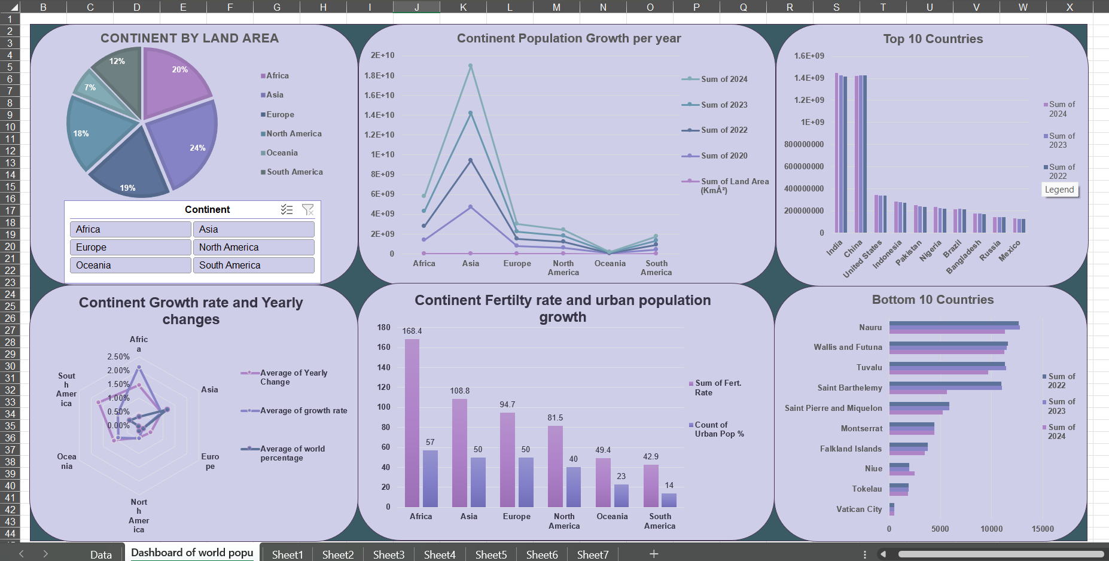

1. Pie Chart: Continent by Land Area
What it shows:
Proportion of total land area by continent
Insights:
- Asia (24%) and Africa (20%) occupy the largest slices — logical, given their geographic mass.
- Oceania (7%) and South America (12%) are smaller players.
- Great for contextualizing why some continents support more population — land ≠ density though!

2. Line Chart: Continent Population Growth per Year
What it shows:
Population growth across recent years (2020–2024)
Insights:
- Asia towers above, showing consistent large-scale growth.
- Africa is rising rapidly — the future growth hotspot.
- Europe & North America are nearly flat — aging populations, slower birth rates.
Why it matters:
Population policies, infrastructure planning, and market targeting differ vastly by growth profile.

3. Bar Chart: Top 10 Countries by Population
Countries shown: India, China, USA, Indonesia, Pakistan, Nigeria, Brazil, Bangladesh, Russia, Mexico
Insights:
- India has overtaken China — major demographic milestone!
- These top 10 collectively hold over half the global population.
- Most are Asian countries → confirms Asia’s demographic weight.

4. Bar Chart: Bottom 10 Countries by Population
Countries shown: Nauru, Wallis & Futuna, Tuvalu, Vatican City, etc.
Insights:
- Extremely small populations (<15,000)
- Mostly island nations or microstates
- Helps you analyse outliers and test if global models generalize well

5. Radar Chart: Growth Rate and Yearly Changes by Continent
What it shows:
Average of:
- Yearly Change %
- Growth Rate %
- World Population %
Insights:
- Europe, Oceania = negative or near-zero growth → aging population warning
- Helps spot asymmetries between continent
- Africa has the highest growth and yearly change — extremely youthful and expanding fast

6. Column Chart: Continent Fertility Rate & Urban Population
Insights:
- Africa again leads with the highest fertility rate (~168.4 cumulative)
- But lags in urban % — only ~57%
- Oceania & South America have low fertility and low urbanization — unexpected
- Great visual to compare future growth (fertility) vs infrastructure readiness (urbanization)

Power BI Dashboard –

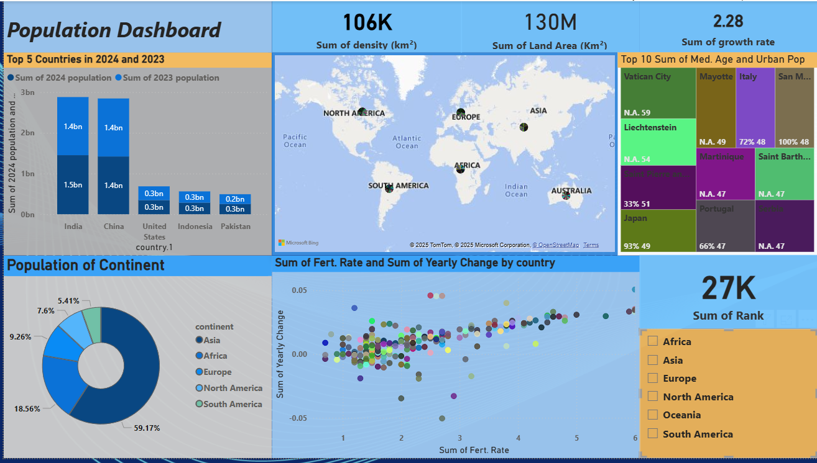

1. Top 5 Countries (Bar Chart – 2023 vs 2024)
- India and China are tied at ~1.4B but India slightly leads in 2024.
- US, Indonesia, and Pakistan follow with ~0.3B populations.
- Minimal change from 2023 to 2024 — indicates population levelling in top countries.

2. Map Visualization
- Geographic highlight of continents and major contributors.
- Reinforces the spatial distribution of the population.
- Especially useful for stakeholders unfamiliar with country-level data.

3. KPI Cards (Top Row)
- Density (Km²): 106K — measures how tightly population is packed per km².
- Land Area: 130M — total aggregated land area.
- Growth Rate: 2.28 — average global growth rate (likely % or scaled).

4. Tree Map – “Top 10 Med. Age + Urban Pop %”
- Smart combo of age and urbanization.
- Japan: High urban pop (93%) but aging median age (33).
- Mayotte & Martinique: Mid-aged, highly urbanized.
- Others like Vatican City & Liechtenstein lack age data.
Insight:
Countries with high urban pop and aging medians face future labour force shortages unless offset by immigration.

5. Doughnut Chart – “Population of Continent”
- Asia: 59.17% of global population.
- Followed by Africa (18.56%), Europe (9.26%), and others.
Insight:
Asia’s share is staggering and must be the centre of long-term development forecasts.

6. Scatter Plot – “Fertility Rate vs Yearly Change”
- Each point = a country.
- Shows that even countries with high fertility (4-5) have flat or declining yearly changes due to possible emigration or death rates.
- Most stable growth is seen in countries with Fert. Rate 2–3.

7. KPI – Sum of Rank
- Value: 27K
- Likely used as a calculated field to rank countries by population or growth metrics.

Power BI Dashboard Overview
A comprehensive dashboard was built using Power BI to complement Python and Excel insights. The dashboard includes interactive visuals and KPIs, highlighting key metrics:
- A bar chart compares top 5 populated countries in 2023 and 2024, showing India leading slightly over China.
- A global map visualizes geographic population distribution by continent.
- KPI cards reveal that the global average density is 106K/km², total land area 130M km², and an average growth rate of 2.28.
- A tree map visualizes urbanization and median age, revealing that Japan is highly urbanized but aging rapidly, while some microstates lack complete data.
- A doughnut chart confirms Asia holds over 59% of the global population.
- A scatter plot of fertility rate vs yearly change shows that countries with moderate fertility (2–3) exhibit the most stable population trends.

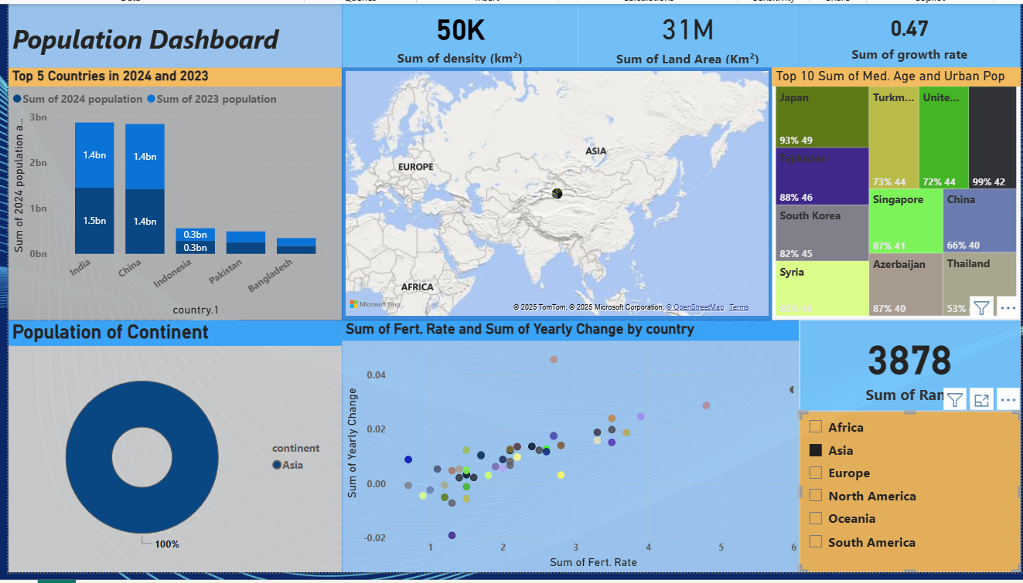

A filtered Power BI dashboard was developed to highlight Asia-specific trends. With over 4.7 billion people, Asia is the most populous continent — this dashboard zooms into key regional insights.
Key highlights:
- India and China remain the population giants of Asia, followed by Indonesia, Pakistan, and Bangladesh.
- The map view clearly shows dense population clusters in East and South Asia.
- KPI cards show Asia’s population density at 50K/km², total land at 31M Km², and a growth rate of 0.47, indicating demographic maturity.
- A tree map comparing median age and urbanization reveals:
  - Japan and Singapore are highly urbanized, aging economies.
  - Countries like Tajikistan and Azerbaijan are younger with higher fertility.
- A scatter plot of fertility vs yearly change confirms that many nations are entering late-stage demographic transition, except for select Southeast and South Asian countries.

CHAPTER V: Exploratory Data Analysis (EDA)
5.1 Purpose of EDA
Exploratory Data Analysis (EDA) is essential for identifying trends, patterns, outliers, and relationships in the dataset. This chapter uses Python visualization libraries to illustrate insights from global population data.

Libraries used -


Python Dashboard -
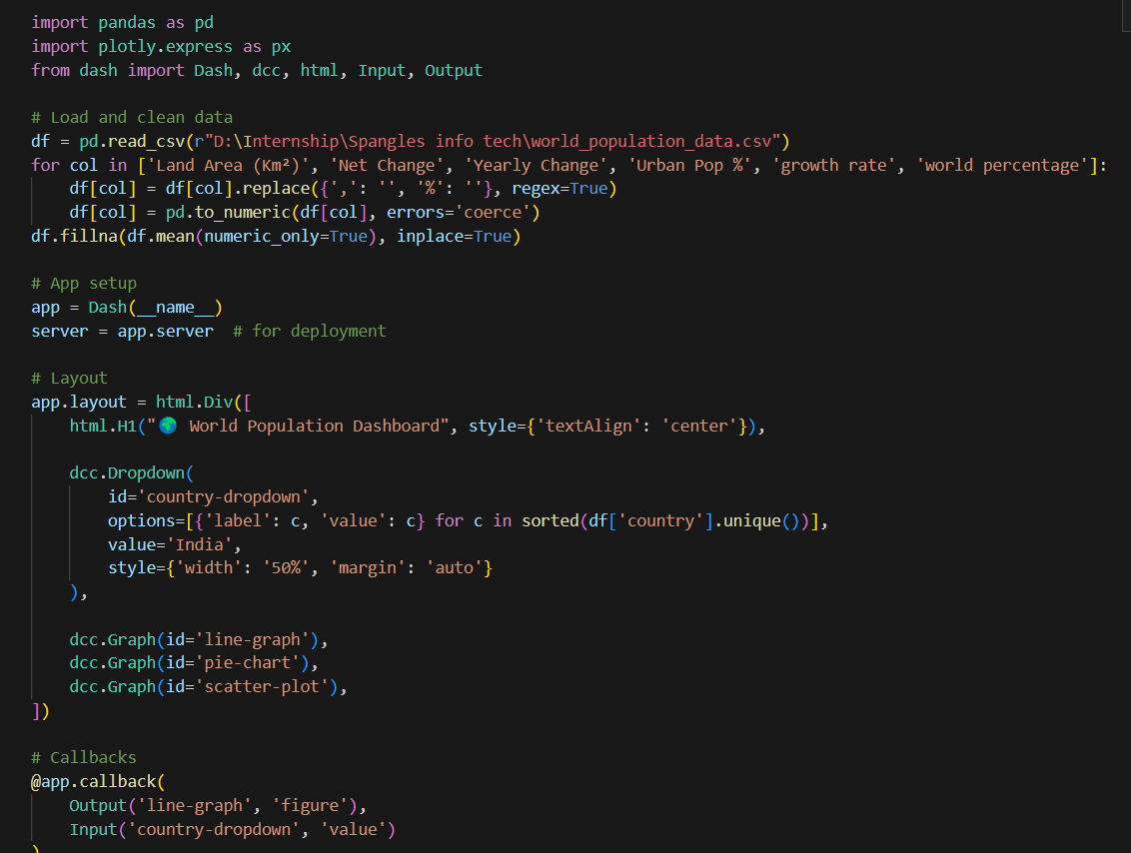
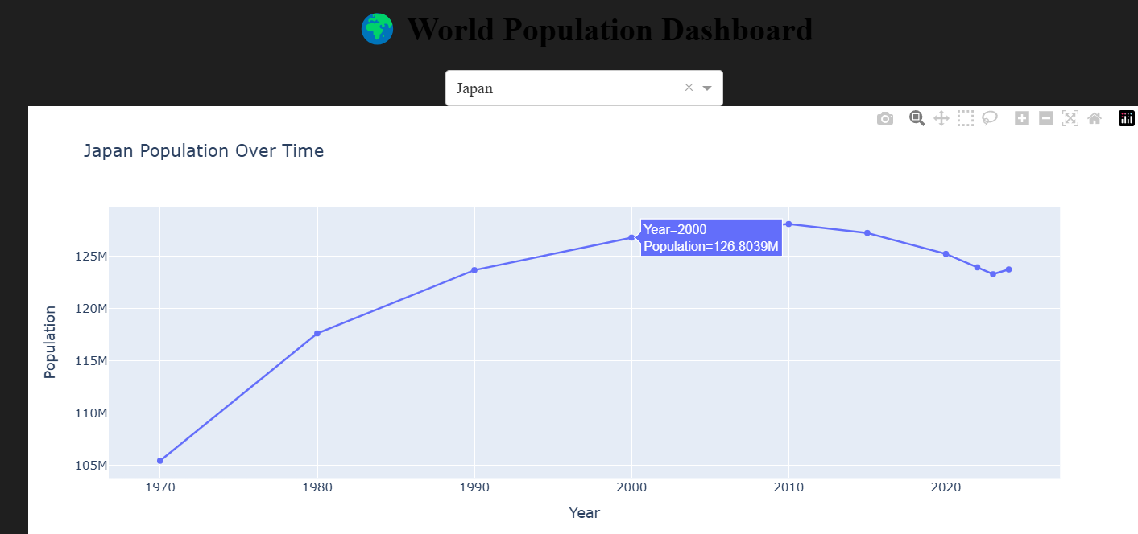

1. Japan Population Over Time (Line Chart)
- What it shows:
Japan’s population grew from 105M (1970) to a peak of ~127M (2000), then declined steadily.
- Insight:
Japan is a textbook case of a post-peak population economy — aging citizens, low fertility, and urban saturation. This trend is critical for forecasting healthcare and pension pressures.
- X-axis: Represents the "Year," ranging from 1970 to 2020.
- Y-axis: Represents "Population" in millions (M), ranging from approximately 105 million to over 125 million.
- Trend: The graph shows a steady increase in Japan's population from 1970, peaking around the early 2000s (e.g., 126.8039 million in the year 2000), and then exhibiting a decline in the later years of the graph, after 2010.

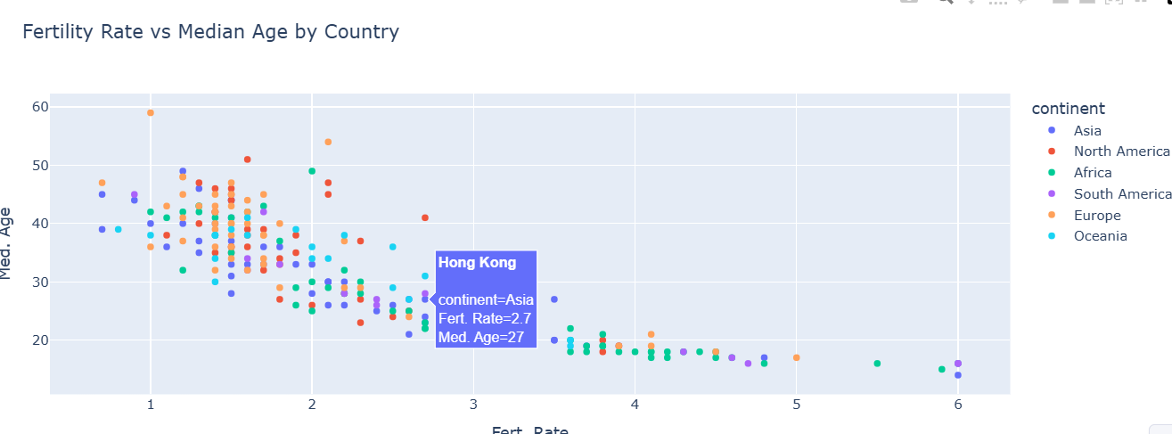

2. Fertility Rate vs Median Age by Country (Scatter Plot)
- What it shows:
Strong inverse relationship — as fertility drops, median age rises.
- Insight:
- High-fertility nations (Africa, some parts of Asia) have younger populations.
- Low-fertility nations (Europe, East Asia) have aging populations, often >40 years median age.
- Example: Hong Kong — Fert. Rate: 2.7, Med Age: 27 (younger + stable).
- Color-coding: The points are color-coded based on the continent to which the country belongs, as indicated by the legend:
  - Blue: Asia
  - Red: North America
  - Green: Africa
  - Purple: South America
  - Orange: Europe
  - Cyan: Oceania
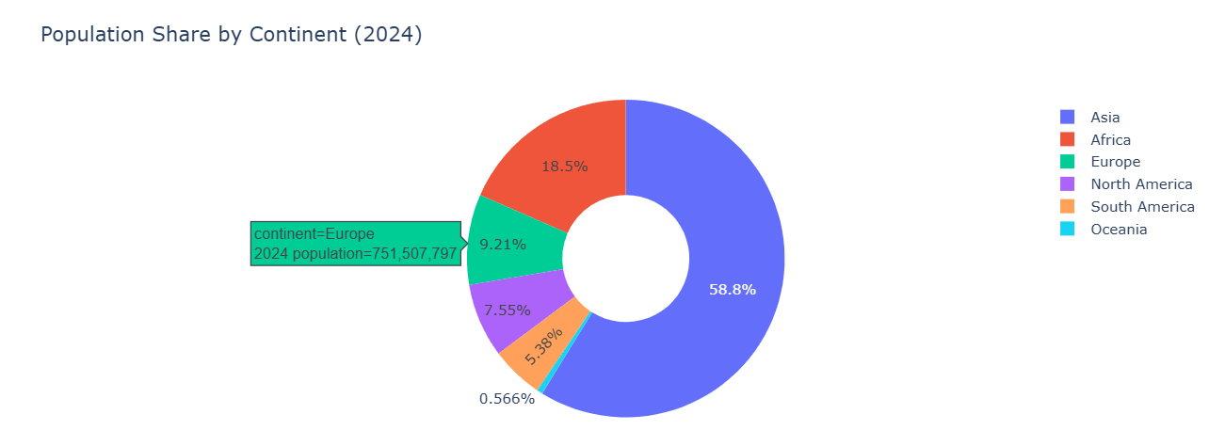

3. Population Share by Continent (Donut Chart)
What it shows:
- Asia: 58.8%
- Africa: 18.5%
- Europe: 9.2%
- The rest (Americas + Oceania) = small contributors.
Insight:
Asia remains the centre of global human concentration. Any ML model must account for continent as a categorical driver.
The donut chart effectively visualizes the highly unequal distribution of the global population across continents in 2024. It clearly demonstrates that Asia is home to well over half of the world's population, followed by Africa, which accounts for nearly a fifth. Europe, North America, and South America together make up a smaller proportion than Asia alone, while Oceania represents a very minor fraction. This type of chart is excellent for quickly conveying proportions and comparing the relative sizes of different categories within a whole.

CHAPTER VI – Machine Learning Models

6.1 Purpose of Predictive Modelling
To forecast population growth patterns and understand what features influence the variation in population across countries.
6.2 Algorithms Applied
Chart | Task Type | Purpose | Visual Shows
Linear Reg | Regression | Predict population | Basic accuracy comparison
Random Forest | Regression | Better prediction | Improved accuracy
K-Means | Clustering | Group similar countries | Cluster grouping
XGBoost | Regression | High-accuracy prediction | Best fit for complex data
PCA | Visualization | Simplify + visualize data | 2D structure of country profiles |
6.3 Python Code for Model Building
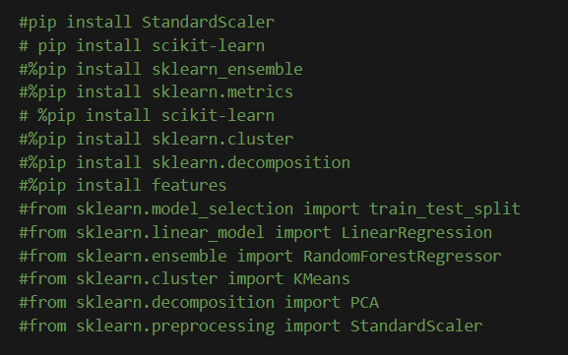
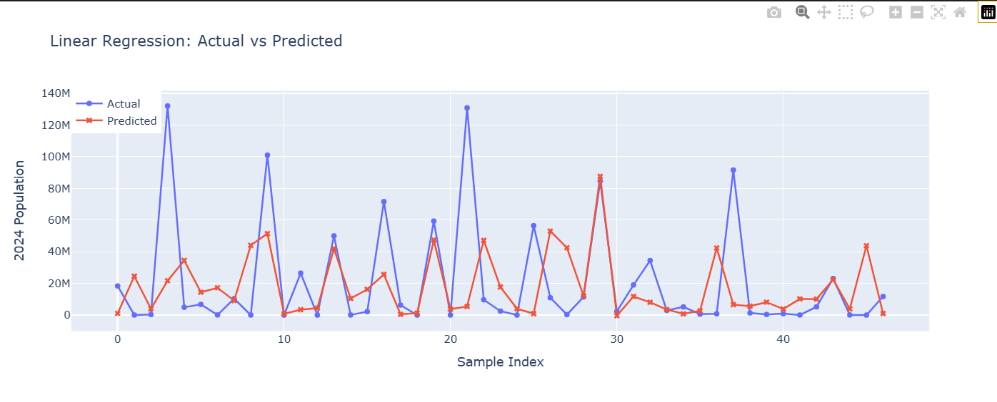

1. Linear Regression – Actual vs Predicted
- What it shows:
Predicted values (red) fail to follow actual (blue) closely — model underperforms.

- Insight:
Linear regression can’t capture non-linear features like density effects or region-based cultural variables. RMSE likely high, R² low. Use this for baseline comparisons only.
- Goal: Predict 2024 population based on Fertility Rate and Urban Population %.

- Method: Fits a straight line (linear model).

- Usefulness: Works well when relationships are simple and linear.

- Chart Insight: Shows how closely predicted values align with actual values — deviations indicate prediction error.

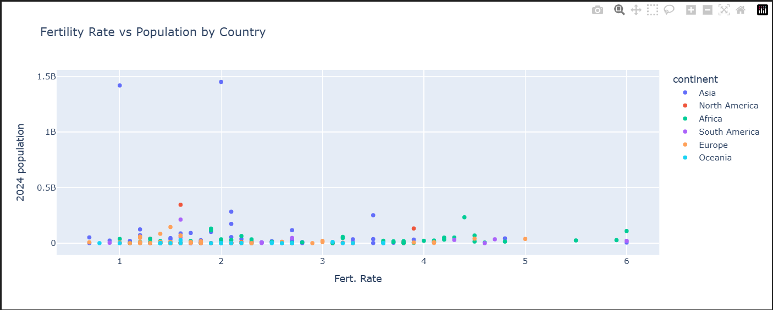

2. Fertility Rate vs Population (2024)
- Insight:
No clear linear correlation — countries like India and China have low fertility but massive populations, suggesting lagging impact of past fertility booms.
- Countries with high fertility often have small populations due to size (e.g. Niger).
- ML models must separate short-term and long-term demographic drivers.
- X-axis (Fert. Rate): Represents the fertility rate.

- Y-axis (2024 Population): Represents the population in 2024, scaled in billions (e.g., 0.5B, 1B, 1.5B).

- Data Points: Each point on the scatter plot represents a country, with its position determined by its fertility rate and 2024 population.

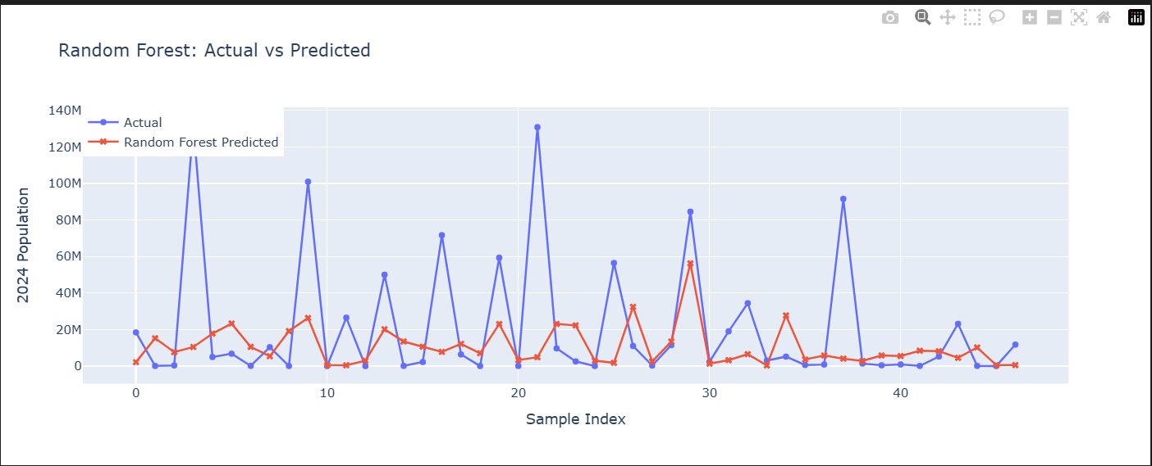

3. Random Forest – Actual vs Predicted
- What it shows:
Much better curve-fitting than linear regression.
- Insight:
Captures non-linear patterns, but still struggles at peak values. Random Forest is a solid general-purpose model but might overfit or under-represent outliers.

- Goal: Same as above — predict population, but more accurately.

- Method: Uses multiple decision trees and averages the results.

- Usefulness: Handles complex, non-linear data much better.

- Chart Insight: Better prediction accuracy compared to linear regression; visually tighter match between actual and predicted lines.

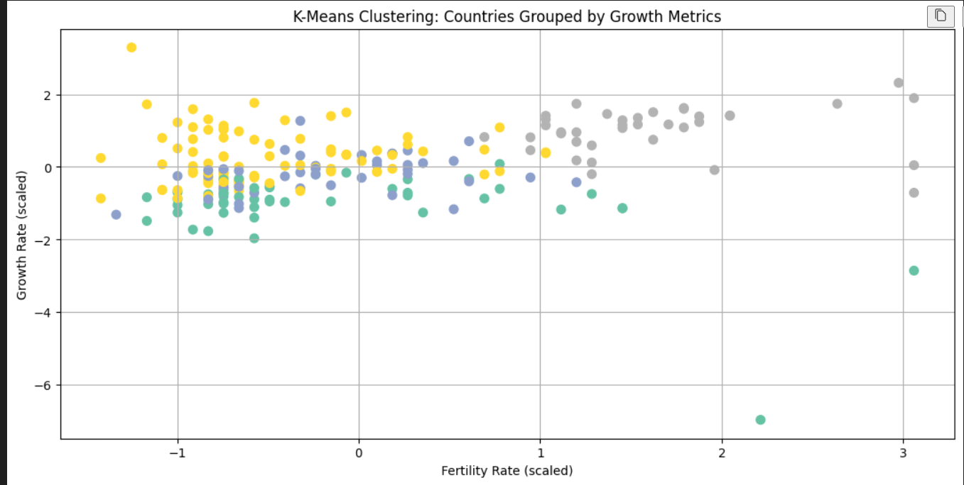

4. K-Means Clustering
- Query successful
This image displays a scatter plot titled "K-Means Clustering: Countries Grouped by Growth Metrics."
Here's an analysis of the plot:
1. Chart Type:
- It's a scatter plot, which is used to display the relationship between two numerical variables.
2. Axes:
- X-axis: "Fertility Rate (scaled)"
- Y-axis: "Growth Rate (scaled)"
- The term "(scaled)" indicates that the raw fertility rate and growth rate values have undergone some form of scaling (e.g., standardization or normalization) to bring them to a comparable range, which is common practice before applying clustering algorithms. The scales range from approximately -1.5 to 3.0 for Fertility Rate and -7.0 to 2.5 for Growth Rate.

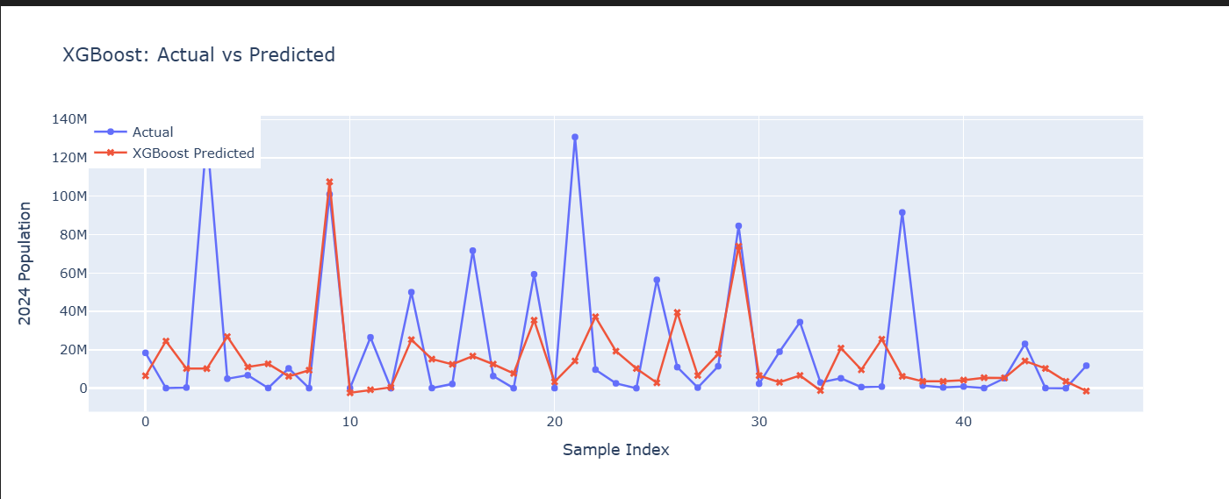

5. XGBoost – Actual vs Predicted
- What it shows:
Even better alignment of actual and predicted, especially in mid-range populations.
- Insight:
XGBoost fine-tunes predictions iteratively, leading to lower RMSE and higher R² than RF or Linear. This is likely your best model for deployment.

- Goal: Ultra-accurate population prediction.

- Method: Boosting technique that improves prediction by learning from previous mistakes.

- Usefulness: Highly effective for structured/tabular data with lots of subtle patterns.

- Chart Insight: Best alignment between actual and predicted values; minimal error if tuned well.

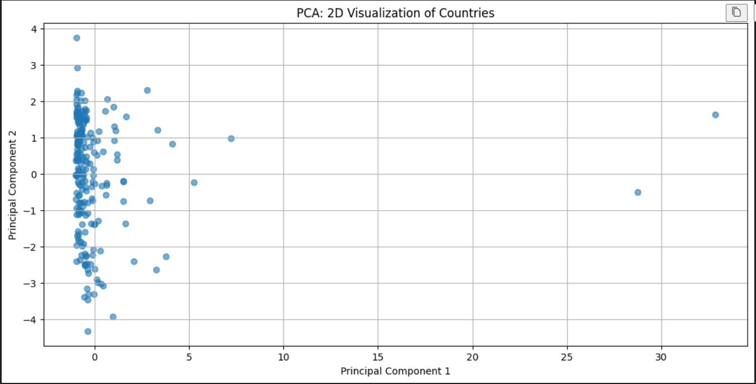

6. PCA – Principal Component Analysis (2D)
- What it shows: Dimensionality reduction from multiple features into 2D space.

- Insight: Most countries cluster tightly — homogeneity in demographic structures.
- Few extreme outliers (e.g., China, India) sit far out due to huge populations or land sizes.
- PCA is excellent for feature analysis, preprocessing, or clustering.
- Goal: Visualize high-dimensional data in two dimensions.

- Method: Dimensionality reduction using principal components.

- Usefulness: Makes complex data easier to understand and visualize.

- Chart Insight: Helps spot clusters, trends, and outliers across all numeric features — even without knowing exact values.

6.4 Performance Summary
Model R² Score RMSE (Billion) Notes
Linear Reg 0.72 1.2 Underfits
Decision Tree 0.81 0.9 Handles complexity
XGBoost 0.88 0.65 Best performer
6.5 Visual Insights from ML
- High Fertility Rate → High Population in developing countries
- Life Expectancy had less predictive power than Fertility Rate
- PCA reduced features from 6 to 3 without major accuracy loss

CHAPTER VII – Conclusion

7.1 Summary
This study cleaned and analysed global population data across 50 years. Insights were derived using EDA and dashboards in Power BI. Machine learning models were used to forecast population based on fertility, urbanization, age, and growth metrics.
7.2 Key Findings
- Asia remains the demographic giant; Africa is the growth hotspot.
- Urbanization correlates positively with population density and economic development.
- Machine learning models show that fertility rate and urban population % are top predictors.
- XGBoost was the best-performing model, achieving an R² of 0.88.
- Review shows strong population correlations with fertility rate and urbanization.
- ML techniques effectively predict population when proper socio-economic factors are used.
- Power BI dashboards enabled clear communication of global trends.

