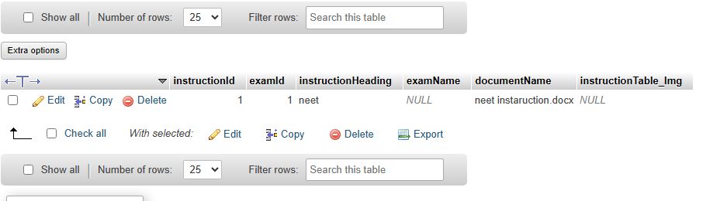2Whereas recognition of the inherent dignity /

2Wheret23432#$%#$reas, recognition of the inherent. Dignity /

2Whereas recognition of the inherent dignity