**1. What is Angular**

Angular is a JS Binding framework, which binds VIEW with Model. This helps to reduce your efforts on writing on lengthy lines of View Model code.

* SPA
* DI

**2. Difference between Angular Js and Angular**

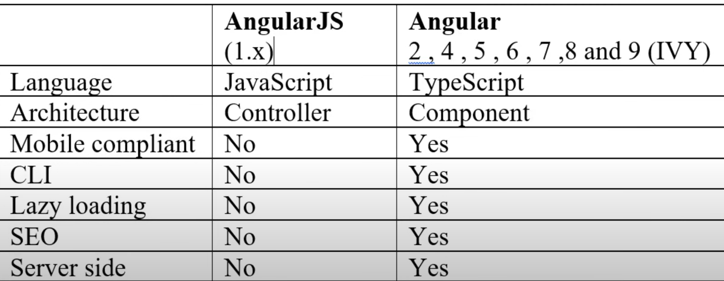

**3. What are directives**

Directives help you to attach the behaviour of HTML code out there.

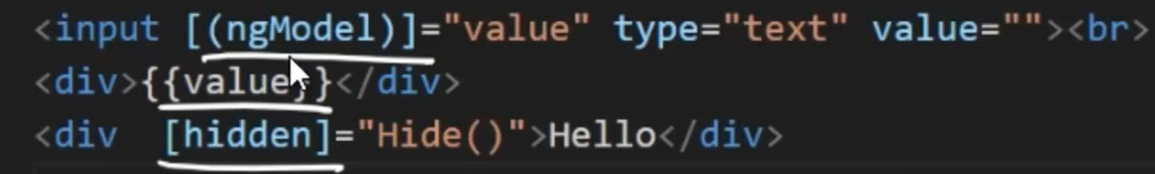

**4. What are different types of directives**

There are 3 types of directives

* Structural – ex: ngFor, ngIf, based on structural objects structure of DOM will change
* Attribute – ex: in above image hidden will hide based on condition, but it still exist in DOM
* Component – ex: customized components

**5. Angular CLI**

CLI stands for Command Line interface, which helps to give scaffold structure of Angular project.

**6. Importance of Components & Modules**

Components – Define and bind model with views

Modules – Combine multiple components

**7. What are Decorators or Annotation or MetaData?**

Decorators define what kind of class is it. For ex, if you decorate with “@Component” then it says it’s Angular Component. If you decorate with “@NgModule”, then it says that it’s Angular Module.

**8. What are Templates?**

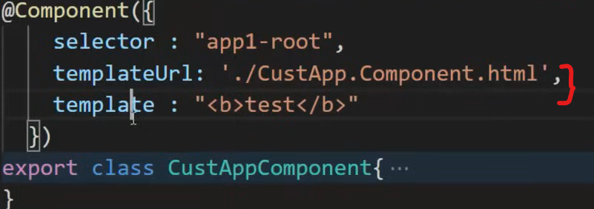

**9. What are Databindings?**

Databindings define how the components and views communicate with each other.

Expression – {{}}

Property Binding – []

Event Binding – ()

2 way binding – [()]

**10. SPA**

SPA loads only once, then based on user clicks the respective components will load.

**11. Lazy loading**

On demand loading components, css, html etc.

Use LoadChildren to bind component in routes

**12. Dependency Injection**

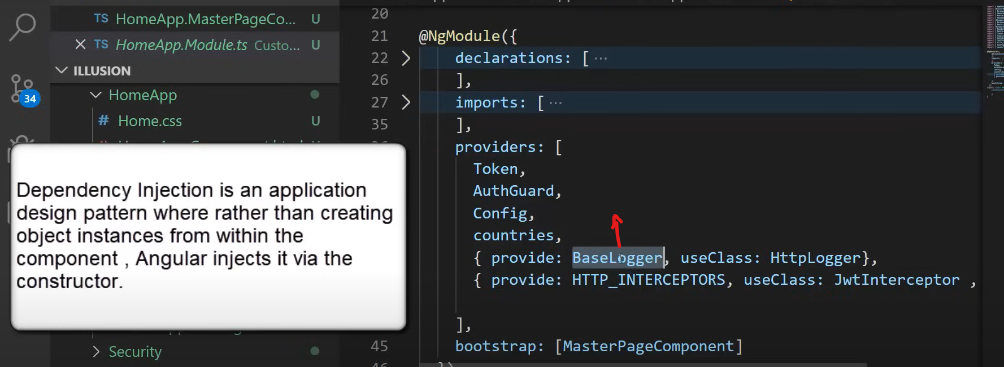

**13. Difference between ng-serve and ng-build?**

Ng-serve builds in-memory (Dev)

Ng-build builds on hard disk (prod)

**14. What does ng-build –prod do?**

--prod minified and remove unnecessary comments etc.

**15. Angular Life Cycle hooks?**

Most frequently used hooks are **ngOnChanges, ngOnInit, ngOnDestroy**

