1. What is React Js?
React js, is a JavaScript library used to build reusable components for the view layer in the MVC architecture. It is used to build the Single Page Application (SPA) due to its component-based architecture, efficient re-rendering with the Virtual DOM, and ability to manage dynamic content without needing full page reloads.
Key Features:
- Virtual DOM
- Component-Based Architecture
- Hooks
- React Router
- SSR
2. Explain Props and State?
Props:
- Data is passed from one component to another component
- It is immutable, cannot be modified
State:
- Data is passed with in the component only
- It is mutable, can be modified
3. What is Virtual DOM?
Virtual DOM in React is in-memory representation of actual DOM. It helps React efficiently update and render the UI by comparing current and previous Virtual DOM by using Diffing Algorithm.
4. Differentiate between Real DOM and virtual DOM?
Real DOM | Virtual DOM
The actual DOM, a tree-like structure representing the UI elements. | A lightweight copy of the Real DOM used to optimize updates.
Slower as it requires direct updates to the actual DOM. | Faster because it minimizes direct manipulation of the Real DOM.
Directly manipulates the Real DOM, causing re-rendering of the entire UI. | Updates are made to the Virtual DOM first, then changes are batched and only the necessary changes are reflected in the Real DOM.
Entire UI might need to be re-rendered when changes occur. | Only the necessary components are re-rendered, reducing unnecessary re-renders.
Less efficient due to repeated direct updates to the Real DOM. | More efficient by minimizing direct DOM manipulation and batch updates.

5. Explain the difference between React and Angular?
React | Angular
React is a JavaScript library. As it indicates react js updates only the virtual DOM is present and the data flow is always in a single direction. | Angular is a framework. Angular updates the Real DOM and the data flow is ensured in the architecture in both directions.
React is more simplified as it follows MVC ie., Model View Control. | The architecture is complex as it follows MVVM models ie., Model View-ViewModel.
It is highly scalable. | It is less scalable than React JS.
It supports Uni-directional data binding which is one-way data binding. | It supports Bi-directional data binding which is two-way data binding.
It has a virtual DOM. | It has regular DOM.

6. Explain the use of render method?
Render method helps to define HTML body of the component.
7. Higher Order Component in React?
HOC is the advanced method of reusing the component functionality logic. It simply takes the original component and returns the enhanced component.
Advantages:
- Reusability
- Flexibility
- Separations of concern
- Composition
When to Use:
- Authentication
- Logging
- Styling and Theming
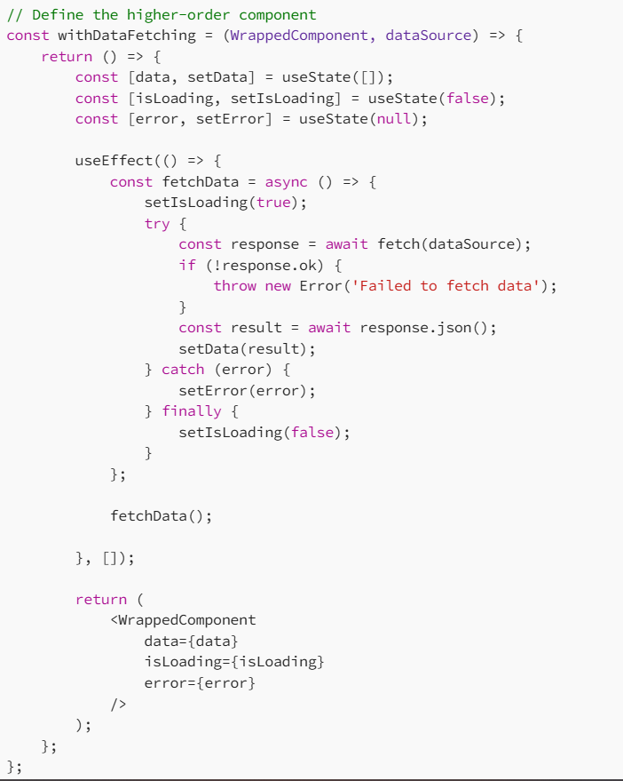
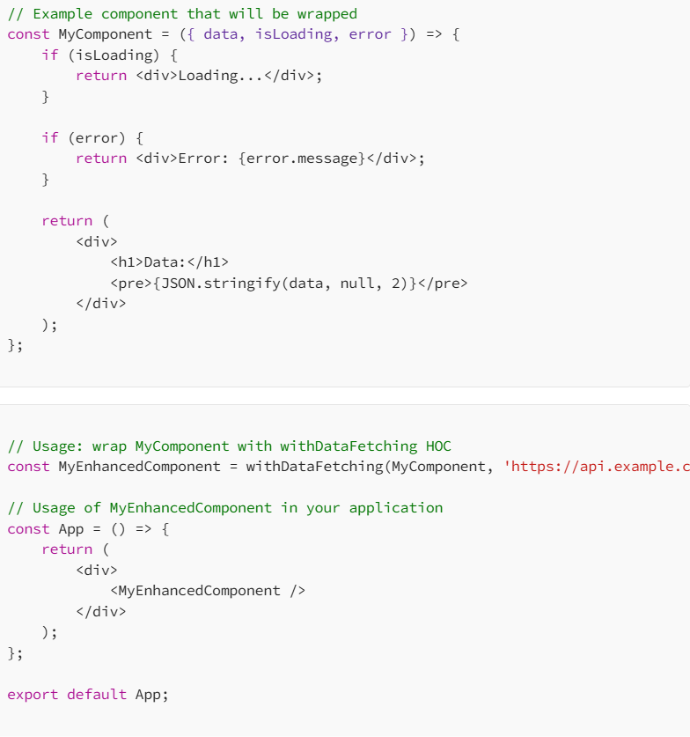

8. React Life Cycle methods?
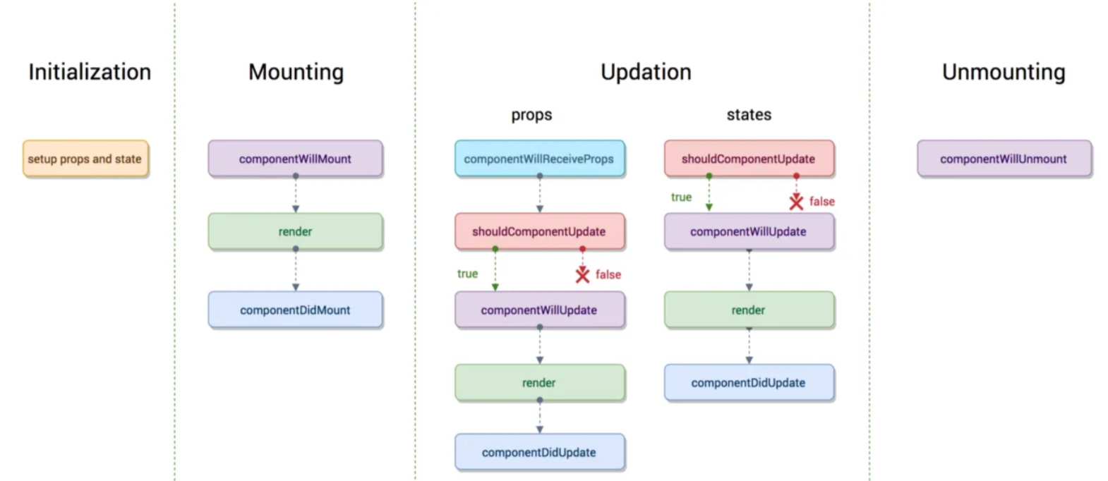
- Initialization: This is the stage where the component is constructed with the given Props and default state. This is done in the constructor of a Component Class.
- Mounting: Mounting is the stage of rendering the JSX returned by the render method itself.
- Updating: Updating is the stage when the state of a component is updated and the application is repainted.
- Unmounting: As the name suggests Unmounting is the final step of the component lifecycle where the component is removed from the page.

9. How is React routing different from conventional routing?
React Routing | Conventional Routing
Used in Single Page Applications (SPA). | Typically used in Multi-Page Applications (MPA).
No full page reloads. React updates only the necessary parts of the UI. | Full page reload is triggered for every navigation request.
React uses a client-side router (e.g., React Router) to handle navigation and manage different views within the same page. | Uses server-side routing where the server responds with new HTML for each navigation.
Routes are managed by JavaScript, and the browser’s address bar reflects the application’s state. | Routes correspond to different server-side routes, and the server responds with new HTML files.

10. React Hooks
- useState
it will deal managing state in react functional components
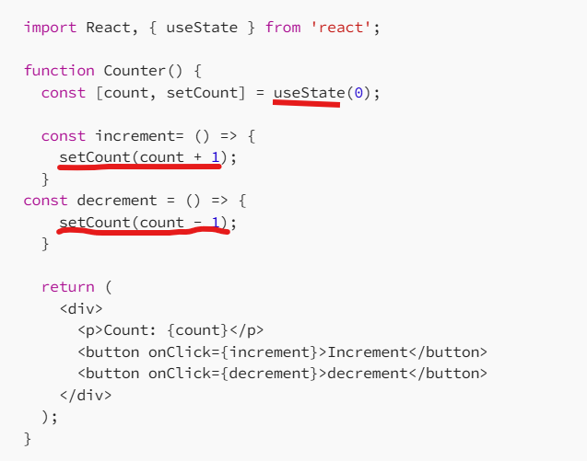
- useEffect
useEffect is a react hook that allows the performance of side effects in functional components, like Data fetching, DOM manipulation etc.
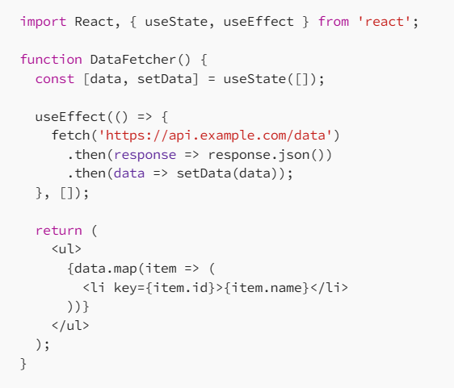
- useContext
to avoid props drilling and passing data to different levels of components we used useContext hook.
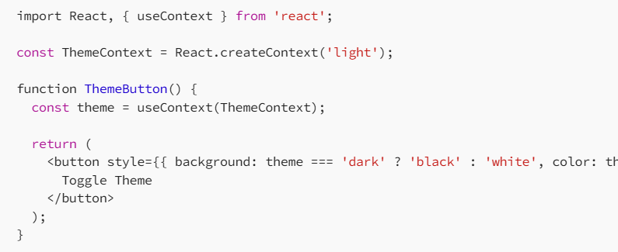
- useReducer
it is similar to useState hook, the difference between these 2 is, useState will update state for simple type with local storage, whereas useReducer will update state for complex details like Reducers with global storage etc.
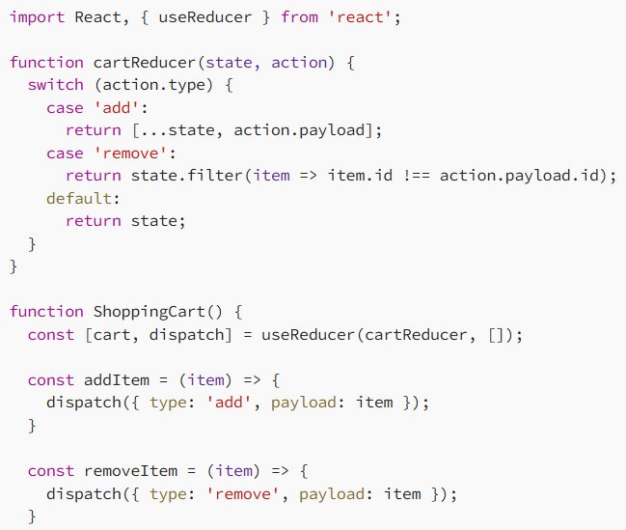
- useCallback
useCallback memoize the function itself.
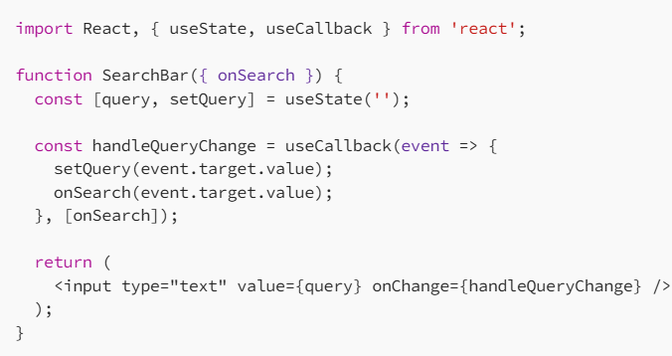
- useMemo
useMemo memorize the result of a function.
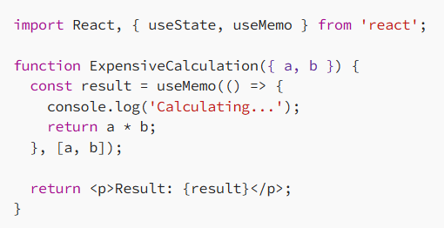
- useRef
useRef hook allows you to create a mutable ref object that persists for the lifetime of a component. We can change the value without re-render the component.

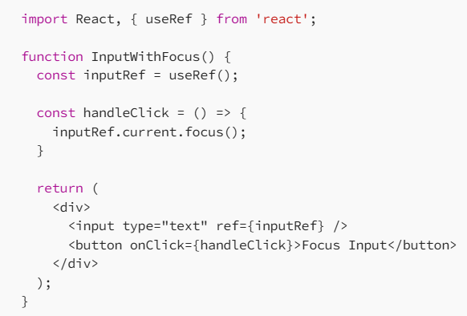
- useImperativeHandle
Ref hold DOM result, but when we want to pass methods to parent component using Ref instance, we are going to use useImperativeHandle hook.
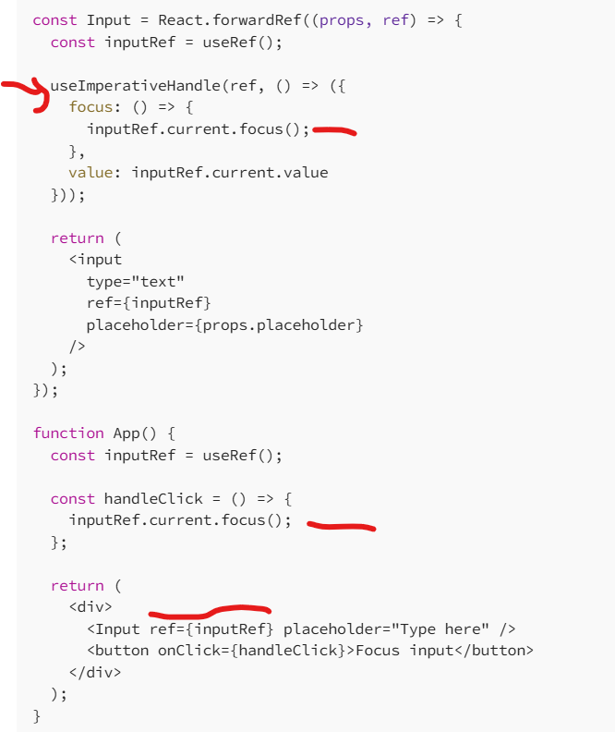

11. Why we use React fragment?
React fragment have a smaller DOM; they render faster and use less memory.
<React.Fragment></React.Fragment>
12. Explain styled components in React?
Styled components we used to design css using code blocks.
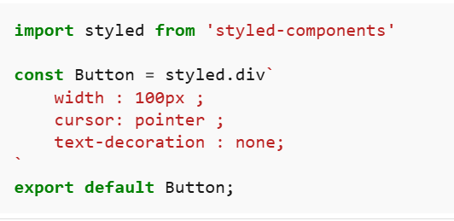
13. Design Custom Hooks?
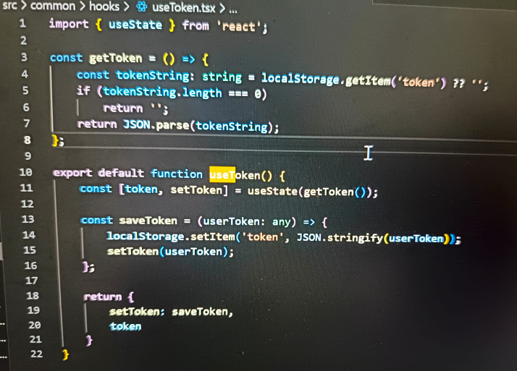
14. ContextAPI?
- Create context
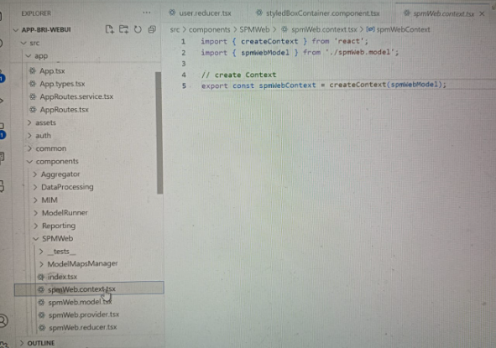
- Create Provider
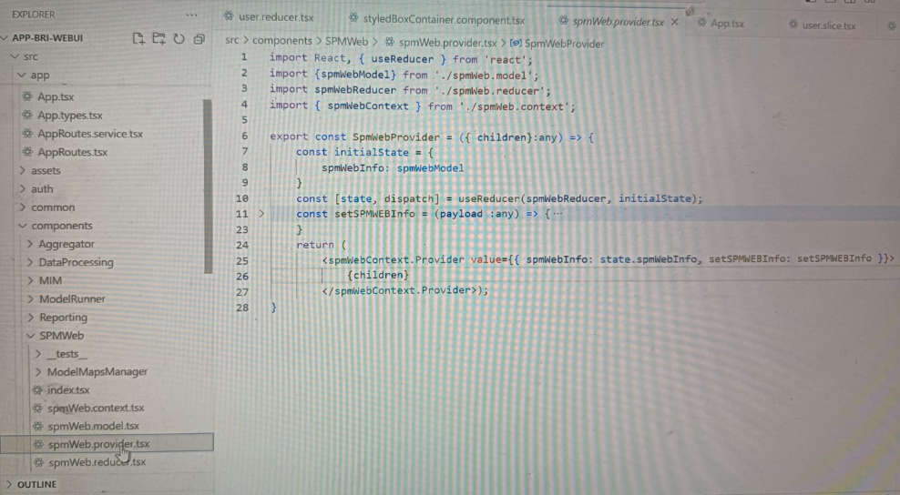
- Use the provider in index file
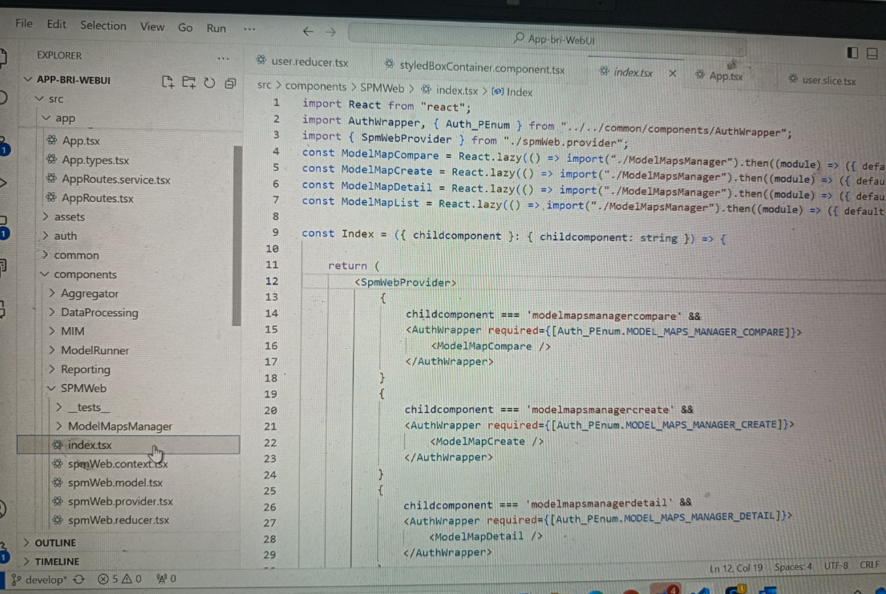
15. React Redux
- Create Reducers
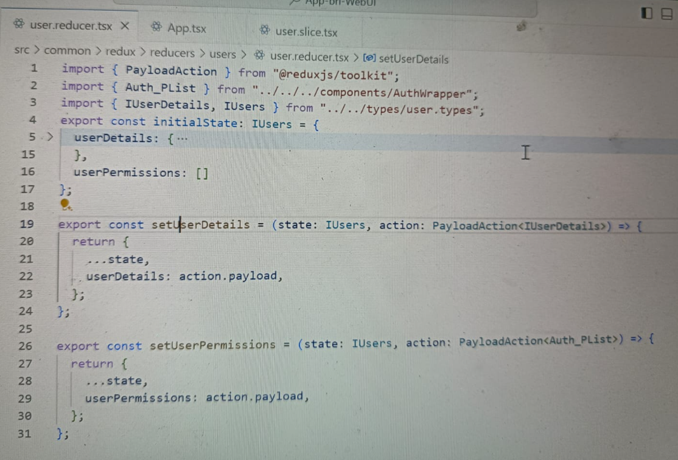
- Create Slice
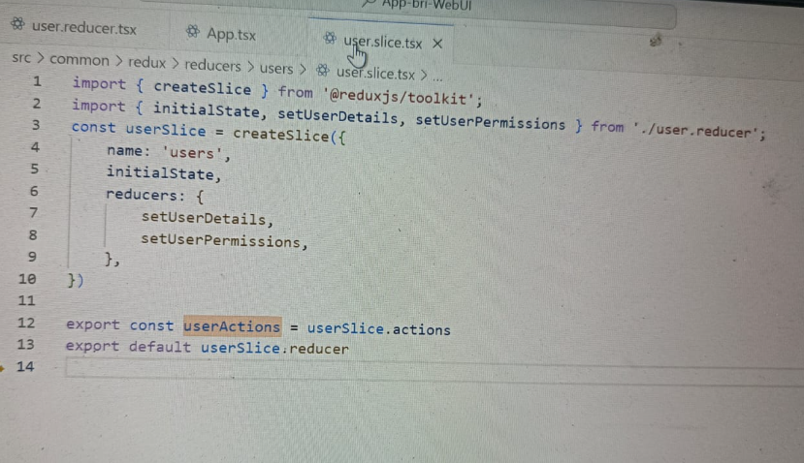
- Combine reducers
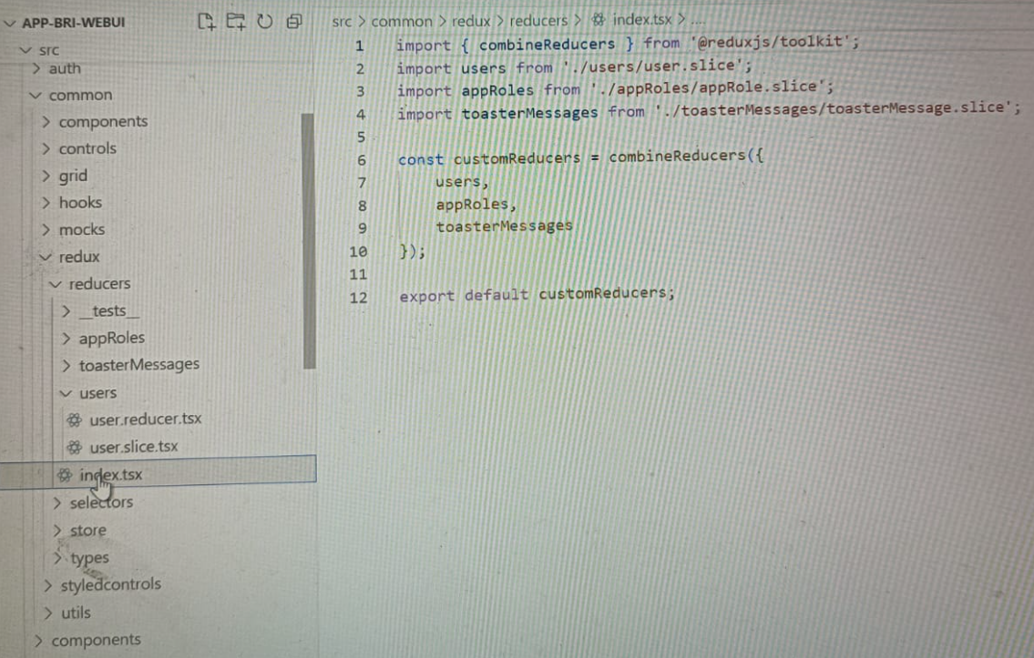
- Create Selector
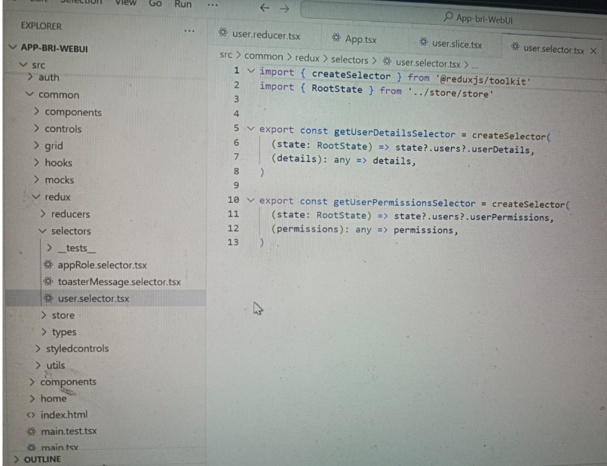
- Create Redux Store
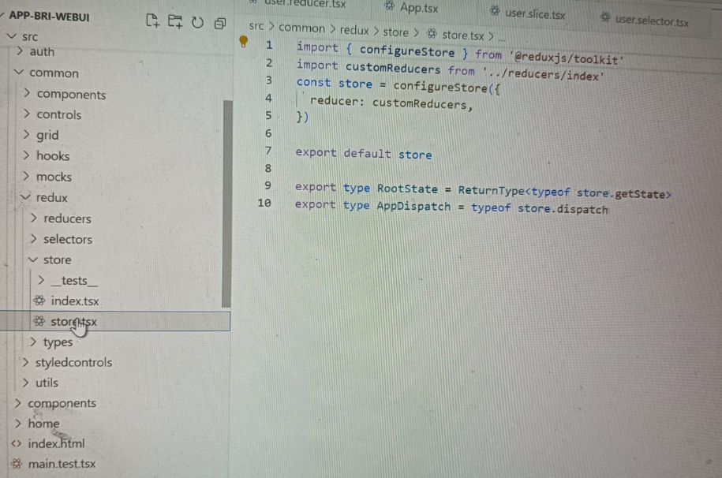
- Accessing in application
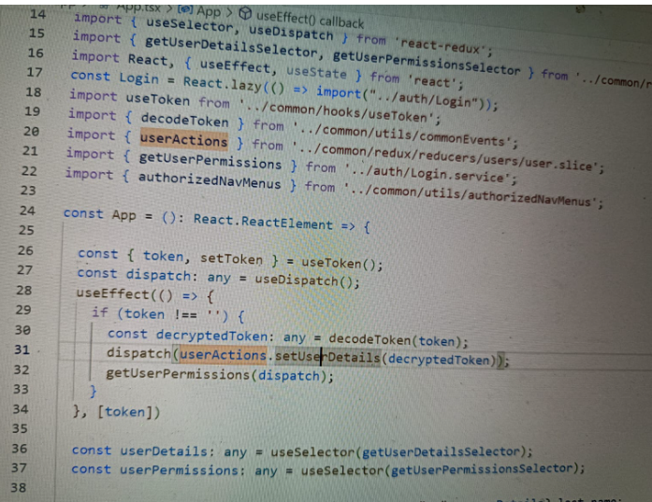

16. Optimize React performance?
- Lazy loading
- UseMemo and useCallback hooks to memorize
- Avoid unnecessary state updates and re-renders
17. use of React Strictmode?
Strict Mode in React is a tool that helps developers find and fix problems in their app while developing.
