https://github.com/iam-veeramalla/Azure-zero-to-hero/
Day:1
1) Virtualization: (EX: VDI)
For suppose Cloud had a configuration of 512GB RAM, 100 CPU etc. one single Developer can’t use entire cloud allocation, that’s why Virtualization concept will come in picture, using a software HyperVisor, it will split cloud configurations in to multiple Virtual machines to each developer.
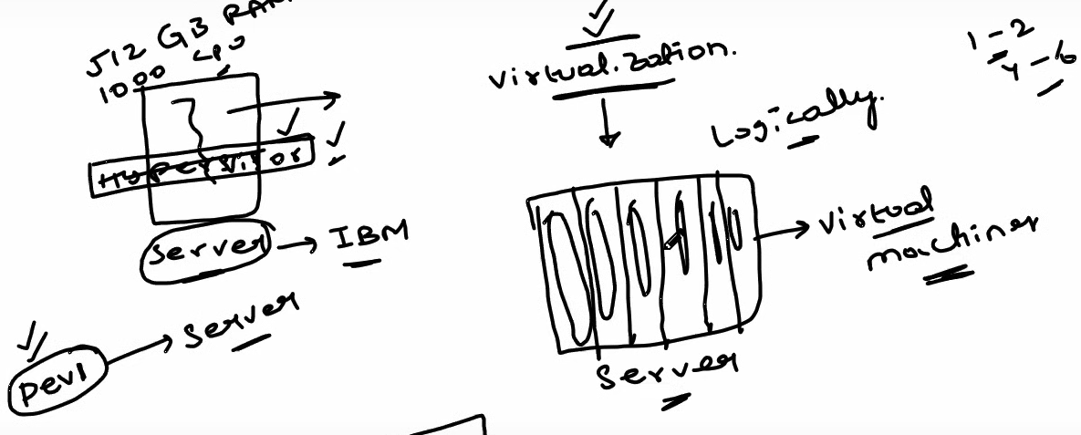
2)Regions:
Splitting Data Centre’s into multiple regions will help us to avoid shutdown, when some region fails.
3)Load Balancing:
Load balancer does the health checks of Regions and VM and if any suspicious found, it will automatically allocate the nearest Regions and VM to continue without crash.
4)Scalability:
For ex when we are watching Cricket in Hotstar, sometimes no of views are drastically increased, in such a case our application performance will decrease. Using scalability, we deployed our application in to multiple servers, and using auto scaling, it will scale the users and assign it to different servers.
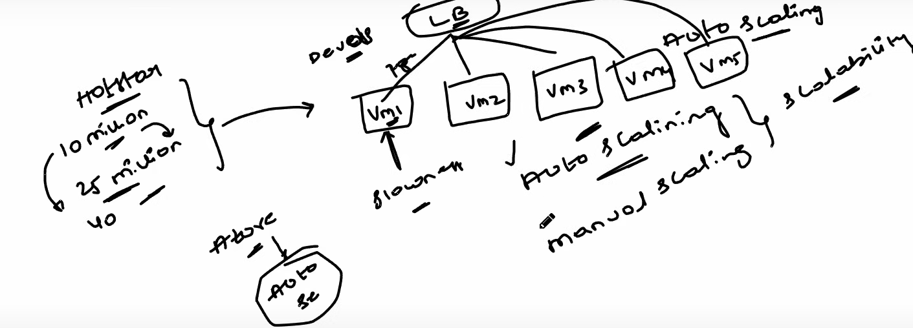
Using node pool, we can scale by providing min n max pool size.
5)Elasticity:
Automatic scaling is called Elasticity.
6)High Availability:
Highly available application most of the time, like Instagram, Facebook etc.
7)Disaster Recovery:
If something goes wrong, we need a Plan B, what is the recovery plan or back up.

Day 2: Getting started with Azure

1)Create Azure Free Account

2)Regions
a) Latency:
Why Latency? In today’s world every user expect data should get reflected in fraction of seconds without delay. For suppose, if Mumbai Data centre fails to fetch data due to power outage or due to natural disasters etc. our applications will give Downtime error messages. As part of Latency, if Mumbai Data Centre fails to fetch data, then it should fetch from nearest available Data centre i.e. Pune, rather giving error message saying that Down time to end user.

3)Iaas, Paas, Saas
Infrastructure As a service: VM’s, Storage, Networking
Platform As a service: Database, App Services
Software As a service: Outlook.

Day 3: Resources, Resource Group and Resource Manager
1)Resources:
Resource is an instance of a service. For ex, if we created SQL DB in Azure services, or Virtual Machine in Azure services, we called them as Resources.
2)Resource Manager:
Who is managing Resources, we called them as Resource Manager. In our case it is Devops Engineers.
3)Resource Group:
Grouping of Resources, we can group a bunch of resources.
Ex: ProjectName or ProjectName_Dev etc.
a)Why should I Group?
- Tracking
- Access
- Permissions
- Security
- Billing cost
b)How should I Group?
Resource and Resource Group is always 1:1 relationship.

Day 4: Azure Virtual Machines
Virtualization
Create VM in Azure:
We can create VM with basic setup in Azure portal
Connect to the VM:
You need to open gitbash, and run the following command
Ssh -i /path to SSH key/ azureuser@VM IP address(above)

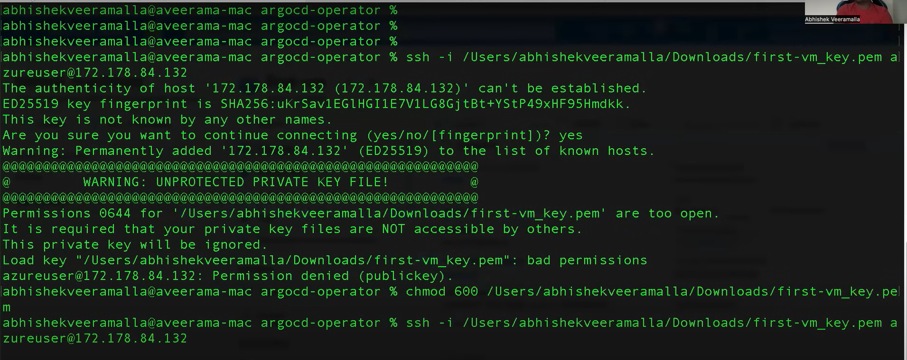
After run the ssh command successfully, you can see the azurevirtualmachine login
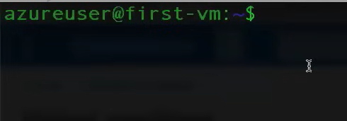
Now VM is ready to deploy our applications.

Deploy your first VM in Azure
Deploying Jenkins into our Virtual Machines.

We need to shootout some commands which is available in Jenkins zero to hero series and then to test Jenkins is running our not we need the following command.

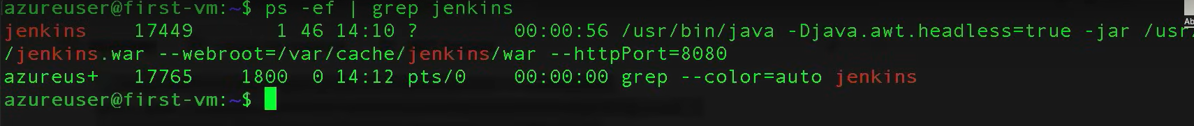

By now, we have a IP address and port, if you are trying to access it through browser, you will not be able to access it with various security reasons it is blocked to access port directly in azure.

For that, you need to go to Virtual Machine-> Networking ->Network Settings

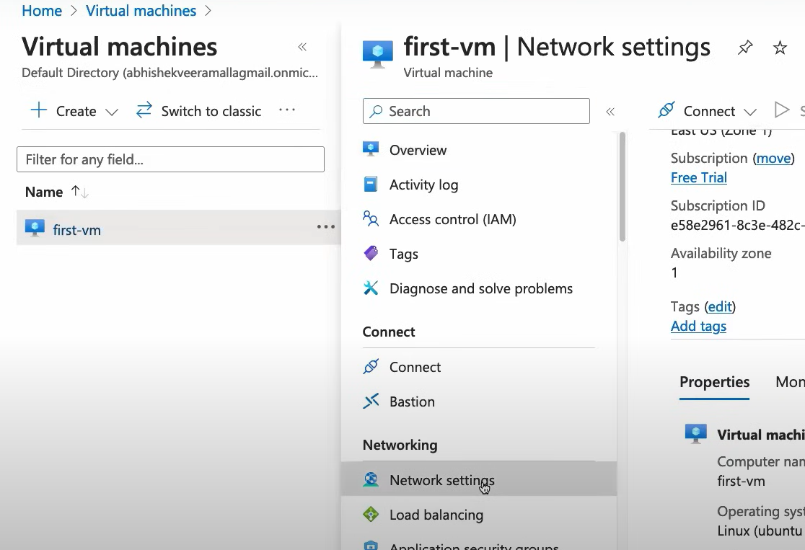

We can see Inbound/ outbound port rules.
In that we need to create new Inbound port rule for the port (8080) which we created for our IP address above.

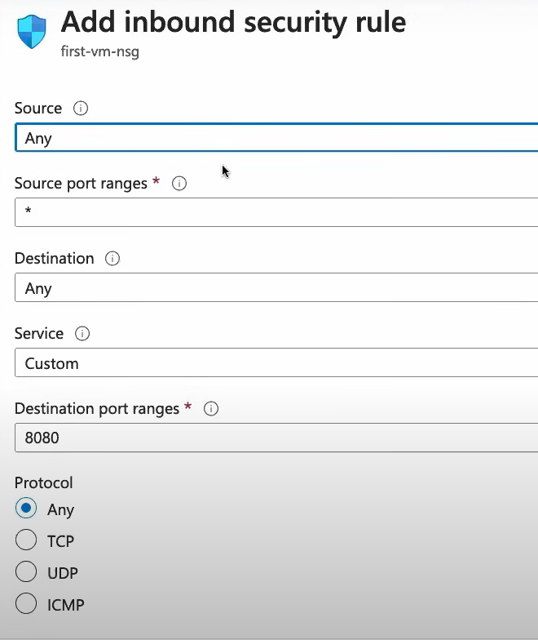

After creating Inbound for port 8080, our application is automatically running as follow.
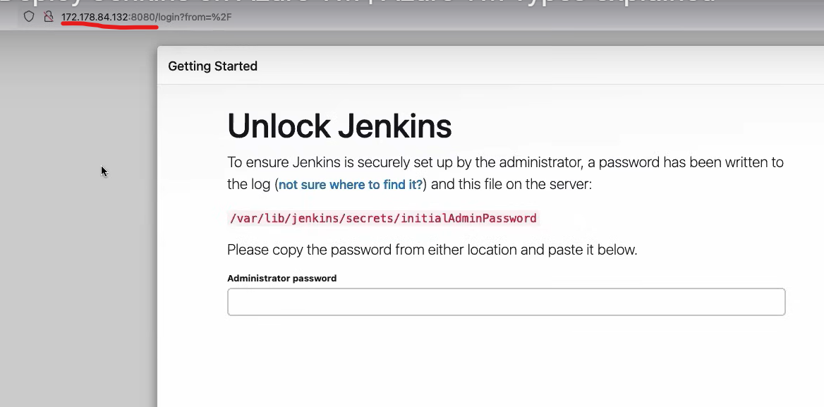

VM scaling:
In above scenario, we created Jenkins VM, it is accessible when we have 1-1000 requests at a time. What if it is 1M requests at a time, our application won’t respond, for that we have a concept called SCALLING.

Auto Scaling: It will create a VM automatically by the system based on user load, and help us to access the application without downtime.

Using node pool, we can scale by providing min n max pool size.

Day 5: Azure Virtual Network
Overview of Azure Networking
Virtual Network:
Multiple organizations kept their data into Azure, how they are secured one with other, that’s because of Virtual Networks.
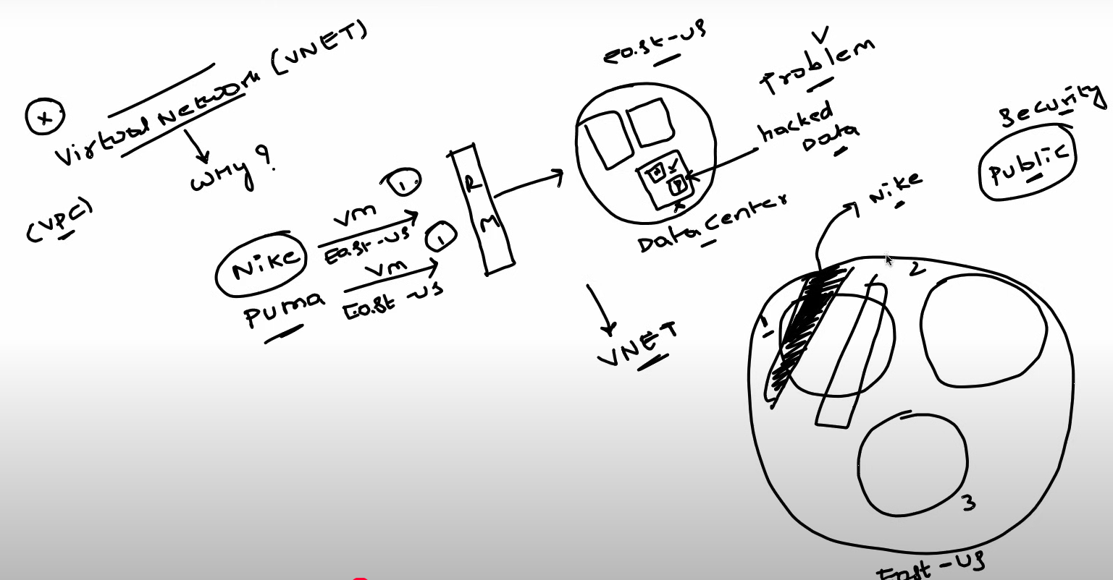
We can able to create N no of Virtual Networks.
How much size has Virtual Network?
That’s depend upon CIDR

Subnets, CIDR:
Subnet – inside VNet, if I want to deploy different services like App, DB etc. all might have different configuration stuff and all might have different security levels.
Rather create VNet and publish services into it, we can create sub nets in between VNet and services, so that we can create separate rules for each subnet.
App – anyone can access, but DB only restricted people should access, that’s why we have a concept called subnets.

CIDR – it will define the size of subnets

Routes and Route Tables:
It will provide the direction with in subnets
Network security Groups:
NSG will help us to access the specific subnets, for suppose when we are working in microservices architecture, some services might not require to access DB. So, how do we handle that?
Simply open NSG and pass the IP addresses of the allowable services.
Here there is a problem, for suppose, if we want to access bunch of services then it’s very difficult to track them all whether it is added in the allowable list or not, that’s the reason ASG comes in picture.

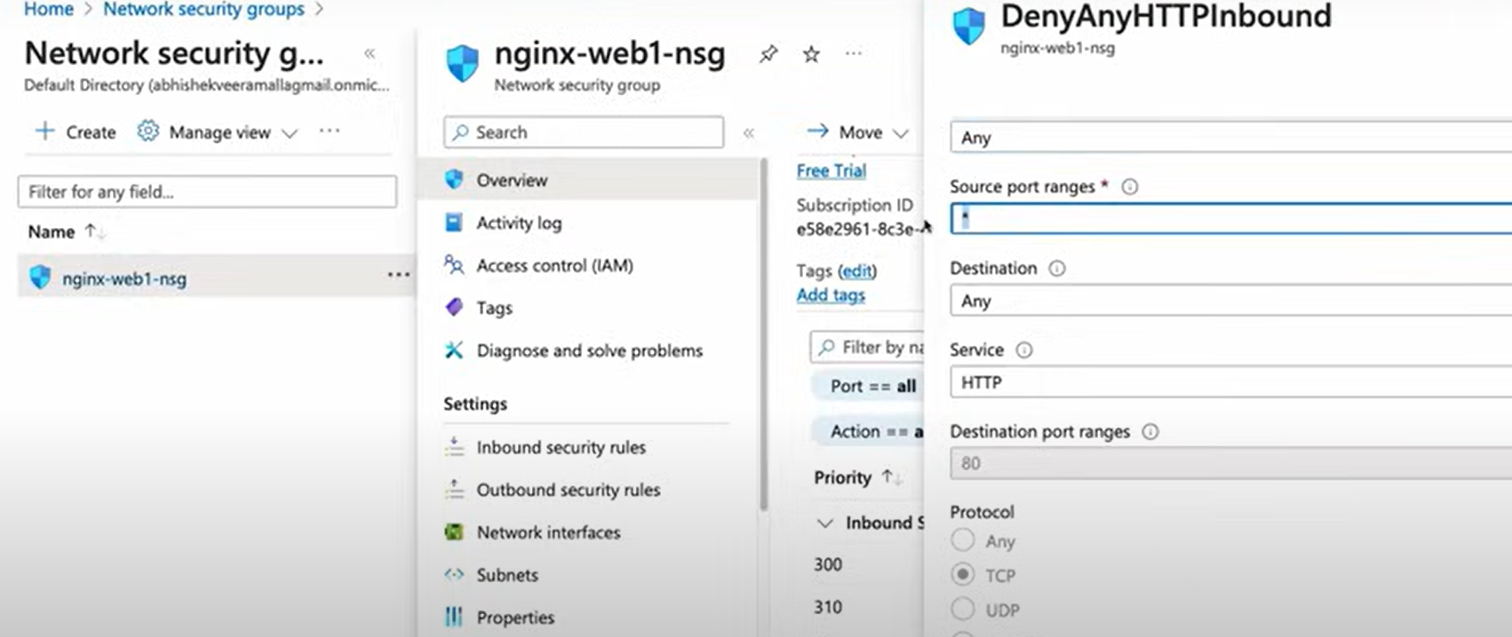

Application Security Groups:
We may have multiple Applications defined, in such a case if we want to access only business logic applications alone to access DB, then we club all those applications in to one group and we provide access to them.
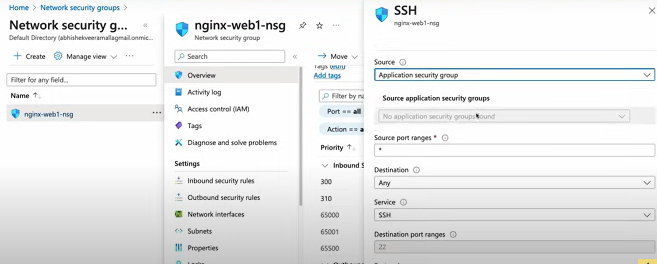
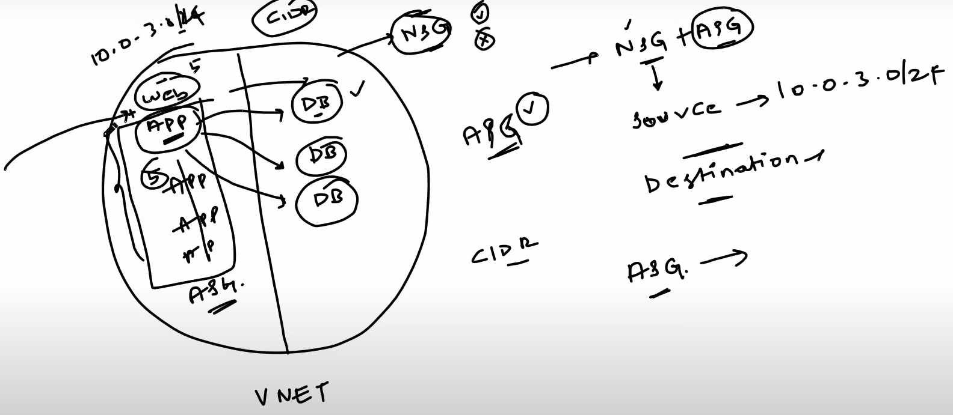

Day 6: Advanced Network services
Azure App Gateway & WAF: L7 traffic or HTTP Route
App gateway will help us to land the desired page based on route.
Azure Load Balancer: L4 traffic
On top of App Gteway, load balancer will keep searching the content based on availability of the resources.
Azure DNS:
Domain name system – when we are searching in internet we are searching with domain name of application, not with IP address.
Azure Firewall:
This is the access area where user gets verified and provide necessary permissions to access it.

Virtual Network peering & VNet Gateway:
In microservice architecture, if we want to access methods from one service to another, similar to that VNet peering is help us to access data from one VNet to another, but you need an admin access to both VNet’s then only it’s possible to access it.

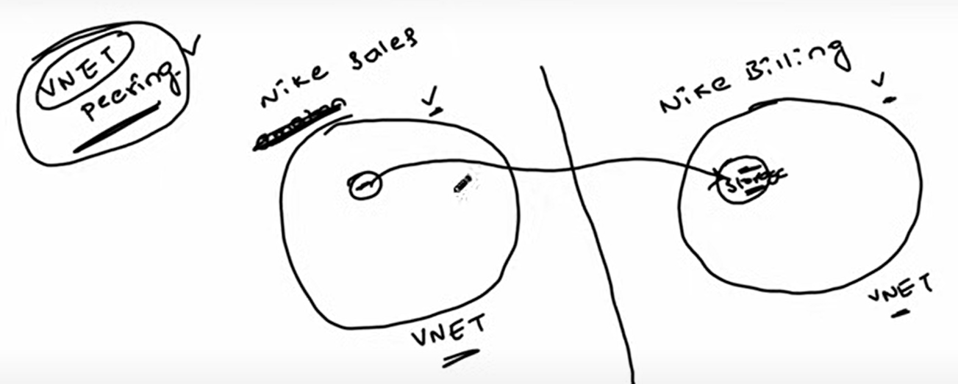
VPN Gateway:

Real time example with Apartment

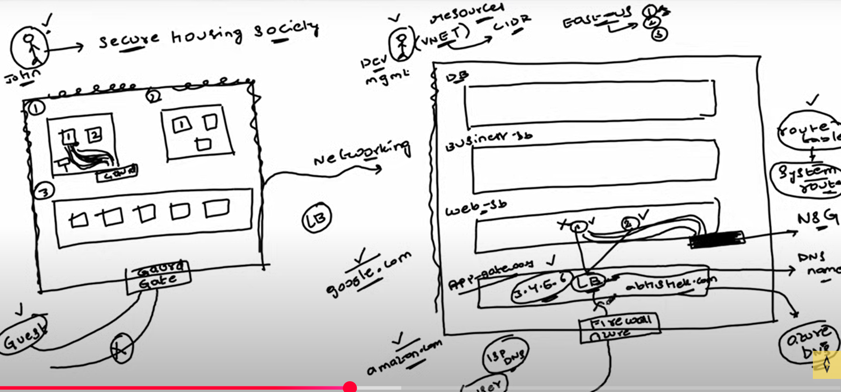

Land – VNet
Gate Guard – Firewall
Block 1, 2, 3 – Sub Nets
Guard at each block – NSG or network security group
FM – App Gateway
Path way – Routes
Maintenance – Azure Billing

Day 7: Deploying an application behind Firewall on Azure

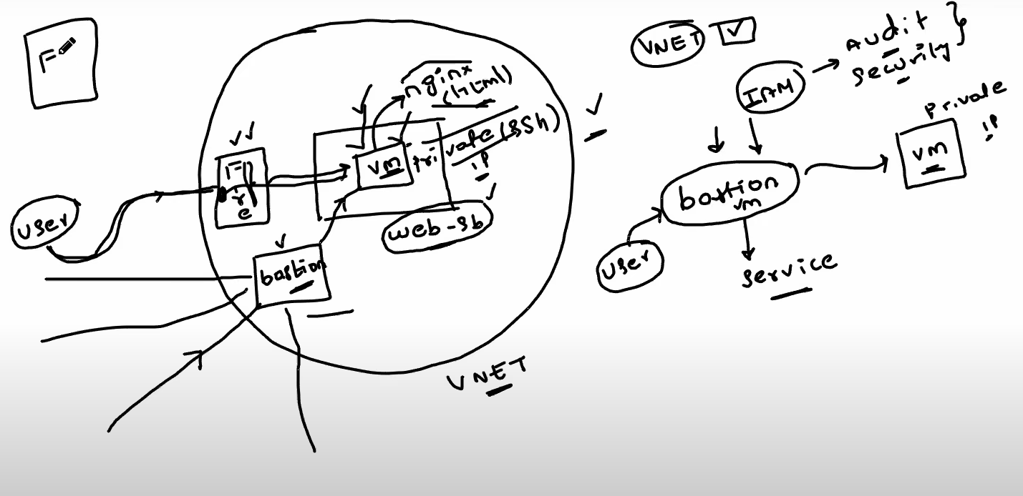
1)Create Resource Group:
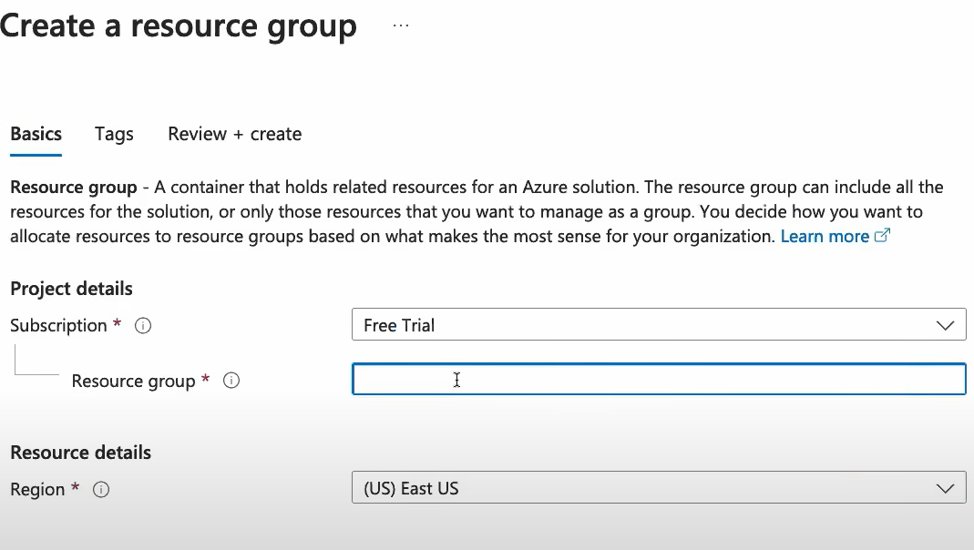
2) Create Virtual Network:
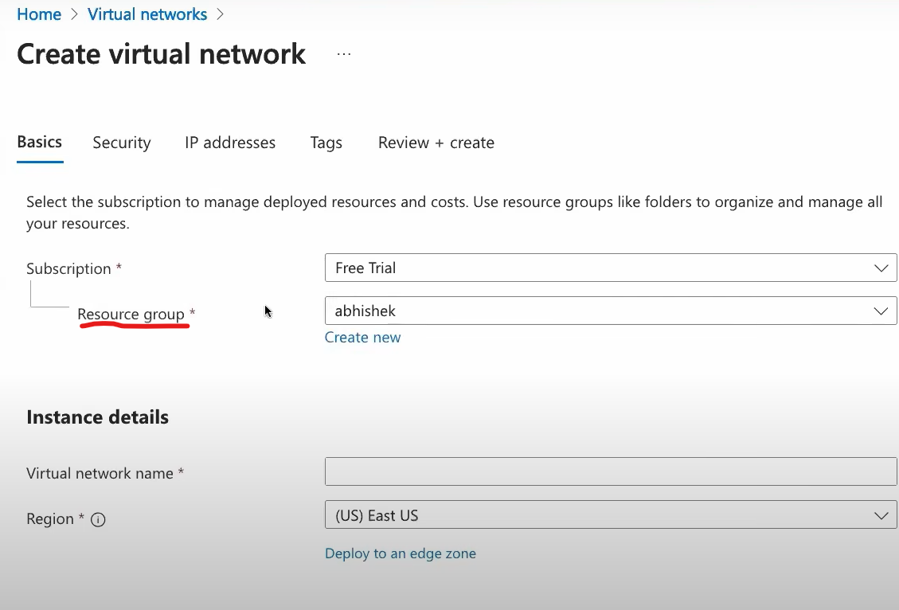
3) Create Virtual Machines:
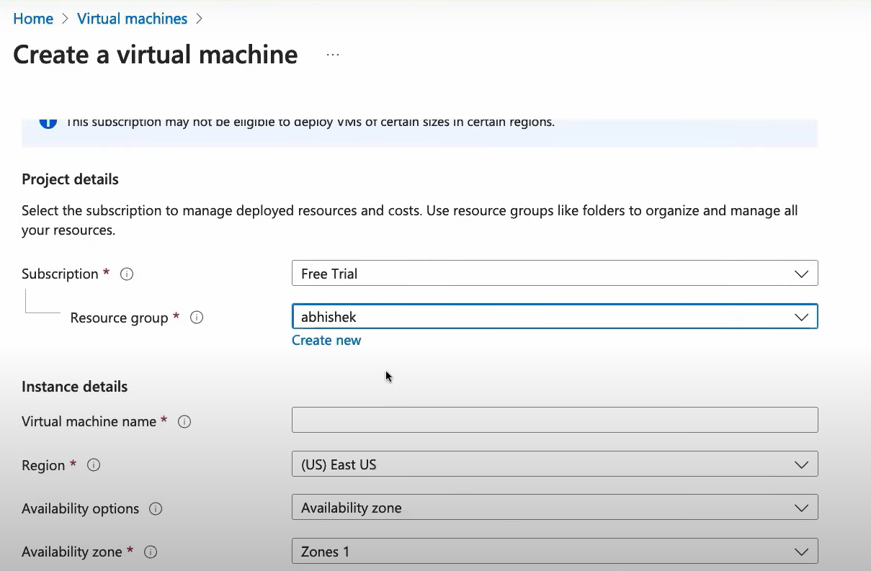
Virtual Machine - > Advanced - >Custom Data – This will help us to performing auto scaling and publish the application deployment during Virtual Machine create time itself.
Bastion:
When we create VNet, we have an option to select Bastion, the main advantage of using bastion is it is act as a proxy between user and application subnet, that’s the reason our Virtual Machine doesn’t hold any IP address.
If you want to restrict users based on roles in bastion, then open bastion service and then click on Access Management (IAM) and provide necessary access controls to the users and roles.

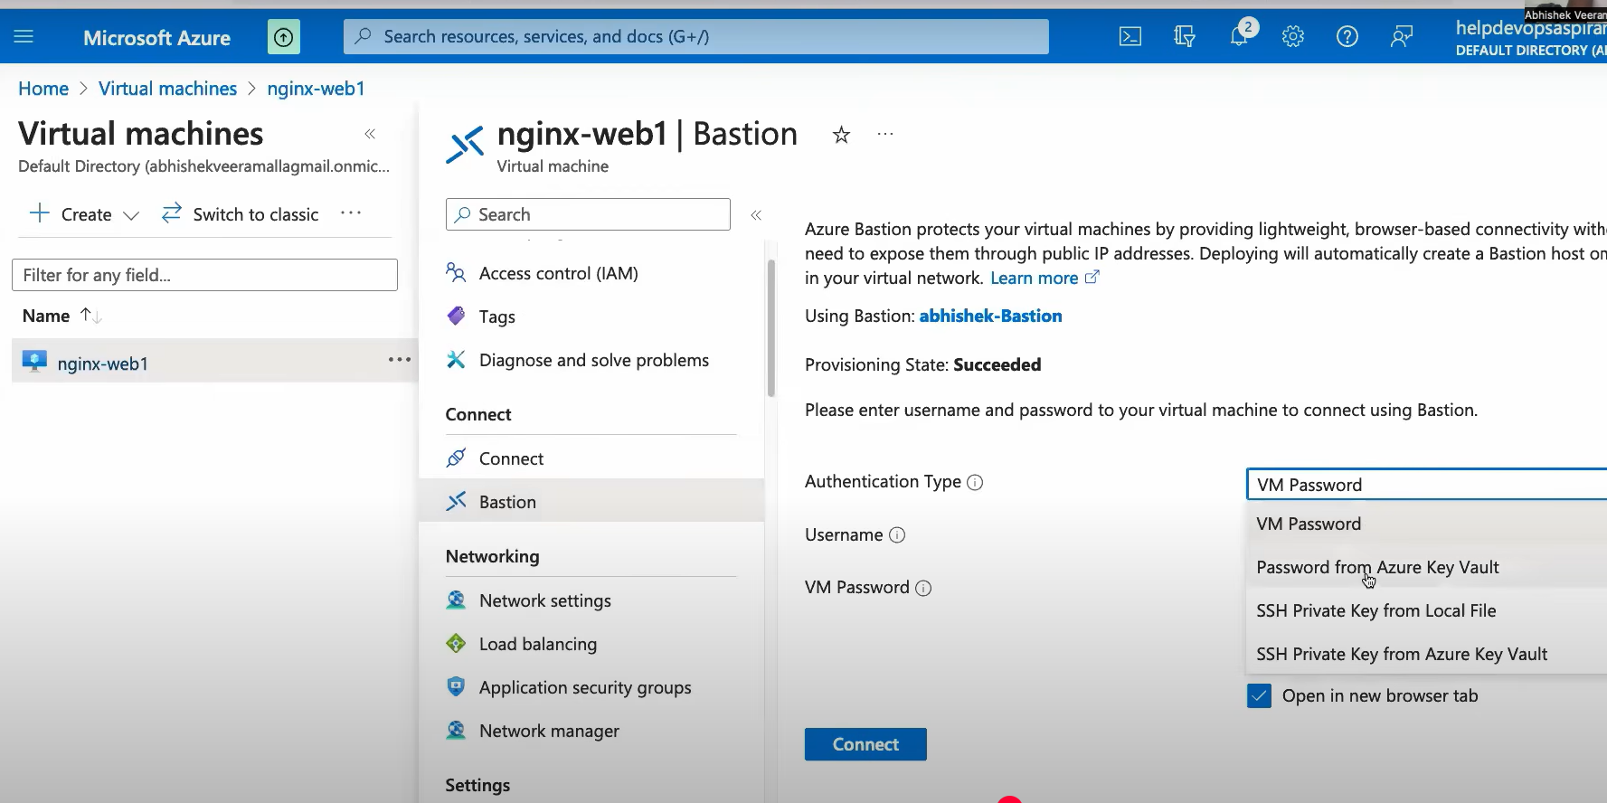
We can secure by providing logins, in our case we are doing SSH(we did this during Virtual Machine creation time), and upload the pem file.
Then a command line will open to perform actions like below.
1)Perform sudo su – to go to root user. And then perform “apt-get update” to update repositories.
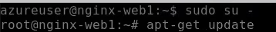
2)Perform “apt-get install nginx -y“ to install ngnix
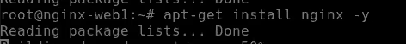
3)Now change the directory path to “/var/www/html”
4)call the index.html file by using below query.
Write simple html
5)restart nginx by following query “systemctl restart nginx”
6)run a command “curl localhost:80” then you will see html which you wrote earlier.
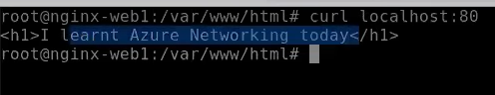
Now our requirement is, if the user is authorized user via Firewall, then we need to allow him to access our application subnet.
For that you need to open Firewall which gets created during VNet, open it and then click on Firewall policy.
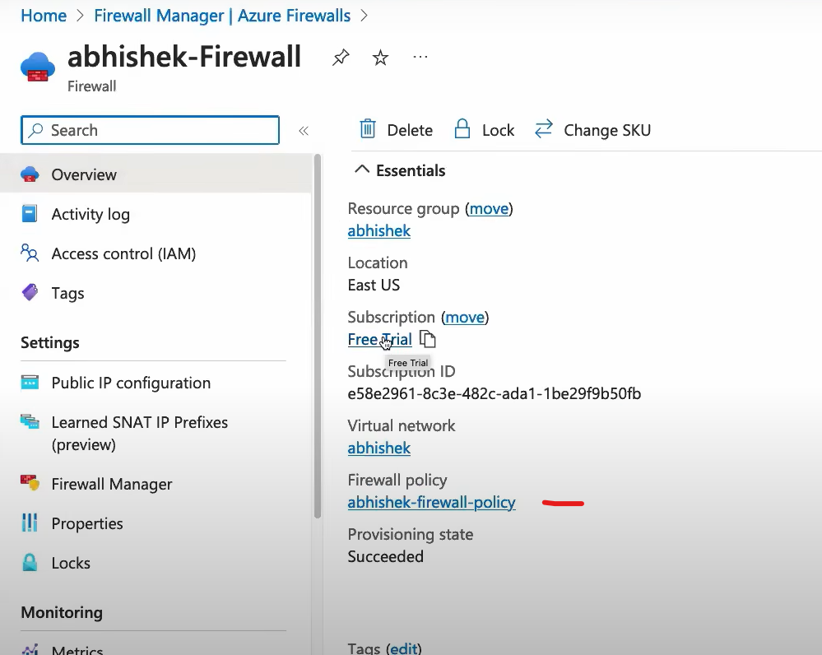
After open firewall policies, under settings we can see different policies, in which we need DNAT rules like below, in case rule’s not existing you need to create one as per your requirement.
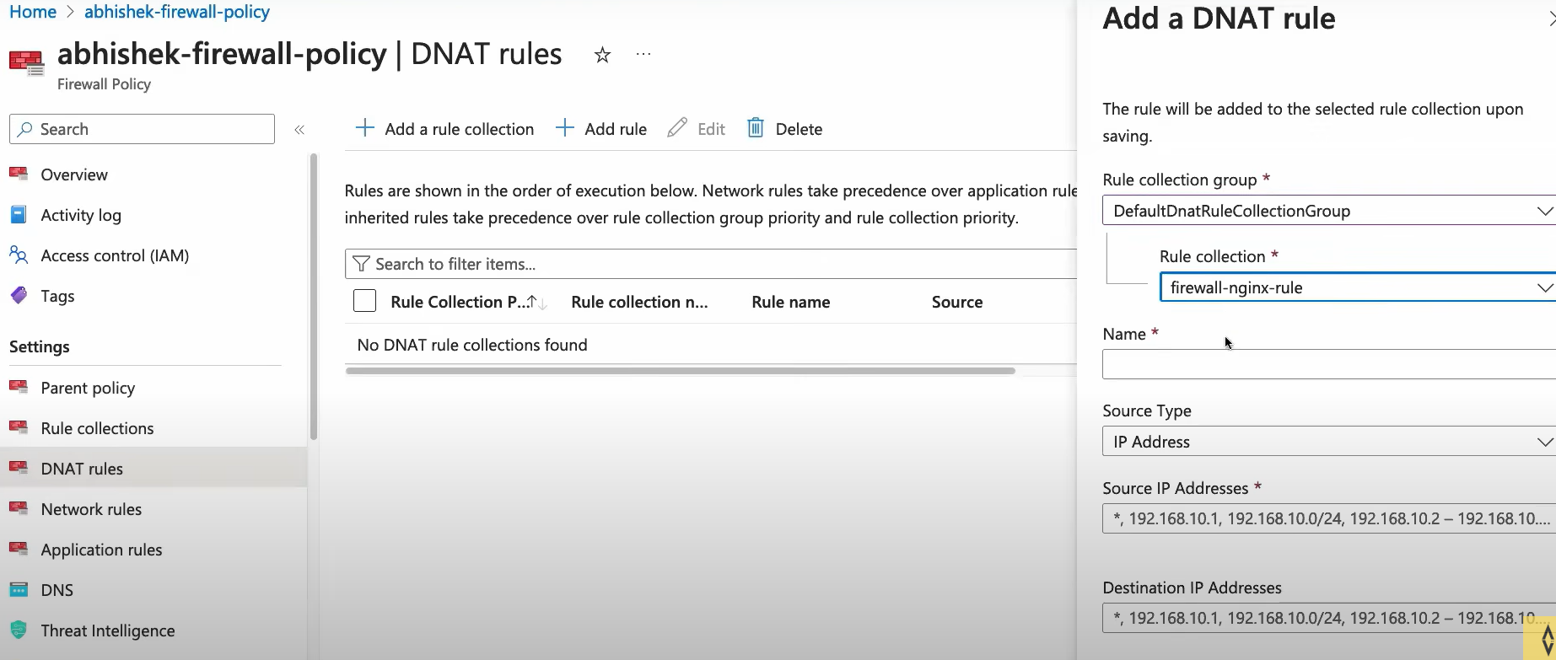
After configuring all this, access the application through Firewall Ip address: with dedicated port.

Day 8: Interview Questions
1)What is the difference between NSG & ASG?
2) How can you block the access to your VM from subnet?
By default, with in VNet we can able to access subnets one to other, this is because of NSG rule “AllowVnetInBound”.
The priority of this rule is 65000, so we need to create a deny rule with less than 65000. That’s where we can override the existing rules.
3) Are Azure NSG’s are stateful or stateless?
Stateful,
4) what is the diff between Azure Firewall and NSG?
Firewall – controlling both in-bound and out-bound traffic for a particular virtual network.
NSG – Associated with subnets or individual network interfaces to control traffic with in VNet
5) Advantages of Resource Groups in Azure?
- Logical Organization
- Lifecycle management
- Resource group tagging
- Role based access control
- Cost management
- Resource group template
- Resource locking
6) Difference between Azure user Data and custom data?
Custom data – cloud init purpose, when we are creating VM’s we need to run some custom data.
advantage:
- no need to run the script post VM setup done
- scaling VM it will take care along with custom data if you provide while creating VM’s.
disadvantage:
- the script will not run if you do reboot, restart etc.
- it is accessible only once during creation
User data – will be available throughout the request or until VM is exist, in simple words it will fix the disadvantages of custom data.
7) Difference between App Gateway and Load Balancer?
App Gateway – L7 Load balancer
Load Balancer – L4 Load balancer
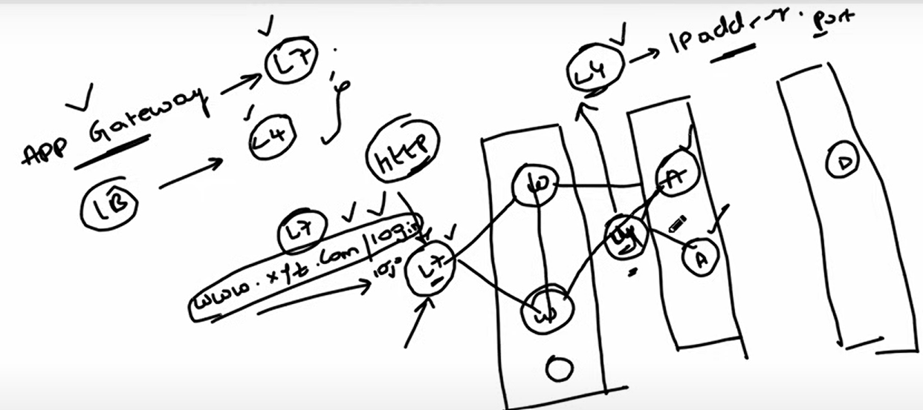
8) Advantages of using Bastion?
- Secure remote access
- Eliminate public IP address
- Reduce attack surface
- Simplified connectivity
- Azure portal-based access
- Role based access
- Multifactor authentication

Day 9: Azure Storage Services
Blob storage / Container storage: When we want to store large amount of unstructured data. Ex: videos, source code
File Storage: multiple Pods can store in VM, Ex: normal files
Table Storage: semi structured data like NoSQL
Queue Storage: messages in queue

Day 10: Azure CLI
Why we need CLI, when we already have UI to create services?
If it is one service creation, we can do the same in UI, but when we want to create multiple services creating through UI is over burden to the Resource Manager or Devops Engineer. Using CLI, we can create them in one shot.

Create VM using Azure CLI
Start with creating a Resource Group
az group create --name learn-azure-cli --location eastus
Set the Resource Group as default (Optional)
az config set defaults.group=learn-azure-cli
Create VM with Vnet
az vm create \
--resource-group learn-azure-cli \
--name vmName \
--image Ubuntu2204 \
--vnet-name default \
--subnet default \
--generate-ssh-keys \
--output json \
--verbose
Delete the Resource Group to delete all the resources
az group delete --name learn-azure-cli

Day 11: Azure Resource Manager
Refer repo example templates

Day 12: Azure Identity Access Management
AD -> Microsoft Entra ID
Day 13: Azure Devops
Day 14: Azure Devops CI Project setup
- Create Project in Azure Devops
- Go to Repos -> Import Repo -> pass the repo url
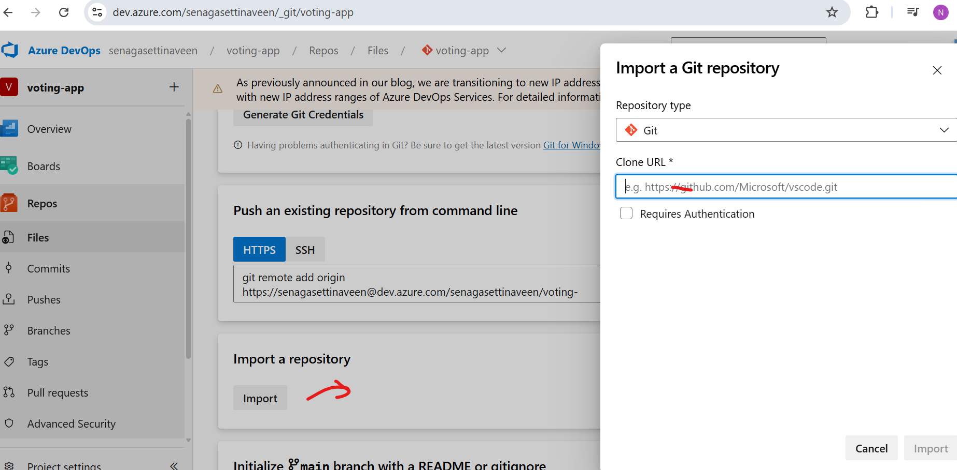
- Azure Devops creates a default branch based on Alphabet sorting order. So, better to change it as per your actual repo.
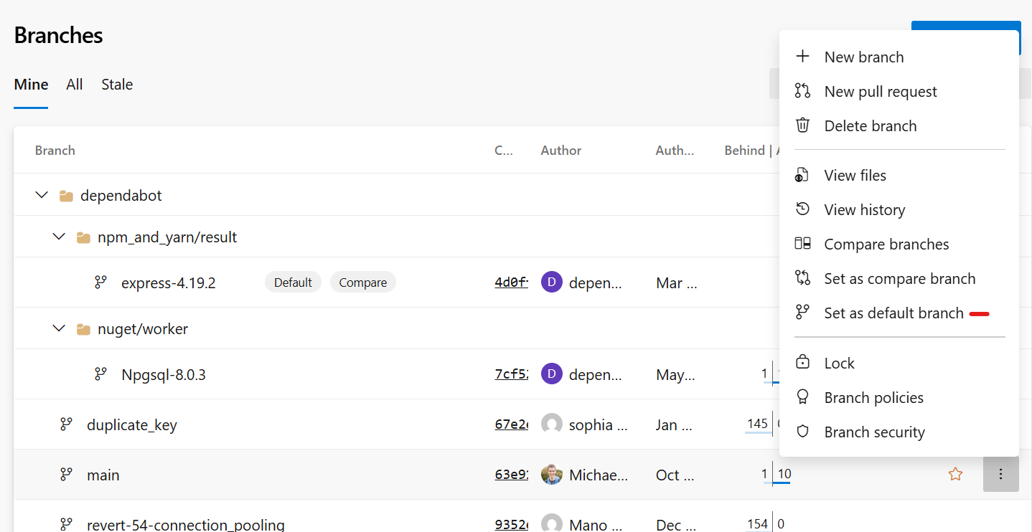
- Create a Pipeline with docker image and then publish artifactory.

Create Docker container inside Microsoft Azure
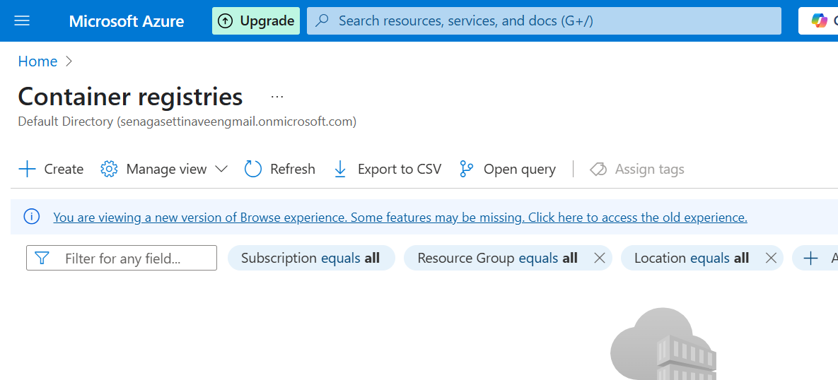
Create pipeline inside Azure Devops, select pipeline then select Azure Repos Git
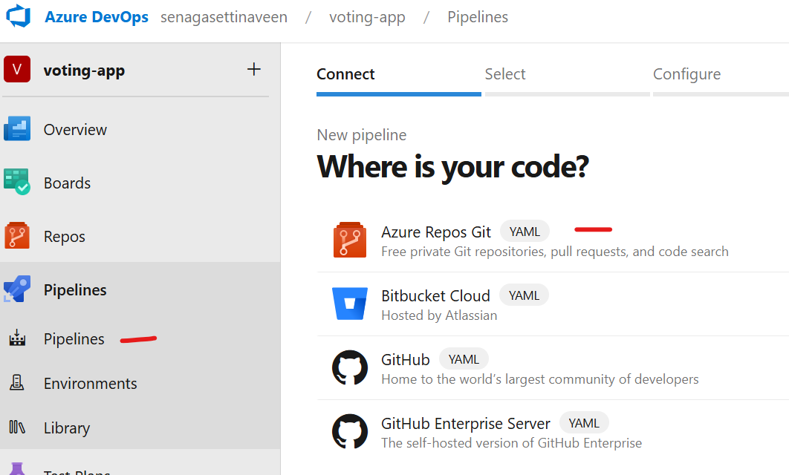
We need to configure, Docker- Build and push container
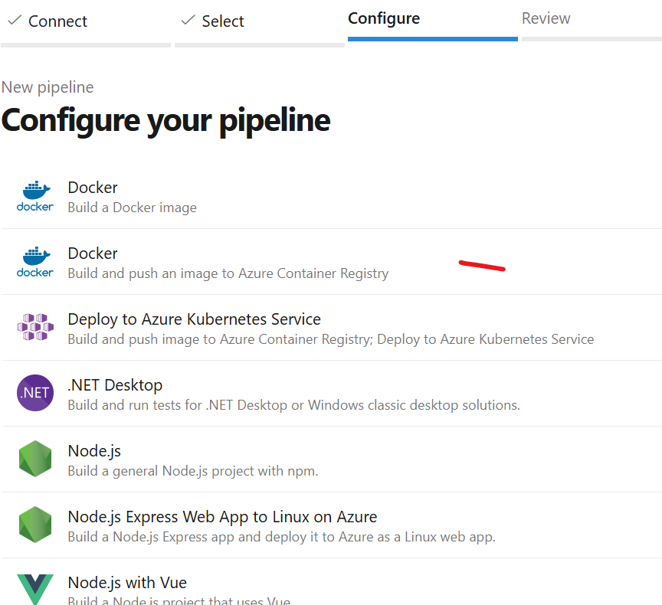
The next you see to configure
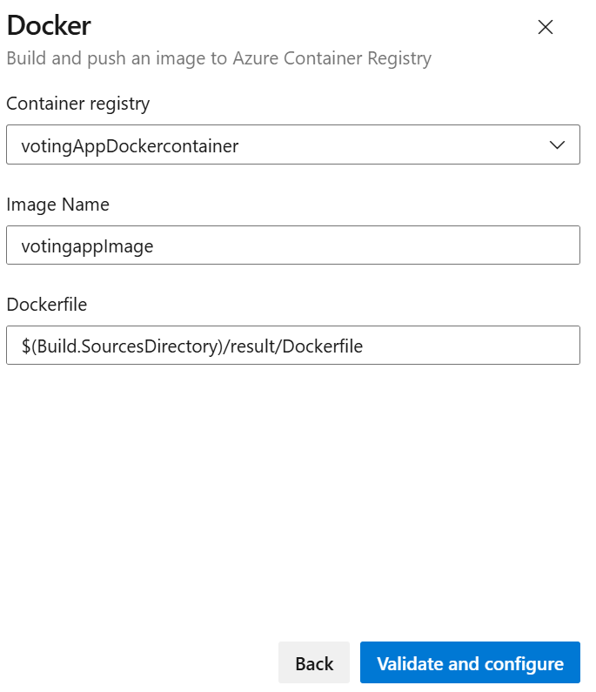

We can see pipeline with following keywords
Triggers – when it should trigger, for suppose in a microservice, only modified service needs to be deployed then it should trigger only particular file, this is called Path based trigger.
Resources -
Variables – usually will pass the keywords to pipeline, like image repo path, container details etc.
Stages – like Build, Dev, Sonar, Checkmarx scan these all are different level of stages in CI deployment.

This is the sample pipeline yaml file.
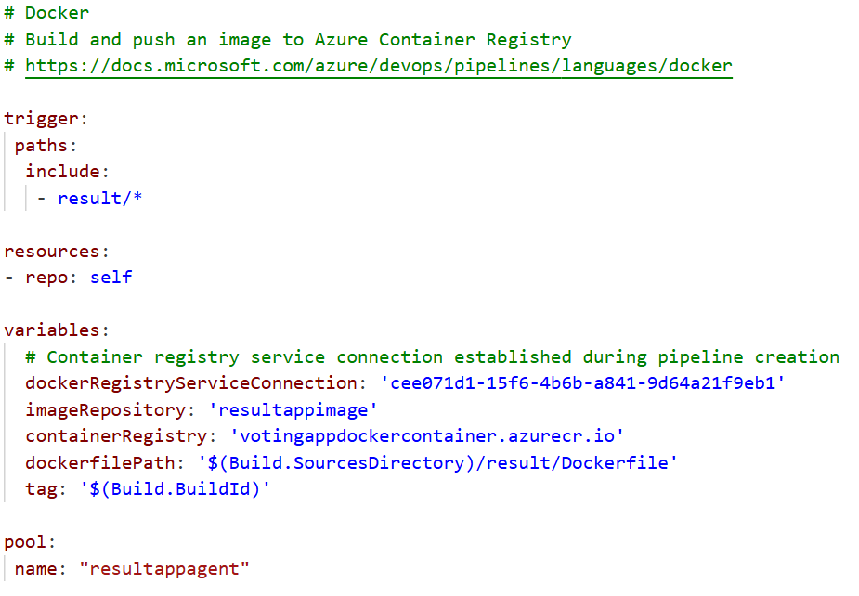
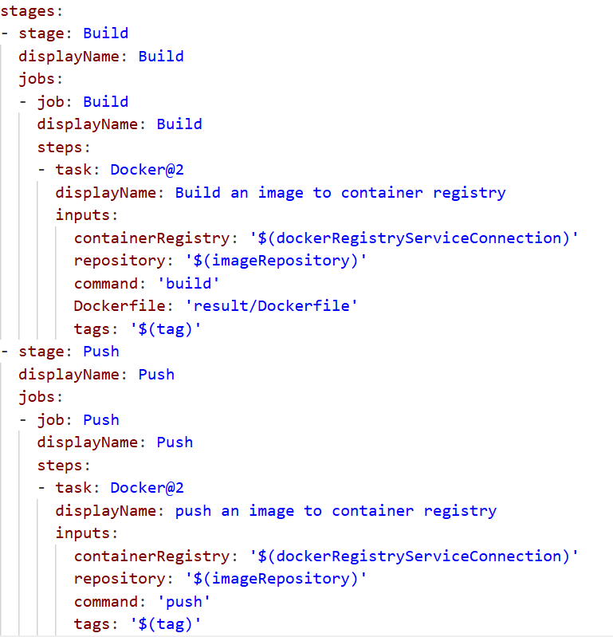

Once we click on Save & Run, we got an error saying that Pipeline is not valid etc.. The reason is we haven’t create an agent with name resultappagent.
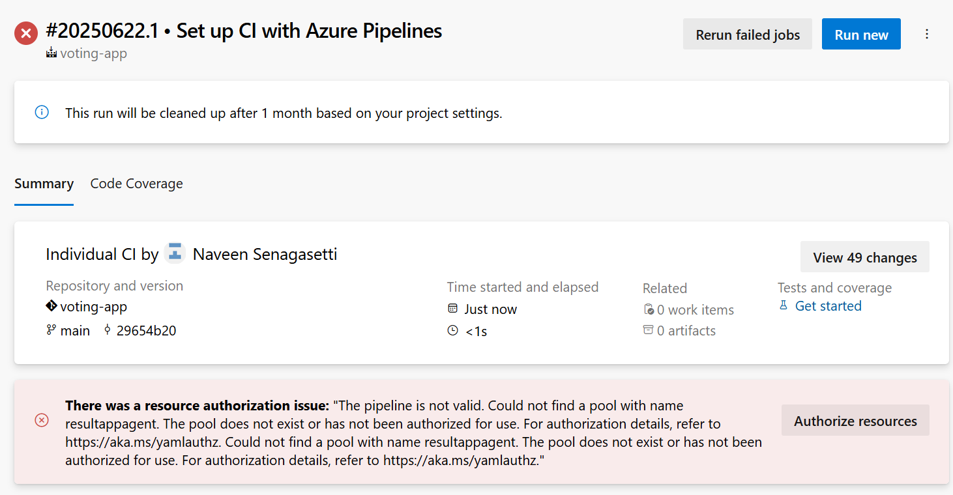

Create a Virtual Machine with same Resource Group as we created above.
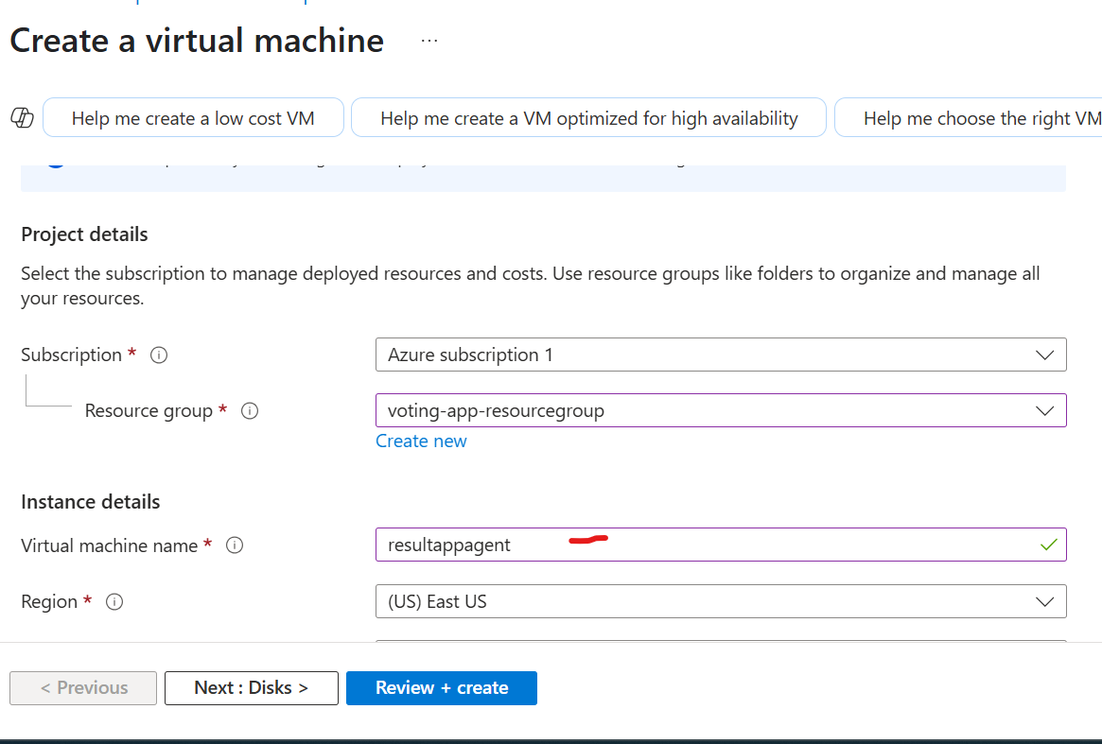

How to integrate Azure Virtual Machine with Azure Devops pipeline? There have to be a connection to run the pipeline, for that we have to run some commands.

https://learn.microsoft.com/en-us/azure/devops/pipelines/agents/linux-agent?view=azure-devops&tabs=IP-V4

- Go to Azure Devops, then click on Project Settings
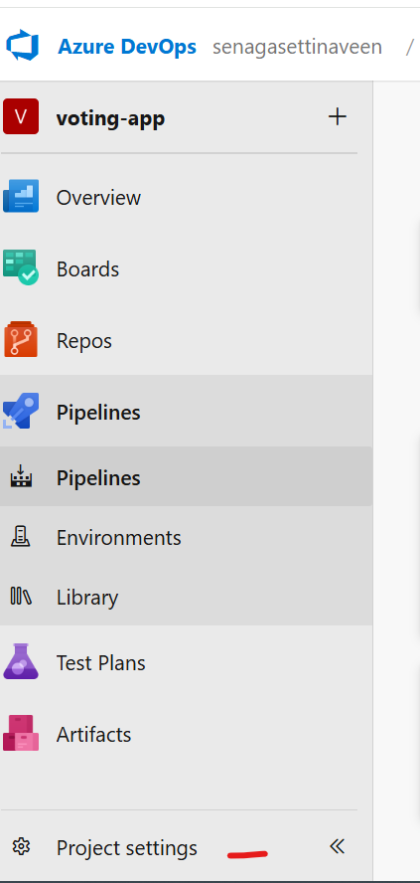
- Select, Agent Pools under pipelines and the create new agent pool.
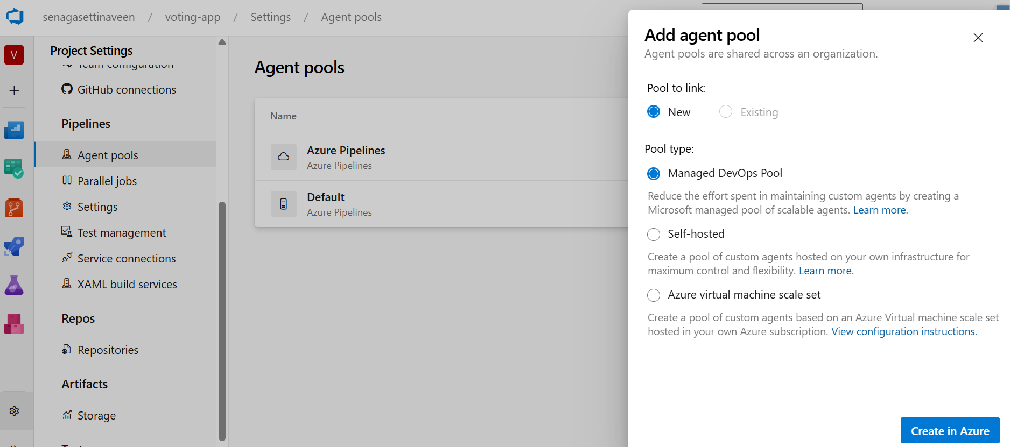

- Open the created agent then create an agent under this
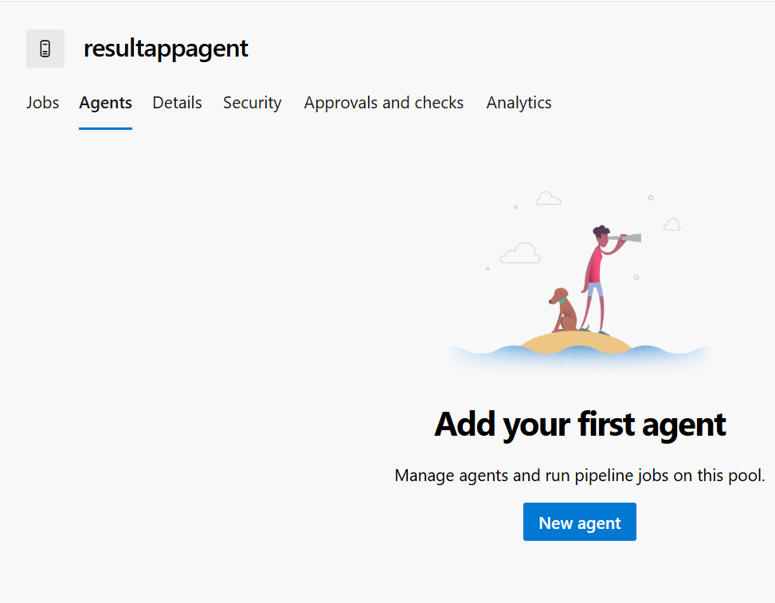
- There you can see Window, Mac, Linux agent related commands, in our case we chosen Linux virtual machine, so go with Linux commands and run.
- First go to Virtual machine which we created above, and get public IP address.
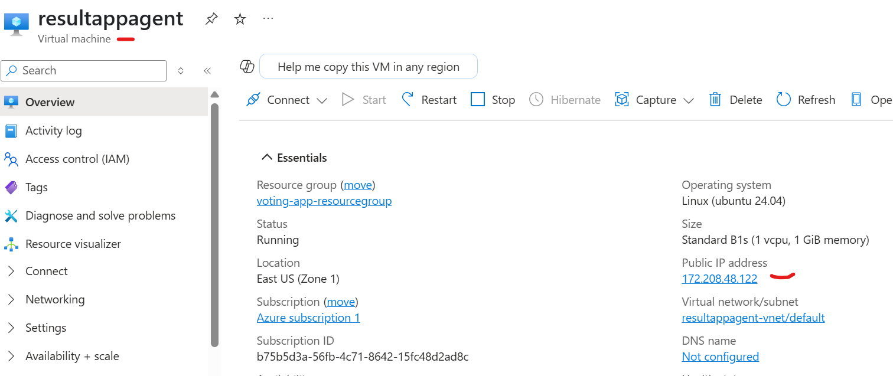
- Go to gitbash and open the folder path where ssh pem file is located
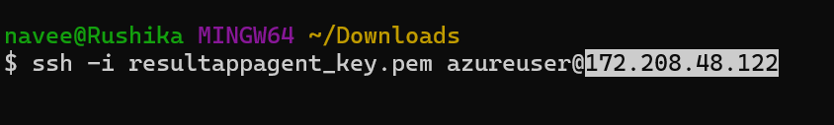
- Now, run the Linux commands as mentioned in point 4
- I was failed to run command, by doing configuration. So I take screen shots as per video.
Post config sh done, we need to serve url
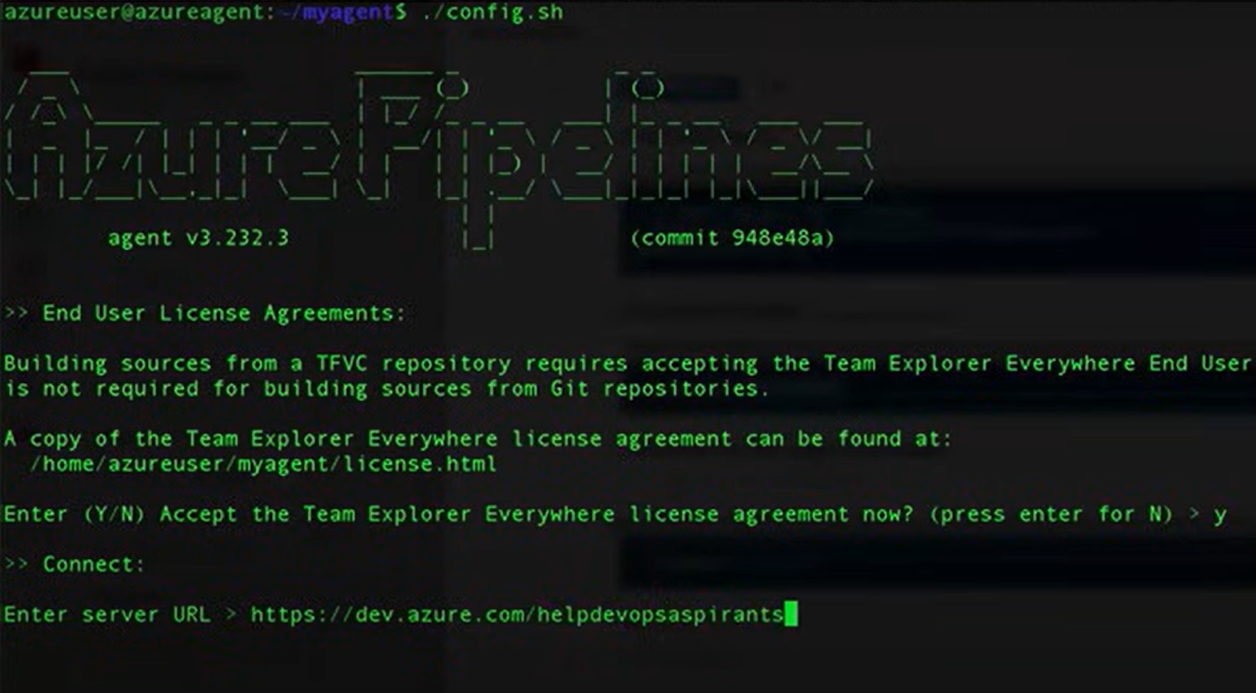
- Enter agent pool
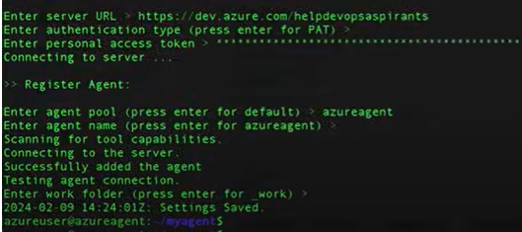

Day 15: Azure DevOps CD setup
Auto Scaling:
Using Node pool we can scale the services by providing min and max pool size.
Day 16: Azure Kubernetes
Day 20: Azure Key Vault
Key vault used to store a sensitive information like passwords, secrets, certificates etc.
Best Ex:
When I change my system password, automatically all my applications like Workday, ADP it uses the updated password without any changes from me.

Here, azure maintenance will use VM, apps etc. Rather modify password in all places if azure maintenance will use Azure Key vault password, then it will reflect in all the places.

Now, we are going to access AKS cluster using Azure Key Vault, for that we need to follow below steps.
- Open Azure CLI and run below command
az group create --name keyvault-demo --location eastus
- Run the AKS cluster create command.
az aks create --name keyvault-demo-cluster -g keyvault-demo --node-count 1 --enable-addons azure-keyvault-secrets-provider --enable-oidc-issuer --enable-workload-identity

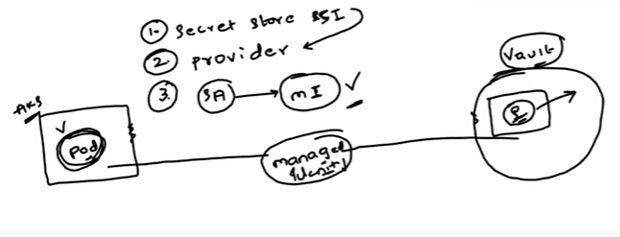
If we want to access AKS pod to Azure Key Vault, we need to access the secret store CSI provider, then using managed Identity we can communicate AKS pod to Azure Key Vault secrets.

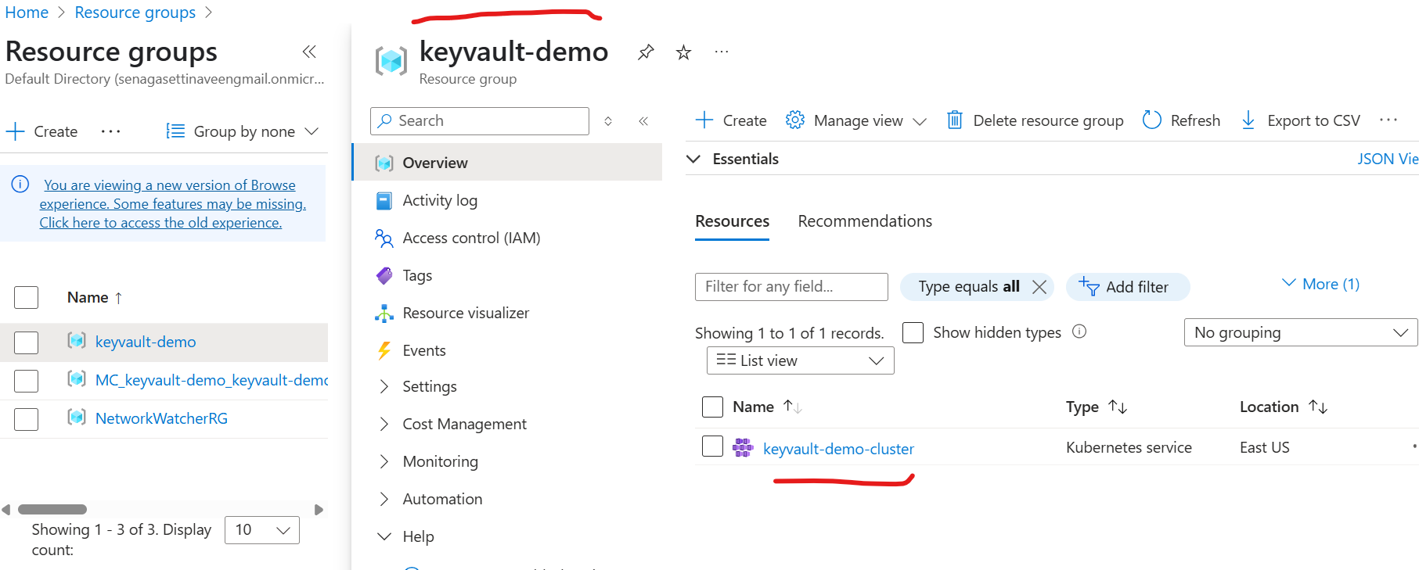

- Merge “keyvault-demo-cluster” as a current context
az aks get-credentials --resource-group keyvault-demo --name keyvault-demo-cluster
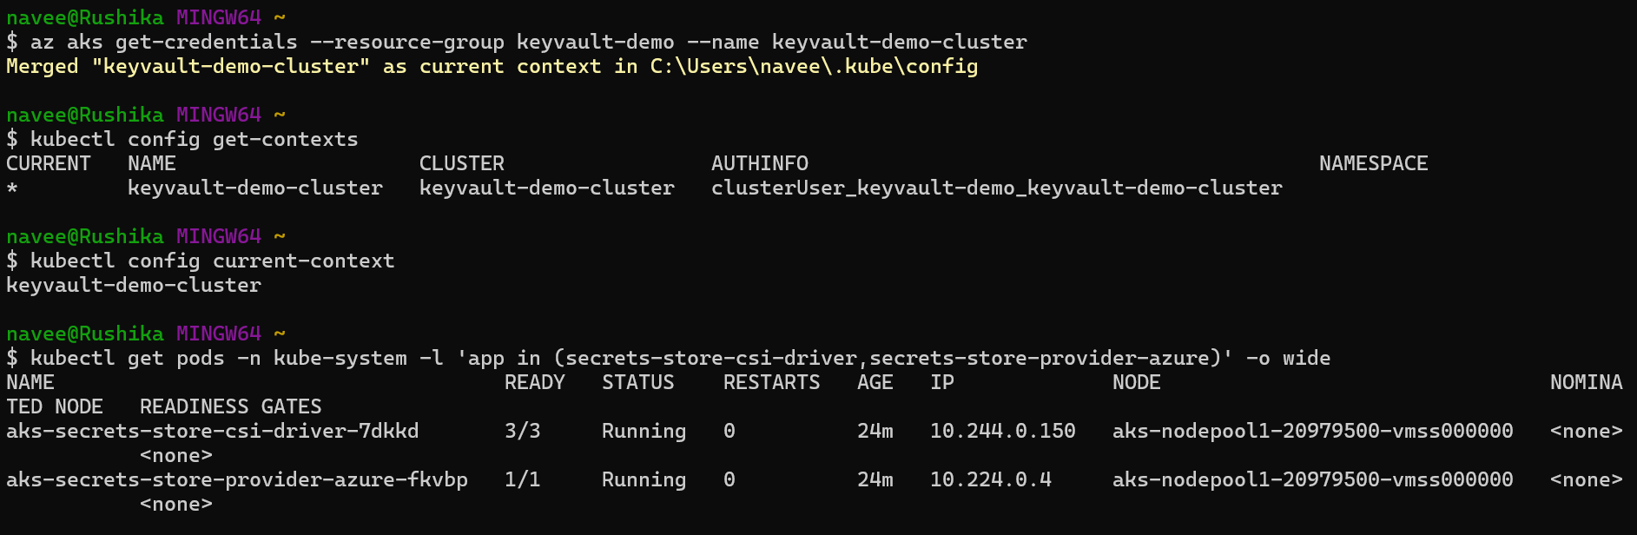

Now verify a Key vault with AKS cluster is created under Resource group.
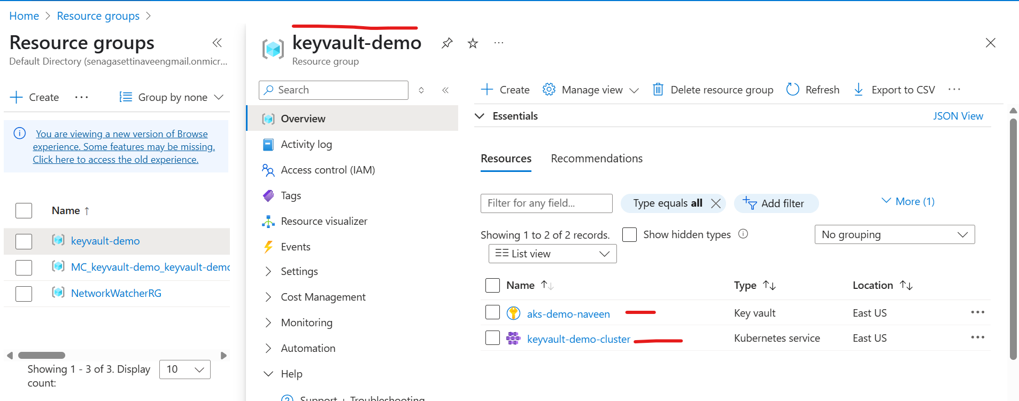
Open Key Vault then we can see unauthorized issue.
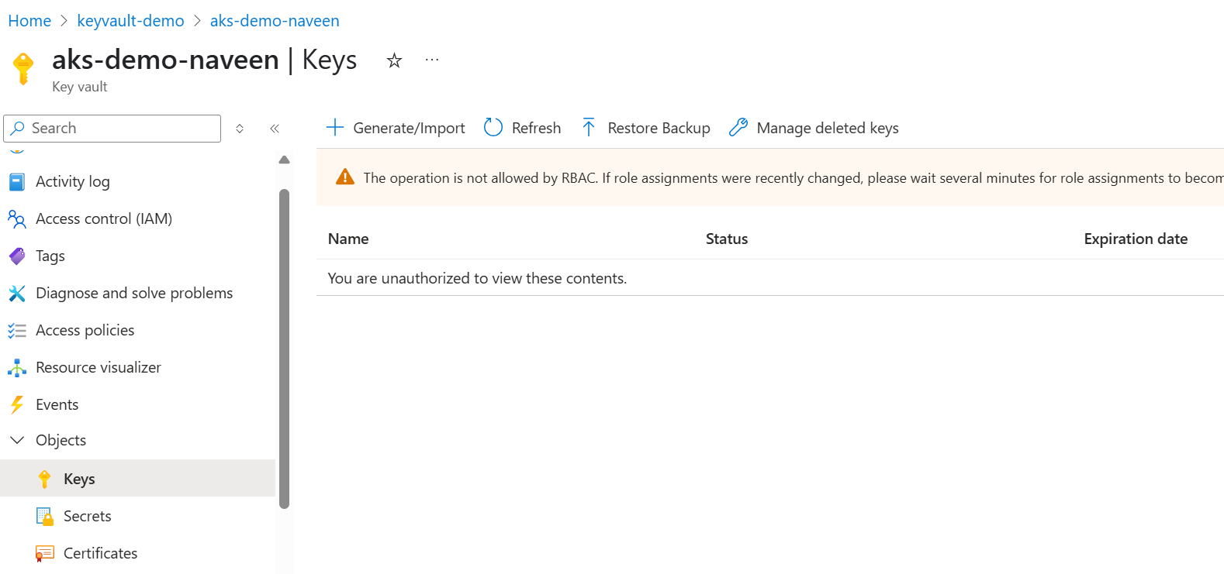

Go to IAM, and click on Grant access to this resource, then search with Key Vault Administrator and grant permission.
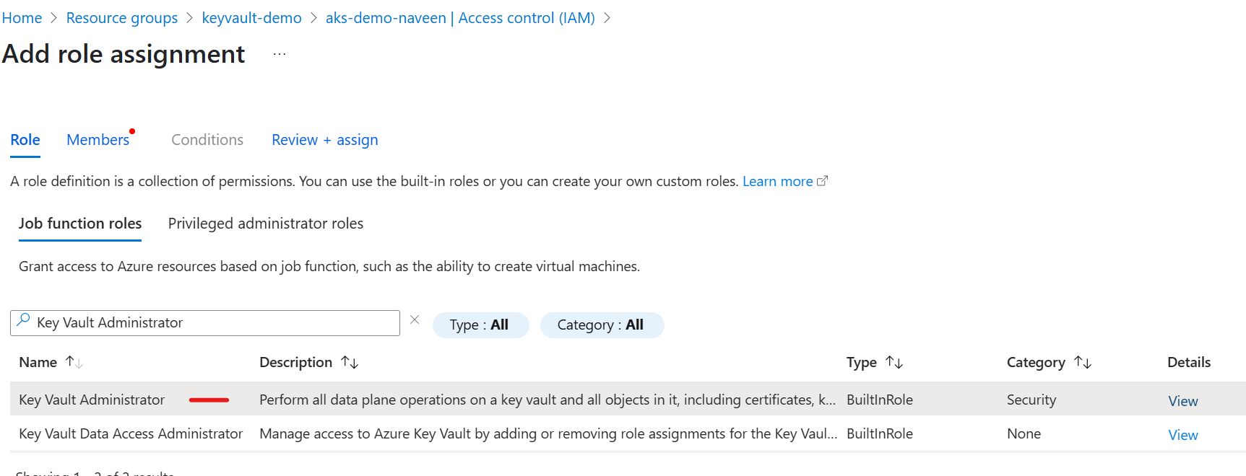
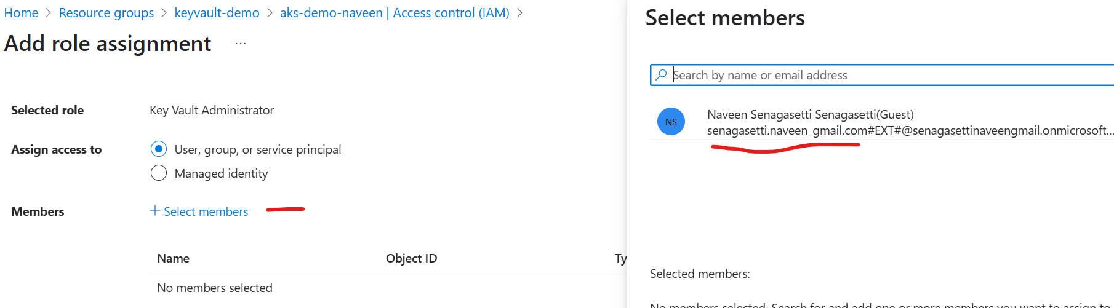

Create Key and secret
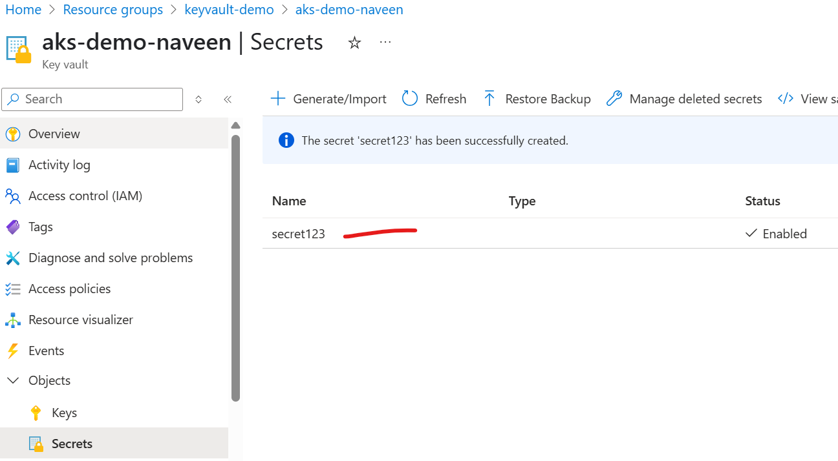

Connect Azure Key vault secret store CSI driver
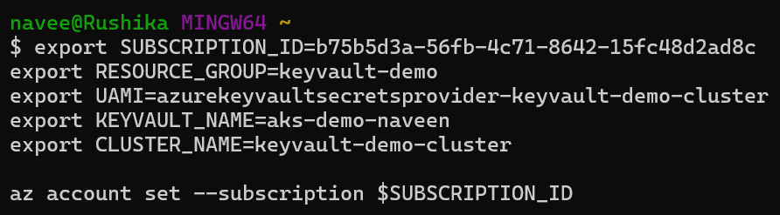

UAMI – Managed Identity

Create Manage identity
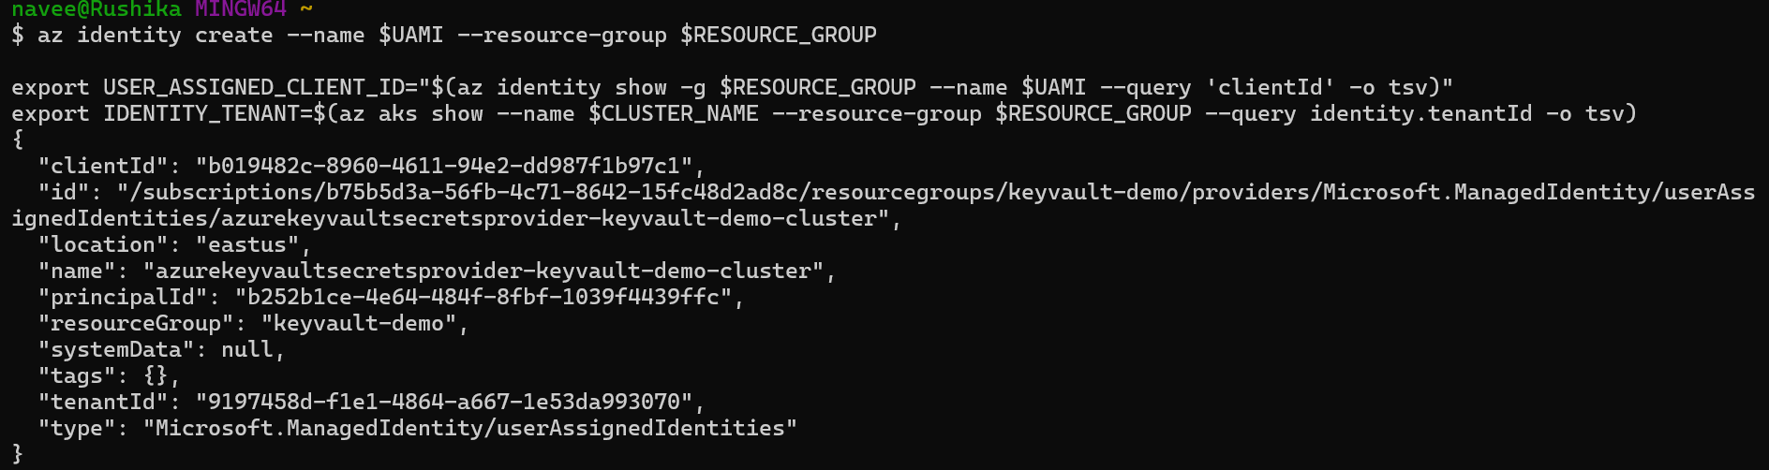

Role assignment that grants the workload id to access the Key vault.

export KEYVAULT_SCOPE=$(az keyvault show --name $KEYVAULT_NAME --query id -o tsv)

az role assignment create --role "Key Vault Administrator" --assignee $USER_ASSIGNED_CLIENT_ID --scope $KEYVAULT_SCOPE

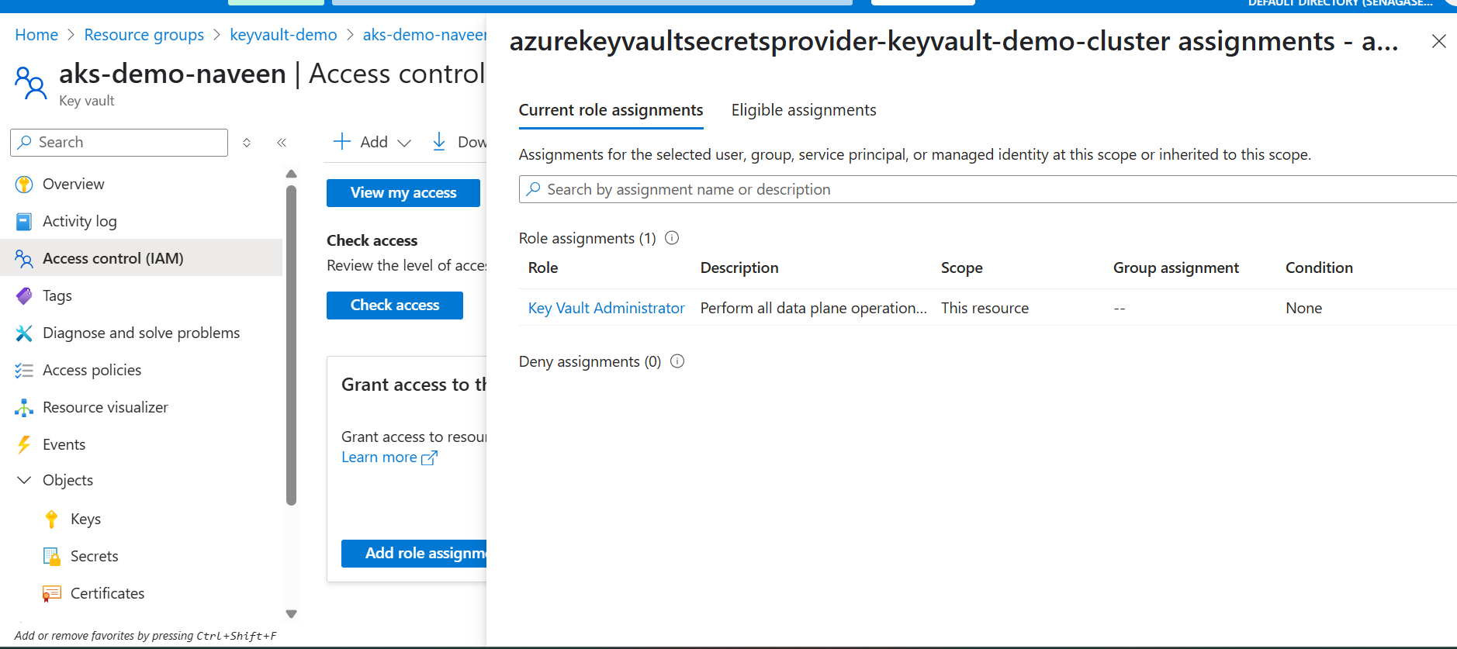

Get the AKS cluster OIDC Issuer URL

Create service account for pod
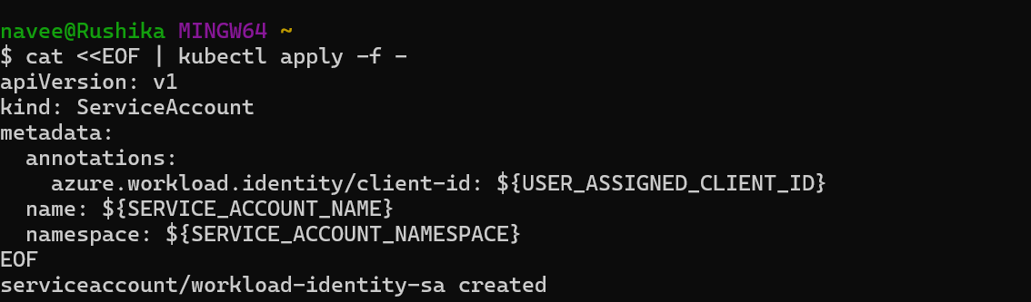

Setup Federation

Day 21: Azure Serverless
In an organization if we have 100 of servers, and VM’s it is waste of cost to having all of them to be active all the times, instead if we trigger a function, whenever a change happening that time only the respective event will trigger and how many servers are requested those many servers will be called dynamically.
Day 22: Event Driven serverless
Day 23: Terraforms
Day 25: Automated Kubernetes
Create a Kubernetes cluster with Automated feature, so that we no need to create a CI/CD and yaml files in source code. The automated service will get created for us and deploy the pipeline.

