1. What is Angular
Angular is a JS Binding framework, which binds VIEW with Model. This helps to reduce your efforts on writing on lengthy lines of View Model code.
- SPA
- DI

2. Difference between Angular Js and Angular
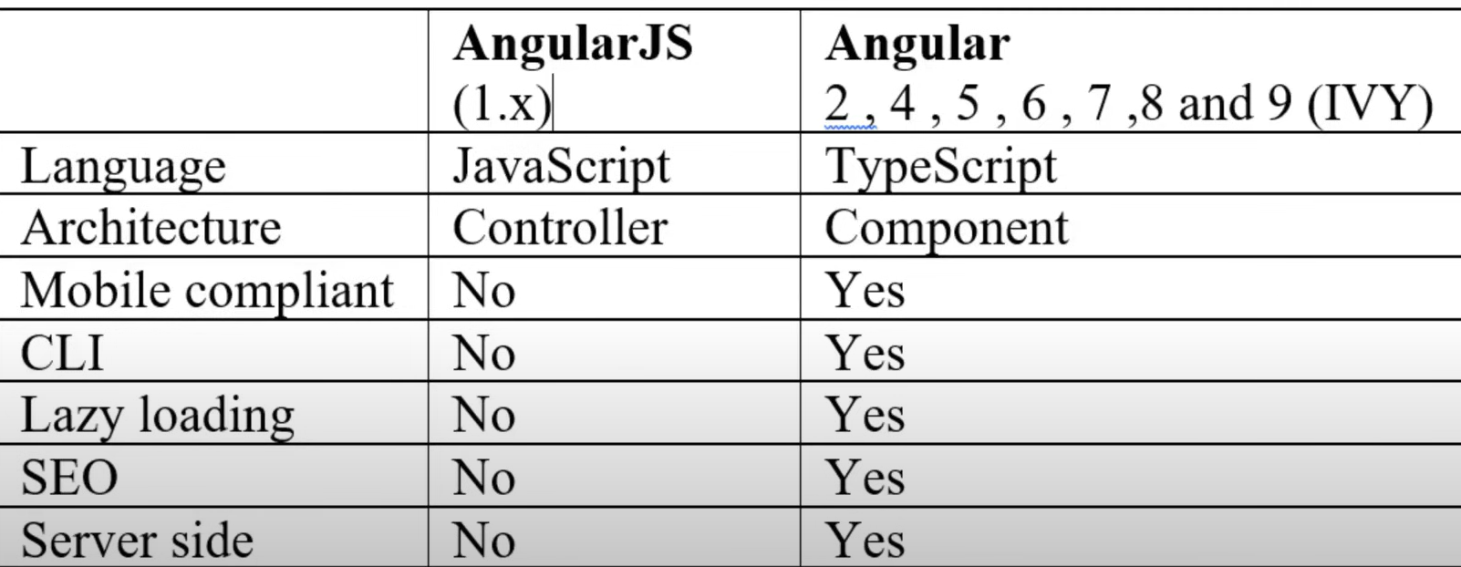

3. What are directives
Directives help you to attach the behaviour of HTML code out there.
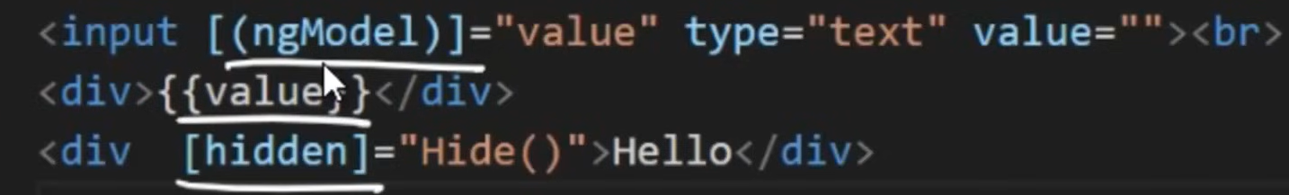
4. What are different types of directives
There are 3 types of directives
- Structural – ex: ngFor, ngIf, based on structural objects structure of DOM will change
- Attribute – ex: in above image hidden will hide based on condition, but it still exist in DOM
- Component – ex: customized components
5. Angular CLI
CLI stands for Command Line interface, which helps to give scaffold structure of Angular project.
6. Importance of Components & Modules
Components – Define and bind model with views
Modules – Combine multiple components
7. What are Decorators or Annotation or MetaData?
Decorators define what kind of class is it. For ex, if you decorate with “@Component” then it says it’s Angular Component. If you decorate with “@NgModule”, then it says that it’s Angular Module.
8. What are Templates?
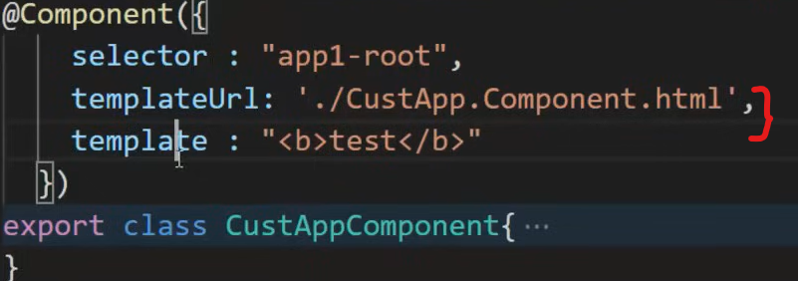
9. What are Databindings?
Databindings define how the components and views communicate with each other.
Expression – {{}}
Property Binding – []
Event Binding – ()
2-way binding – [()]
10. SPA
SPA loads only once, then based on user clicks the respective components will load.
11. Lazy loading
On demand loading components, css, html etc.
Use LoadChildren to bind component in routes
12. Dependency Injection
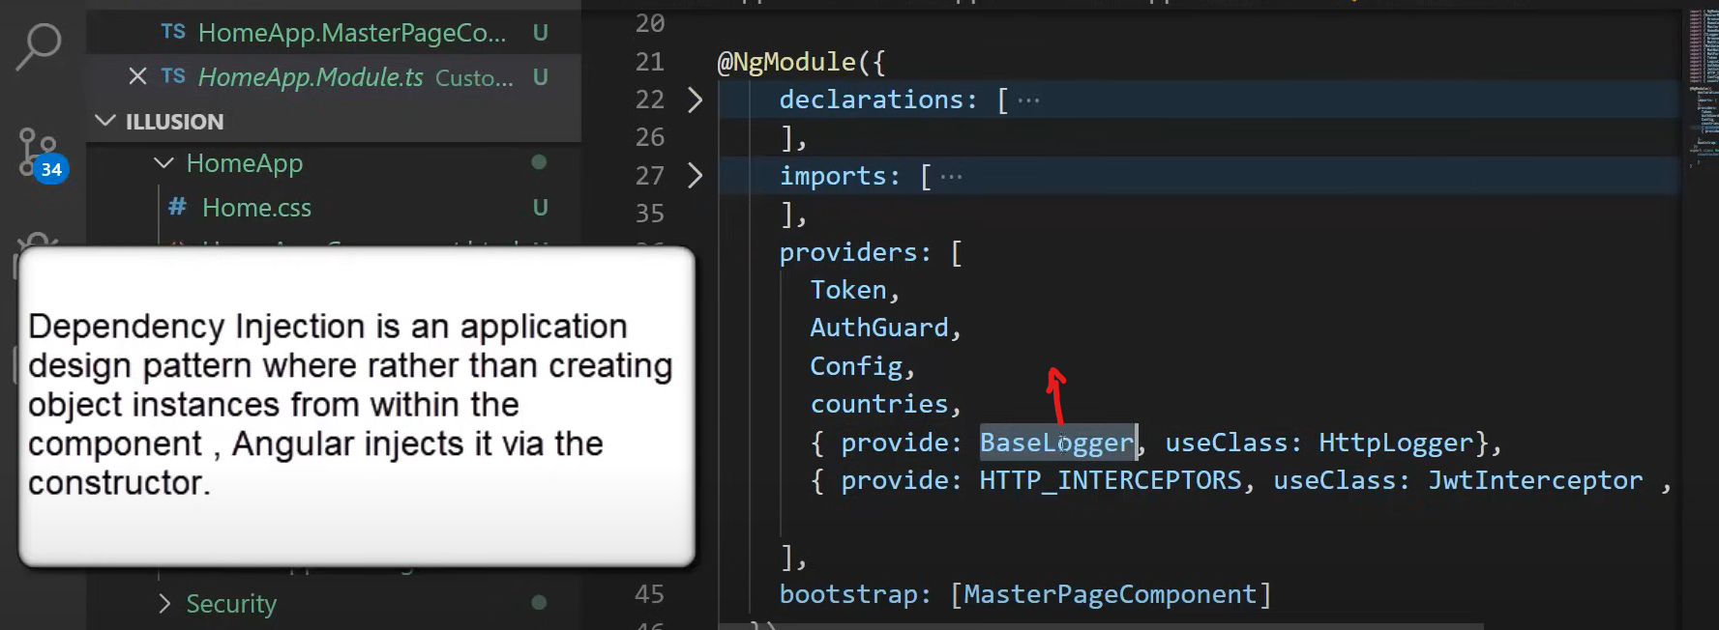
13. Difference between ng-serve and ng-build?
Ng-serve builds in-memory (Dev)
Ng-build builds on hard disk (prod)
14. What does ng-build –prod do?
--prod minified and remove unnecessary comments etc.
15. Angular Life Cycle hooks?
Most frequently used hooks are ngOnChanges, ngOnInit, ngOnDestroy
