What is Solid?
SOLID are five basic principles which help to create good software architecture. SOLID is an acronym where: -
- S stands for SRP (Single responsibility principle
- O stands for OCP (Open closed principle)
- L stands for LSP (Liskov substitution principle)
- I stand for ISP (Interface segregation principle)
- D stands for DIP (Dependency inversion principle)

SRP (Single Responsibility Principle)
Single Responsibility principle says that a class should have only one responsibility, rather dealing multiple activities.

Open Closed Principle
Stop modifying existing class, rather create new class and implement our logic.

Liskov Substitutional Principle:
LISKOV principle says that parent should easily replace the child object. So, to implement Liskov we should extend derived classes with our new functionalities.
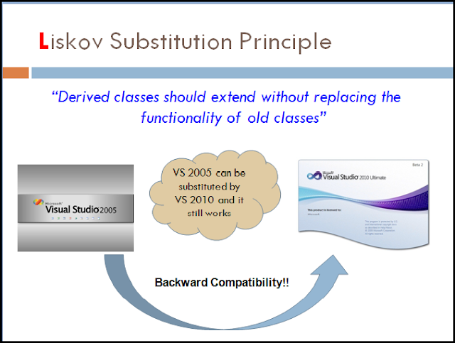

Interface Segregation Principle:
Interface segregation principle says that, rather modifying existing interface, we should create new one to avoid unnecessary object utilization in our classes.

Dependency inversion Principle:
High level modules should not depend on low level modules but should depend on abstraction.
