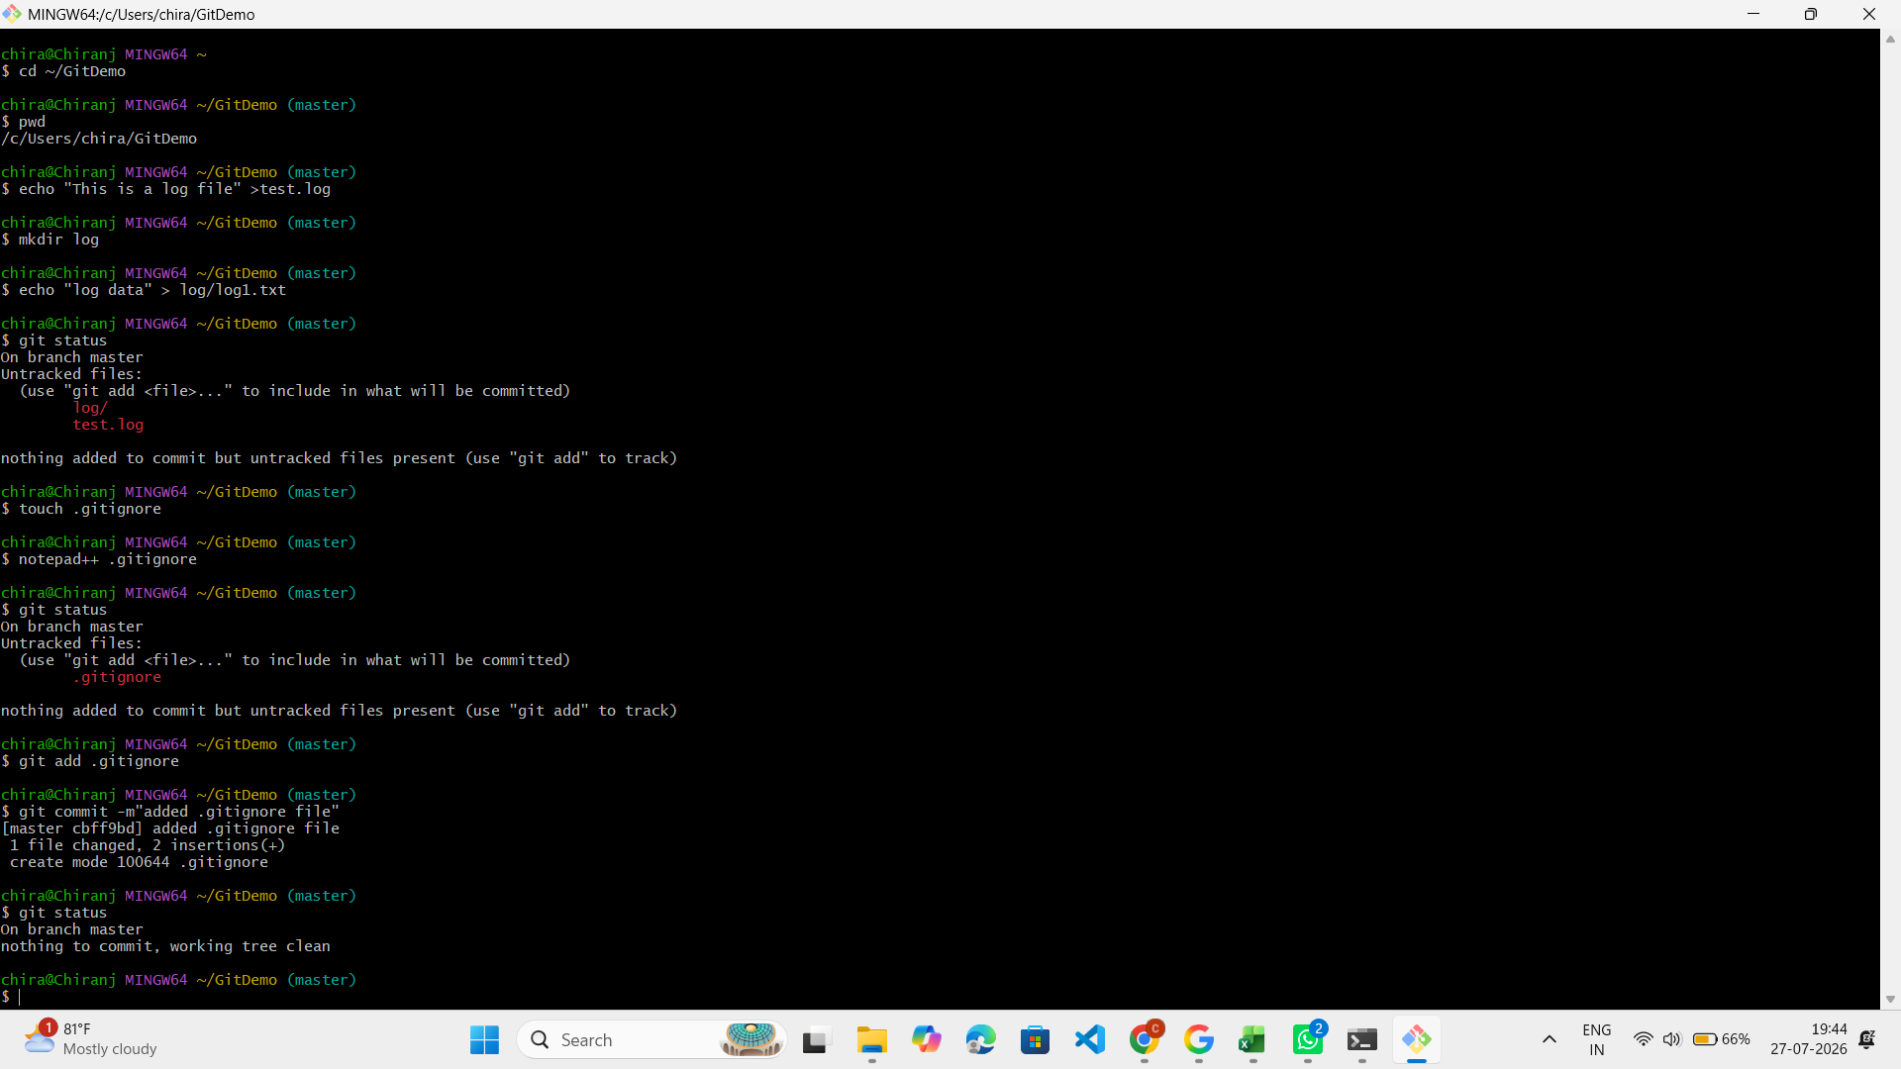
cd ~/GitDemo
echo "This is a log file" > test.log
mkdir log
echo "Log data" > log/log1.txt
git status
touch .gitignore
notepad++ .gitignore
git status
git add .gitignore
git commit -m "Added .gitignore file"
git status

