**ASSESSMENT – 01**

**PROBLEM STATEMENT:**

**Program 1. Write a simple code to get two variable one as integer and another as float. Display the given value as output also print the size of both the variables. Perform all stages of compilation process one by one (preprocessing, Compiling, assembling, linking). Share the documents and screenshot of each process.**

**Solution:**

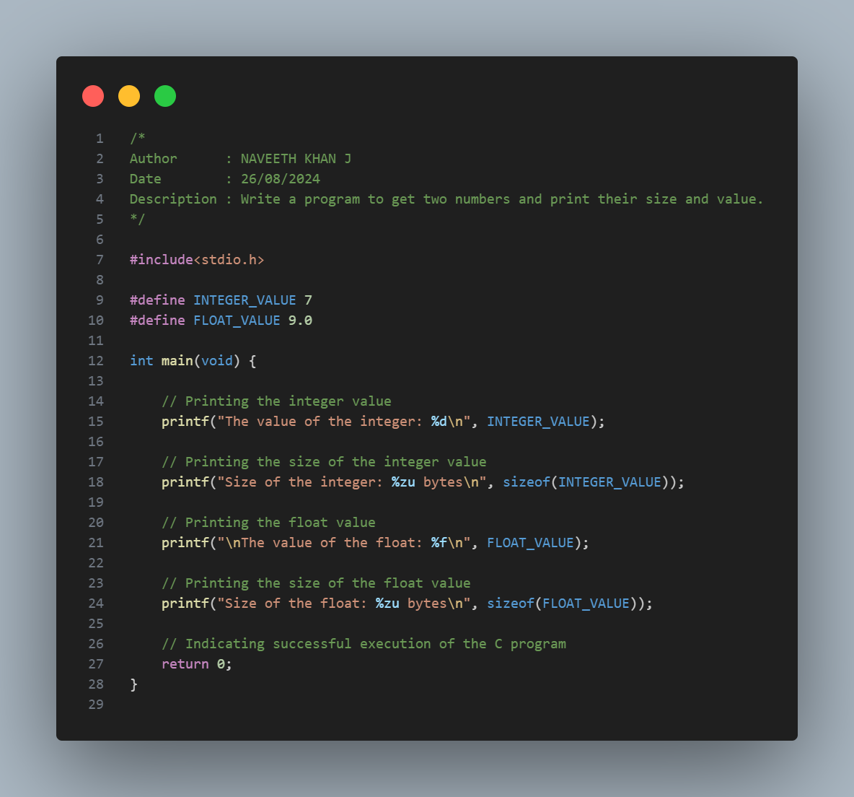

**Explanation:**

1. Defines an integer and a float value globally using #define.

2. In the main function, prints the integer value using %d and the float value using %f.

3. Prints the sizes of the integer and float using %zu with the sizeof operator.

4. Uses %d for integer values, %f for floating-point values, and %zu for printing sizes.

**Output:**

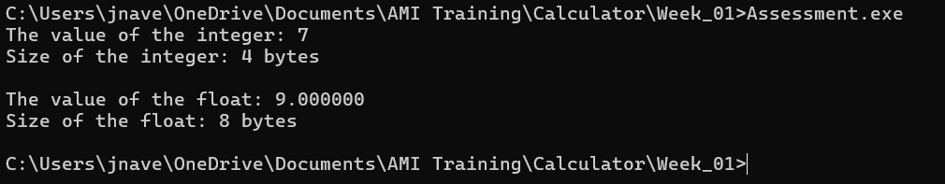

**Phases of Compilation:**

1. **Preprocessing:**

gcc -Wall -E Assessment.c -o Assessment.i

1. **Compilation:**

gcc -Wall -S Assessment.i -o Assessment.s

1. **Assesmbling:**

gcc -Wall -c Assessment.s -o Assessment.o

1. **Linking:**

gcc Assessment.o -o Assessment.exe

