**ASSESSMENT – 02**

**Name : NAVEETH KHAN J**

**Date : 01/09/2024**

**Problem Statement:**

Create a C program for the below requirements

1. Create two source file main.c & display.c
2. Create a header file main.h
3. In the header file create a macro "STAGE", also by using conditional compilation for "STAGE" value as 1 & 2 define a macro for "AREA". if STAGE = 1, the AREA should have the expression for area of square, if STAGE = 2, the AREA should have the expression of area of circle.
4. In main.c create a global variable for the radius(for circle) and side (square) by using another conditional compilation
5. in display.c print the output of area in this file based on the AREA macro. the global variables should accessed as extern variable
6. share the program and output.

**Solution: Main.h**

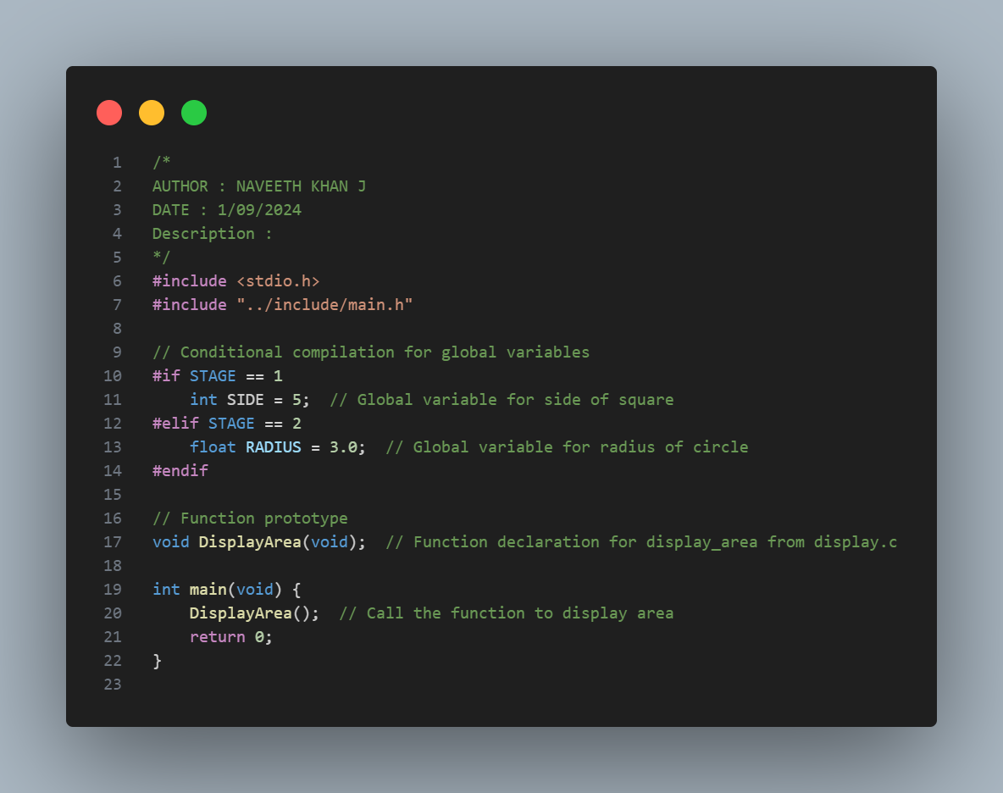

**Explanation:**

1. Includes stdio.h and main.h for required functions and definitions.
2. Declared Side and Radius as global variable for accessing in a another file.
3. Conditionally compiles code to handle either square or circle area calculations depending on STAGE.
4. The DisplayArea function prints the area of a square or circle.

**Display.c**

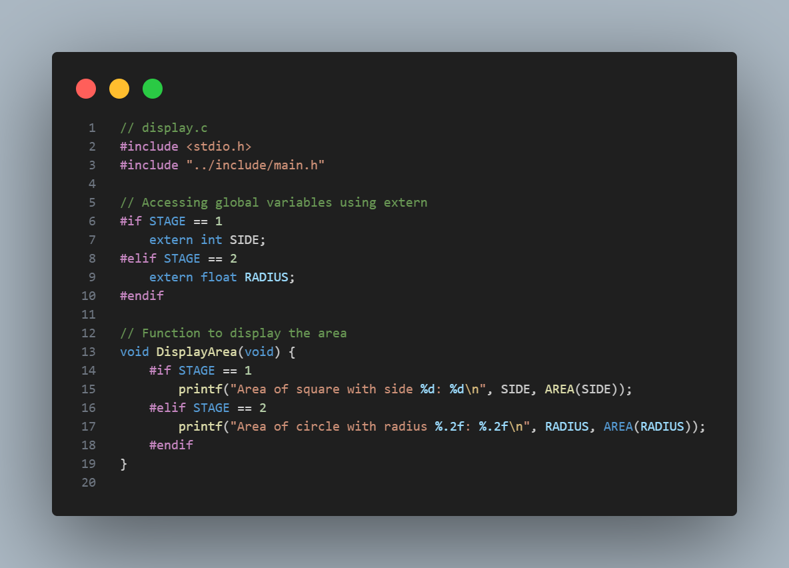

**Explanation:**

1. Includes necessary headers (stdio.h and main.h) for functionality.
2. Uses extern to access global variables (SIDE or RADIUS) defined elsewhere.
3. Applies conditional compilation to determine which variable to use based on STAGE.
4. Displays the calculated area of a square or circle using the DisplayArea function.

**Main.h**

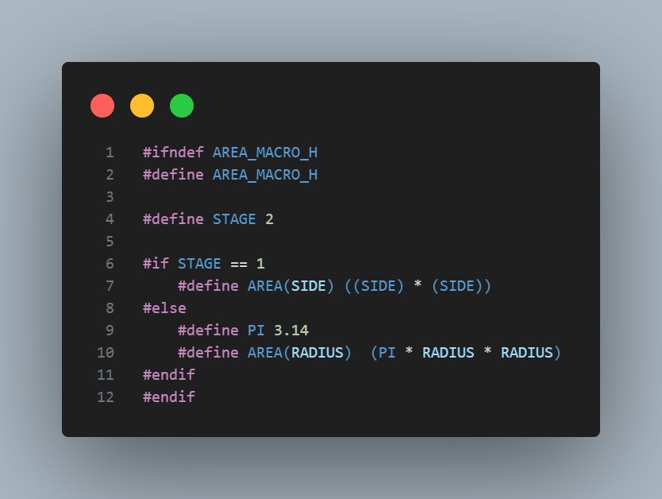

**Explanation:**

1. This header file contains the definition of AREA macros based on the conditional compilation using STAGE preprocessor variable.
2. If AREA_MACRO_H is not defined, then define and avoid the conflicts of header file.
3. The STAGE preprocessor variable is defined for AREA macro compilation based on its value. If STAGE is 1, then it calculate the area of square else evaluate the area of circle.

**Output:**

