Static-Website-Hosting-on-AWS

**📘 Project Overview:**

This project demonstrates how to host a secure, scalable, and cost-effective static website on AWS using four core services:

**Amazon S3** — For static file storage (HTML, CSS, JS, images).

**Amazon CloudFront** — For global content delivery and HTTPS access.

**AWS Certificate Manager (ACM)** — For managing SSL/TLS certificates.

**Amazon Route 53** — For DNS management and domain routing.

**⚙️ Setup Steps**

**Step 1: Create an S3 Bucket:**

1. Navigate to the S3 Console → Click Create bucket.

2. Enter a unique bucket name (e.g., mywebsite.com).

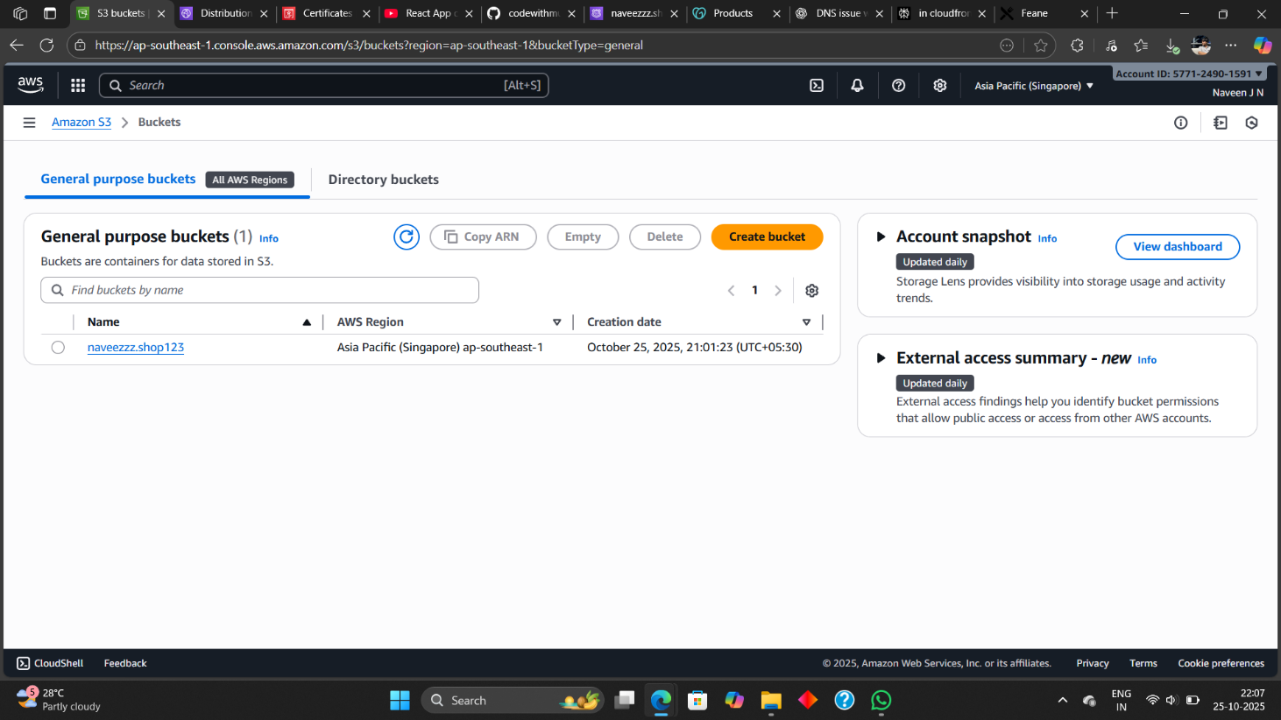

3. Uncheck the option “**Block all public access**” since CloudFront will control access.

4. Enable Static website hosting:

Under Properties → **Static website hosting, enable** it.

Specify:

Index document: **index.html**(main file)

5. Configure the bucket policy to allow permission read access:

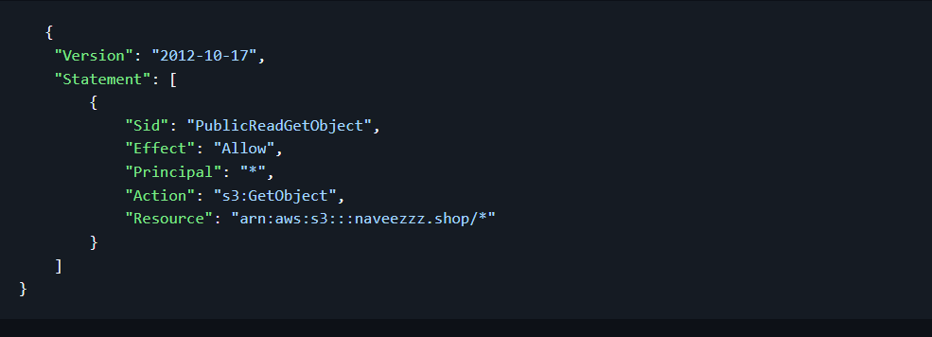

6. Add you Doc of the website in the s3 bucket using upload (file or folder):

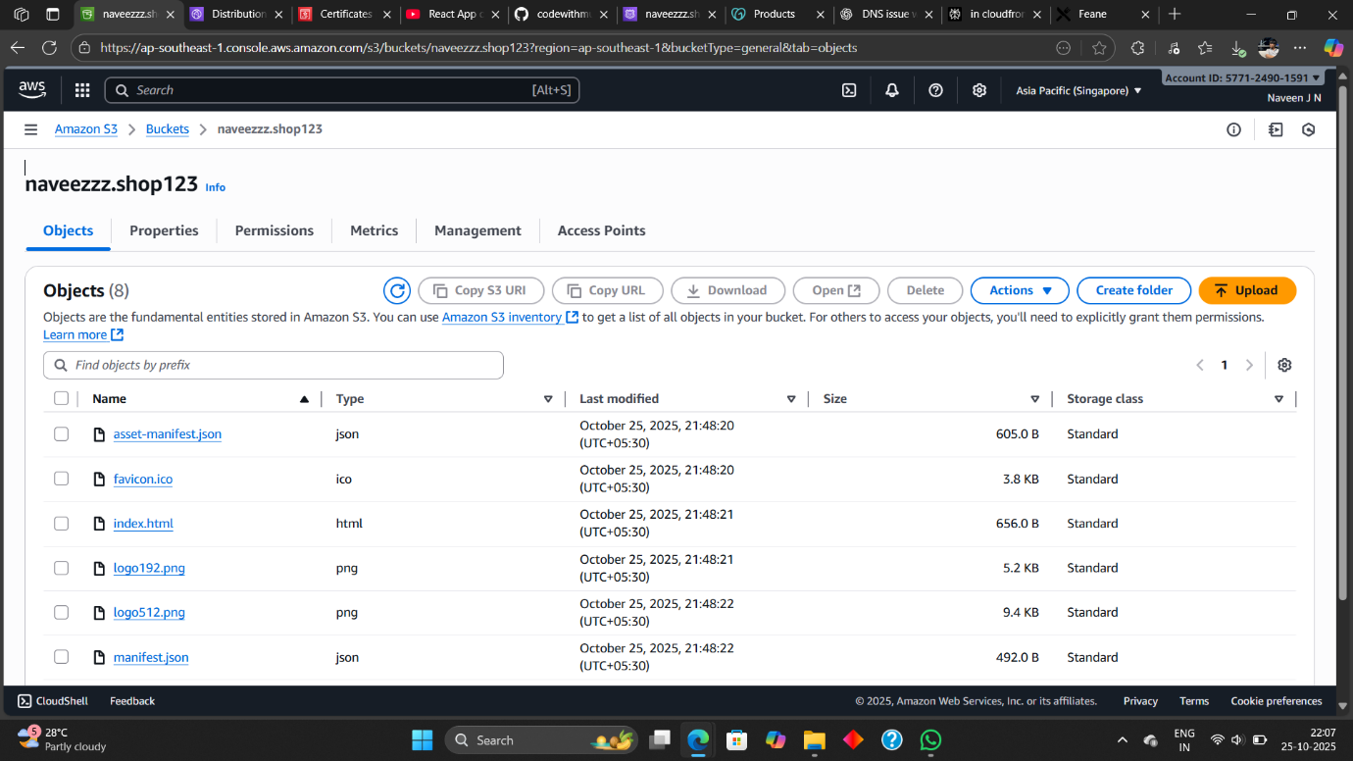

**Step 2: Request an SSL Certificate (ACM):**

1. Go to the AWS Certificate Manager (ACM) Console.
2. Choose Request a public certificate.
3. Enter your domain names: (mywebsite.com) or ([www.mywebsite.com](http://www.mywebsite.com)).

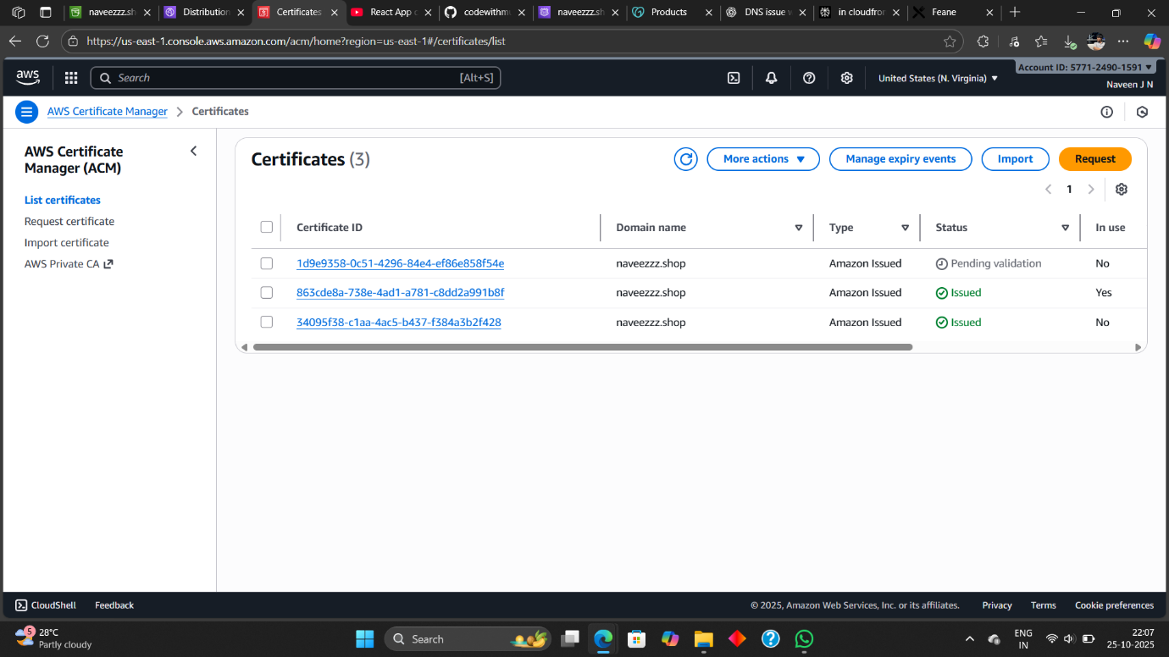

1. • Select **DNS validation**.
2. If your domain is managed in Route 53, ACM can automatically create DNS records.

6. Wait until the certificate status changes to **“Issued”**.

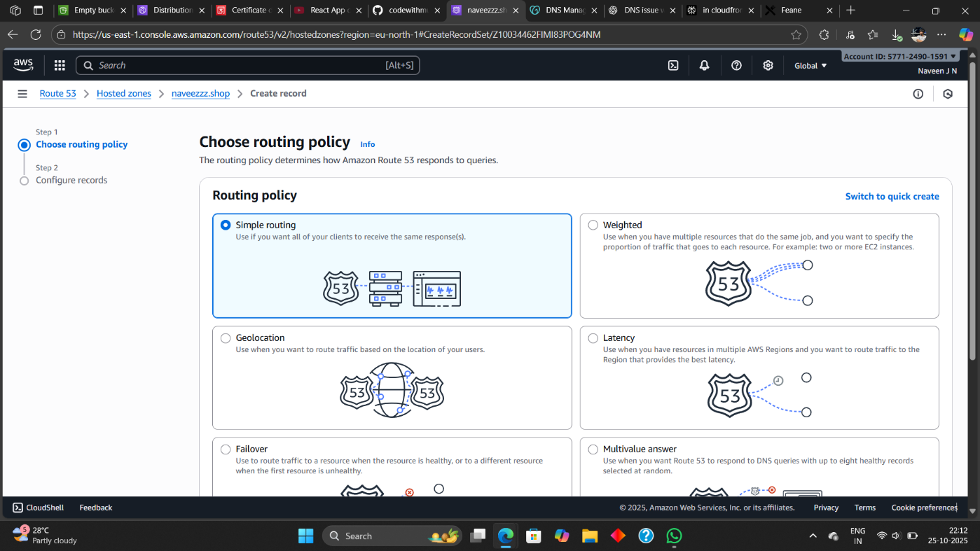

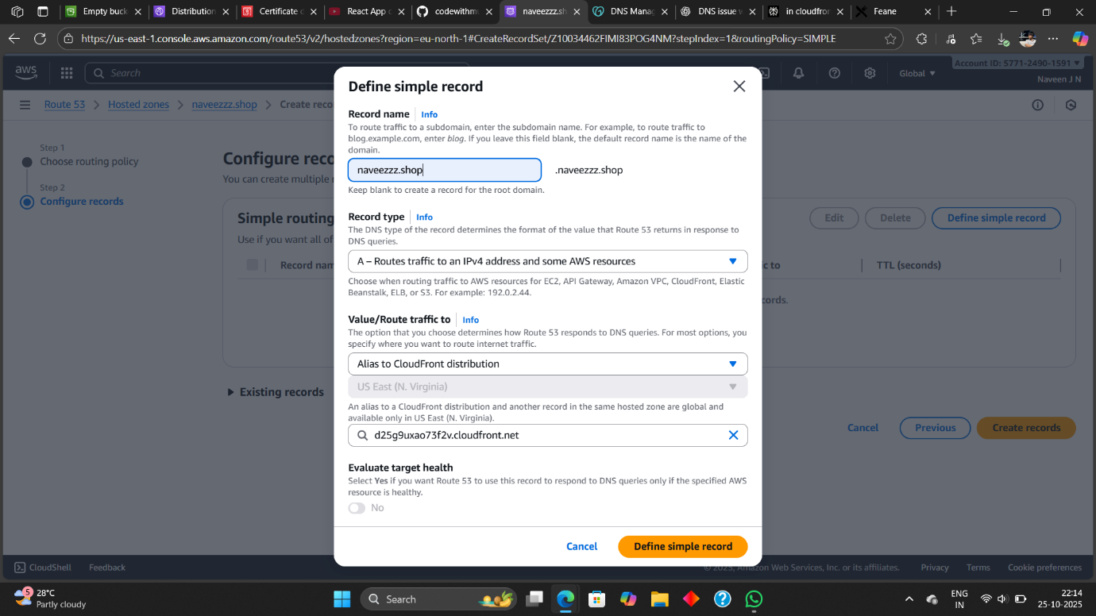

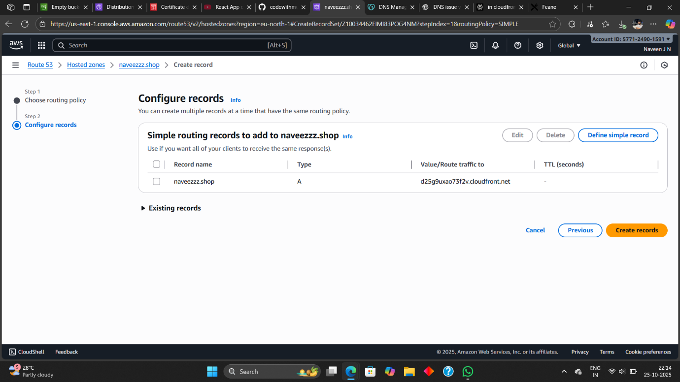

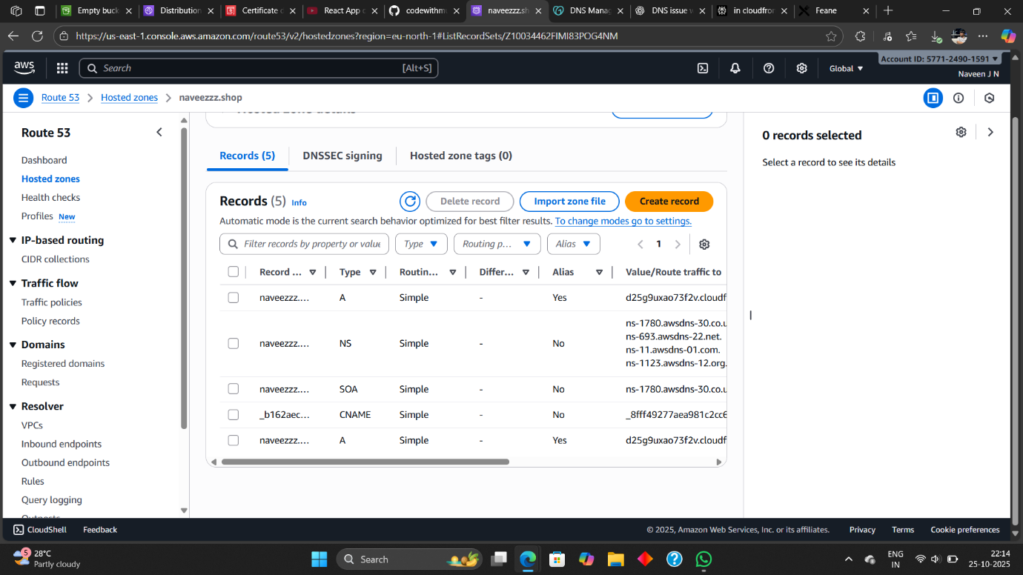

**Step 3: Create a CloudFront Distribution:**

1. Navigate to CloudFront Console → Click Create distribution.

Under Origin settings:

2. rigin domain: Select your S3 bucket (not the static website endpoint).

3. Origin access: Choose Origin access control (OAC) to restrict direct S3 access.

4. Under Default cache behavior settings:

5. Viewer protocol policy: **Redirect HTTP to HTTPS.**

6. Cache policy: Choose Managed-CachingOptimized.

Under Settings:

6. Alternate domain name (CNAME): Add your domain (e.g., mywebsite.com, www.mywebsite.com).

7. Custom SSL certificate: Choose the one you created in ACM.

8. Click Create distribution and wait for deployment.

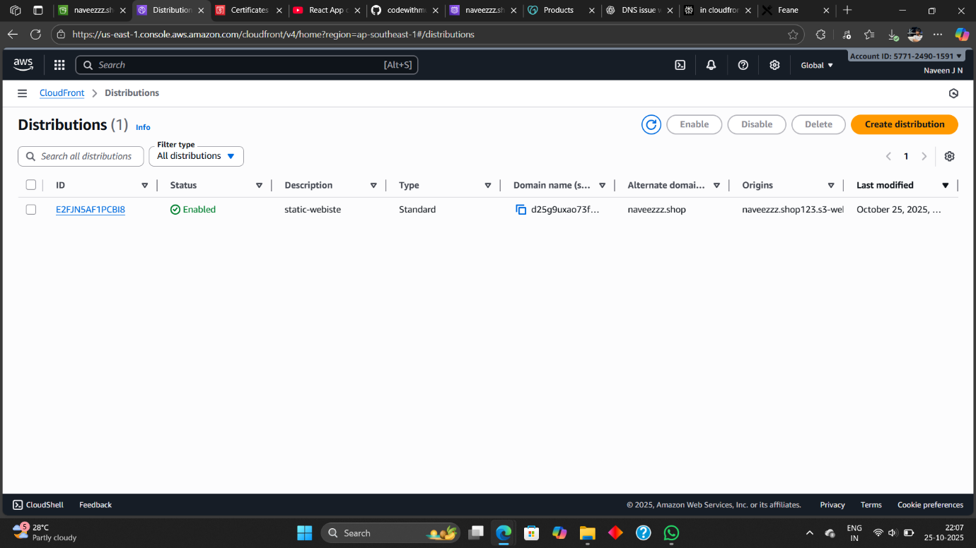

**Step 4: Configure Route 53 (DNS):**

1. Go to Route 53 Console → Hosted zones → Select your domain → Create Hosted zones.

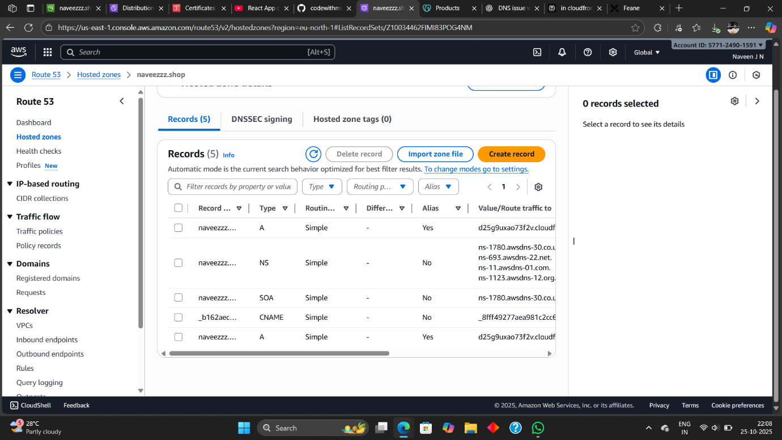

2. Connect you DNS to the domain ex: (Godaddy)

Ex: Go to Godaddy → My Product → DNS(Select) → Nameserver → Change Nameserver (Copy the nameserver from Route 53 to godaddy nameserver).

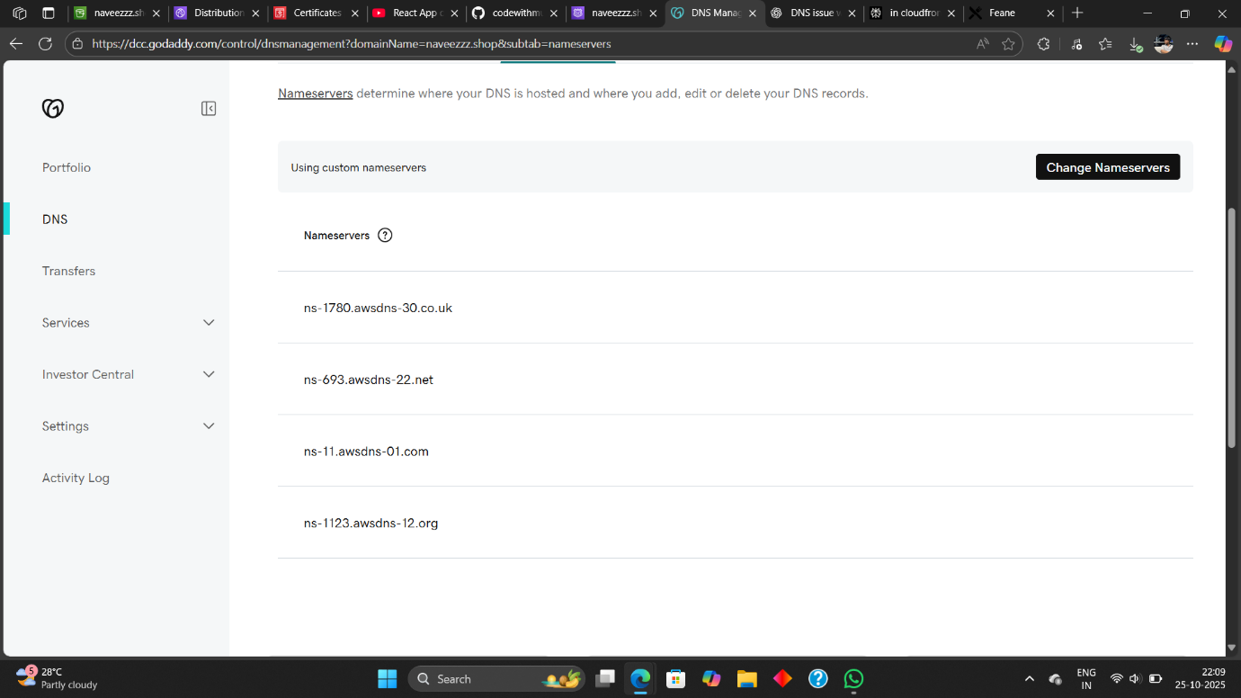

**Output:**



**ACM Security Issued:**

