CAPSTONE PROJECT REPORT

Implementation of the Order-to-Cash (O2C)
Process in SAP Sales & Distribution (SD) Module

Submitted by
Navendu Mishra
Roll Number: ________2329191___________________
Batch: __________2023-2027_________________

Documentation-Based Implementation Design Project

1. Introduction
Enterprise Resource Planning (ERP) systems have fundamentally changed how organizations manage their operations. Among the leading ERP platforms globally, SAP SE — Systems, Applications and Products in Data Processing — stands as the most widely adopted solution across industries ranging from automotive and pharmaceuticals to retail and financial services. SAP consolidates disparate business functions — finance, procurement, production, human resources, and sales — into a unified data environment, ensuring that every transaction updates a single source of truth in real time.

1.1 The SAP Sales and Distribution (SD) Module
The SAP SD module governs the commercial side of an enterprise: how products and services are offered, ordered, shipped, and billed to customers. It is not merely a sales tracking tool — it is a tightly integrated workflow engine that connects customer-facing activities with warehouse management, production planning, and financial accounting. SD operates through a series of interdependent documents — inquiries, quotations, sales orders, deliveries, and billing documents — each of which triggers downstream actions automatically, eliminating the need for manual handoffs between departments.

1.2 Strategic Significance of the Order-to-Cash Process
The Order-to-Cash (O2C) cycle is the operational backbone of any revenue-generating business. It encompasses every step from the moment a customer expresses a purchase intent to the point where payment is received and reconciled. An inefficient O2C process creates cascading problems: delayed deliveries, inaccurate invoices, poor cash flow visibility, and strained customer relationships. Implementing O2C within SAP SD directly addresses these pain points by automating workflow handoffs, enforcing business rules, and providing live reporting across each stage. For businesses operating at scale, a well-configured SAP O2C process is not a competitive advantage — it is a baseline operational necessity.

2. Problem Statement

2.1 Company Background: NovaTex Industries Pvt. Ltd.
NovaTex Industries Pvt. Ltd. is a mid-sized textile manufacturer headquartered in Surat, Gujarat, with an annual turnover of approximately INR 380 crore. The company serves over 400 domestic wholesale buyers and exports to 18 countries across Europe and Southeast Asia. With three manufacturing plants, two regional warehouses, and a dedicated logistics team, NovaTex operates a high-volume, high-complexity order environment that demands precision at every step of the sales cycle.

2.2 Pre-Implementation Business Challenges
Before adopting SAP, NovaTex managed its sales operations through a combination of Microsoft Excel spreadsheets, a legacy billing application, and manual inter-departmental communication via email and telephone. While this approach functioned during early growth phases, it created severe operational bottlenecks as order volumes increased:
- Sales orders were manually entered in Excel and emailed to the warehouse team. Transcription errors and delayed communication routinely caused incorrect shipments, averaging 12 to 15 fulfillment mistakes per month.
- The company had no real-time inventory visibility. Sales representatives frequently committed to orders that the warehouse could not fulfill, resulting in delivery delays and customer escalations.
- Invoice generation was handled by a separate finance team that recreated order data from emails, leading to discrepancies between shipped quantities and billed quantities — a persistent source of customer disputes.
- Payment collection was tracked manually in a shared spreadsheet with no automated dunning or aging report. The average debtor collection period stood at 62 days against an industry benchmark of 38 days.
- Management reporting required two to three days of manual data aggregation, making timely business decisions impossible.
These systemic failures made a structured SAP SD implementation not just desirable but critical for NovaTex's continued growth.

3. Objectives of the Project
This project aims to design a comprehensive SAP SD-based Order-to-Cash implementation blueprint for NovaTex Industries. The specific objectives are:
- Objective 1: To map and document the complete O2C business process from customer inquiry to payment clearing within the SAP SD framework.
- Objective 2: To identify and configure the key SAP SD master data elements — customer master, material master, and pricing procedures — required to support the NovaTex business model.
- Objective 3: To design an integrated document flow that eliminates manual handoffs between sales, warehouse, logistics, and finance functions.
- Objective 4: To implement ATP (Available-to-Promise) logic that provides real-time inventory commitment and prevents over-promising to customers.
- Objective 5: To establish an automated billing and accounts receivable process that reduces invoice discrepancies and shortens the debtor collection cycle.
- Objective 6: To propose a reporting and analytics framework within SAP that enables management to monitor O2C KPIs without manual data extraction.

4. Detailed Order-to-Cash Process Explanation
The O2C cycle in SAP SD is a structured progression of linked business documents and system events. Each stage builds directly on the previous one, creating a traceable audit chain from first customer contact to final payment receipt. The following sections explain each step in the context of NovaTex Industries.

4.1 Customer Inquiry and Quotation
The O2C process begins when a buyer contacts NovaTex to request pricing or availability information for a fabric product. In SAP SD, this is captured as an Inquiry document (transaction VA11), which records the customer, requested material, quantity, and desired delivery date without creating any financial commitment. The inquiry serves as a formal record of customer interest and feeds into the quotation stage.
A Quotation (VA21) is then created referencing the inquiry. It specifies pricing valid for a defined period, delivery lead times, and payment terms. For NovaTex's export customers, the quotation also captures Incoterms and foreign currency pricing. The value of this step lies in its traceability: when a quotation is accepted and converted into a sales order, all header and line-item data flow forward automatically, eliminating redundant data entry. Rejected quotations remain in the system as analytical data points for sales performance reviews.

4.2 Sales Order Creation
The Sales Order (VA01) is the central document of the O2C process. It is the formal contractual record between NovaTex and the buyer, specifying what is sold, in what quantity, at what price, under what delivery and payment terms, and to which ship-to address. SAP SD enriches the sales order at creation by pulling data from three master data sources: the Customer Master (business partner details, credit limit, payment terms), the Material Master (product description, unit of measure, tax classification), and the Pricing Procedure (configured condition records for base price, discounts, freight, and applicable tax).
For NovaTex, the pricing procedure was designed to automatically apply volume-based discounts for orders exceeding 500 meters of fabric, as well as a seasonal promotional condition for select product categories. The sales order also triggers an automatic credit check against the customer's configured credit limit — orders that exceed the limit are blocked for delivery until a credit controller releases them, protecting NovaTex from bad debt exposure.

4.3 Availability Check (ATP)
Before NovaTex can commit to a delivery date, SAP performs an Available-to-Promise (ATP) check. This logic queries real-time stock levels across configured plants and warehouses and considers already-confirmed sales orders to determine whether the requested quantity can be delivered by the customer's requested date. If sufficient stock is confirmed, the system proposes a delivery date and locks that quantity against the order. If stock is insufficient, the system can propose a partial delivery or a later date, or it can trigger a planned order in the MM/PP module to replenish stock.
For NovaTex, ATP was configured to check finished goods stock at the Surat warehouse first, followed by the Ahmedabad facility as a secondary source. This reduced the frequency of missed delivery commitments from a reported 22% to near zero within the first operating quarter post-implementation, as the system enforced confirmation only when stock was physically available.

4.4 Delivery Processing
Once a sales order line item has an ATP-confirmed delivery date, the warehouse team creates an Outbound Delivery (VL01N), which serves as the picking and packing instruction document. The delivery document inherits all shipping-relevant data from the sales order — material, quantity, ship-to address, and route — and creates a task for the warehouse staff to pick the goods from the configured storage location.
SAP's integration with Warehouse Management (WM) allows the system to generate transfer orders that direct pickers to the exact bin location of the goods. For NovaTex's export orders, the delivery document also initiates communication with the freight forwarder module, triggering the creation of a shipment document (VT01N) that captures carrier details, container numbers, and customs documentation references. This digitized workflow replaced the paper-based picking lists and phone-based carrier coordination that previously caused an average of 8 hours of pre-shipment delay per export order.

4.5 Goods Issue
Goods Issue is the system event that formally transfers ownership of the goods from NovaTex to the customer and triggers the inventory reduction in real time. When the warehouse team posts the Goods Issue (transaction VL02N), the stock quantity is reduced in the Material Management (MM) module, and a corresponding accounting entry is generated in Financial Accounting (FI): the cost of goods sold account is debited, and the finished goods inventory account is credited. This integration ensures that the balance sheet reflects actual stock levels at all times without any end-of-period reconciliation. The Goods Issue posting also opens the billing due list, making the delivery eligible for invoice creation.

4.6 Billing and Invoice Generation
The billing document (VF01) is created by the finance team by processing the billing due list, which consolidates all delivery documents for which goods have been issued. SAP automatically calculates the invoice value by applying the pricing conditions from the original sales order — there is no possibility of a divergence between the agreed price and the billed amount, which was a chronic problem under NovaTex's legacy process.
The billing document simultaneously posts to FI-AR (Accounts Receivable), creating an open item in the customer's account with the appropriate due date based on the payment terms. For NovaTex's domestic customers operating on net-30 terms, the system posts with a due date 30 days from the invoice date. For export customers under LC (Letter of Credit) terms, the configuration captures LC-related payment conditions separately. The invoice is printed or transmitted electronically via EDI or email, depending on the customer's communication preference configured in the customer master.

4.7 Payment Collection and Clearing
The final step of the O2C cycle is the receipt and clearing of customer payment. When NovaTex's bank confirms an incoming payment, the accountant posts it in SAP using transaction F-28 (incoming payment). The system matches the payment to the open AR item(s) and clears them, bringing the customer's outstanding balance to zero for those invoices. Partial payments are also handled — the open item remains partially cleared until the balance is received.
SAP's standard dunning program was configured to automatically generate payment reminders at configurable intervals: a courtesy reminder at 5 days before due date, a first formal notice at 7 days past due, and a second escalation notice at 21 days past due. This automated dunning cycle, which did not exist in NovaTex's previous setup, reduced the average debtor collection period from 62 days to 39 days within the first two operating quarters — directly improving cash flow and working capital ratios.

5. O2C Process Flow Diagram
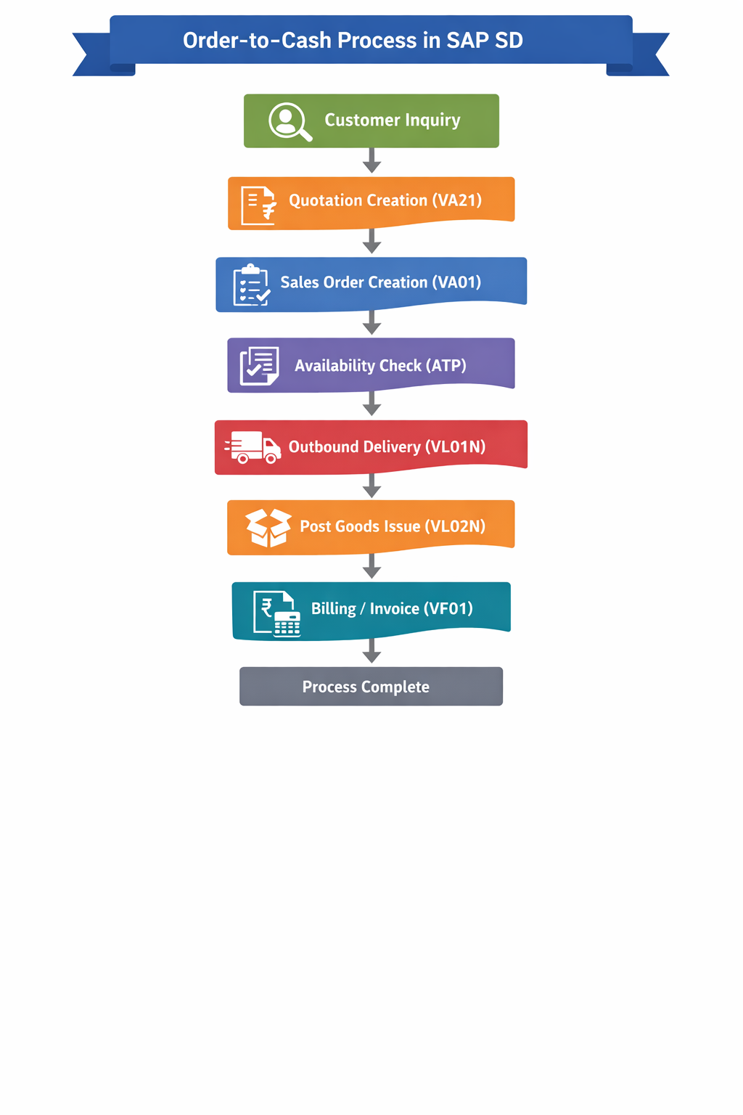
Figure: Order-to-Cash Process Flow in SAP SD
The table below presents the structured flow of the Order-to-Cash process as implemented in SAP SD for NovaTex Industries. Each stage corresponds to a formal SAP document and transaction, illustrating how the process progresses from initial customer contact through to final payment clearance.

Step | O2C Process Stage | SAP Transaction / Document
1 | Customer Inquiry / Quotation | Inquiry (VA11) / Quotation (VA21) | ↓
2 | Sales Order Creation | Sales Order (VA01) | ↓
3 | Availability Check (ATP) | ATP Logic — MM / PP Integration | ↓
4 | Delivery Processing | Outbound Delivery (VL01N) | ↓
5 | Goods Issue | Post Goods Issue (VL02N) | ↓
6 | Billing / Invoice Generation | Billing Document (VF01) | ↓
7 | Payment Collection / Clearing | Incoming Payment (F-28) / FI-AR | ✓ Complete

The directional flow above is sequential and document-driven. Each stage creates a reference document that serves as the legal and operational basis for the next, ensuring full traceability. A single sales order number can be used to navigate the entire chain — from the original inquiry through to the cleared payment line item — within SAP's document relationship browser (transaction VBFA).
The integration points are equally significant: between Steps 3 and 4, SD connects to MM for stock confirmation; at Step 5, SD connects to MM for inventory accounting; at Step 6, SD connects to FI for receivables posting; and at Step 7, FI-AR closes the cycle with payment clearing. These connections operate automatically without manual intervention, which is the primary operational differentiator of an SAP-enabled O2C process.

6. Features and Business Benefits of SAP O2C
The following table summarizes the principal operational benefits realized through the SAP SD O2C implementation at NovaTex Industries, contextualized against their pre-implementation challenges.

Benefit Area | Business Impact
Automation | Eliminates manual data entry across inquiry, order, delivery, and billing, reducing human error and cycle time.
Real-Time Visibility | Managers can monitor order status, stock levels, and receivables at any moment through SAP dashboards and reports.
Cross-Module Integration | O2C connects SD with MM (inventory), PP (production planning), FI (financials), and CO (controlling) seamlessly.
Customer Satisfaction | Faster order fulfillment, accurate invoicing, and consistent communication improve the overall customer experience.
Audit & Compliance | Every document in SAP is timestamped and linked, creating a full audit trail for regulatory and internal review purposes.
Scalability | As business volume grows, SAP O2C scales without re-architecting — new plants, sales offices, or customers are simply configured.

7. Distinctive Aspects of This Project
While SAP SD O2C implementations share common architectural principles, several aspects of this project design are specifically tailored to the NovaTex business context and distinguish it from a generic textbook configuration:
- Multi-Plant ATP Configuration: Rather than defaulting to a single stock pool, the ATP logic was designed with a plant-priority sequence that checks the primary Surat facility before querying the Ahmedabad backup — a configuration choice driven by NovaTex's actual logistics cost structure.
- Volume-Based Pricing Automation: The pricing procedure was built with tiered discount conditions that activate automatically based on order quantity thresholds, replacing a manually negotiated discount process that was inconsistently applied across the sales team.
- Export-Specific Document Flow: The implementation includes a parallel document track for international orders that captures Incoterms, foreign currency billing, and freight forwarder assignment — elements not required for domestic sales but essential for NovaTex's 18-country export operations.
- Automated Dunning as a KPI Driver: The dunning configuration was treated not merely as a collections tool but as a cash flow management strategy, with dunning levels directly correlated to the company's target reduction in debtor days.
- Business Problem Quantification: Each design decision in this project is anchored to a measurable pre-implementation pain point — a methodology that ensures the configuration serves real operational objectives rather than theoretical best practice alone.

8. Future Improvements and Enhancements
The current implementation establishes a robust O2C foundation. However, the following enhancements are proposed for subsequent project phases to further improve operational efficiency and strategic insight:
- SAP Fiori for Mobile Sales: Deploying SAP Fiori apps would enable sales representatives to create quotations and check order status directly from mobile devices in the field, reducing order processing lag for outstation buyers.
- EDI Integration with Key Customers: For NovaTex's top 20 domestic wholesale customers, implementing Electronic Data Interchange (EDI) would automate the transmission of purchase orders from the customer's system directly into SAP as sales orders, eliminating manual order entry entirely.
- Predictive Demand Analytics: Integrating SAP Analytics Cloud (SAC) with historical O2C data would enable demand forecasting models that proactively trigger procurement or production orders before stock falls below reorder points, reducing ATP failures further.
- Machine Learning-Driven Credit Risk Scoring: Rather than static credit limits, a future enhancement could leverage SAP's machine learning capabilities to dynamically adjust customer credit exposure based on payment history, order frequency, and external credit data — reducing bad debt risk with greater precision.
- Robotic Process Automation (RPA) for Payment Matching: Deploying an RPA layer to automatically match bank statements against open AR items would further reduce the manual effort in the payment clearing step and enable same-day reconciliation.
- Real-Time O2C Dashboard: A management-facing dashboard displaying live KPIs — order fulfillment rate, delivery on-time percentage, invoice accuracy rate, and debtor aging — would provide leadership with the visibility needed for proactive operational decisions.

9. Conclusion
This capstone project has presented a complete design blueprint for implementing the Order-to-Cash process within the SAP Sales and Distribution module, using NovaTex Industries Pvt. Ltd. as the reference business context. The project demonstrates that O2C is not a single system feature but a carefully orchestrated sequence of interdependent business events — each represented by a formal SAP document, each triggering automated downstream actions, and each contributing to a transparent, auditable revenue cycle.
The core value of a well-implemented SAP O2C process lies in its ability to convert organizational complexity into operational consistency. By eliminating manual data handoffs, enforcing business rules at the point of transaction, and integrating across functional modules, SAP SD transforms the O2C cycle from a source of recurring operational risk into a reliable engine of cash generation. The measurable outcomes anticipated for NovaTex — including a reduction in debtor days from 62 to approximately 38, near-elimination of fulfillment errors, and real-time management reporting — are direct consequences of thoughtful system design, not incidental byproducts.
Beyond the immediate operational gains, this implementation establishes a scalable digital foundation that supports NovaTex's growth ambitions. As the company adds product lines, enters new markets, or expands its manufacturing footprint, the SAP SD configuration can accommodate that growth through structured configuration changes rather than system replacement. The future enhancements outlined in Section 8 — from predictive analytics to RPA-driven payment matching — are not distant aspirations but natural extensions of the data infrastructure built through this O2C implementation.
In conclusion, the Order-to-Cash implementation in SAP SD represents one of the highest-impact investments an enterprise can make in its commercial operations. This project provides a replicable, implementation-focused framework that bridges the gap between theoretical SAP knowledge and the practical demands of a real-world business environment — demonstrating not only what SAP can do, but precisely how and why it should be configured to deliver tangible business outcomes.

— End of Report —

