

Topic: ScriptWell – Online Book Purchasing Store

ADVANCED INTERNET PROGRAMMING PROJECT REPORT

Submitted by:

Student name
UID: 26MCA22333

Submitted to:
Mr. Ajay Yadav(E13382)

Submitted in partial fulfilment of the requirements for the degree of

MASTER OF COMPUTER APPLICATIONS (MCA)

CHANDIGARH UNIVERSITY
University Institute of Computing Punjab, India

BONAFIDE CERTIFICATE
This is to certify that the project report titled “ScriptWell – Online Book Purchasing Store” has been prepared as an academic project using Java Servlets, JavaServer Pages (JSP), JSTL, JDBC, HTML, CSS, JavaScript and Bootstrap, following the Model-View-Controller (MVC) architecture on Apache Tomcat 10.1 with JDK 17. The project demonstrates catalogue browsing, search and filters, user registration and login, session management, a shopping cart with AJAX updates, Buy Now, checkout with simulated payment, order history and an administrator dashboard for book, inventory and order management, backed by an Oracle database.
This project report is submitted in partial fulfilment of the requirements for the degree of Master of Computer Applications (MCA).

Student Signature: Project Supervisor:

Head of Department: Date:

TABLE OF CONTENTS

Chapter 1: Introduction and Background Study PAGE 1 - 2
- 1.1 Project Overview
- 1.2 Problem Definition
- 1.3 Objectives and Scope
- 1.4 Technologies Used
- 1.5 Existing System and Proposed Solution

Chapter 2: System Requirements and Design PAGE 3 - 4
- 2.1 Hardware and Software Requirements
- 2.2 System Architecture (MVC)
- 2.3 Request Flow and Program Workflow
- 2.4 Project Structure and Modules
- 2.5 Functional and Non-Functional Requirements

Chapter 3: Implementation PAGE 5 - 7
- 3.1 Servlet Controllers and URL Mapping
- 3.2 JSP Views, JSTL and Custom Tag
- 3.3 Database Access with JDBC CallableStatement
- 3.4 Session Management, Filters and Security
- 3.5 Client-side Scripting and AJAX
- 3.6 User Interface and Responsive Design

Chapter 4: Testing, Results and Conclusion PAGE 8 - 12
- 4.1 Testing Methodology
- 4.2 Test Cases and Validation
- 4.3 Results and Screenshots
- 4.4 Limitations and Future Scope
- 4.5 Conclusion
- 4.6 Pushing the Project to GitHub
- References

CHAPTER 1:

INTRODUCTION AND BACKGROUND STUDY

1.1 Project Overview
ScriptWell is a modern, responsive online bookstore built as a dynamic Java web application. Visitors can browse 34 books in seven categories, search by title, author or ISBN, filter by category and price, and open detailed book pages. Registered customers can manage a shopping cart, buy a single book instantly with Buy Now, check out with a simulated Card, UPI or Cash-on-Delivery payment, see an order confirmation and follow their order history. An administrator gets a dashboard with sales figures and full control over books, stock and orders.
This report covers the web tier of the project. The application is written with Java Servlets and JSP and follows the Model-View-Controller (MVC) pattern. It runs on Apache Tomcat 10.1 with JDK 17 and is developed in Eclipse IDE. The data is stored in Oracle Database Free, which the web tier reaches only through JDBC CallableStatement calls to stored PL/SQL.

1.2 Problem Definition
A small bookstore needs an online channel that is easy to use on any device, secure, and simple for staff to manage. Static web pages cannot do this, because the catalogue, cart, stock and orders change all the time. The specific problems to solve were:
- Generate pages dynamically from database data while keeping presentation code separate from business logic.
- Remember who the user is and what is in their cart across many HTTP requests, which are stateless.
- Protect customer pages and the administrator area from unauthorised access.
- Give a fast, app-like experience (for example, adding to the cart without reloading the page) on desktop and mobile.

1.3 Objectives and Scope
Objectives
1. Build a dynamic web application with Java Servlets as controllers and JSP + JSTL as views, following MVC.
2. Use JDBC with CallableStatement for all database access through a DAO layer.
3. Implement session management, servlet filters for authentication and role-based authorisation, and the Post/Redirect/Get pattern.
4. Design a clean, premium and responsive interface with HTML5, CSS3, Bootstrap 5 and JavaScript.
5. Provide search, filters, book details, registration/login, cart, Buy Now, checkout, confirmation and order history.
6. Provide an administrator dashboard for book CRUD, inventory and order management.
Scope
The application supports guests, customers and administrators. Payment is simulated: card numbers are checked for format with the Luhn algorithm, but no money is charged and no card data is stored. E-mail notifications, reviews and a real payment gateway are outside the scope and are listed as future work.

1.4 Technologies Used
Table 1.1: Technologies and tools
Technology | Purpose in the project
Java Servlets (Jakarta Servlet 6.0) | Controllers that handle HTTP GET/POST requests
JSP 3.1, EL and JSTL 3.0 | Server-side views without Java scriptlets; core, fmt and functions tags
JDBC (ojdbc11) and CallableStatement | Calling stored PL/SQL procedures and functions in Oracle
HTML5, CSS3, Bootstrap 5.3, Bootstrap Icons | Page structure, custom styling and responsive grid
JavaScript (Fetch API) and Chart.js | AJAX add-to-cart, form helpers and the admin sales chart
Apache Tomcat 10.1, JDK 17 | Servlet container and Java runtime
Eclipse IDE (Dynamic Web Project) | Development, building and deployment to Tomcat
Oracle Database Free 23ai | Data storage and business logic in PL/SQL

1.5 Existing System and Proposed Solution
Table 1.2: Comparison of the existing approach and ScriptWell
Aspect | Typical existing system | Proposed ScriptWell application
Pages | Static HTML or scriptlet-heavy JSP | MVC: servlets prepare data, JSTL views render it
User state | None or cookies only | HttpSession with session-fixation protection
Access control | Checks copied into every page | One AuthFilter for all protected URLs
Cart updates | Full page reload | AJAX with the Fetch API and JSON responses
Data access | SQL strings in JSP pages | DAO layer using CallableStatement only
Devices | Desktop-only layout | Responsive Bootstrap layout for phones and desktops

CHAPTER 2:

SYSTEM REQUIREMENTS AND DESIGN

2.1 Hardware and Software Requirements
Table 2.1: Hardware and software requirements
Item | Requirement
Processor / Memory | 64-bit dual-core CPU or better, minimum 8 GB RAM
Operating system | Windows 10/11, Linux or macOS
Java | JDK 17 (the code is compiled with --release 17)
Web server | Apache Tomcat 10.1
IDE | Eclipse IDE for Enterprise Java and Web Developers
Database | Oracle Database Free 23ai (FREEPDB1)
Libraries | ojdbc11, Jakarta JSTL 3.0 (in WEB-INF/lib); Bootstrap 5.3 and Chart.js from CDN
Client | Any current browser: Chrome, Edge or Firefox

2.2 System Architecture (MVC)
The application has a three-tier architecture, and the middle tier is organised as MVC (Figure 2.1). The Model is a set of JavaBeans (Book, Category, User, CartItem, Order). The View is JSP pages stored under WEB-INF/views, so the browser can only reach them through a controller. The Controller layer is seven servlets that read the request, call the DAO layer and choose the view. Two filters handle cross-cutting concerns before any servlet runs.
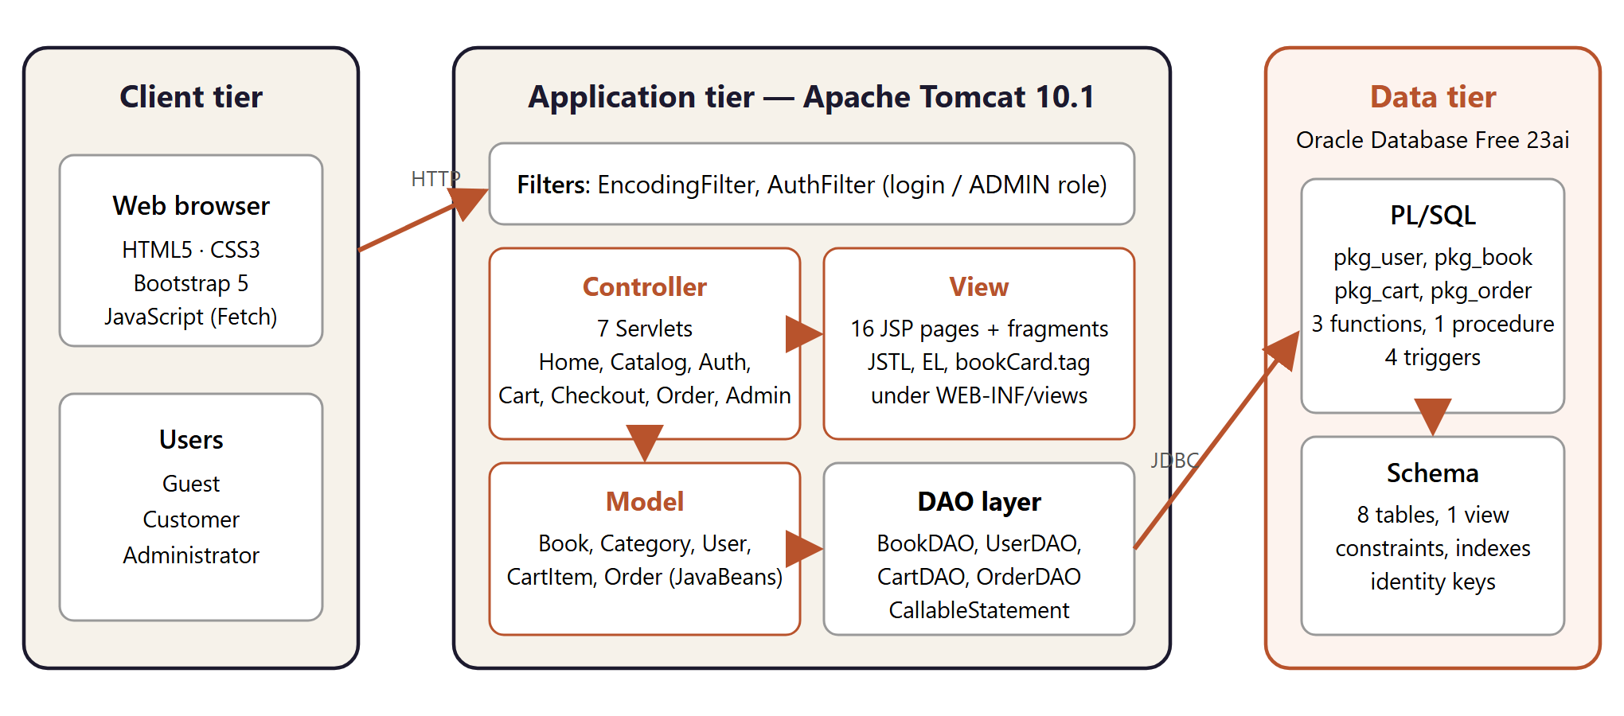
Figure 2.1: Three-tier MVC architecture of ScriptWell

2.3 Request Flow and Program Workflow
The workflow for placing an order shows how the parts work together:
1. The browser submits the checkout form with POST /checkout.
2. EncodingFilter sets UTF-8. AuthFilter checks that the session contains a signed-in user and otherwise redirects to /login?next=/checkout.
3. CheckoutServlet reads the address fields and validates the simulated payment (card format and Luhn check, UPI pattern, or COD).
4. OrderDAO.placeOrder() calls the stored procedure pkg_order.place_order through a CallableStatement and receives the order ID.
5. The servlet updates the cart badge count in the session and sends a redirect to /order?id=...&placed=1 (Post/Redirect/Get).
6. OrderServlet loads the order and forwards to order.jsp, which shows the confirmation page.

2.4 Project Structure and Modules
scriptwell/
|-- src/main/java/
| |-- db.properties JDBC URL, user and password
| `-- com/scriptwell/
| |-- controller/ HomeServlet, CatalogServlet, AuthServlet, CartServlet,
| | CheckoutServlet, OrderServlet, AdminServlet
| |-- dao/ BookDAO, UserDAO, CartDAO, OrderDAO
| |-- model/ Book, Category, User, CartItem, Order
| |-- filter/ AuthFilter, EncodingFilter
| `-- util/ DBConnection, WebUtil
|-- src/main/webapp/
| |-- WEB-INF/web.xml, views/*.jsp, views/admin/*.jsp, tags/bookCard.tag, lib/
| `-- assets/ css/style.css, js/app.js, img/, covers/ (35 SVG covers)
`-- database/ Oracle schema, PL/SQL packages, triggers, seed data
Listing 2.1: Eclipse Dynamic Web Project structure
Table 2.2: Application modules
Module | Main features
Catalogue | Home page (top rated, new arrivals, categories), browse page with search, filters and sorting, book details
Accounts | Registration with validation, login, logout, safe redirect back to the requested page
Cart and checkout | AJAX add-to-cart, quantity update, remove, clear, Buy Now, simulated payment, confirmation
Orders | Order history, order details with status timeline, cancellation before shipping
Administration | Dashboard and chart, book CRUD, inventory and restock, order status, customer list

2.5 Functional and Non-Functional Requirements
Functional requirements
- Display, search, filter and sort the book catalogue, and show book details with related titles.
- Register and authenticate users. Keep the user signed in for the session.
- Add, update, remove and clear cart items. Support Buy Now and checkout with Card, UPI or COD.
- Show order confirmation and history, and let administrators manage books, stock and orders.
Non-functional requirements
- Responsiveness: layouts adapt from 360 px phones to wide desktop screens.
- Security: filters for authentication and authorisation, output escaping, HttpOnly session cookie.
- Maintainability: strict MVC layering, one DAO per area, reusable JSP fragments and tag file.

CHAPTER 3:

IMPLEMENTATION

3.1 Servlet Controllers and URL Mapping
The servlets are registered with the @WebServlet annotation instead of XML. Each one handles GET requests by loading data and forwarding to a view. POST requests change data and end with a redirect, so refreshing the browser never resubmits a form.
Table 3.1: Servlets and URL patterns
Servlet | URL pattern(s) | Responsibility
HomeServlet | "", /home | Categories, top-rated books and new arrivals
CatalogServlet | /books, /book | Search, filter and sort listing; book details with related books
AuthServlet | /login, /register, /logout | Sign in, create account, sign out
CartServlet | /cart | Show cart; POST add, update, remove, clear; JSON reply for AJAX
CheckoutServlet | /checkout | Cart or Buy Now summary, payment validation, order placement
OrderServlet | /orders, /order | Order history, details and confirmation, cancellation
AdminServlet | /admin/* | Dashboard, books CRUD, inventory, orders, customers

@WebServlet(urlPatterns = { "", "/home" })
public class HomeServlet extends HttpServlet {
private final BookDAO bookDAO = new BookDAO();

@Override
protected void doGet(HttpServletRequest req, HttpServletResponse resp)
throws ServletException, IOException {
try {
req.setAttribute("categories", bookDAO.categories());
req.setAttribute("featured", bookDAO.featured(8));
req.setAttribute("arrivals", bookDAO.newArrivals(6));
} catch (SQLException e) {
req.setAttribute("error", DBConnection.friendlyMessage(e));
}
req.getRequestDispatcher("/WEB-INF/views/home.jsp").forward(req, resp);
}
}
Listing 3.1: HomeServlet - a controller that prepares data and forwards to a view

3.2 JSP Views, JSTL and Custom Tag
The views use Expression Language and the JSTL core, fmt and functions libraries. They contain no Java scriptlets. Shared markup (navigation bar, flash messages, footer and scripts) lives in common/header.jspf and common/footer.jspf. The book card, used on the home, catalogue and related-books sections, is a JSP tag file, so its markup is written only once:
<%@ attribute name="book" required="true" type="com.scriptwell.model.Book" %>
...
<c:forEach items="${featured}" var="b">
<div class="col-6 col-md-4 col-lg-3"><sw:bookCard book="${b}" /></div>
</c:forEach>

<span class="price">&#8377;<fmt:formatNumber value="${book.price}" maxFractionDigits="0"/></span>
<a href="${ctx}/book?id=${book.id}">${fn:escapeXml(book.title)}</a>
Listing 3.2: Using the bookCard tag file, fmt and fn:escapeXml
A context parameter in web.xml sets the JSTL locale to en_IN, so rupee amounts use Indian digit grouping. Custom error pages for HTTP 403, 404 and 500 are also configured in web.xml.

3.3 Database Access with JDBC CallableStatement
Every DAO method opens a connection in a try-with-resources block, prepares a JDBC escape call to a stored procedure, binds the IN parameters, registers the OUT parameters and executes the call. Query results come back as a REF CURSOR, which is read as a normal ResultSet and mapped to model objects:
public List<Book> search(String keyword, Integer categoryId, Double minPrice,
Double maxPrice, String sort) throws SQLException {
try (Connection con = DBConnection.getConnection();
CallableStatement cs = con.prepareCall("{call pkg_book.search_books(?,?,?,?,?,?)}")) {
setString(cs, 1, keyword); // setNull(...) when a filter is empty
setInt(cs, 2, categoryId);
setDouble(cs, 3, minPrice);
setDouble(cs, 4, maxPrice);
setString(cs, 5, sort);
cs.registerOutParameter(6, Types.REF_CURSOR);
cs.execute();
return readBooks(cs.getObject(6, ResultSet.class));
}
}
Listing 3.3: BookDAO.search() calling a stored procedure
Stored functions use the {? = call ...} syntax, for example {? = call pkg_cart.cart_total(?)}. DBConnection loads its settings from db.properties. Its friendlyMessage() method turns Oracle application errors (codes -20000 to -20999) into messages for the user, and logs any other error.

3.4 Session Management, Filters and Security
After a successful login, the old session is invalidated and a new one is created. This prevents session fixation. The session stores the User bean and the cart count shown on the navigation badge. One-time flash messages are kept in the session and removed after they are displayed. AuthFilter protects all customer and administrator URLs:
@WebFilter(urlPatterns = { "/cart", "/checkout", "/orders", "/order", "/admin/*" })
public class AuthFilter implements Filter {
public void doFilter(ServletRequest request, ServletResponse response, FilterChain chain)
throws IOException, ServletException {
HttpServletRequest req = (HttpServletRequest) request;
HttpServletResponse resp = (HttpServletResponse) response;
User user = WebUtil.currentUser(req);
if (user == null) { // not signed in
resp.sendRedirect(req.getContextPath() + "/login?next=" + URLEncoder.encode(
req.getServletPath(), StandardCharsets.UTF_8));
return;
}
if (req.getServletPath().startsWith("/admin") && !user.isAdmin()) {
resp.sendError(HttpServletResponse.SC_FORBIDDEN, "Administrators only");
return;
}
chain.doFilter(request, response);
}
}
Listing 3.4: AuthFilter (simplified)
- All dynamic text in the views is escaped with fn:escapeXml to prevent cross-site scripting.
- All database calls use bound parameters, so SQL injection is not possible.
- The session cookie is HttpOnly (set in web.xml). The next redirect only accepts paths inside the application.
- Passwords are hashed with SHA-256 in the database and are never stored or logged in plain text.

3.5 Client-side Scripting and AJAX
assets/js/app.js adds behaviour on top of the pages:
- AJAX add-to-cart: the form is sent with fetch() and the header X-Requested-With: fetch. CartServlet replies with JSON, and the script updates the cart badge and shows a toast without reloading the page.
- Quantity steppers on the book and cart pages. Cart rows submit automatically when the quantity changes.
- Checkout helpers: shows only the fields for the chosen payment method, formats the card number and expiry, uses HTML5 validation, and shows a short “Processing payment” state.
- Admin: confirmation dialogs before deletes, and a Chart.js bar chart of revenue by category.
const res = await fetch(form.action, {
method: "POST",
headers: { "X-Requested-With": "fetch" },
body: new URLSearchParams(new FormData(form)),
});
const data = await res.json(); // {"ok":true,"count":3,"message":"Added to your cart"}
toast(data.message, data.ok);
document.getElementById("cartBadge").textContent = data.count;
Listing 3.5: AJAX add-to-cart with the Fetch API

3.6 User Interface and Responsive Design
The interface is built on the Bootstrap 5 grid with a custom stylesheet that defines design tokens: a deep ink colour, a terracotta accent, gold highlights, rounded cards and soft shadows. Headings use the Playfair Display font and body text uses Inter. Each of the 35 book covers is a generated SVG with a palette for its category. The grid changes from four columns on desktop to two on phones, and the admin sidebar becomes a horizontal scrolling menu on small screens.

CHAPTER 4:

TESTING, RESULTS AND CONCLUSION

4.1 Testing Methodology
The application was deployed on Apache Tomcat 10.1 and tested with black-box functional testing. Every servlet was exercised with valid and invalid input using real HTTP requests, including redirects, status codes and JSON responses. Then complete user journeys for customers and administrators were tested in the browser at desktop and mobile widths. Test inputs were chosen with equivalence partitioning and boundary values (for example quantity 1, the available stock, and stock + 1).

4.2 Test Cases and Validation
Table 4.1: Web application test cases
No. | Test case | Expected result | Status
1 | Open home, catalogue and book pages | HTTP 200; 8 top-rated books on home, 34 in catalogue | Pass
2 | Search 'java'; category + price filters | 2 results; 6 results; 16 results in range | Pass
3 | Open /book?id=999 | Custom 404 error page | Pass
4 | Register with an existing e-mail | Error message, form kept with entered values | Pass
5 | Login with wrong / correct password | Error message / redirect, admin goes to dashboard | Pass
6 | Open /cart without logging in | 302 redirect to /login?next=/cart | Pass
7 | AJAX add to cart | JSON {ok:true,count:1}; badge and toast updated | Pass
8 | Add more copies than in stock | “Only 1 copy ... available”, cart unchanged | Pass
9 | Checkout with an invalid card number | Luhn check fails, form shown again with error | Pass
10 | Checkout with valid test card / Buy Now with UPI | Order created, redirect to confirmation page | Pass
11 | Customer opens another user's order | HTTP 404 | Pass
12 | Customer opens /admin | HTTP 403 from AuthFilter | Pass
13 | Admin adds, edits and deletes a book | Changes saved; flash message shown | Pass
14 | Admin updates order status | Status badge changes; history kept | Pass

4.3 Results and Screenshots
All test cases passed. The screenshots below were taken from the running application.
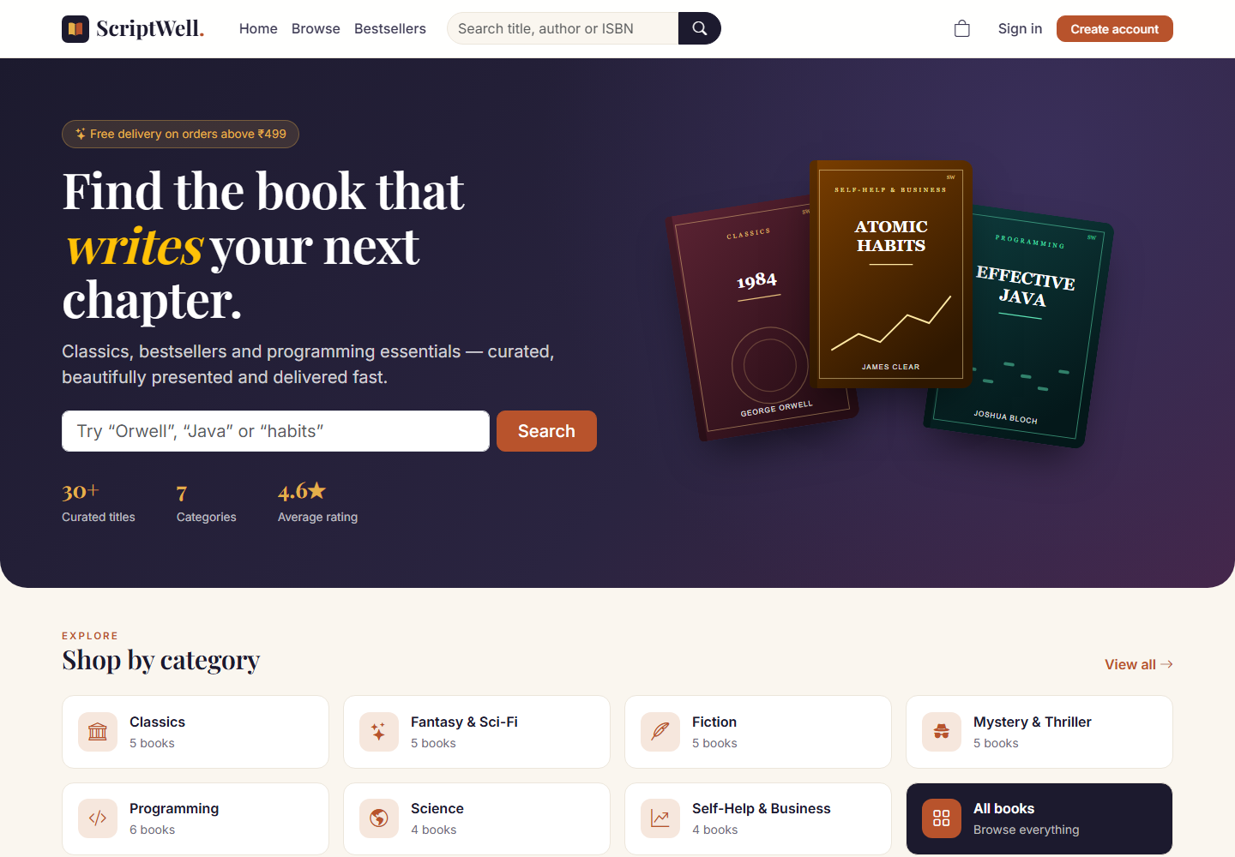
Figure 4.1: Home page with hero section, search and categories
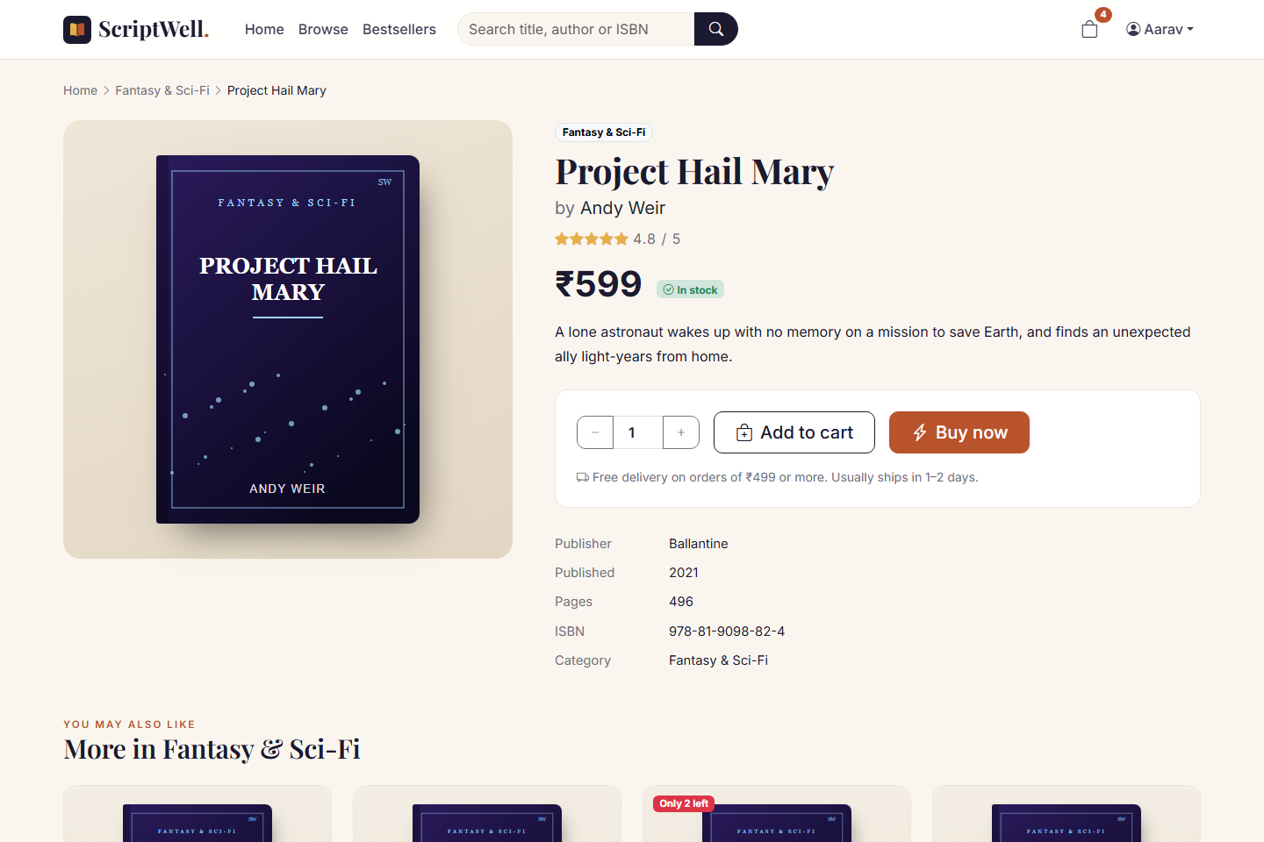
Figure 4.2: Book details page with Add to cart and Buy Now
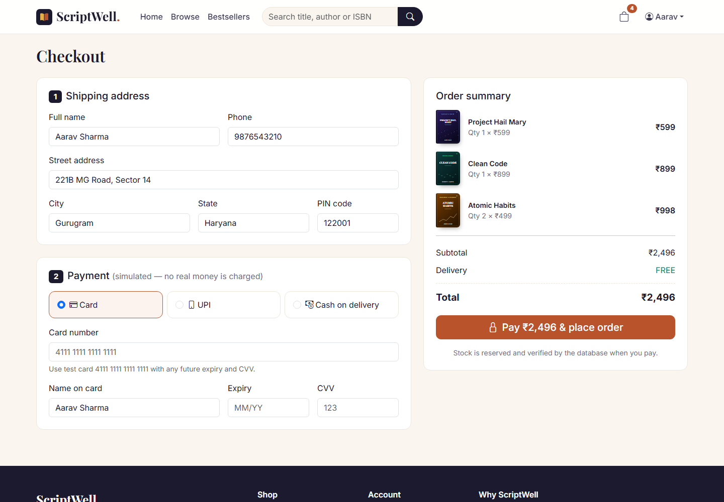
Figure 4.3: Checkout with simulated Card, UPI and Cash-on-delivery payment
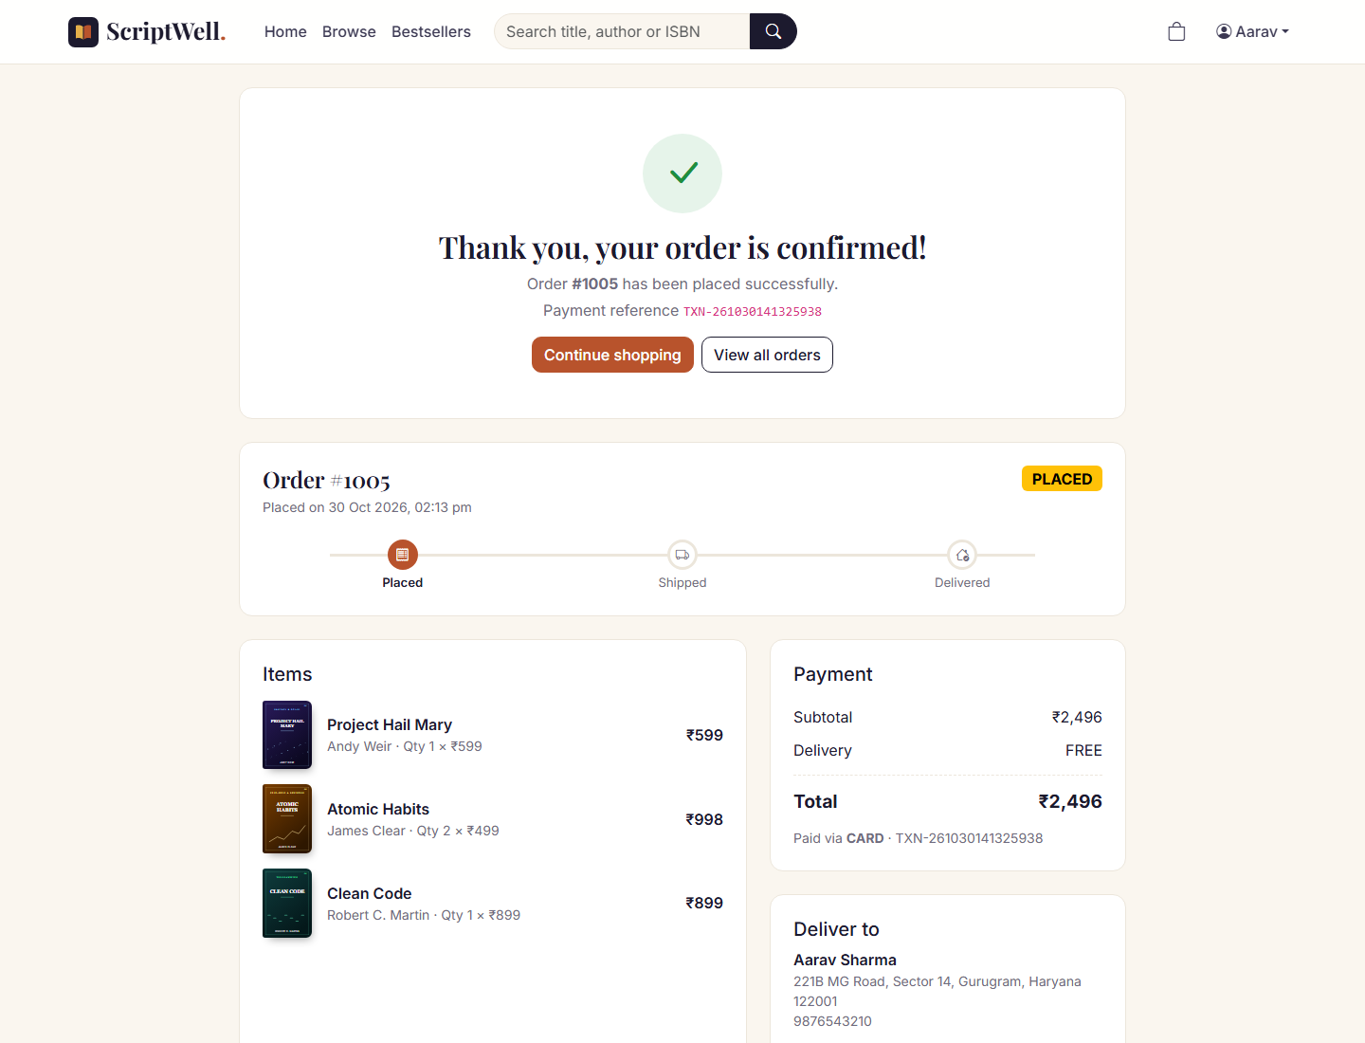
Figure 4.4: Order confirmation page with payment reference and status timeline
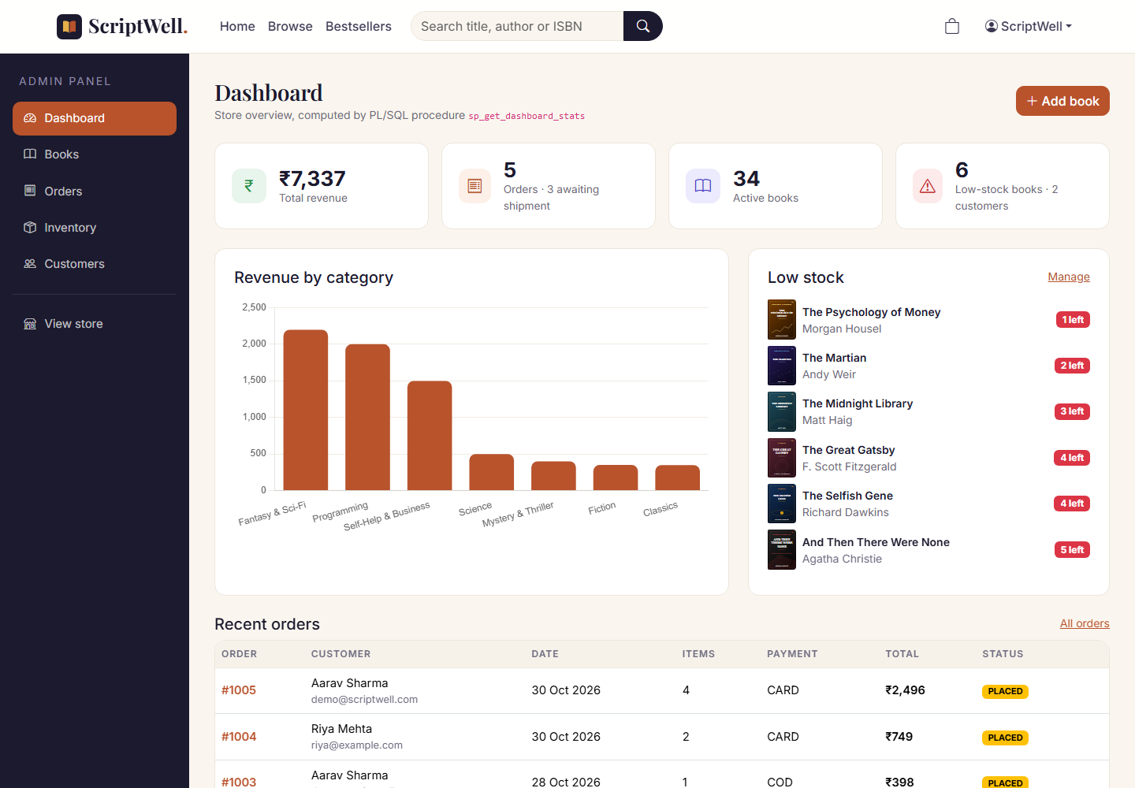
Figure 4.5: Administrator dashboard with statistics and sales chart

4.4 Limitations and Future Scope
- Integrate a real payment gateway (e.g. Razorpay or Stripe) in test mode with webhook confirmation.
- Send e-mail or SMS notifications when orders are placed or shipped.
- Add reviews, wish lists and recommendations, and image upload for book covers.
- Use a JNDI DataSource for connection pooling, and expose a REST API (JAX-RS) for a mobile app.

4.5 Conclusion
ScriptWell meets all of its objectives. The Servlet and JSP application follows a clean MVC structure, keeps user state with sessions, protects pages with filters and talks to Oracle only through CallableStatement. Bootstrap and JavaScript give it a modern, responsive and interactive interface. The project covers the main topics of Advanced Internet Programming in one working application that can be fully explained and demonstrated in a viva.

4.6 Pushing the Project to GitHub
The complete Eclipse project, SQL scripts and reports are published at https://github.com/lovishv1718/scriptwell using these commands:
git init -b main
git add .
git commit -m "ScriptWell online book store (Servlets, JSP, JDBC, Oracle PL/SQL)"
git remote add origin https://github.com/lovishv1718/scriptwell.git
git push -u origin main

REFERENCES-
[1] Eclipse Foundation, Jakarta Servlet Specification 6.0 and Jakarta Server Pages 3.1, jakarta.ee.
[2] The Apache Software Foundation, Apache Tomcat 10.1 Documentation, tomcat.apache.org.
[3] Oracle Corporation, Oracle Database JDBC Developer's Guide, 23ai, docs.oracle.com.
[4] M. Hall and L. Brown, Core Servlets and JavaServer Pages, 2nd ed., Prentice Hall.
[5] Bootstrap Team, Bootstrap 5.3 Documentation, getbootstrap.com.
[6] Mozilla, MDN Web Docs: Fetch API, HTML and CSS, developer.mozilla.org.
[7] ScriptWell source code repository, https://github.com/lovishv1718/scriptwell.

