

Topic: ScriptWell – Online Book Purchasing Store

PL/SQL PROJECT REPORT

Submitted by:

Student name
UID: 26MCA22333

Submitted to:
Mr. Ajay Yadav(E13382)

Submitted in partial fulfilment of the requirements for the degree of

MASTER OF COMPUTER APPLICATIONS (MCA)

CHANDIGARH UNIVERSITY
University Institute of Computing Punjab, India

BONAFIDE CERTIFICATE
This is to certify that the project report titled “ScriptWell – Online Book Purchasing Store” has been prepared as an academic project using Oracle Database Free 23ai and PL/SQL. The project demonstrates relational database design, stored procedures, stored functions, packages, triggers, explicit and implicit cursors, transaction control and structured exception handling. The database layer manages the book catalogue, user accounts, shopping carts, order processing, inventory auditing and administrative reporting, and it is accessed from a Java web application through JDBC CallableStatement.
This project report is submitted in partial fulfilment of the requirements for the degree of Master of Computer Applications (MCA).

Student Signature: Project Supervisor:

Head of Department: Date:

TABLE OF CONTENTS

Chapter 1: Introduction and Background Study PAGE 1 - 2
- 1.1 Project Overview
- 1.2 Problem Definition
- 1.3 Objectives and Scope
- 1.4 Technologies Used
- 1.5 Existing System and Proposed Solution

Chapter 2: System Requirements and Database Design PAGE 3 - 5
- 2.1 Hardware and Software Requirements
- 2.2 System Architecture
- 2.3 Data Flow and Transaction Workflow
- 2.4 Entity-Relationship Model and Data Dictionary
- 2.5 Functional and Non-Functional Requirements

Chapter 3: PL/SQL Implementation PAGE 6 - 9
- 3.1 Database Objects Overview
- 3.2 Packages and Stored Procedures
- 3.3 Stored Functions
- 3.4 Cursors and Transaction Control
- 3.5 Triggers
- 3.6 Exception Handling
- 3.7 Calling PL/SQL from Java (JDBC CallableStatement)

Chapter 4: Testing, Results and Conclusion PAGE 10 - 12
- 4.1 Testing Methodology
- 4.2 Test Cases and Validation
- 4.3 Results and Analysis
- 4.4 Limitations and Future Scope
- 4.5 Conclusion
- 4.6 Pushing the Project to GitHub
- References

CHAPTER 1:

INTRODUCTION AND BACKGROUND STUDY

1.1 Project Overview
ScriptWell is an online book purchasing store. Customers can browse 34 books in seven categories, search and filter the catalogue, keep a shopping cart, buy books with a simulated payment and track their orders. An administrator manages books, stock and orders from a dashboard. This report covers the database layer of the project, which is built entirely on Oracle Database Free 23ai and written in PL/SQL.
The main design decision is that the database owns the business rules. Stock checks, cart rules, price calculation, checkout, order cancellation, password hashing, validation and auditing all run as stored PL/SQL code. The Java web application never builds SQL strings. It only calls packaged procedures and functions through JDBC CallableStatement, and reads query results from SYS_REFCURSOR OUT parameters. As a result, every rule is applied the same way whichever client calls the database, and concurrent customers cannot leave the data in an inconsistent state.

1.2 Problem Definition
Many small e-commerce applications treat the database as passive storage and keep all logic in the application code. This causes several practical problems:
- Overselling: two customers who buy the last copy at the same moment can both succeed, because the stock check and the stock update are separate statements.
- Partial data: if an error occurs halfway through checkout, an order header can exist without its items, or stock can be reduced without an order.
- Duplicated validation: the same rules (price must be positive, quantity must be in range, e-mail must be unique) are re-implemented in several places and drift apart.
- No audit trail: nobody can later answer when stock changed, or who changed an order status.
The problem addressed by this project is to design a database that enforces these rules itself, using constraints, PL/SQL program units, triggers and transactions.

1.3 Objectives and Scope
Objectives
1. Design a normalised relational schema with primary keys, foreign keys, UNIQUE and CHECK constraints, indexes and a view.
2. Implement all core operations as packages (pkg_user, pkg_book, pkg_cart, pkg_order) with public and private sub-programs.
3. Write stand-alone stored functions and a stored procedure with OUT parameters for reusable calculations and dashboard statistics.
4. Use explicit cursors, cursor FOR loops and SELECT ... FOR UPDATE row locking to make checkout atomic and safe under concurrency.
5. Create row-level triggers for data cleaning and automatic auditing of stock and order status changes.
6. Apply consistent exception handling with predefined, user-defined and application error codes (-20001 to -20010).
Scope
The database supports two roles, Customer and Administrator, and covers the full purchase cycle: registration and login, catalogue search, cart, checkout and Buy Now, order history and cancellation, and administration of books, inventory and orders. Payment is simulated, so no card data is stored. Multiple warehouses, coupons and real payment gateways are outside the scope.

1.4 Technologies Used
Table 1.1: Technologies and tools
Technology | Purpose in the project
Oracle Database Free 23ai | Relational database server (pluggable database FREEPDB1)
PL/SQL | Packages, procedures, functions, triggers, cursors and exception handling
SQL*Plus / SQL Developer | Running the install scripts, testing program units, inspecting results
Docker (gvenzl/oracle-free image) | Quick, repeatable local installation of Oracle Database Free
Java 17 + JDBC (ojdbc11) | Web application that calls PL/SQL through CallableStatement
Apache Tomcat 10.1 | Runs the web front end used to demonstrate the database features
Git and GitHub | Version control and publishing of SQL scripts and source code

1.5 Existing System and Proposed Solution
Table 1.2: Comparison of the existing approach and ScriptWell
Aspect | Typical existing system | Proposed ScriptWell database
Business logic | Written in application code | Stored in PL/SQL packages inside Oracle
Stock control | Check then update, no locking | Row locking with FOR UPDATE inside one transaction
Failure handling | Partial rows may remain | Full ROLLBACK in exception handlers
Validation | Repeated in many places | Constraints, triggers and package validation in one place
Auditing | Manual or missing | Automatic logs written by triggers
Data access | Dynamic SQL strings | Only CallableStatement calls to stored programs

CHAPTER 2:

SYSTEM REQUIREMENTS AND DATABASE DESIGN

2.1 Hardware and Software Requirements
Table 2.1: Hardware and software requirements
Item | Requirement
Processor / Memory | 64-bit dual-core CPU or better, minimum 8 GB RAM (Oracle Free uses about 2 GB)
Disk space | About 10 GB for Oracle Database Free and the project
Operating system | Windows 10/11, Linux or macOS (Docker or native Oracle installation)
Database | Oracle Database Free 23ai (also runs on Oracle 19c and later)
Database tools | SQL*Plus or Oracle SQL Developer
Application tier | JDK 17, Apache Tomcat 10.1, Eclipse IDE for Enterprise Java

2.2 System Architecture
ScriptWell has a three-tier architecture. The browser shows the pages, the Java application on Tomcat handles requests, and the Oracle database stores the data and runs the business logic. For this subject the important point is the boundary between the second and third tiers. Every DAO class in Java calls a PL/SQL program, and every program returns either scalar OUT parameters or a REF CURSOR (Figure 2.1).
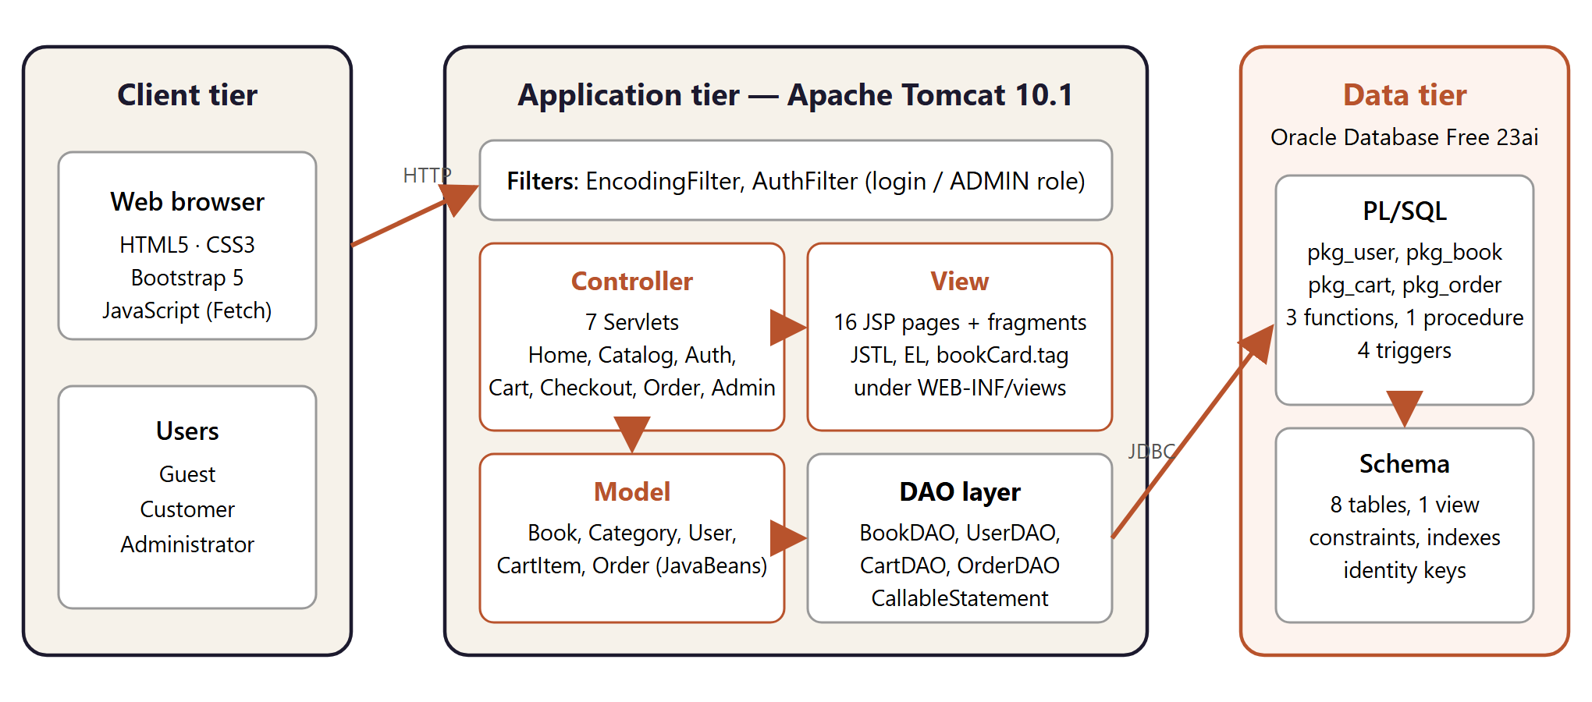
Figure 2.1: Three-tier architecture of ScriptWell with PL/SQL in the data tier

2.3 Data Flow and Transaction Workflow
The most important workflow is checkout. When a customer pays, a single call to pkg_order.place_order performs the following steps inside one transaction:
1. Validate the shipping address and payment method (private procedure check_input).
2. Raise the user-defined exception e_empty_cart if the cart has no rows.
3. Calculate the subtotal with pkg_cart.cart_total and the delivery charge with fn_shipping_charge.
4. Insert the order header and return the new order_id with RETURNING ... INTO.
5. Open an explicit cursor over the cart joined with BOOKS, locking each book row with FOR UPDATE.
6. For every line: check the stock, insert into ORDER_ITEMS and reduce the stock. Trigger trg_books_stock_audit logs each change.
7. Delete the cart rows and COMMIT. On any error, close the cursor and ROLLBACK the whole order.

2.4 Entity-Relationship Model and Data Dictionary
The schema contains six business tables and two audit tables. All primary keys are Oracle IDENTITY columns. Order numbers start at 1001. The view V_BOOK_CATALOG joins BOOKS with CATEGORIES and is used by every catalogue query.
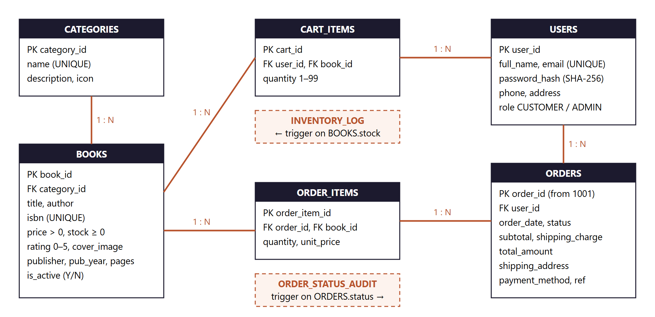
Figure 2.2: Entity-relationship diagram of the ScriptWell schema
Table 2.2: Data dictionary (main tables)
Table | Key columns | Constraints
CATEGORIES | category_id, name, description, icon | PK; name UNIQUE
BOOKS | book_id, title, author, isbn, category_id, price, stock, rating, is_active | PK; FK to CATEGORIES; isbn UNIQUE; CHECK price > 0, stock >= 0, rating 0-5, is_active IN (Y,N)
USERS | user_id, full_name, email, password_hash, phone, address, role | PK; email UNIQUE; CHECK role IN (CUSTOMER, ADMIN)
CART_ITEMS | cart_id, user_id, book_id, quantity | UNIQUE (user_id, book_id); CHECK quantity 1-99; ON DELETE CASCADE
ORDERS | order_id, user_id, subtotal, shipping_charge, total_amount, status, payment_method, payment_ref | PK from 1001; FK to USERS; CHECK status and payment_method
ORDER_ITEMS | order_item_id, order_id, book_id, quantity, unit_price | FKs to ORDERS (cascade) and BOOKS
INVENTORY_LOG | log_id, book_id, old_stock, new_stock, change_qty, reason | Written only by trigger
ORDER_STATUS_AUDIT | audit_id, order_id, old_status, new_status, changed_by | Written only by trigger

The design is in third normal form. Category names are stored once, and order lines are separate from order headers. The price at the moment of sale is copied deliberately into ORDER_ITEMS.unit_price, so later price changes do not alter past orders. Indexes on books(category_id), the function-based index books(UPPER(title)), orders(user_id) and order_items(order_id) speed up the most frequent queries.

2.5 Functional and Non-Functional Requirements
Functional requirements
- Register users with unique e-mail addresses and store only SHA-256 password hashes.
- Search books by keyword, category and price range, with sorting, through a single procedure.
- Maintain a persistent cart whose quantities never exceed the available stock.
- Place orders from the cart or with Buy Now, and generate a payment reference.
- Let customers cancel unshipped orders, returning the stock automatically.
- Let administrators run book CRUD, restock, update order status and view dashboard statistics.
Non-functional requirements
- Consistency: all-or-nothing checkout and no negative stock (CHECK constraint plus locking).
- Security: bind variables only, hashed passwords, and generic messages for unexpected errors.
- Maintainability: logic grouped into four packages, and scripts that can be re-run safely (00_install.sql).
- Auditability: every stock and order-status change is recorded automatically.

CHAPTER 3:

PL/SQL IMPLEMENTATION

3.1 Database Objects Overview
The PL/SQL code is organised into five script files that run in order from 00_install.sql: schema, functions, packages, triggers and seed data. Table 3.1 summarises the program units.
Table 3.1: PL/SQL program units
Object | Type | Sub-programs / responsibility
pkg_user | Package | hash_password, register_user, login_user, get_all_users
pkg_book | Package | search_books, get_book, get_featured, get_new_arrivals, get_related, get_categories, add_book, update_book, delete_book, adjust_stock, get_low_stock, get_inventory_log, private validate_book
pkg_cart | Package | add_item (MERGE), update_item, remove_item, clear_cart, get_cart, cart_total, cart_count, private check_stock
pkg_order | Package | place_order, buy_now, get_user_orders, get_order, get_all_orders, update_status, cancel_order, sales_by_category, private restock_order and new_payment_ref
fn_shipping_charge | Function | Free delivery for subtotal >= Rs.499, otherwise Rs.49
fn_is_in_stock | Function | Returns Y/N for a requested quantity
fn_total_revenue | Function | Revenue of all non-cancelled orders
sp_get_dashboard_stats | Procedure | Six OUT parameters for the admin dashboard
4 triggers | Trigger | Data normalisation, validation, stock audit, order status audit

3.2 Packages and Stored Procedures
Each package has a specification, which is the public interface that Java calls, and a body, which holds the implementation. Helpers such as validate_book and check_stock exist only in the body, so they are private to the package. The specification of the cart package is shown below:
CREATE OR REPLACE PACKAGE pkg_cart AS
PROCEDURE add_item (p_user_id IN NUMBER, p_book_id IN NUMBER, p_qty IN NUMBER);
PROCEDURE update_item (p_user_id IN NUMBER, p_book_id IN NUMBER, p_qty IN NUMBER);
PROCEDURE remove_item (p_user_id IN NUMBER, p_book_id IN NUMBER);
PROCEDURE clear_cart (p_user_id IN NUMBER);
PROCEDURE get_cart (p_user_id IN NUMBER, p_result OUT SYS_REFCURSOR);
FUNCTION cart_total (p_user_id IN NUMBER) RETURN NUMBER;
FUNCTION cart_count (p_user_id IN NUMBER) RETURN NUMBER;
END pkg_cart;
Listing 3.1: Package specification of pkg_cart
Query procedures return their rows through a SYS_REFCURSOR OUT parameter. The catalogue search handles optional filters in one static statement. A NULL parameter disables its filter, and a CASE expression in the ORDER BY clause selects the sort order:
PROCEDURE search_books (p_keyword IN VARCHAR2, p_category_id IN NUMBER,
p_min_price IN NUMBER, p_max_price IN NUMBER,
p_sort IN VARCHAR2, p_result OUT SYS_REFCURSOR) IS
v_kw VARCHAR2(210) := '%' || UPPER(TRIM(p_keyword)) || '%';
BEGIN
OPEN p_result FOR
SELECT * FROM v_book_catalog
WHERE is_active = 'Y'
AND (p_keyword IS NULL OR UPPER(title) LIKE v_kw OR UPPER(author) LIKE v_kw
OR UPPER(isbn) LIKE v_kw OR UPPER(category_name) LIKE v_kw)
AND (p_category_id IS NULL OR category_id = p_category_id)
AND (p_min_price IS NULL OR price >= p_min_price)
AND (p_max_price IS NULL OR price <= p_max_price)
ORDER BY CASE WHEN p_sort = 'price_asc' THEN price END ASC,
CASE WHEN p_sort = 'price_desc' THEN price END DESC,
CASE WHEN p_sort = 'rating' THEN rating END DESC,
title;
END search_books;
Listing 3.2: Search procedure returning a REF CURSOR
The cart uses a MERGE statement, so adding a book that is already in the cart increases its quantity instead of creating a duplicate row. Before the MERGE, the private procedure check_stock makes sure the combined quantity is available.

3.3 Stored Functions
Stand-alone functions hold small, reusable rules that can be called from SQL, from other PL/SQL code and from Java. fn_is_in_stock also shows how a predefined exception is handled:
CREATE OR REPLACE FUNCTION fn_shipping_charge (p_subtotal IN NUMBER) RETURN NUMBER IS
BEGIN
IF p_subtotal IS NULL OR p_subtotal = 0 THEN RETURN 0;
ELSIF p_subtotal >= 499 THEN RETURN 0;
ELSE RETURN 49;
END IF;
END fn_shipping_charge;

CREATE OR REPLACE FUNCTION fn_is_in_stock (p_book_id IN NUMBER, p_qty IN NUMBER)
RETURN VARCHAR2 IS
v_stock books.stock%TYPE;
BEGIN
SELECT stock INTO v_stock FROM books WHERE book_id = p_book_id AND is_active = 'Y';
RETURN CASE WHEN v_stock >= p_qty THEN 'Y' ELSE 'N' END;
EXCEPTION
WHEN NO_DATA_FOUND THEN RETURN 'N';
END fn_is_in_stock;
Listing 3.3: Stored functions
The stand-alone procedure sp_get_dashboard_stats returns six values (active books, customers, orders, revenue, low-stock books and pending orders) through OUT parameters in one round trip. It calls fn_total_revenue internally, so one stored program reuses another.

3.4 Cursors and Transaction Control
pkg_order.place_order uses an explicit cursor with FOR UPDATE OF b.stock. Opening the cursor locks every book in the customer's cart until the transaction ends. If two customers try to buy the last copy, the second one waits, then sees the reduced stock and receives error -20003. If anything fails, the handler closes the cursor and rolls back.
CURSOR c_cart IS
SELECT c.book_id, c.quantity, b.price, b.stock, b.title
FROM cart_items c JOIN books b ON b.book_id = c.book_id
WHERE c.user_id = p_user_id
FOR UPDATE OF b.stock;
r_item c_cart%ROWTYPE;
...
OPEN c_cart;
LOOP
FETCH c_cart INTO r_item;
EXIT WHEN c_cart%NOTFOUND;
IF r_item.stock < r_item.quantity THEN
RAISE_APPLICATION_ERROR(-20003, 'Only ' || r_item.stock || ' copies of "'
|| r_item.title || '" left in stock');
END IF;
INSERT INTO order_items (order_id, book_id, quantity, unit_price)
VALUES (p_order_id, r_item.book_id, r_item.quantity, r_item.price);
UPDATE books SET stock = stock - r_item.quantity WHERE book_id = r_item.book_id;
END LOOP;
CLOSE c_cart;
DELETE FROM cart_items WHERE user_id = p_user_id;
COMMIT;
EXCEPTION
WHEN e_empty_cart THEN
ROLLBACK;
RAISE_APPLICATION_ERROR(-20004, 'Your cart is empty');
WHEN OTHERS THEN
IF c_cart%ISOPEN THEN CLOSE c_cart; END IF;
ROLLBACK;
RAISE;
Listing 3.4: Explicit cursor with row locking in place_order
A cursor FOR loop is used when an order is cancelled. The private procedure restock_order loops over the order lines and returns each quantity to stock. Oracle opens, fetches from and closes the cursor automatically:
PROCEDURE restock_order (p_order_id IN NUMBER) IS
CURSOR c_lines IS SELECT book_id, quantity FROM order_items WHERE order_id = p_order_id;
BEGIN
FOR r IN c_lines LOOP
UPDATE books SET stock = stock + r.quantity WHERE book_id = r.book_id;
END LOOP;
END restock_order;
Listing 3.5: Cursor FOR loop
Implicit cursor attributes are also used. For example, update_book checks SQL%ROWCOUNT = 0 to detect a book that does not exist, and raises -20005.

3.5 Triggers
Table 3.2: Row-level triggers
Trigger | Timing and event | Action
trg_users_normalize | BEFORE INSERT OR UPDATE OF email | Lower-cases and trims the e-mail; rejects values without '@'
trg_books_before_save | BEFORE INSERT OR UPDATE | Trims title and author, upper-cases ISBN, rejects a future publication year
trg_books_stock_audit | AFTER INSERT OR UPDATE OF stock | Writes old stock, new stock, change and reason to INVENTORY_LOG
trg_orders_status_audit | AFTER INSERT OR UPDATE OF status | Writes the status history and session user to ORDER_STATUS_AUDIT

CREATE OR REPLACE TRIGGER trg_books_stock_audit
AFTER INSERT OR UPDATE OF stock ON books
FOR EACH ROW
DECLARE
v_reason inventory_log.reason%TYPE;
BEGIN
IF INSERTING THEN v_reason := 'INITIAL STOCK';
ELSIF :NEW.stock < :OLD.stock THEN v_reason := 'SALE / ADJUSTMENT';
ELSE v_reason := 'RESTOCK / RETURN';
END IF;
IF INSERTING OR :NEW.stock <> :OLD.stock THEN
INSERT INTO inventory_log (book_id, old_stock, new_stock, change_qty, reason)
VALUES (:NEW.book_id, :OLD.stock, :NEW.stock, :NEW.stock - NVL(:OLD.stock, 0), v_reason);
END IF;
END;
Listing 3.6: Stock audit trigger using :NEW, :OLD and INSERTING

3.6 Exception Handling
Three kinds of exceptions are used. Predefined exceptions (NO_DATA_FOUND, DUP_VAL_ON_INDEX) are caught and turned into clear messages. The user-defined exception e_empty_cart is declared in the pkg_order specification and raised with RAISE. Business-rule violations call RAISE_APPLICATION_ERROR with codes reserved for this application:
Table 3.3: Application error codes
Code | Meaning | Raised by
-20001 | E-mail already registered | register_user (also maps DUP_VAL_ON_INDEX)
-20002 | Invalid e-mail or password | login_user (maps NO_DATA_FOUND)
-20003 | Insufficient stock | check_stock, place_order, buy_now
-20004 | Cart is empty | place_order (from e_empty_cart)
-20005 / -20008 | Book / order not found | book and order procedures
-20006 | Invalid quantity or negative stock | check_stock, adjust_stock
-20007 / -20009 | Order cannot be cancelled / invalid status change | cancel_order, update_status
-20010 | Validation failed | validation helpers and triggers

3.7 Calling PL/SQL from Java (JDBC CallableStatement)
The web tier calls the packages through JDBC escape syntax. IN parameters are bound with setter methods, OUT parameters are registered before execution, and a REF CURSOR is read as a normal ResultSet. When Oracle raises an error between -20000 and -20999, Java shows its message to the user. Any other error is logged and replaced with a generic message.
try (Connection con = DBConnection.getConnection();
CallableStatement cs = con.prepareCall("{call pkg_order.place_order(?,?,?,?,?)}")) {
cs.setInt(1, userId);
cs.setString(2, address);
cs.setString(3, payment); // CARD, UPI or COD
cs.registerOutParameter(4, Types.NUMERIC); // new order id
cs.registerOutParameter(5, Types.VARCHAR); // payment reference
cs.execute();
return new Object[] { cs.getInt(4), cs.getString(5) };
}
Listing 3.7: Calling place_order from OrderDAO.java

CHAPTER 4:

TESTING, RESULTS AND CONCLUSION

4.1 Testing Methodology
The database was tested at two levels. Unit testing called each procedure and function directly in SQL*Plus with valid, invalid and boundary values, then checked the returned values, the rows affected, the audit rows written by triggers and the error codes raised. Integration testing ran the same operations through the web application, confirming that the Java DAOs pass parameters correctly and show the PL/SQL messages to the user. The install script 00_install.sql lists any compilation errors from USER_ERRORS, and none were reported.

4.2 Test Cases and Validation
Table 4.1: PL/SQL test cases
No. | Test case | Expected result | Status
1 | register_user with an existing e-mail | ORA-20001 'An account with this email already exists' | Pass
2 | register_user with a 3-character password | ORA-20010 validation error | Pass
3 | login_user with a wrong password | ORA-20002 'Invalid email or password' | Pass
4 | search_books('java', NULL, NULL, NULL, NULL) | 2 rows returned | Pass
5 | search_books with category 5, sort price_desc | 6 rows, highest price first | Pass
6 | add_item: 5 copies of a book with stock 1 | ORA-20003 'Only 1 copy ... available' | Pass
7 | place_order with an empty cart | ORA-20004 'Your cart is empty' | Pass
8 | place_order with a valid cart | Order created, stock reduced, cart emptied, log rows added | Pass
9 | cancel_order on a PLACED order | Status CANCELLED, stock restored by cursor loop | Pass
10 | update_status of a CANCELLED order to PLACED | ORA-20009 'A cancelled order cannot be reopened' | Pass
11 | add_book with price -5 / year 2099 | ORA-20010 from validate_book / trigger | Pass
12 | delete_book on a book that has been sold | Book deactivated (is_active = 'N'), not deleted | Pass
13 | fn_shipping_charge(300) / fn_shipping_charge(600) | 49 / 0 | Pass

4.3 Results and Analysis
The seed script places four orders through the packages. The queries below show that the procedures, functions and triggers worked together correctly. Order 1003 (subtotal Rs.349) was charged Rs.49 delivery, and every sale and status change was audited automatically.
SQL> SELECT order_id, subtotal, shipping_charge, total_amount, status, payment_method FROM orders;
ORDER_ID SUBTOTAL SHIPPING_CHARGE TOTAL_AMOUNT STATUS PAYMENT_METHOD
1001 1598 0 1598 DELIVERED CARD
1002 2096 0 2096 SHIPPED UPI
1003 349 49 398 PLACED COD
1004 749 0 749 PLACED CARD

SQL> SELECT book_id, old_stock, new_stock, change_qty, reason FROM inventory_log
WHERE reason <> 'INITIAL STOCK';
BOOK_ID OLD_STOCK NEW_STOCK CHANGE_QTY REASON
31 65 64 -1 SALE / ADJUSTMENT
11 45 43 -2 SALE / ADJUSTMENT ... (8 rows selected)

SQL> SELECT name, type FROM user_errors;
no rows selected
Listing 4.1: Verification queries in SQL*Plus
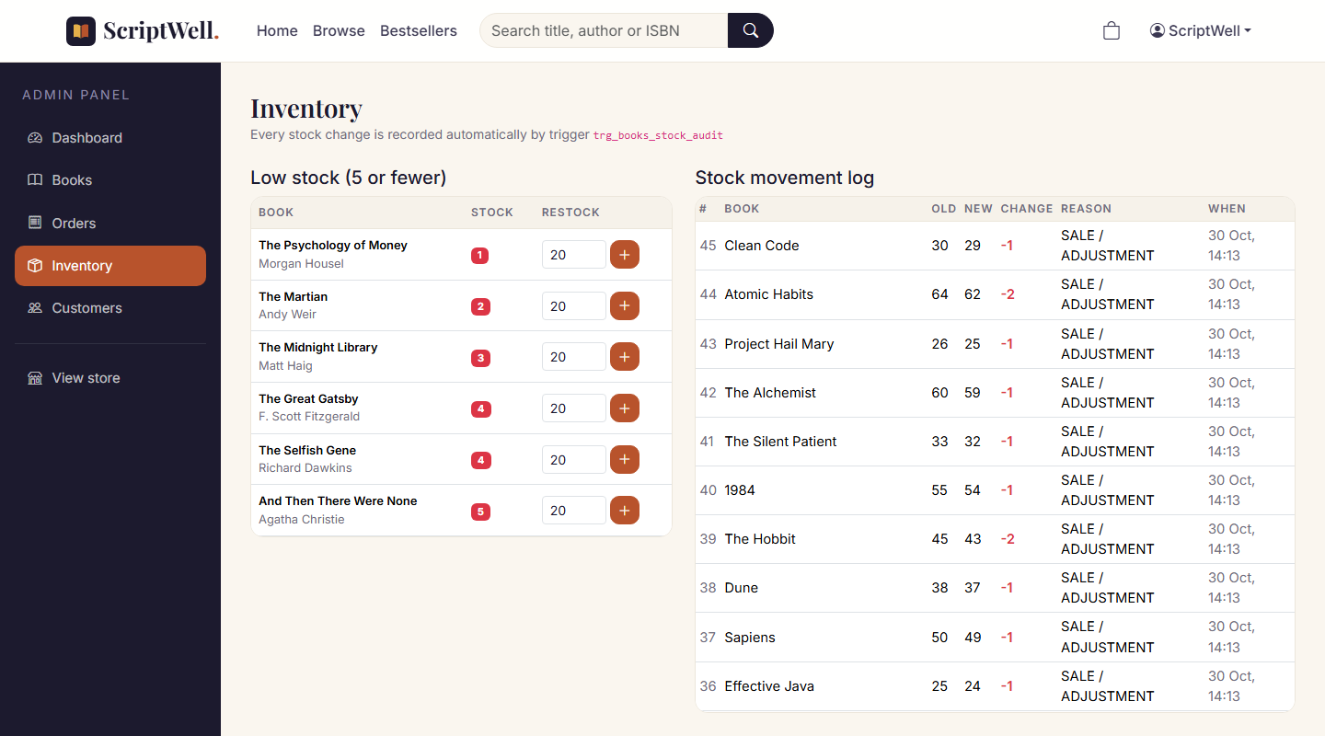
Figure 4.1: Inventory page showing the stock movement log written by trg_books_stock_audit

4.4 Limitations and Future Scope
- Payment is simulated. A real gateway would need a confirmation table and webhook handling.
- Only one warehouse is modelled. A STOCK_LOCATIONS table could support multiple warehouses.
- Coupons and discounts could be added as a new pkg_promo package with validity rules.
- Reports such as monthly sales could use analytic functions and materialised views.
- Bulk operations could use BULK COLLECT and FORALL for very large catalogues.

4.5 Conclusion
The ScriptWell database meets all of its objectives. The schema is normalised and protected by constraints. Business operations are grouped into four packages with clear public interfaces. Stored functions and a stored procedure provide reusable calculations. Explicit cursors with row locking make checkout atomic and safe when many customers order at once, triggers keep complete audit trails without any application code, and structured exception handling gives clear, consistent messages. Because the rules live in PL/SQL, the Java application is simpler, and the data stays correct whichever client uses the database.

4.6 Pushing the Project to GitHub
All SQL scripts, the Java source code and this report are under version control with Git and are published to GitHub at https://github.com/lovishv1718/scriptwell. The commands used were:
git init -b main
git add .
git commit -m "ScriptWell online book store (Servlets, JSP, JDBC, Oracle PL/SQL)"
git remote add origin https://github.com/lovishv1718/scriptwell.git
git push -u origin main

REFERENCES-
[1] Oracle Corporation, Oracle Database PL/SQL Language Reference, 23ai, docs.oracle.com.
[2] Oracle Corporation, Oracle Database SQL Language Reference, 23ai, docs.oracle.com.
[3] Oracle Corporation, Oracle Database JDBC Developer's Guide, 23ai, docs.oracle.com.
[4] S. Feuerstein and B. Pribyl, Oracle PL/SQL Programming, 6th ed., O'Reilly Media, 2014.
[5] R. Elmasri and S. B. Navathe, Fundamentals of Database Systems, 7th ed., Pearson, 2016.
[6] ScriptWell source code repository, https://github.com/lovishv1718/scriptwell.

