1 – 2 : Admin page/ Student Menu

* please see my comment regarding the value of Remaining hour.
* Please allow use view only “Active student” ( who has total hour/remaining hour > 0 ). You can add new button for this or Add it to the Time report, depend on you.
* Please add 1 text box for Skipping class

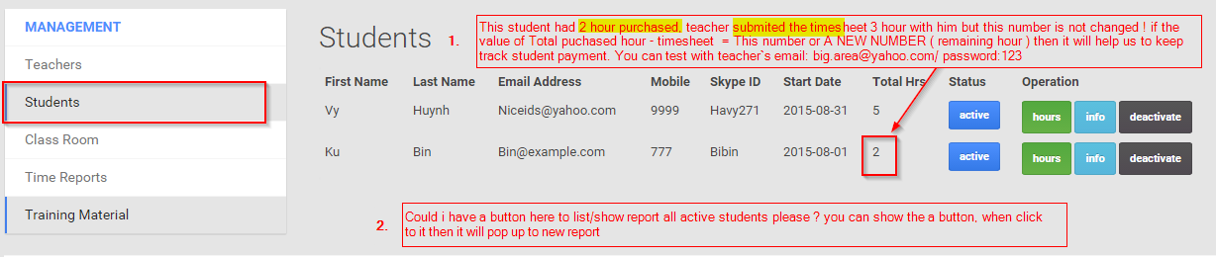

3. Admin page/Student menu – request adding 1 more textbox for updated manually by Admin.

* Please add 1 textbox to the updated student on the Admin page. As I will explain the story below…

**The story of skipping the class:**

- Student A purchased 4 hours of us, his schedule will be in class today. But he will get busy and cannot take the class. He called us to ask permission for skipping the class today. Our manage confirm it`s ok ( won`t charge him ). Then he will skip the class, and we email teacher to inform the skipping schedule ( teacher won`t be paid this one ). Our school will need login to Admin and update Skipping class of this student is : 1, the next case/postponing of student then we will replace 1 by 2, increase the number until we don`t allow him skip the class by our policy.

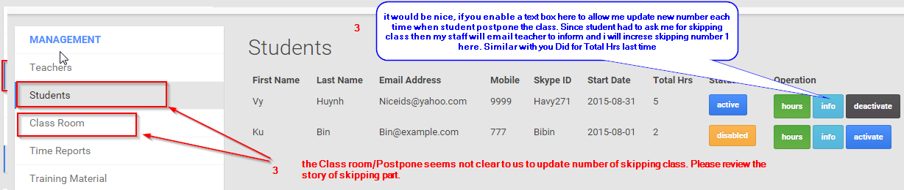

Just a question if it`s not tough for you. Student bought 3 hour, but she used it up and there is no warning, teacher thought student get valid hours, and teacher still teach student but we have empty charge . so could you please consider the remaining hour value = timesheet – total hour please ? if it`s tough then please ignore this part

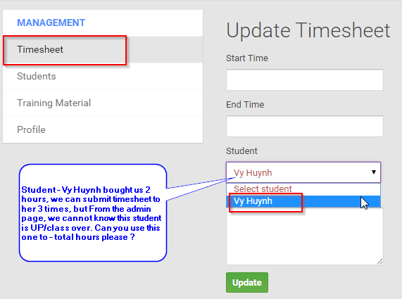

4. Admin page/ Training Material menu – adding one more item: Allow view all for a specific document

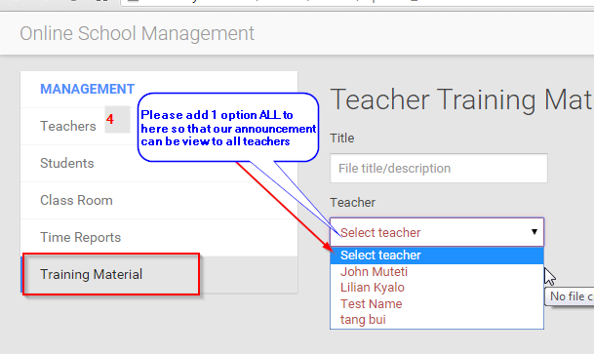

5. please let top pane in static view so that new teacher always can see it to make their timesheet